**Laporan Projek Web Programming**

**Toko Komputer Online Minify**



|  |  |
| --- | --- |
| Disusun Oleh : | |
| Kevin Adhi Dhamma Setiawan | 535200050 |
| Stephen Adhikurnia | 535200056 |
| Richard Stephen | 535200058 |
| Wendy Bunandi | 535200066 |
| Hongi Nagaputra | 535200082 |

**UNIVERSITAS TARUMANEGARA**

**JAKARTA**

**2021**

# DAFTAR ISI

DAFTAR ISI i

BAB I 1

PROJECT PLAN 1

BAB II 2

PEMBAHASAN HALAMAN 2

1. Header dan Footer 2

1.1. Header 2

1.1.A. Mockup 2

1.1.B. Tampilan 2

1.1.C. Flowchart 3

1.1.D. Fitur 4

1.2. Footer 6

1.2.A. Mockup 6

1.2.B. Tampilan 6

1.2.C. Flowchart 6

1.2.D. Fitur 7

1.3. Source Code 7

2. Home 19

2.A. Mock Up 19

2.B. Tampilan 20

2.C. Flowchart 21

2.D. Fitur 21

2.E. Source Code 22

Html 22

CSS 32

3. Login Page 35

3. A. Mock Up 35

3. B. Tampilan 36

3. C. Flowchart 36

3. D. Fitur 37

3. E. Source Code 38

Html 38

CSS 39

4. Register Page 40

4.A. Mockup 40

4.B. Tampilan 41

4.C. Flowchart 42

4.D. Fitur 42

4.E. Source Code 43

Html 43

CSS 46

5. Forget Password 47

5.A. Mock Up 47

5.B. Tampilan 48

5.C. Flowchart 48

5.D. Fitur 49

5.E. Source Code 49

Html 49

6. Verification Code 51

6.A. Mock Up 51

6.B. Tampilan 52

6.C. Flowchart 53

6.D. Fitur 54

6.E. Source Code 54

Html 54

7. Change Password 56

7.A. Mock Up 56

7.B. Tampilan 57

7.C. Flowchart 58

7.D. Fitur 58

7.E. Source Code 59

Html 59

8. Profile dan Edit Profile 61

8.A. Mockup 61

8.B. Tampilan 62

8.C. Flowchart 64

8.D. Fitur 64

8.E. Source Code 65

8.D.1 Source Code Profile 65

Html 65

CSS 66

Javascript 67

8.D.2 Source Code Edit Profile 67

Html 67

CSS 70

JavaScript 70

9. Wishlist 71

9.A. Mockup 71

9.B. Tampilan 72

9.C. Flowchart 73

9.D. Fitur 73

9.E. Source Code 73

Html 73

CSS 87

10. My Order 88

10.A.Mockup 88

10.B. Tampilan 89

10.C. Flowchart 89

10.D. Fitur 90

10.E. Source Code 90

Html 90

11. My Order Detail 97

11.A. Tampilan 97

11.B. Flowchart 98

11.C. Fitur 98

11.D. Source Code 98

Html 98

12. Messages 102

12.A. Mockup 102

12.B. Tampilan 103

12.C. Flowchart 104

12.D. Fitur 104

12.E. Source Code 105

Html 105

13. Chat Room 119

13.A. Mockup 119

13.B. Tampilan 120

13.C. Flowchart 120

13.D. Fitur 121

13.E. Source Code 121

Html 121

CSS 123

Javascript 125

14. Cart 127

14.A. Mockup 127

14.B. Tampilan 128

14.C. Flowchart 129

14.D. Fitur 129

14.E. Source Code 130

Html 130

Javascript 135

15. Checkout 136

15.A. Mockup 136

15.B. Tampilan 137

15.C. Flowchart 138

15.D. Fitur 138

15.E. Source Code 139

Html 139

Javascript 144

16. Payment 145

16.A. Mockup 145

16.A. Tampilan 146

16.B. Flowchart 146

16.C. Fitur 147

16.D. Source Code 147

Html 147

17. Best Seller 152

17.A. Mockup 152

17.B. Tampilan 153

17.C. Flowchart 154

17.D. Fitur 154

17.E. Source Code 155

Html 155

CSS 168

18. New Arrival 169

18.A. Tampilan 169

18.B. Flowchart 170

18.C. Fitur 170

18.D. Source Code 171

**Html** 171

**CSS** 183

19. Products 185

19.A. Mockup 185

19.B. Tampilan 186

19.C. Flowchart 187

19.D. Fitur 189

19.E. Source Code 190

HTML 190

CSS 208

20. Product Details 211

20.A. Tampilan 211

20.B. Flowchart 212

20.C. Fitur 212

20.D. Source Code 213

Html 213

CSS 222

Javascript 225

21. Company 227

21. A. Mock Up 227

21. B. Tampilan 228

21. C. Flowchart 229

21. D. Fitur 229

21. E. Source Code 230

Html 230

CSS 232

22. Terms 235

22. A. Mock Up 235

22. B. Tampilan 236

22. C. Flowchart 236

22. D. Fitur 236

22. E. Source Code 237

Html 237

CSS 239

JavaScript 241

23. FAQ 242

23. A. Mock Up 242

23. B. Tampilan 243

23. C. Flowchart 243

23. D. Fitur 244

23. E. Source Code 244

Html 244

CSS 246

JavaScript 248

24. How To Order 249

24. A. Mock Up 249

24. B. Tampilan 250

24. C. F lowchart 250

24. D. Fitur 251

24. E. Source Code 251

Html 251

CSS 253

Javascript 255

25. Dashboard 256

25.1. General 257

25.1.A. Mock Up 257

25.1.B. Tampilan 258

25.1.C. Flowchart 258

25.1.D. Fitur 258

25.2. Katalog 259

25.2.A. Mock Up 259

25.2.B. Tampilan 260

25.2.C. Flowchart 261

25.2.D. Fitur 261

25.3. Order 262

25.3.A. Mock Up 262

25.3.B. Tampilan 262

25.3.C. Flowchart 263

25.3.D. Fitur 263

25.4. Messages 264

25.4.A. Mock Up 264

25.4.B. Tampilan 264

25.4.C. Flowchart 266

25.4.D. Fitur 266

26. Add Products 267

26.A. Tampilan 267

26.B. Flowchart 268

26.C. Fitur 268

27. Add Category/Brand 269

27.A. Tampilan 269

27.B. Flowchart 270

27.C. Fitur 271

28. Edit Product 272

28.A. Tampilan 272

28.B. Flowchart 273

28.C. Fitur 273

28.D. Source Code 274

Html 274

CSS 276

Javascript 276

29. Source Code Dashboard, Add Product, dan Add Category/Brand 276

Html 276

CSS 301

Javascript 305

# BAB I

## PROJECT PLAN

1. **What**

Toko Komputer berbasis website

1. **Who**

Calon customer dari toko ini seperti Pekerja WFH, Pelajar, Content Creator, dan Gamer.

Website akan dibuat oleh seluruh anggota kelompok 3

1. **Where**

Toko akan dalam bentuk website. Pembuatan website melalui aplikasi Visual Studio Code

1. **When**

Project akan dikerjakan selama semester 3 atau selama perkuliahan Web Programming

1. **Why**

Sejak pandemi merebak dan sebagian besar orang melakukan kegiatan secara online(seperti WFH), maka kebutuhan akan komputer, laptop dan berbagai jenis aksesorisnya meningkat.

1. **How**

Pembuatan website akan dilakukan menggunakan HTML, CSS, JS, dan Bootstrap sebagai front-end untuk membuat tampilan yang menarik, serta Node JS/MongoDB akan digunakan untuk bagian back-end.

# BAB II

## PEMBAHASAN HALAMAN

### Header dan Footer

#### 1.1. Header

##### 1.1.A. Mockup

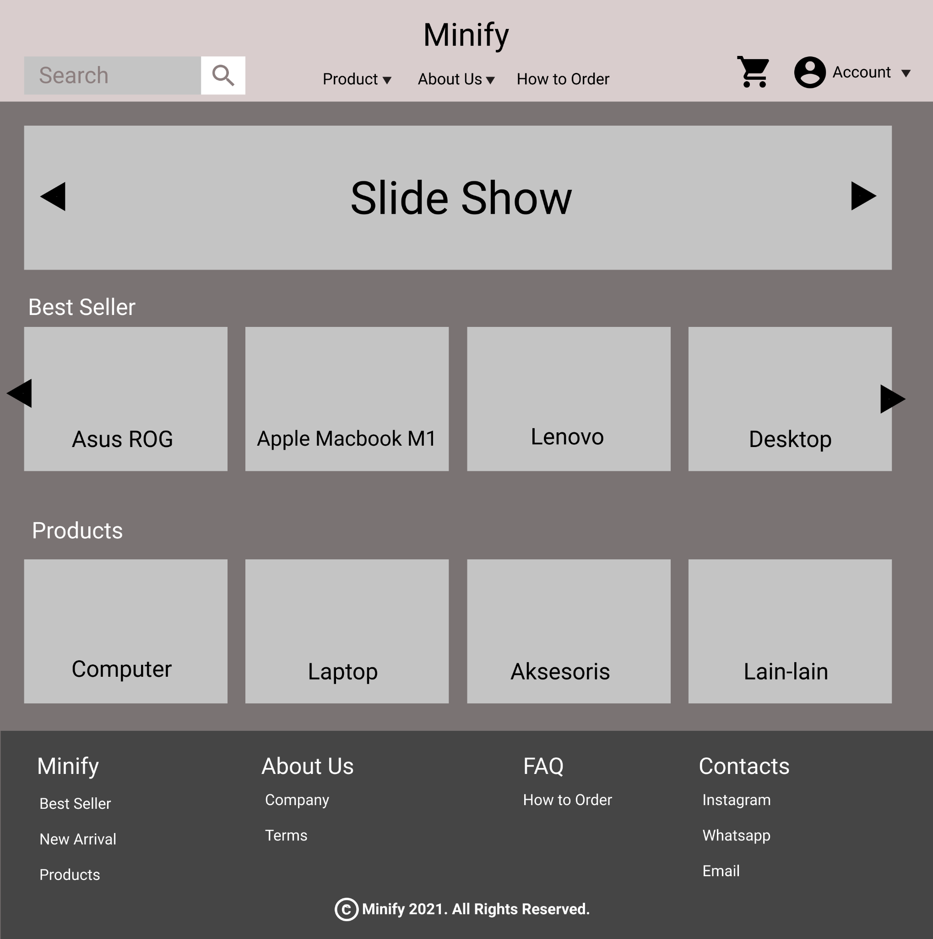

**Gambar 1.1.1. Mockup Header**

##### 1.1.B. Tampilan

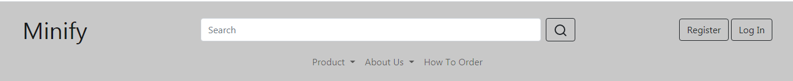

**Gambar 1.1.2. Tampilan Header**

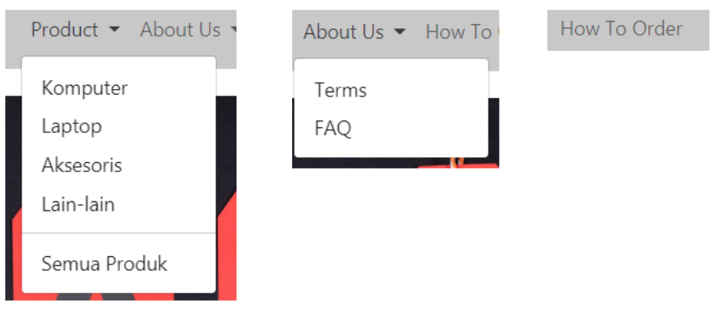

**Gambar 1.1.3. Navigation Menu Dropdown**

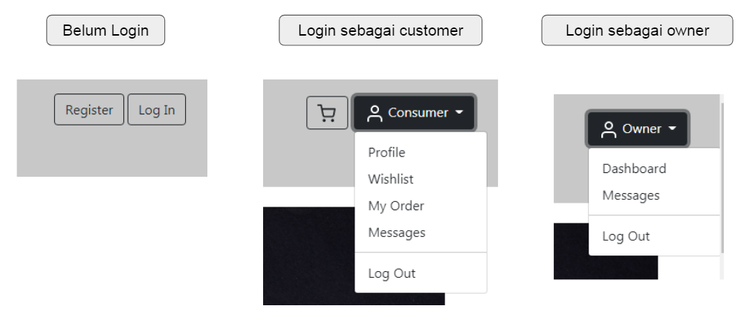

**Gambar 1.1.4. Jenis Tampilan Account Menu**

##### 1.1.C. Flowchart

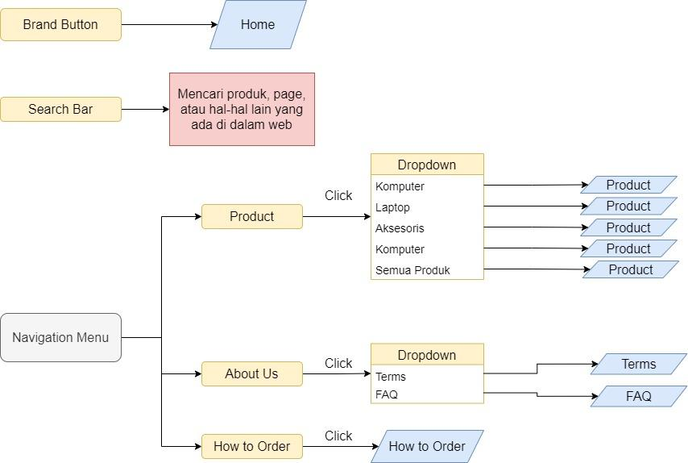

**Gambar 1.1.5. Flowchart Header 1**

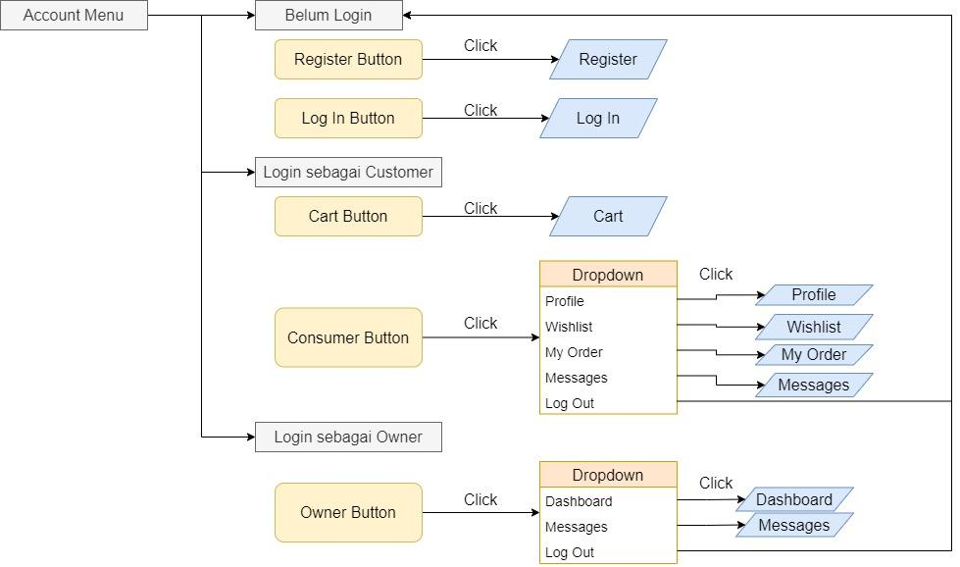

**Gambar 1.1.6. Flowchart Header 2**

##### 1.1.D. Fitur

Pada bagian Header terdapat Brand button, Search Bar, Account Menu, dan Navigation Menu.

1. Brand Button

Brand Button berfungsi untuk menampilkan nama dari toko Minify dan pada saat di klik akan mengarahkan pengguna ke page Home.

1. Search Bar

Search Bar akan digunakan untuk mencari produk, page, atau hal-hal lain yang ada di dalam web.

1. Account menu

Untuk menampilkan menu yang bisa diakses berdasarkan akun yang digunakan. Account menu akan memiliki 3 tampilan berdasarkan akun yang digunakan :

* 1. Jika pengguna belum Login atau belum menggunakan akun apapun maka akan ditampilkan menu button register dan login yang jika diklik akan mengarahkan ke page Register dan Login.
  2. Jika pengguna Login menggunakan akun Customer, maka akan ditampilkan button cart yang jika diklik akan mengarahkan pengguna ke page Cart, dan juga button menu dropdown yang jika diklik akan menampilkan menu Profile, Wishlist, My Order, Messages yang jika diklik akan mengarahkan pengguna ke Page tersebut, dan juga menu Logout yang jika diklik akan mengeluarkan pengguna dari akunnya.
  3. Jika pengguna Login menggunakan akun Owner, maka akan ditampilkan button button menu dropdown yang jika diklik akan menampilkan menu Dashboard dan Messages yang jika diklik akan mengarahkan pengguna ke Page tersebut, dan juga menu Logout yang jika diklik akan mengeluarkan pengguna dari akunnya.

1. Navigation Menu

Menu navigasi untuk mengarahkan pengguna ke page-page dari web. Navigation Menu memiliki 3 menu :

* 1. Product

Menu Dropdown yang akan menampilkan kategori produk dan link ke page Products

* 1. About Us

Menu Dropdown yang akan menampilkan link ke page Terms dan FAQ

* 1. How to Order

Link untuk ke page How To Order

#### 1.2. Footer

##### 1.2.A. Mockup



**Gambar 1.2.1. Mockup Footer**

##### 1.2.B. Tampilan

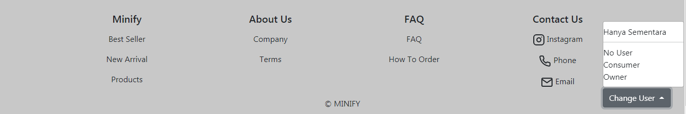

**Gambar 1.2.2. Tampilan Footer**

##### 1.2.C. Flowchart

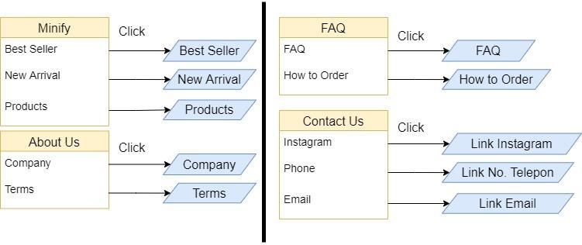

**Gambar 1.2.3. Flowchart Footer**

##### 1.2.D. Fitur

Footer berisi link-link dari beberapa page website dan juga link untuk social media Minify. Button Change User adalah fitur sementara yang berupa menu drop-up yang digunakan untuk mengganti user yang digunakan.

#### 1.3. Source Code

**<!DOCTYPE html>**

**<html lang="en">**

**<head>**

**<meta charset="UTF-8" />**

**<meta http-equiv="X-UA-Compatible" content="IE=edge" />**

**<meta name="viewport" content="width=device-width, initial-scale=1.0" />**

**<title>Document</title>**

**<link**

**href="https://cdn.jsdelivr.net/npm/bootstrap@5.1.0/dist/css/bootstrap.min.css"**

**rel="stylesheet"**

**integrity="sha384-KyZXEAg3QhqLMpG8r+8fhAXLRk2vvoC2f3B09zVXn8CA5QIVfZOJ3BCsw2P0p/We"**

**crossorigin="anonymous"**

**/>**

**<script**

**src="https://cdn.jsdelivr.net/npm/@popperjs/core@2.9.3/dist/umd/popper.min.js"**

**integrity="sha384-eMNCOe7tC1doHpGoWe/6oMVemdAVTMs2xqW4mwXrXsW0L84Iytr2wi5v2QjrP/xp"**

**crossorigin="anonymous"**

**></script>**

**<script**

**src="https://cdn.jsdelivr.net/npm/bootstrap@5.1.0/dist/js/bootstrap.min.js"**

**integrity="sha384-cn7l7gDp0eyniUwwAZgrzD06kc/tftFf19TOAs2zVinnD/C7E91j9yyk5//jjpt/"**

**crossorigin="anonymous"**

**></script>**

**<script src="https://unpkg.com/feather-icons"></script>**

**</head>**

**<body>**

**<!-- HEADER -->**

**<header>**

**<nav**

**class="navbar navbar-expand-lg navbar-light"**

**style="**

**padding: 1% 2%;**

**display: flex;**

**flex-direction: column;**

**background-color: rgb(200, 200, 200);**

**"**

**>**

**<div class="container-fluid">**

**<a class="navbar-brand fs-1" href="homePage.html"> Minify </a>**

**<!-- search -->**

**<form class="d-none d-lg-flex navbar-nav" style="width: 50%">**

**<input**

**class="form-control me-2"**

**type="search"**

**placeholder="Search"**

**aria-label="Search"**

**/>**

**<button class="btn btn-outline-dark" type="submit">**

**<i data-feather="search"></i>**

**</button>**

**</form>**

**<!-- cart & account & register & login-->**

**<div class="d-none d-lg-flex navbar-nav nav-item">**

**<!-- login sebagai pembeli -->**

**<a**

**class="btn btn-outline-dark"**

**href="cart.html"**

**aria-current="page"**

**style="margin: 0 5pt"**

**id="cartBtn"**

**>**

**<i data-feather="shopping-cart" style="padding-right: 2px"></i>**

**</a>**

**<div class="navbar-nav nav-item dropdown" id="consumerBtn">**

**<button**

**class="nav-item btn btn-outline-dark dropdown-toggle"**

**href="#"**

**id="navbarDropdown"**

**role="button"**

**data-bs-toggle="dropdown"**

**aria-expanded="true"**

**>**

**<i data-feather="user"></i> Consumer**

**</button>**

**<div**

**class="dropdown-menu dropdown-menu-right"**

**aria-labelledby="navbarDropdown"**

**>**

**<a class="dropdown-item" href="profile.html">Profile</a>**

**<a class="dropdown-item" href="wishlist.html">Wishlist</a>**

**<a class="dropdown-item" href="myorder.html">My Order</a>**

**<a class="dropdown-item" href="message.html">Messages</a>**

**<hr class="dropdown-divider" />**

**<a class="logoutBtn dropdown-item" href="#">Log Out</a>**

**</div>**

**</div>**

**<!-- login sebagai penjual -->**

**<div class="navbar-nav nav-item dropdown" id="ownerBtn">**

**<button**

**class="nav-item btn btn-outline-dark dropdown-toggle"**

**id="navbarDropdown"**

**role="button"**

**data-bs-toggle="dropdown"**

**aria-expanded="true"**

**>**

**<i data-feather="user"></i> Owner**

**</button>**

**<div**

**class="dropdown-menu dropdown-menu-right"**

**aria-labelledby="navbarDropdown"**

**>**

**<a class="dropdown-item" href="Dashboard.html">Dashboard</a>**

**<a class="dropdown-item" href="message.html">Messages</a>**

**<hr class="dropdown-divider" />**

**<a class="logoutBtn dropdown-item" href="#">Log Out</a>**

**</div>**

**</div>**

**<!-- belum login -->**

**<div id="regisLogIn">**

**<a href="register.html"**

**><button**

**class="nav-item btn btn-outline-dark"**

**role="button"**

**aria-expanded="true"**

**>**

**Register**

**</button></a**

**>**

**<a href="login.html"**

**><button**

**class="nav-item btn btn-outline-dark"**

**role="button"**

**aria-expanded="true"**

**>**

**Log In**

**</button>**

**</a>**

**</div>**

**</div>**

**<!-- responsive menu button -->**

**<button**

**class="navbar-toggler"**

**type="button"**

**data-bs-toggle="collapse"**

**data-bs-target="#navbarResponsiveDropdown"**

**aria-expanded="false"**

**aria-label="Toggle navigation"**

**style="margin-left: auto"**

**>**

**<span class="navbar-toggler-icon"></span>**

**</button>**

**</div>**

**<div class="container">**

**<!-- search & cart & account responsive-->**

**<div**

**class="navbar-nav d-lg-none collapse"**

**id="navbarResponsiveDropdown"**

**>**

**<form style="display: flex">**

**<input**

**class="form-control me-2"**

**type="search"**

**placeholder="Search"**

**aria-label="Search"**

**/>**

**<button class="btn btn-outline-dark" type="submit">**

**<i data-feather="search"></i>**

**</button>**

**</form>**

**<br />**

**<div class="nav-item" id="cartResp">**

**<a class="nav-link" aria-current="page" href="cart.html"**

**><i data-feather="shopping-cart"></i> Shopping Cart</a**

**>**

**</div>**

**<div class="nav-item" id="consumerResp">**

**<a**

**class="nav-link dropdown-toggle"**

**href="#"**

**id="navbarDropdown"**

**role="button"**

**data-bs-toggle="dropdown"**

**aria-expanded="true"**

**>**

**<i data-feather="user"></i> Consumer**

**</a>**

**<div**

**class="dropdown-menu dropdown-menu"**

**aria-labelledby="navbarDropdown"**

**>**

**<a class="dropdown-item" href="profile.html">Profile</a>**

**<a class="dropdown-item" href="wishlist.html">Wishlist</a>**

**<a class="dropdown-item" href="myorder.html">My Order</a>**

**<a class="dropdown-item" href="message.html">Messages</a>**

**<hr class="dropdown-divider" />**

**<a class="logoutBtn dropdown-item" href="#">Log Out</a>**

**</div>**

**</div>**

**<div class="nav-item" id="ownerResp">**

**<a**

**class="nav-link dropdown-toggle"**

**href="#"**

**id="navbarDropdown"**

**role="button"**

**data-bs-toggle="dropdown"**

**aria-expanded="true"**

**>**

**<i data-feather="user"></i> Owner**

**</a>**

**<div**

**class="dropdown-menu dropdown-menu"**

**aria-labelledby="navbarDropdown"**

**>**

**<a class="dropdown-item" href="Dashboard.html">Dashboard</a>**

**<a class="dropdown-item" href="message.html">Messages</a>**

**<hr class="dropdown-divider" />**

**<a class="logoutBtn dropdown-item" href="#">Log Out</a>**

**</div>**

**</div>**

**<div id="regisLogInResp">**

**<a**

**class="nav-item btn btn-outline-dark"**

**href="register.html"**

**role="button"**

**aria-expanded="true"**

**>Register</a**

**>**

**<a**

**class="nav-item btn btn-outline-dark"**

**href="login.html"**

**role="button"**

**aria-expanded="true"**

**>Log In</a**

**>**

**</div>**

**</div>**

**<!-- navigation bar -->**

**<div class="collapse navbar-collapse" id="navbarResponsiveDropdown">**

**<ul class="navbar-nav mx-auto">**

**<!-- product -->**

**<li class="nav-item dropdown">**

**<a**

**class="nav-link dropdown-toggle"**

**href="#"**

**id="productDropdown"**

**role="button"**

**data-bs-toggle="dropdown"**

**aria-expanded="false"**

**>**

**Product**

**</a>**

**<ul class="dropdown-menu" aria-labelledby="productDropdown">**

**<li>**

**<a class="dropdown-item" href="product.html">Komputer</a>**

**</li>**

**<a class="dropdown-item" href="product.html">Laptop</a>**

**<a class="dropdown-item" href="product.html">Aksesoris</a>**

**<a class="dropdown-item" href="product.html">Lain-lain</a>**

**<hr class="dropdown-divider" />**

**<a class="dropdown-item" href="product.html">Semua Produk</a>**

**</ul>**

**</li>**

**<!-- about us -->**

**<li class="nav-item dropdown">**

**<a**

**class="nav-link dropdown-toggle"**

**href="#"**

**id="aboutUsDropdown"**

**role="button"**

**data-bs-toggle="dropdown"**

**aria-expanded="false"**

**>**

**About Us**

**</a>**

**<ul class="dropdown-menu" aria-labelledby="aboutUsDropdown">**

**<li><a class="dropdown-item" href="Terms.html">Terms</a></li>**

**<li><a class="dropdown-item" href="FAQ.html">FAQ</a></li>**

**</ul>**

**</li>**

**<!-- how to order -->**

**<li class="nav-item">**

**<a class="nav-link" aria-current="page" href="HowToOrder.html"**

**>How To Order</a**

**>**

**</li>**

**</ul>**

**</div>**

**</div>**

**</nav>**

**</header>**

**<!-- ISI -->**

**<section>**

**<div style="height: 100px"></div>**

**</section>**

**<!-- button sementara -->**

**<div style="position: fixed; right: 2%; bottom: 2%; z-index: 2">**

**<!-- Default dropup button -->**

**<div class="btn-group dropup">**

**<button**

**type="button"**

**class="btn btn-secondary dropdown-toggle"**

**data-bs-toggle="dropdown"**

**aria-expanded="false"**

**>**

**Change User**

**</button>**

**<ul class="dropdown-menu">**

**<!-- Dropdown menu links -->**

**Hanya Sementara**

**<hr class="dropdown-divider" />**

**<li role="button" id="toNoUsr">No User</li>**

**<li role="button" id="toConsumer">Consumer</li>**

**<li role="button" id="toOwner">Owner</li>**

**</ul>**

**</div>**

**</div>**

**<script src="https://code.jquery.com/jquery-3.5.1.min.js"></script>**

**<script src="https://cdn.jsdelivr.net/npm/popper.js@1.16.1/dist/umd/popper.min.js"></script>**

**<script>**

**var toNoUsr = document.getElementById("toNoUsr");**

**var toConsumer = document.getElementById("toConsumer");**

**var toOwner = document.getElementById("toOwner");**

**var cart = document.getElementById("cartBtn");**

**var consumerBtn = document.getElementById("consumerBtn");**

**var ownerBtn = document.getElementById("ownerBtn");**

**var regisLogIn = document.getElementById("regisLogIn");**

**var cartResp = document.getElementById("cartResp");**

**var consumerBtnResp = document.getElementById("consumerResp");**

**var ownerBtnResp = document.getElementById("ownerResp");**

**var regisLogInResp = document.getElementById("regisLogInResp");**

**function noUserState() {**

**cart.style.display = "none";**

**consumerBtn.style.display = "none";**

**ownerBtn.style.display = "none";**

**regisLogIn.style.display = "initial";**

**cartResp.style.display = "none";**

**consumerResp.style.display = "none";**

**ownerResp.style.display = "none";**

**regisLogInResp.style.display = "initial";**

**}**

**noUserState();**

**toNoUsr.onclick = noUserState;**

**toConsumer.onclick = function () {**

**cart.style.display = "initial";**

**consumerBtn.style.display = "initial";**

**ownerBtn.style.display = "none";**

**regisLogIn.style.display = "none";**

**cartResp.style.display = "initial";**

**consumerResp.style.display = "initial";**

**ownerResp.style.display = "none";**

**regisLogInResp.style.display = "none";**

**};**

**toOwner.onclick = function () {**

**cart.style.display = "none";**

**consumerBtn.style.display = "none";**

**ownerBtn.style.display = "initial";**

**regisLogIn.style.display = "none";**

**cartResp.style.display = "none";**

**consumerResp.style.display = "none";**

**ownerResp.style.display = "initial";**

**regisLogInResp.style.display = "none";**

**};**

**$(".logoutBtn").click(noUserState);**

**</script>**

**<!-- FOOTER -->**

**<footer>**

**<div style="padding-top: 2%; background-color: rgb(200, 200, 200)">**

**<div class="container text-center text-dark">**

**<div class="row row-cols-2 row-cols-lg-4 g-3">**

**<div class="col text-dark">**

**<div class="header">**

**<h5>Minify</h5>**

**</div>**

**<div>**

**<a class="nav-link text-dark" href="best.html">Best Seller </a>**

**<a class="nav-link text-dark" href="newArrival.html"**

**>New Arrival</a**

**>**

**<a class="nav-link text-dark" href="product.html">Products</a>**

**</div>**

**</div>**

**<div class="col">**

**<div class="header">**

**<h5>About Us</h5>**

**</div>**

**<div>**

**<a class="nav-link text-dark" href="Company.html">Company</a>**

**<a class="nav-link text-dark" href="Terms.html">Terms</a>**

**</div>**

**</div>**

**<div class="col">**

**<div class="header">**

**<h5>FAQ</h5>**

**</div>**

**<div>**

**<a class="nav-link text-dark" href="FAQ.html">FAQ</a>**

**<a class="nav-link text-dark" href="HowToOrder.html"**

**>How To Order</a**

**>**

**</div>**

**</div>**

**<div class="col">**

**<div class="header">**

**<h5>Contact Us</h5>**

**</div>**

**<div>**

**<a class="nav-link text-dark" href=""**

**><i data-feather="instagram"></i> Instagram</a**

**>**

**<a class="nav-link text-dark" href=""**

**><i data-feather="phone"></i> Phone</a**

**>**

**<a class="nav-link text-dark" href=""**

**><i data-feather="mail"></i> Email</a**

**>**

**</div>**

**</div>**

**</div>**

**<div style="padding: 10px 0">&copy; MINIFY</div>**

**</div>**

**</div>**

**</footer>**

**<script>**

**feather.replace();**

**</script>**

**</body>**

**</html>**

### Home

#### 2.A. Mock Up

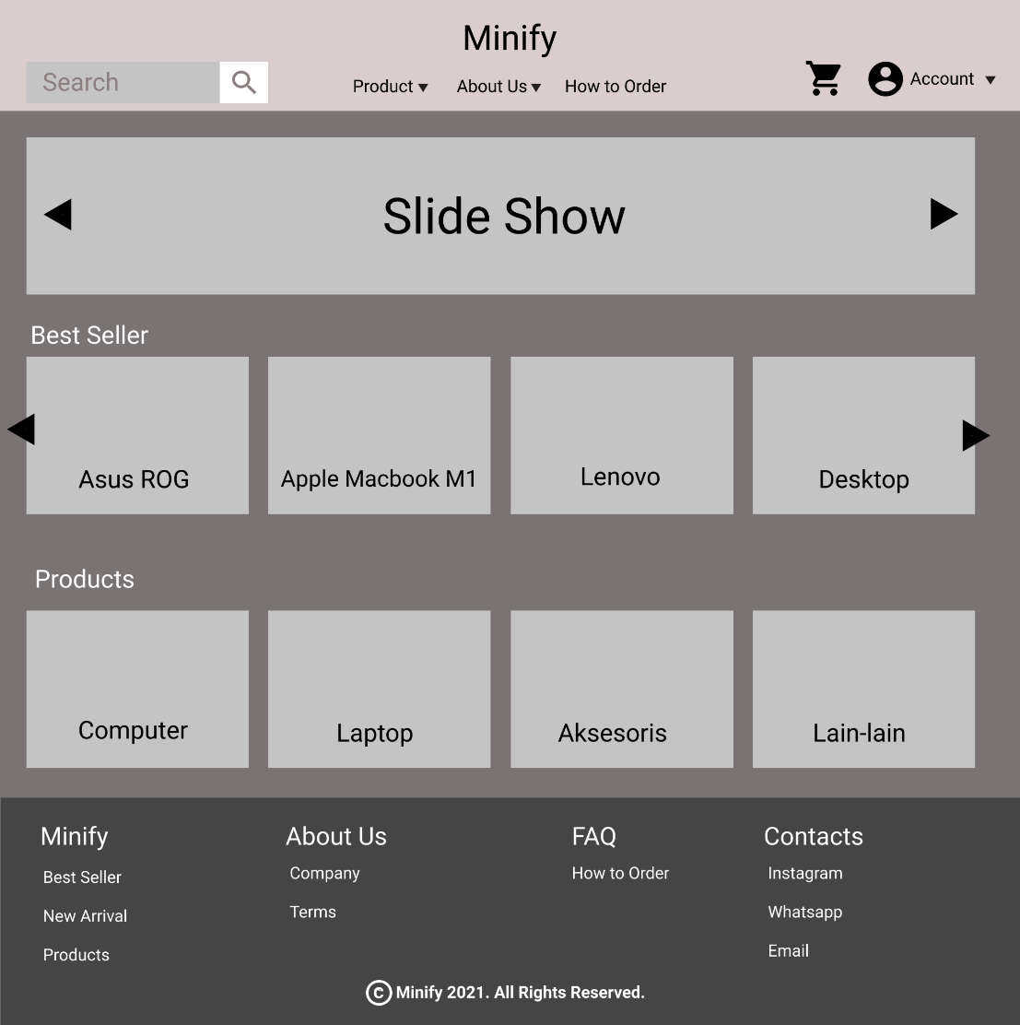

**Gambar 2.1. Mock Up Home**

#### 2.B. Tampilan

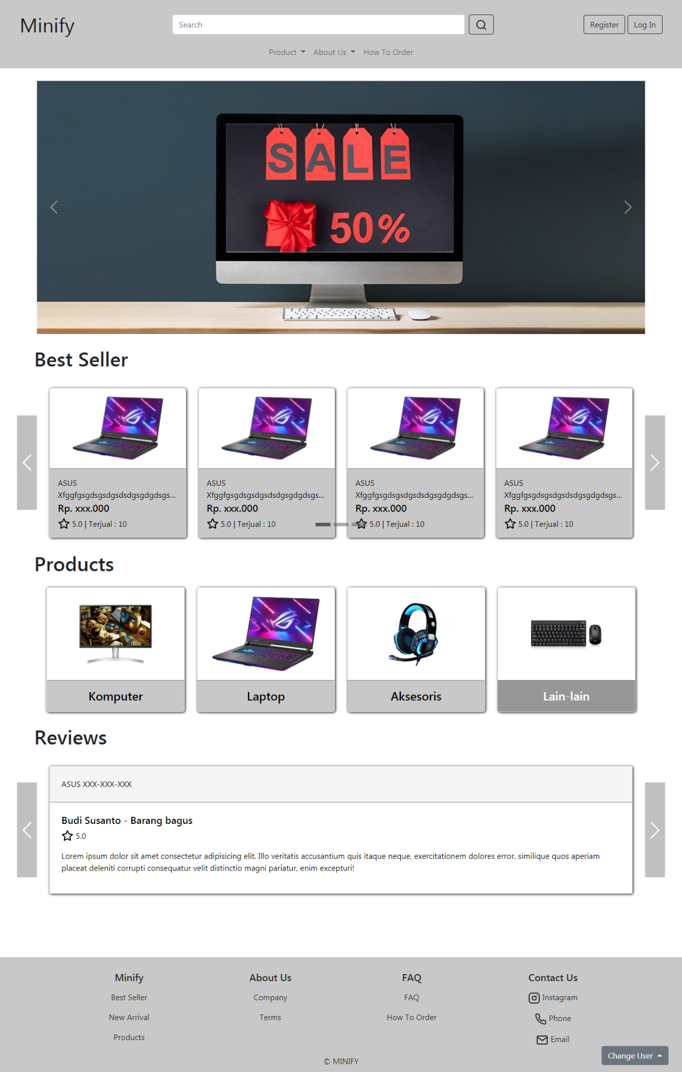

**Gambar 2.2. Tampilan Home**

#### 2.C. Flowchart

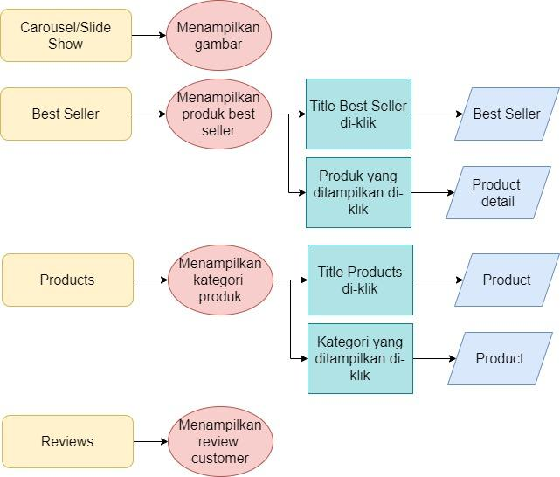

**Gambar 2.3. Flowchart Home**

#### 2.D. Fitur

Page Home menampilkan beberapa bagian :

1. Carousel/SlideShow

Bagian digunakan untuk menampilkan gambar-gambar seperti banner promo/diskon, produk baru, dan lain-lain.

1. Best Seller

Bagian ini digunakan untuk menampilkan beberapa produk terlaris dari Minify. Jika judul Best Seller di klik maka pengguna akan diarahkan ke page Best Seller. Jika produk yang ditampilkan di klik maka pengguna akan diarahkan ke halaman detail produk tersebut.

1. Products

Bagian ini menampilkan kategori-kategori produk yang ada di Minify. Jika judul Products di klik maka pengguna akan diarahkan ke page Products. Jika kategori produk di klik maka pengguna akan diarahkan ke halaman Products dengan filter kategori tersebut.

1. Review

Bagian ini menampilkan beberapa review baik dari customer Minify.

#### 2.E. Source Code

##### Html

**<section style="margin: 0 5%;">**

**<!-- slide show 1 -->**

**<div>**

**<div id="slideShow1" class="carousel slide" data-bs-ride="carousel" style="padding: 2% 0; margin: 0 -5%;" >**

**<div class="carousel-indicators pb-lg-5" >**

**<button type="button" data-bs-target="#slideShow1" data-bs-slide-to="0" class="active" aria-current="true" aria-label="Slide 1"></button>**

**<button type="button" data-bs-target="#slideShow1" data-bs-slide-to="1" aria-label="Slide 2"></button>**

**<button type="button" data-bs-target="#slideShow1" data-bs-slide-to="2" aria-label="Slide 3"></button>**

**</div>**

**<div class="carousel-inner mx-auto" style="width: 90%;">**

**<div class="carousel-item active" >**

**<img src="image/slide1.jpg" class="d-block w-100 " alt="..." >**

**</div>**

**<div class="carousel-item">**

**<img src="image/slide2.jpg" class="d-block w-100" alt="...">**

**</div>**

**<div class="carousel-item">**

**<img src="image/slide3.jpg" class="d-block w-100" alt="...">**

**</div>**

**</div>**

**<button class="carousel-control-prev" type="button" data-bs-target="#slideShow1" data-bs-slide="prev">**

**<span class="carousel-control-prev-icon" aria-hidden="true"></span>**

**<span class="visually-hidden">Previous</span>**

**</button>**

**<button class="carousel-control-next" type="button" data-bs-target="#slideShow1" data-bs-slide="next">**

**<span class="carousel-control-next-icon" aria-hidden="true"></span>**

**<span class="visually-hidden">Next</span>**

**</button>**

**</div>**

**</div>**

**<!-- Best Seller -->**

**<div id="bestSeller">**

**<a href="best.html" class="text-dark text-decoration-none"><h1>Best Seller</h1></a>**

**<div id="slideShow2" class="carousel slide d-none d-lg-block" data-bs-ride="carousel" data-bs-interval="false" style=" margin: 0 -5%;">**

**<div class="carousel-indicators pb-4" >**

**<button type="button" data-bs-target="#slideShow2" data-bs-slide-to="0" class="active" aria-current="true" aria-label="Slide 1"></button>**

**<button type="button" data-bs-target="#slideShow2" data-bs-slide-to="1" aria-label="Slide 2"></button>**

**<button type="button" data-bs-target="#slideShow2" data-bs-slide-to="2" aria-label="Slide 3"></button>**

**</div>**

**<div class="carousel-inner mx-auto" style=" width: 90%;padding: 2% 0; ">**

**<div class="carousel-item active" >**

**<div class="card-group">**

**<a href="details.html" class="card rounded-3" >**

**<img src="image/Asus.jpg" class="card-img-top" alt="...">**

**<div class="card-body">**

**<p>ASUS XfggfgsgdsgsdgsdsdgsgdgdsgsdgdsgsdggsdgdsXX</p>**

**<h5>Rp. xxx.000</h5>**

**<p><i data-feather="star" style="vertical-align: bottom;"></i> 5.0 | Terjual : 10</p>**

**</div>**

**</a>**

**<a href="details.html" class="card rounded-3" >**

**<img src="image/Asus.jpg" class="card-img-top" alt="...">**

**<div class="card-body">**

**<p>ASUS XfggfgsgdsgsdgsdsdgsgdgdsgsdgdsgsdggsdgdsXX</p>**

**<h5>Rp. xxx.000</h5>**

**<p><i data-feather="star" style="vertical-align: bottom;"></i> 5.0 | Terjual : 10</p>**

**</div>**

**</a>**

**<a href="details.html" class="card rounded-3" >**

**<img src="image/Asus.jpg" class="card-img-top" alt="...">**

**<div class="card-body">**

**<p>ASUS XfggfgsgdsgsdgsdsdgsgdgdsgsdgdsgsdggsdgdsXX</p>**

**<h5>Rp. xxx.000</h5>**

**<p><i data-feather="star" style="vertical-align: bottom;"></i> 5.0 | Terjual : 10</p>**

**</div>**

**</a>**

**<a href="details.html" class="card rounded-3" >**

**<img src="image/Asus.jpg" class="card-img-top" alt="...">**

**<div class="card-body">**

**<p>ASUS XfggfgsgdsgsdgsdsdgsgdgdsgsdgdsgsdggsdgdsXX</p>**

**<h5>Rp. xxx.000</h5>**

**<p><i data-feather="star" style="vertical-align: bottom;"></i> 5.0 | Terjual : 10</p>**

**</div>**

**</a>**

**</div>**

**</div>**

**<div class="carousel-item">**

**<div class="card-group">**

**<a href="details.html" class="card rounded-3" >**

**<img src="image/monitor.jpg" class="card-img-top" alt="...">**

**<div class="card-body">**

**<p>ASUS XfggfgsgdsgsdgsdsdgsgdgdsgsdgdsgsdggsdgdsXX</p>**

**<h5>Rp. xxx.000</h5>**

**<p><i data-feather="star" style="vertical-align: bottom;"></i> 5.0 | Terjual : 10</p>**

**</div>**

**</a>**

**<a href="details.html" class="card rounded-3" >**

**<img src="image/monitor.jpg" class="card-img-top" alt="...">**

**<div class="card-body">**

**<p>ASUS XfggfgsgdsgsdgsdsdgsgdgdsgsdgdsgsdggsdgdsXX</p>**

**<h5>Rp. xxx.000</h5>**

**<p><i data-feather="star" style="vertical-align: bottom;"></i> 5.0 | Terjual : 10</p>**

**</div>**

**</a>**

**<a href="details.html" class="card rounded-3" >**

**<img src="image/monitor.jpg" class="card-img-top" alt="...">**

**<div class="card-body">**

**<p>ASUS XfggfgsgdsgsdgsdsdgsgdgdsgsdgdsgsdggsdgdsXX</p>**

**<h5>Rp. xxx.000</h5>**

**<p><i data-feather="star" style="vertical-align: bottom;"></i> 5.0 | Terjual : 10</p>**

**</div>**

**</a>**

**<a href="details.html" class="card rounded-3" >**

**<img src="image/monitor.jpg" class="card-img-top" alt="...">**

**<div class="card-body">**

**<p>ASUS XfggfgsgdsgsdgsdsdgsgdgdsgsdgdsgsdggsdgdsXX</p>**

**<h5>Rp. xxx.000</h5>**

**<p><i data-feather="star" style="vertical-align: bottom;"></i> 5.0 | Terjual : 10</p>**

**</div>**

**</a>**

**</div>**

**</div>**

**<div class="carousel-item">**

**<div class="card-group">**

**<a href="details.html" class="card rounded-3" >**

**<img src="image/Asus.jpg" class="card-img-top" alt="...">**

**<div class="card-body">**

**<p>ASUS XfggfgsgdsgsdgsdsdgsgdgdsgsdgdsgsdggsdgdsXX</p>**

**<h5>Rp. xxx.000</h5>**

**<p><i data-feather="star" style="vertical-align: bottom;"></i> 5.0 | Terjual : 10</p>**

**</div>**

**</a>**

**<a href="details.html" class="card rounded-3" >**

**<img src="image/Asus.jpg" class="card-img-top" alt="...">**

**<div class="card-body">**

**<p>ASUS XfggfgsgdsgsdgsdsdgsgdgdsgsdgdsgsdggsdgdsXX</p>**

**<h5>Rp. xxx.000</h5>**

**<p><i data-feather="star" style="vertical-align: bottom;"></i> 5.0 | Terjual : 10</p>**

**</div>**

**</a>**

**<a href="details.html" class="card rounded-3" >**

**<img src="image/Asus.jpg" class="card-img-top" alt="...">**

**<div class="card-body">**

**<p>ASUS XfggfgsgdsgsdgsdsdgsgdgdsgsdgdsgsdggsdgdsXX</p>**

**<h5>Rp. xxx.000</h5>**

**<p><i data-feather="star" style="vertical-align: bottom;"></i> 5.0 | Terjual : 10</p>**

**</div>**

**</a>**

**<a href="details.html" class="card rounded-3" >**

**<img src="image/Asus.jpg" class="card-img-top" alt="...">**

**<div class="card-body">**

**<p>ASUS XfggfgsgdsgsdgsdsdgsgdgdsgsdgdsgsdggsdgdsXX</p>**

**<h5>Rp. xxx.000</h5>**

**<p><i data-feather="star" style="vertical-align: bottom;"></i> 5.0 | Terjual : 10</p>**

**</div>**

**</a>**

**</div>**

**</div>**

**</div>**

**<button style=" width: 7%;" class="carousel-control-prev " type="button" data-bs-target="#slideShow2" data-bs-slide="prev">**

**<span class="carousel-control-prev-icon" style="background-color: gray; padding: 100% 20px;"></span>**

**</button>**

**<button style=" width: 7%;" class="carousel-control-next" type="button" data-bs-target="#slideShow2" data-bs-slide="next">**

**<span class="carousel-control-next-icon" style="background-color: gray; padding: 100% 20px;"></span>**

**</button>**

**</div>**

**<!-- Best Seller Responsive -->**

**<div id="bestSellerResp" class="carousel slide d-lg-none" data-bs-ride="carousel" data-bs-interval="false" style="margin: 0 -5%;">**

**<div class="carousel-inner mx-auto" style=" width: 90%; padding: 2% 0; ">**

**<div class="carousel-item active" >**

**<a href="details.html" class="card rounded-3" >**

**<img src="image/Asus.jpg" class="card-img-top" alt="...">**

**<div class="card-body">**

**<p>ASUS XfggfgsgdsgsdgsdsdgsgdgdsgsdgdsgsdggsdgdsXX</p>**

**<h5>Rp. xxx.000</h5>**

**<p><i data-feather="star" style="vertical-align: bottom;"></i> 5.0 | Terjual : 10</p>**

**</div>**

**</a>**

**</div>**

**<div class="carousel-item" >**

**<a href="details.html" class="card rounded-3" >**

**<img src="image/Asus.jpg" class="card-img-top" alt="...">**

**<div class="card-body">**

**<p>ASUS XfggfgsgdsgsdgsdsdgsgdgdsgsdgdsgsdggsdgdsXX</p>**

**<h5>Rp. xxx.000</h5>**

**<p><i data-feather="star" style="vertical-align: bottom;"></i> 5.0 | Terjual : 10</p>**

**</div>**

**</a>**

**</div>**

**<div class="carousel-item" >**

**<a href="details.html" class="card rounded-3" >**

**<img src="image/Asus.jpg" class="card-img-top" alt="...">**

**<div class="card-body">**

**<p>ASUS XfggfgsgdsgsdgsdsdgsgdgdsgsdgdsgsdggsdgdsXX</p>**

**<h5>Rp. xxx.000</h5>**

**<p><i data-feather="star" style="vertical-align: bottom;"></i> 5.0 | Terjual : 10</p>**

**</div>**

**</a>**

**</div>**

**<div class="carousel-item" >**

**<a href="details.html" class="card rounded-3" >**

**<img src="image/Asus.jpg" class="card-img-top" alt="...">**

**<div class="card-body">**

**<p>ASUS XfggfgsgdsgsdgsdsdgsgdgdsgsdgdsgsdggsdgdsXX</p>**

**<h5>Rp. xxx.000</h5>**

**<p><i data-feather="star" style="vertical-align: bottom;"></i> 5.0 | Terjual : 10</p>**

**</div>**

**</a>**

**</div>**

**</div>**

**<button style=" width: 7%;" class="carousel-control-prev " type="button" data-bs-target="#bestSellerResp" data-bs-slide="prev">**

**<span class="carousel-control-prev-icon" style="background-color: gray; padding: 100% 20px;"></span>**

**</button>**

**<button style=" width: 7%;" class="carousel-control-next" type="button" data-bs-target="#bestSellerResp" data-bs-slide="next">**

**<span class="carousel-control-next-icon" style="background-color: gray; padding: 100% 20px;"></span>**

**</button>**

**</div>**

**</div>**

**<!-- products -->**

**<div id="products">**

**<a href="product.html" class="text-dark text-decoration-none"><h1>Products</h1></a>**

**<div class="card-group" style="margin: 2% 0;">**

**<a href="product.html" class="card rounded-3">**

**<img src="image/monitor.jpg" class="card-img-top" alt="...">**

**<div class="card-body ">**

**<h4 class="card-title">Komputer</h4>**

**</div>**

**</a>**

**<a href="product.html" class="card rounded-3">**

**<img src="image/Asus.jpg" class="card-img-top" alt="...">**

**<div class="card-body ">**

**<h4 class="card-title">Laptop</h4>**

**</div>**

**</a>**

**<a href="product.html" class="card rounded-3">**

**<img src="image/headset.jpg" class="card-img-top" alt="...">**

**<div class="card-body ">**

**<h4 class="card-title">Aksesoris</h4>**

**</div>**

**</a>**

**<a href="product.html" class="card rounded-3">**

**<img src="image/keyboard.jpg" class="card-img-top" alt="...">**

**<div class="card-body">**

**<h4 class="card-title">Lain-lain</h4>**

**</div>**

**</a>**

**</div>**

**</div>**

**<div id="reviews">**

**<h1>Reviews</h1>**

**<div id="slideShow3" class="carousel slide" data-bs-ride="carousel" style=" margin: 0 -5%;">**

**<div class="carousel-inner mx-auto" style="width: 90%;padding: 2% 0;">**

**<div class="carousel-item active" >**

**<div class="card">**

**<div class="card-review-header">ASUS XXX-XXX-XXX</div>**

**<div class="card-review-body">**

**<h5 class="card-review-title">Budi Susanto - Barang bagus</h5>**

**<p><i data-feather="star" style="vertical-align: bottom;"></i> 5.0</p>**

**<p class="card-review-text">Lorem ipsum dolor sit amet consectetur adipisicing elit. Illo veritatis accusantium quis itaque neque, exercitationem dolores error, similique quos aperiam placeat deleniti corrupti consequatur velit distinctio magni pariatur, enim excepturi!</p>**

**</div>**

**</div>**

**</div>**

**<div class="carousel-item" >**

**<div class="card">**

**<div class="card-review-header">ACER XXX-XXX-XXX</div>**

**<div class="card-review-body">**

**<h5 class="card-review-title">Ahmad Budi - Barang bagus</h5>**

**<p><i data-feather="star" style="vertical-align: bottom;"></i> 5.0</p>**

**<p class="card-review-text">Lorem ipsum dolor sit amet consectetur adipisicing elit. Illo veritatis accusantium quis itaque neque, exercitationem dolores error, similique quos aperiam placeat deleniti corrupti consequatur velit distinctio magni pariatur, enim excepturi!</p>**

**</div>**

**</div>**

**</div>**

**<div class="carousel-item" >**

**<div class="card">**

**<div class="card-review-header">MSI XXX-XXX-XXX</div>**

**<div class="card-review-body">**

**<h5 class="card-review-title">Joko Budi - Barang bagus</h5>**

**<p><i data-feather="star" style="vertical-align: bottom;"></i> 5.0</p>**

**<p class="card-review-text">Lorem ipsum dolor sit amet consectetur adipisicing elit. Illo veritatis accusantium quis itaque neque, exercitationem dolores error, similique quos aperiam placeat deleniti corrupti consequatur velit distinctio magni pariatur, enim excepturi!</p>**

**</div>**

**</div>**

**</div>**

**</div>**

**<button style=" width: 7%;" class="carousel-control-prev " type="button" data-bs-target="#slideShow3" data-bs-slide="prev">**

**<span class="carousel-control-prev-icon" style="background-color: gray; padding: 100% 20px;"></span>**

**</button>**

**<button style=" width: 7%;" class="carousel-control-next" type="button" data-bs-target="#slideShow3" data-bs-slide="next">**

**<span class="carousel-control-next-icon" style="background-color: gray; padding: 100% 20px;"></span>**

**</button>**

**</div>**

**</div>**

**<div style="height: 100px;"></div>**

**</section>**

##### CSS

**<style>**

**.card{**

**/* position: inherit; */**

**overflow: hidden;**

**margin: 0 2%;**

**text-decoration: none;**

**box-shadow: 1px 1px 5px black;**

**color: black;**

**height: 300px;**

**}**

**.card-img-top{**

**height: 50%;**

**width: auto;**

**padding: 10px;**

**margin: 2% auto;**

**}**

**.card-body p{**

**display: -webkit-box;**

**-webkit-line-clamp: 2;**

**-webkit-box-orient: vertical;**

**overflow: hidden;**

**line-height: 1.5em;**

**margin-bottom: 1%;**

**text-overflow: ellipsis;**

**}**

**.card:hover .card-body{**

**color: white;**

**background-color: rgb(150, 150, 150);**

**transition: 0.2s;**

**}**

**.card-body{**

**border-top: 1px solid gray;**

**background-color: rgb(200, 200, 200);**

**}**

**#products .card{**

**height: 250px;**

**}**

**#products .card img{**

**height: 70%;**

**}**

**#products .card-body{**

**height: 30%;**

**text-align: center;**

**}**

**#slideShow2 .carousel-indicators button{**

**height: 7px;**

**background-color: rgb(88, 88, 88);**

**}**

**.card-review-header{**

**padding: 2%;**

**text-decoration: none;**

**color: black;**

**background-color: rgb(245, 245, 245);**

**}**

**.card-review-body{**

**padding: 2%;**

**border-top: 1px solid gray;**

**}**

**#reviews .card{**

**height: fit-content;**

**}**

**/* media query */**

**@media screen and (max-width: 770px) {**

**#products .card-group{**

**display: flex;**

**flex-direction: row;**

**flex-wrap: wrap;**

**}**

**#products .card{**

**width: 45%;**

**}**

**}**

**</style>**

### Login Page

#### 3. A. Mock Up

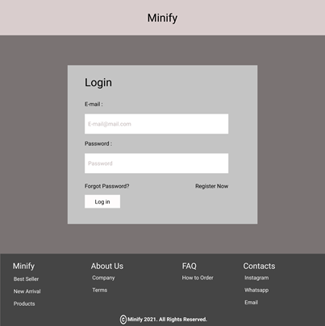

**Gambar 3.A. Mock Up Login Page**

#### 3. B. Tampilan

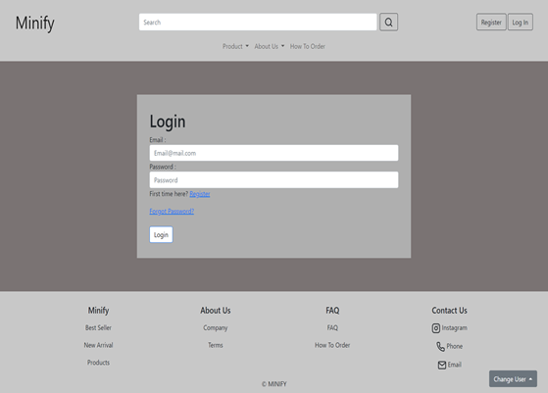

**Gambar 3.B. Tampilan**

#### 3. C. Flowchart

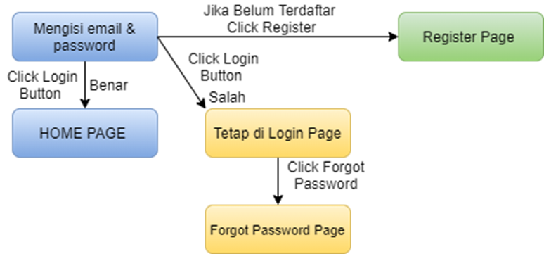

**Gambar 3.C. Flowchart**

#### 3. D. Fitur

Halaman login adalah halaman yang digunakan untuk pembeli/customer dan juga dan juga admin untuk login. hal-hal yang terdapat pada halaman login adalah :

1. Form input

Form ini berfungsi untuk mengisi identitas pembeli atau admin untuk login dengan email dan password masing-masing. Hal-hal yang harus diisi untuk melakukan login yaitu :

* Email
* Password

1. Register link

Register link ini jika di klik akan langsung menuju ke Register page. Link ini berfungsi untuk apabila pelanggan ternyata belum memiliki akun sehingga pelanggan tinggal mengklik Register link lalu akan menuju ke Register page untuk melakukan pendaftaran.

1. Forgot Password link

Forgot Password link ini jika di klik akan langsung menuju ke Forgot Password page. Link ini berfungsi untuk apabila pelanggan lupa dengan kata sandi/password maka dapat ke Forgot Password page untuk mengubah password .

1. Login Button

Login Button jika di klik maka form akan di cek apakah seluruh data yang dimasukan sudah benar atau belum bila sudah benar maka form akan di submit dan dapat ter-login ke akun yang diinput, tetapi jika salah maka kemungkinan email/password salah, atau lupa password, atau mungkin juga akun tersebut belum terdaftar.

#### 

#### 3. E. Source Code

##### Html

**<div style="background-color: grey; padding: 5% 25% ">**

**<div class="Login">**

**<div>**

**<form>**

**<h1>Login</h1>**

**<div class="form-group">**

**<label for="exampleInputEmail1">Email : </label>**

**<input**

**type="email"**

**class="form-control"**

**id="exampleInputEmail1"**

**aria-describedby="emailHelp"**

**placeholder="Email@mail.com"**

**required**

**/>**

**</div>**

**<br>**

**<div class="form-group">**

**<label for="exampleInputPassword1">Password :</label>**

**<input**

**type="password"**

**class="form-control"**

**id="exampleInputPassword1"**

**placeholder="Password"**

**required**

**/>**

**</div>**

**<br>**

**<p>First time here? <a href="register.html">Register</a></p>**

**<a href="forgetpassword.html">Forgot Password?</a>**

**<br>**

**<br>**

**<a href="homePage.html">**

**<button type="submit" class="btnLogin btn btn-primary" style="background-color: white; color: black; border: none;"> Login </button>**

**</a>**

**</form>**

**</div>**

**</div>**

**</div>**

##### CSS

**<style>**

**\* {**

**margin: 0;**

**padding: 0;**

**}**

**.custom-select {**

**width: 13%;**

**margin-right: 5px;**

**}**

**.btnLogin {**

**margin: 15px 0;**

**padding: 10px 10px;**

**}**

**.Login**

**background-color: rgb(175, 175, 175);**

**padding: 35px;**

**}**

**</style>**

### Register Page

#### 4.A. Mockup

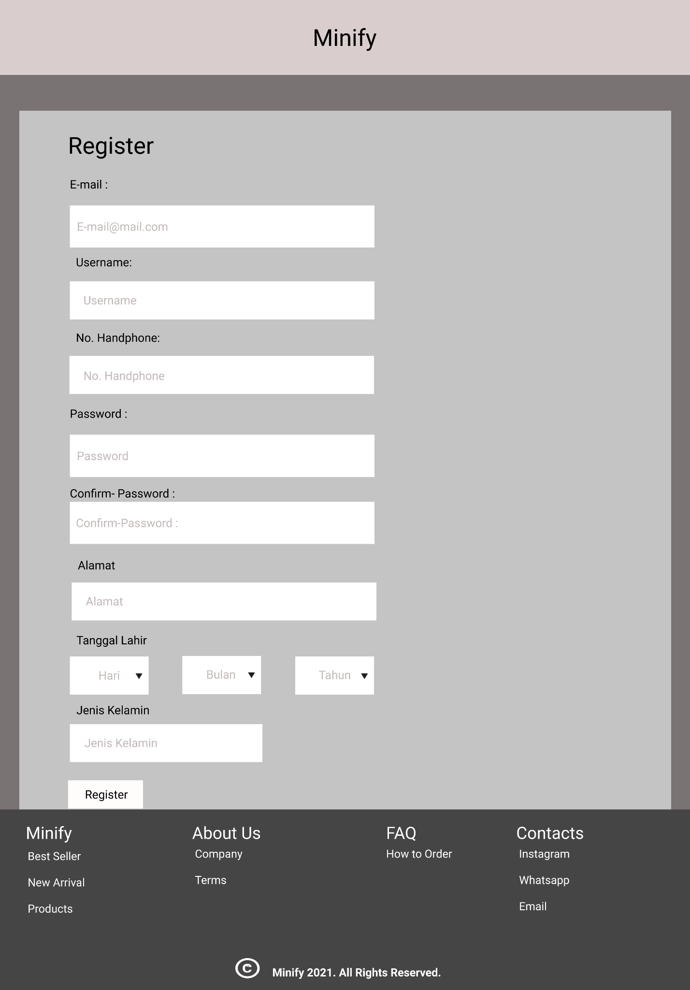

**Gambar 4.1 Mockup Register Page**

#### 4.B. Tampilan

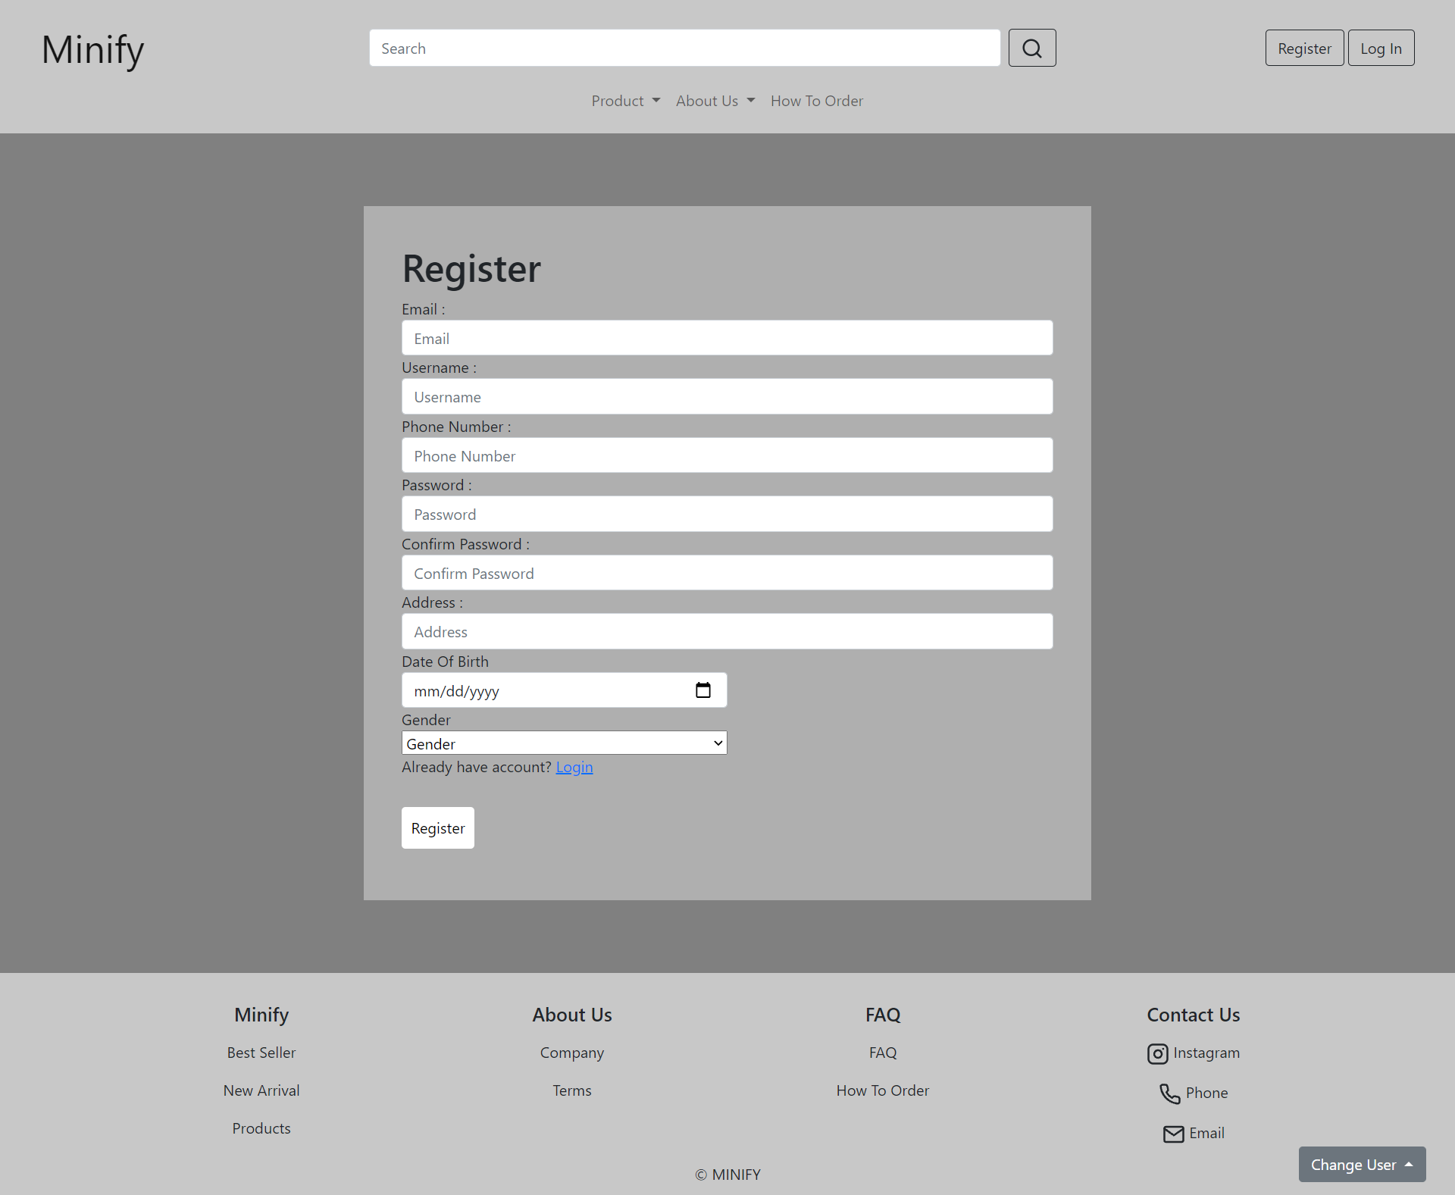

**Gambar 4.2 Tampilan Register Page**

#### 4.C. Flowchart

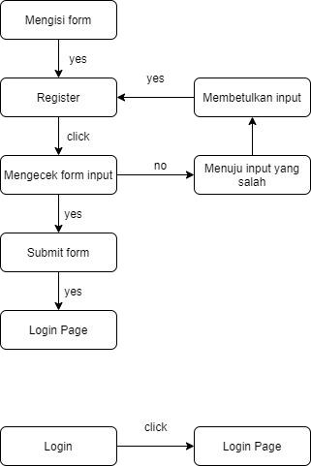

**Gambar 4.3 Flowchart Register Page**

#### 4.D. Fitur

Halaman register ini digunakan untuk para pelanggan membuat akun pada website minify agar mereka bisa melakukan order. Beberapa hal yang terdapat pada halaman register yaitu :

1. Form input

Form ini berfungsi untuk mengisi identitas diri pelanggan agar bisa membuat akun. Hal-hal yang harus diisi untuk melakukan registrasi yaitu :

* Email
* Username
* Phone Number
* Password
* Confirm Password
* Address
* Date of Birth
* Gender

1. Login link

Login link ini jika di klik akan langsung menuju ke login page. Link ini berfungsi untuk apabila pelanggan ternyata sudah memiliki akun sehingga pelanggan tinggal mengklik login link lalu akan menuju ke login page.

1. Register Button

Register Button jika di klik maka form akan di cek apakah seluruh data yang dimasukan sudah benar atau belum bila sudah benar maka form akan di submit, tetapi jika salah maka akan ada pemberitahuan tentang input yang salah

#### 4.E. Source Code

##### Html

**<div style="background-color: grey; padding: 5% 25%">**

**<div class="register">**

**<div>**

**<form>**

**<h1>Register</h1>**

**<div class="form-group">**

**<label for="exampleInputEmail1">Email : </label>**

**<input**

**type="email"**

**class="form-control"**

**id="exampleInputEmail1"**

**aria-describedby="emailHelp"**

**placeholder="Email"**

**required**

**/>**

**</div>**

**<div class="form-group">**

**<label for="exampleInputEmail1">Username : </label>**

**<input**

**type="text"**

**class="form-control"**

**id="exampleInputUsername1"**

**aria-describedby="usernameHelp"**

**placeholder="Username"**

**required**

**/>**

**</div>**

**<div class="form-group">**

**<label for="exampleInputEmail1">Phone Number : </label>**

**<input**

**type="text"**

**class="form-control"**

**id="exampleInputPhone1"**

**aria-describedby="phoneHelp"**

**placeholder="Phone Number"**

**required**

**/>**

**</div>**

**<div class="form-group">**

**<label for="exampleInputPassword1">Password :</label>**

**<input**

**type="password"**

**class="form-control"**

**id="exampleInputPassword1"**

**placeholder="Password"**

**required**

**/>**

**</div>**

**<div class="form-group">**

**<label for="exampleInputPassword1">Confirm Password :</label>**

**<input**

**type="password"**

**class="form-control"**

**id="exampleInputConfirmPassword1"**

**placeholder="Confirm Password"**

**required**

**/>**

**</div>**

**<div class="form-group">**

**<label for="exampleInputEmail1">Address : </label>**

**<input**

**type="text"**

**class="form-control"**

**id="exampleInputAddress1"**

**aria-describedby="addressHelp"**

**placeholder="Address"**

**required**

**/>**

**</div>**

**<div class="form-group">**

**<label for="exampleInputDOB1">Date Of Birth</label>**

**<div>**

**<input**

**type="date"**

**class="form-control dob"**

**aria-describedby="addressHelp"**

**id="dob"**

**required**

**/>**

**</div>**

**</div>**

**<div class="form-group">**

**<label for="exampleInputDOB1">Gender</label>**

**<div>**

**<select class="custom-select gender">**

**<option selected>Gender</option>**

**<option value="1">Man</option>**

**<option value="2">Woman</option>**

**</select>**

**</div>**

**</div>**

**<p>Already have account? <a href="login.html">Login</a></p>**

**<a**

**href="login.html"**

**type="submit"**

**class="btnRegister btn btn-primary"**

**style="background-color: white; color: black; border: none"**

**>**

**Register**

**</a>**

**</form>**

**</div>**

**</div>**

**</div>**

##### CSS

**<style>**

**\* {**

**margin: 0;**

**padding: 0;**

**}**

**.custom-select {**

**width: 13%;**

**margin-right: 5px;**

**}**

**.gender,**

**.dob {**

**width: 50%;**

**}**

**.btnRegister {**

**margin: 15px 0;**

**padding: 10px 10px;**

**}**

**.register {**

**background-color: rgb(175, 175, 175);**

**padding: 40px;**

**}**

**</style>**

### Forget Password

#### 5.A. Mock Up

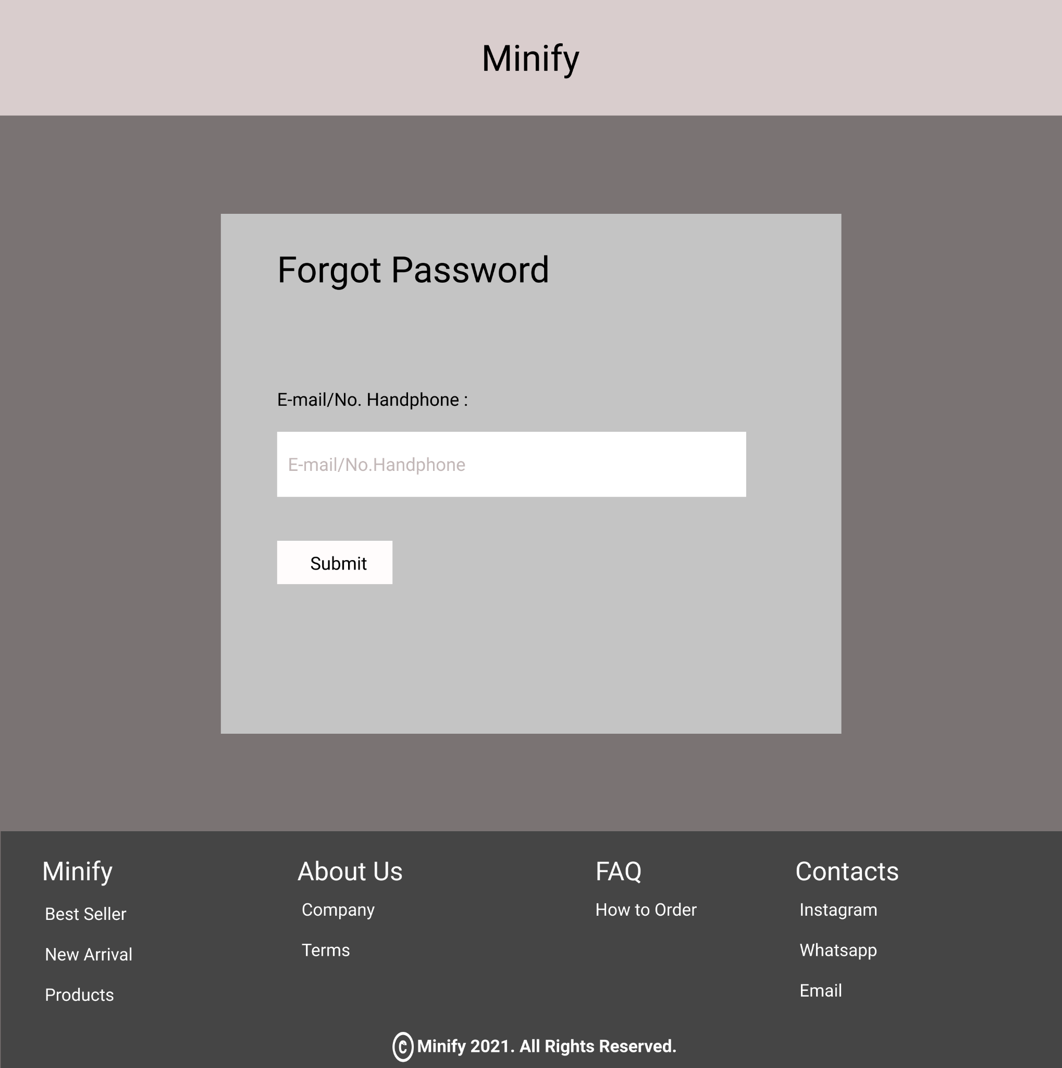

**Gambar 5.1. Mock Up Forget Password Page**

#### 5.B. Tampilan

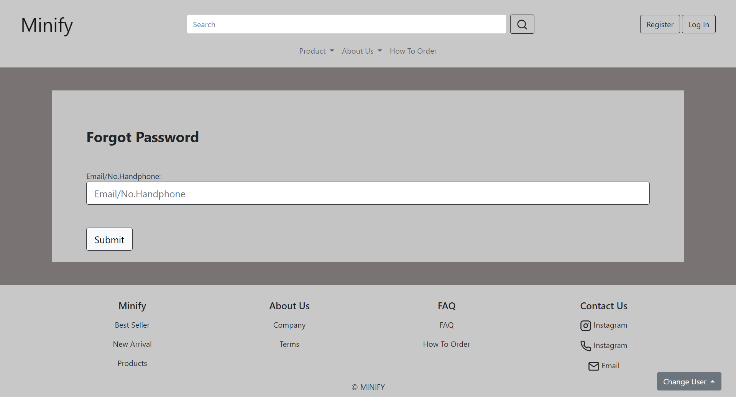

**Gambar 5.2. Tampilan Forget Password Page**

#### 5.C. Flowchart

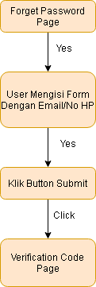

**5.3. Flowchart Forget Password Page**

#### 5.D. Fitur

Halaman Forget Password digunakan bagi user yang sudah pernah melakukan register, tetapi lupa akan password dari akun yang didaftarkan

1. Judul : Forgot Password
2. Form : Tempat user melakukan input email/No HP untuk menerima Verification Code
3. Submit Button : Saat di klik, user akan diarahkan ke Page Verification Code

#### 5.E. Source Code

##### Html

**<section>**

**<div style="background-color: #7a7373">**

**<br /><br />**

**<div class="container-sm py-4" style="background-color: #c4c4c4">**

**<div class="row mx-5">**

**<!-- Isi Forget Pass -->**

**<div class="form-group">**

**<div**

**class="text-left"**

**style="margin-top: 50px; font-size: 30px; font-weight: bold"**

**>**

**<label for="headerText">Forgot Password</label>**

**</div>**

**<br /><br />**

**<label for="exampleInputEmail1">Email/No.Handphone:</label>**

**<input**

**type="email"**

**class="form-control form-control-lg border-dark"**

**id="exampleInputEmail1"**

**aria-describedby="emailHelp"**

**placeholder="Email/No.Handphone"**

**/>**

**<br /><br />**

**</div>**

**<div class="text-left">**

**<a href="verificationcode.html">**

**<button type="submit" class="btn btn-light btn-lg border-dark">**

**Submit**

**</button>**

**<br /><br /><br /><br />**

**</a>**

**</div>**

**</div>**

**</div>**

**<br /><br />**

**</div>**

**</section>**

### Verification Code

#### 6.A. Mock Up

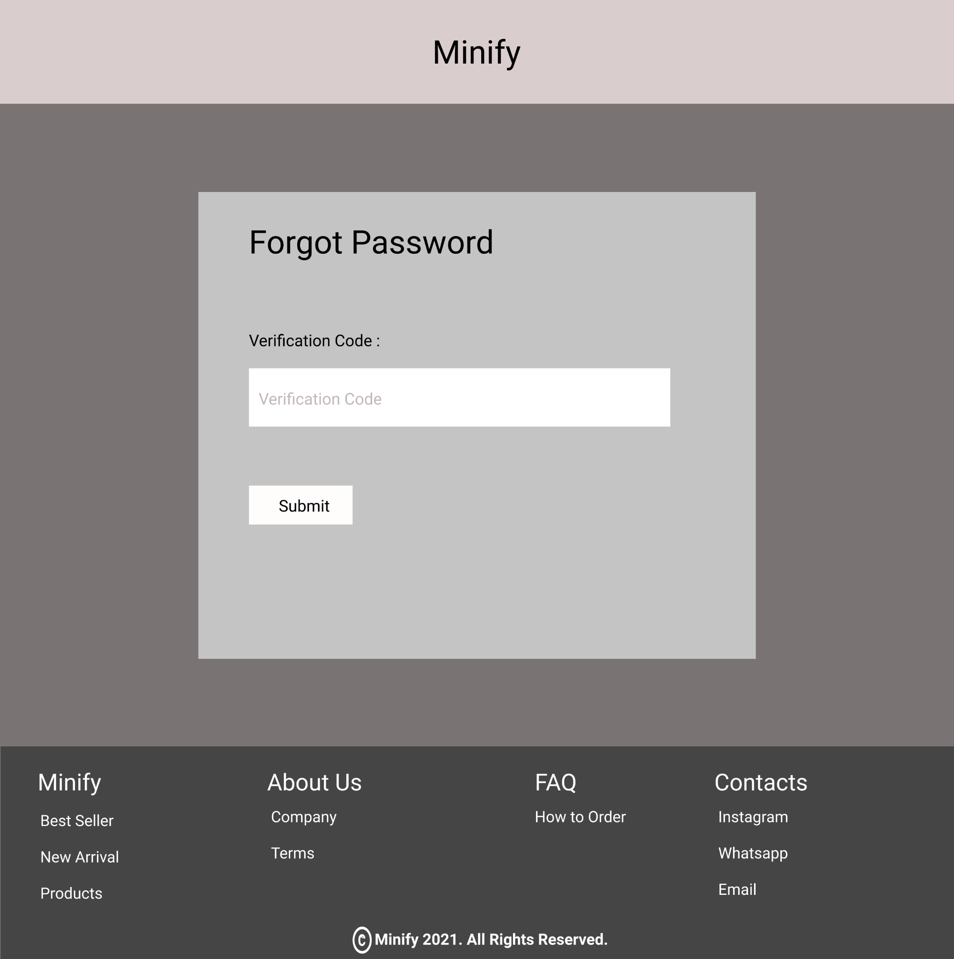

**6.1. Mock Up Verification Code Page**

#### 6.B. Tampilan

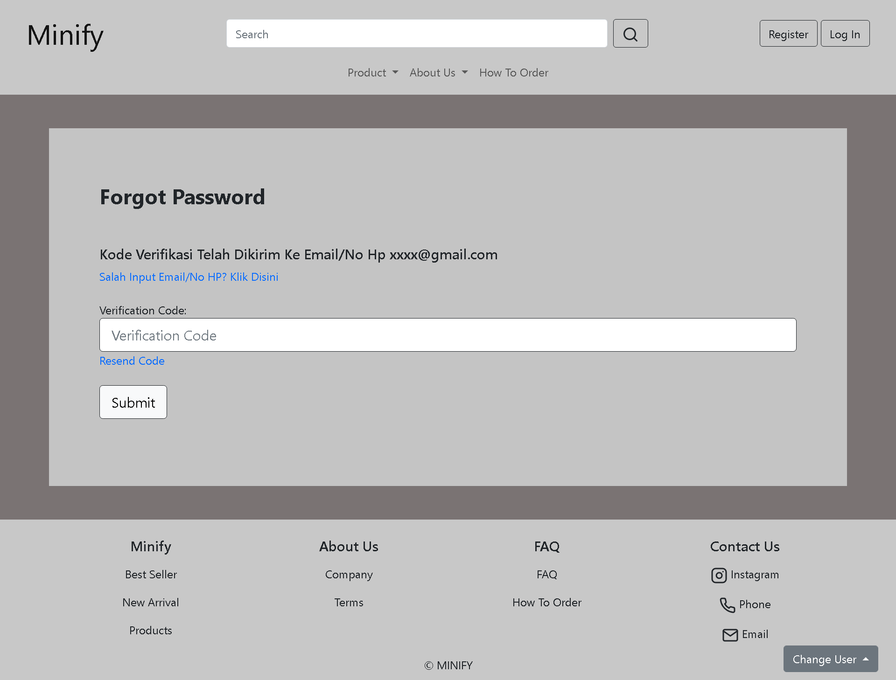

**6.2. Tampilan Verification Code Page**

#### 6.C. Flowchart

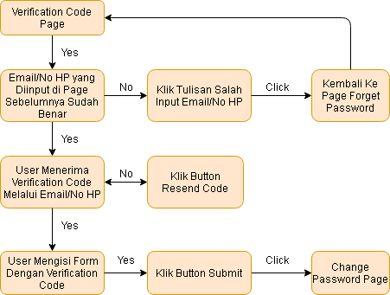

**6.3. Flowchart Verification Code Page**

#### 6.D. Fitur

Pada Halaman ini, user akan menginput kode verifikasi yang telah dikirim melalui email/No HP

1. Judul : Forgot Password
2. Wrong Input : Jika user salah dalam memasukkan email/No Hp, maka dengan mengklik tulisan “Salah…”, akan diarahkan ke page sebelumnya yaitu page Forget Password
3. Form : User melakukan input kode verifikasi yang telah dikirimkan melalui email/No HP
4. Resend Code : Saat tulisan ini diklik, user melakukan request untuk mengirim ulang kode verifikasi
5. Submit Button : Saat diklik, user akan diarahkan ke page Change Password

#### 6.E. Source Code

##### Html

**<section>**

**<div style="background-color: #7a7373">**

**<br /><br />**

**<div class="container-sm py-4" style="background-color: #c4c4c4">**

**<div class="row mx-5">**

**<!-- Isi Forget Pass -->**

**<div class="form-group">**

**<div**

**class="text-left"**

**style="margin-top: 50px; font-size: 30px; font-weight: bold"**

**>**

**<label for="headerText">Forgot Password</label>**

**</div>**

**<br /><br />**

**<h5>Kode Verifikasi Telah Dikirim Ke Email/No Hp xxxx@gmail.com</h5>**

**<a href="#" class="text-decoration-none">Salah Input Email/No HP? Klik Disini</a>**

**<br><br>**

**<label for="exampleInputEmail1">Verification Code:</label>**

**<input**

**type="email"**

**class="form-control form-control-lg border-dark"**

**id="exampleInputEmail1"**

**aria-describedby="emailHelp"**

**placeholder="Verification Code"**

**/>**

**<a href="#" class="text-decoration-none">Resend Code</a>**

**<br /><br />**

**</div>**

**<div class="text-left">**

**<a href="changepassword.html">**

**<button type="submit" class="btn btn-light btn-lg border-dark">**

**Submit**

**</button>**

**<br /><br /><br /><br />**

**</a>**

**</div>**

**</div>**

**</div>**

**<br /><br />**

**</div>**

**</section>**

### Change Password

#### 7.A. Mock Up

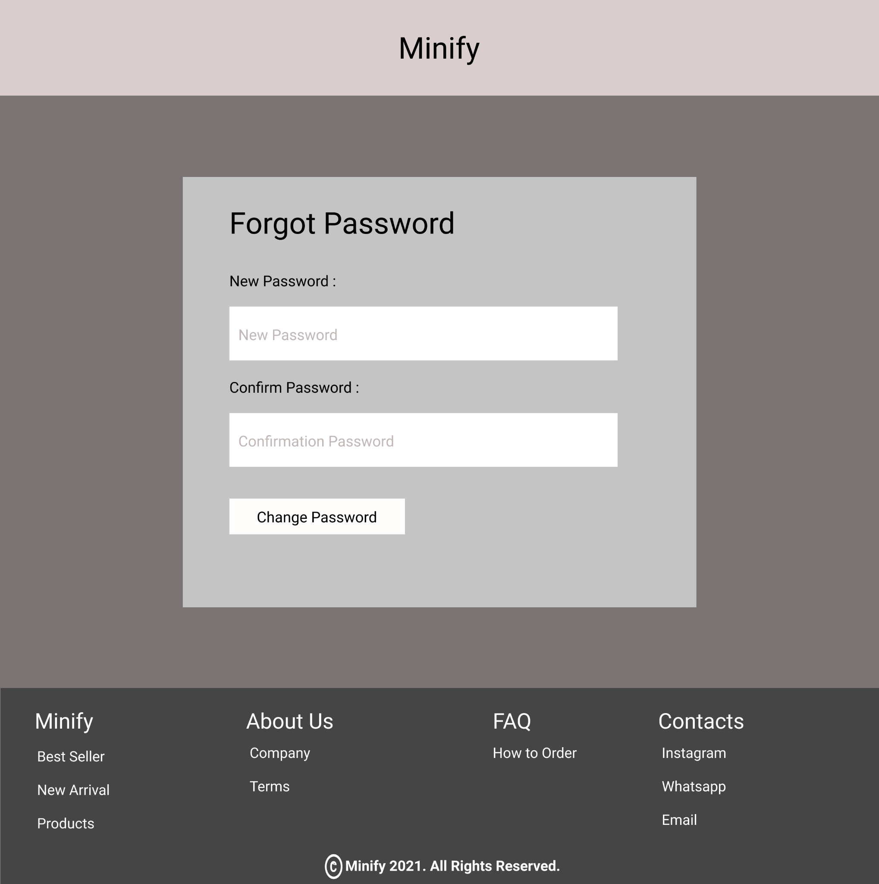

**7.1. Mock Up Change Password Page**

#### 7.B. Tampilan

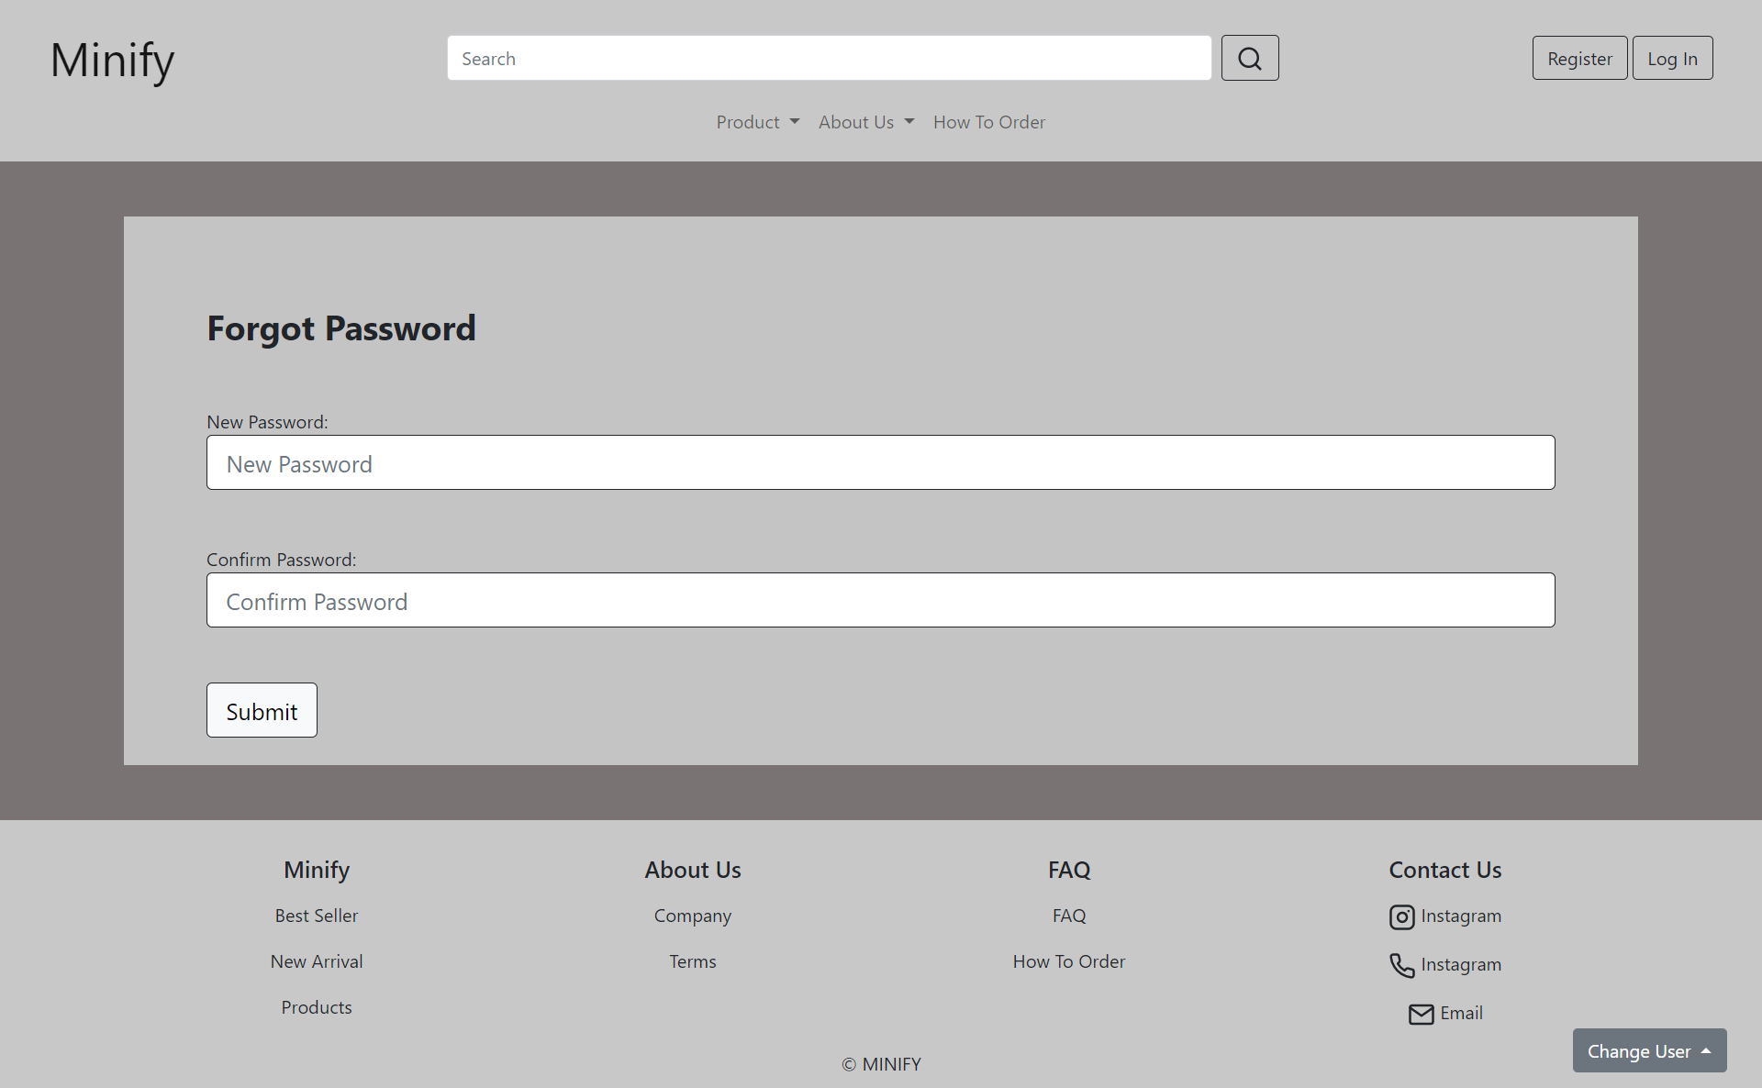

**7.2. Tampilan Change Password Page**

#### 7.C. Flowchart

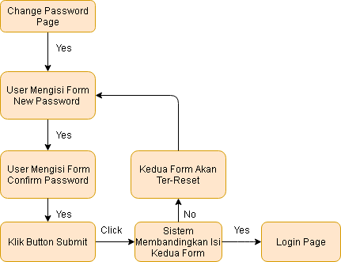

**7.3. Flowchart Change Password Page**

#### 7.D. Fitur

Pada halaman ini, user melakukan input terhadap password baru untuk akun

1. Judul : Forgot Password
2. Form 1 : Pada form ini, user melakukan input password baru yang diinginkan
3. Form 2 : Pada form ini, user mengonfirmasi ulang password baru
4. Submit Button : Jika diklik, user akan diarahkan ke page login kembali

#### 

#### 7.E. Source Code

##### Html

**<section>**

**<div style="background-color: #7a7373">**

**<br /><br />**

**<div class="container-sm py-4" style="background-color: #c4c4c4">**

**<div class="row mx-5">**

**<!-- Isi Forget Pass -->**

**<div class="form-group">**

**<div**

**class="text-left"**

**style="margin-top: 50px; font-size: 30px; font-weight: bold"**

**>**

**<label for="headerText">Forgot Password</label>**

**</div>**

**<br /><br />**

**<label for="exampleInputEmail1">New Password:</label>**

**<input**

**type="email"**

**class="form-control form-control-lg border-dark"**

**id="exampleInputEmail1"**

**aria-describedby="emailHelp"**

**placeholder="New Password"**

**/>**

**<br /><br />**

**<label for="exampleInputEmail1">Confirm Password:</label>**

**<input**

**type="email"**

**class="form-control form-control-lg border-dark"**

**id="exampleInputEmail1"**

**aria-describedby="emailHelp"**

**placeholder="Confirm Password"**

**/>**

**<br /><br />**

**</div>**

**<div class="text-left">**

**<a href="login.html">**

**<button type="submit" class="btn btn-light btn-lg border-dark">**

**Submit**

**</button>**

**<br /><br /><br /><br />**

**</a>**

**</div>**

**</div>**

**</div>**

**<br /><br />**

**</div>**

**</section>**

### Profile dan Edit Profile

#### 8.A. Mockup

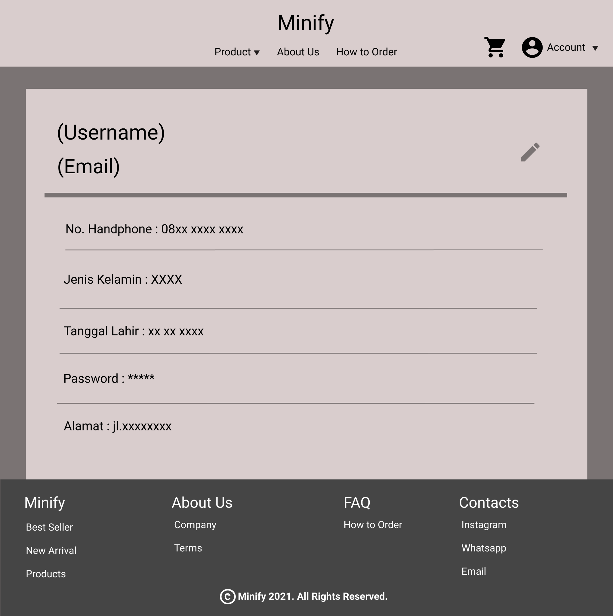

**Gambar 8.1. Mockup Profile**

#### 8.B. Tampilan

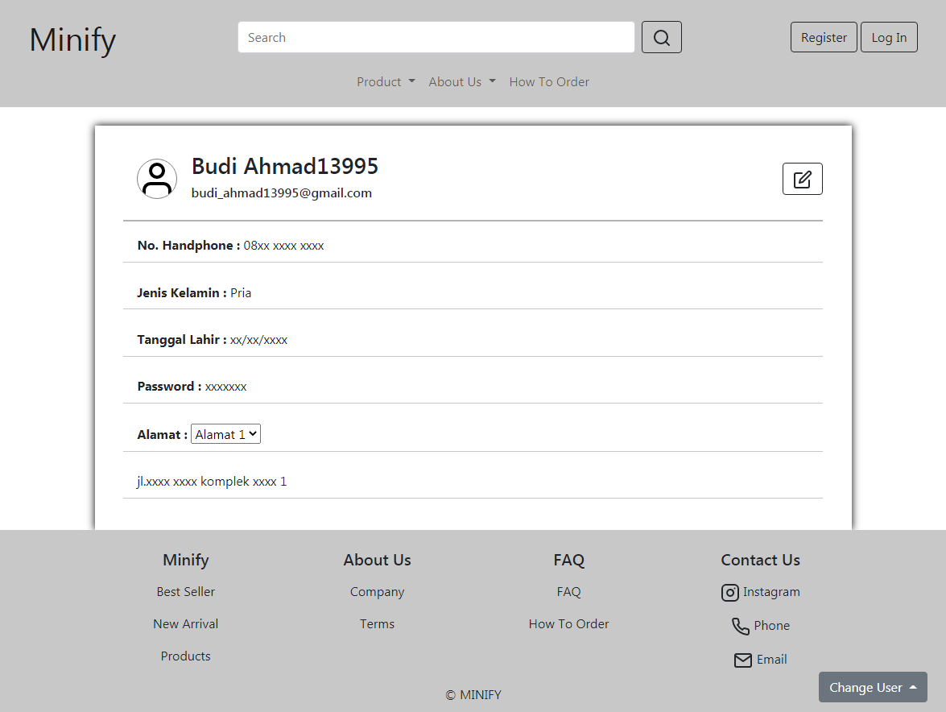

**Gambar 8.2. Profile**

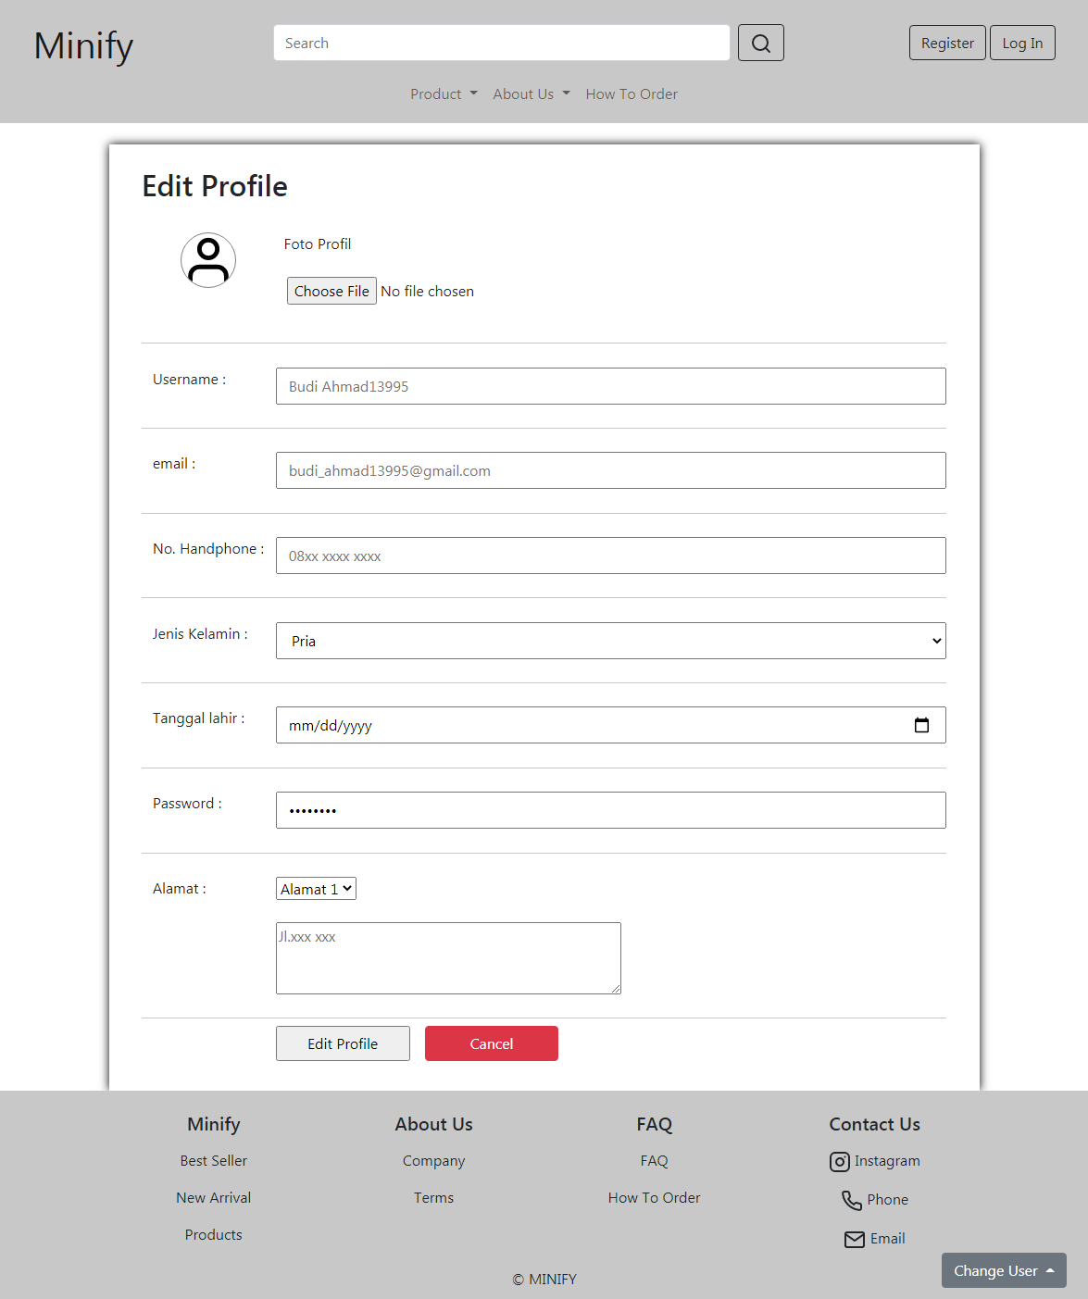

**Gambar 8.3. Edit Profile**

#### 8.C. Flowchart

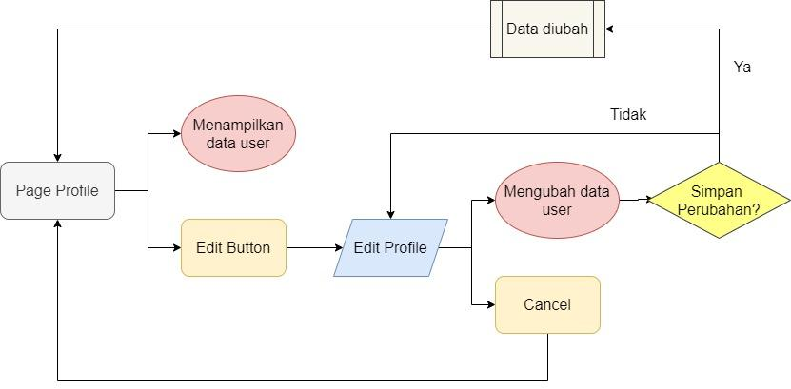

**Gambar 8.3. Flowchart Profile dan Edit Profile**

#### 8.D. Fitur

Pada halaman Profile akan ditampilkan data-data dari User yaitu :

* Foto profil
* Username
* Email
* Nomor Handphone
* Jenis Kelamin
* Tanggal Lahir
* Password
* Alamat (ada beberapa alamat)

Tombol dengan icon edit di sebelah kanan username dan email akan mengarahkan pengguna ke page Edit Profile

Pada page Edit Profile pengguna dapat mengubah data-data yang tersedia. Jika pengguna menekan tombol Cancel maka pengguna akan diarahkan kembali ke page Profile. Setelah pengguna telah selesai mengubah data, kemudian pengguna dapat menekan tombol Edit Profile, kemudian akan muncul pertanyaan verifikasi untuk mengubah data. Jika pengguna menyetujuinya maka perubahan akan disimpan dan pengguna akan diarahkan kembali ke page Profile, jika pengguna tidak setuju maka akan kembali ke page Edit Profile.

#### 8.E. Source Code

##### 8.D.1 Source Code Profile

##### Html

**<section>**

**<div id="profile">**

**<div class="head">**

**<img src="image/user.svg" class="chat-avatar" alt="...">**

**<div>**

**<h3>Budi Ahmad13995</h3>**

**<h6>budi_ahmad13995@gmail.com</h6>**

**</div>**

**<div style="margin-left: auto;">**

**<a type="button" href="editProfile.html" class="btn btn-outline-dark" title="Edit Profile"><i data-feather="edit"></i></a>**

**</div>**

**</div>**

**<div class="body">**

**<p><b> No. Handphone : </b> 08xx xxxx xxxx</p>**

**<p><b>Jenis Kelamin : </b> Pria</p>**

**<p><b>Tanggal Lahir : </b> xx/xx/xxxx</p>**

**<p><b>Password : </b> xxxxxxx</p>**

**<div>**

**<p>**

**<span><b>Alamat : </b> </span>**

**<select name="" id="selectAlamat">**

**<option class="optionAlamat" value="jl.xxxx xxxx komplek xxxx 1">Alamat 1</option>**

**<option class="optionAlamat" value="jl.xxxx xxxx komplek xxxx 2">Alamat 2</option>**

**<option class="optionAlamat" value="jl.xxxx xxxx komplek xxxx 3">Alamat 3</option>**

**</select>**

**</p>**

**<p id="viewAlamat">**

**jl.xxxx xxxx komplek xxxx**

**</p>**

**</div>**

**</div>**

**</div>**

**</section>**

##### CSS

**<style>**

**#profile{**

**width: 80%;**

**margin: 2% auto 0;**

**padding: 2% 3%;**

**box-shadow: 0 0 10px black;**

**}**

**#profile .chat-avatar{**

**width: 50px;**

**margin: 2%;**

**border-radius: 100%;**

**border: 1px solid gray;**

**background-color: white;**

**}**

**#profile .head{**

**align-items: center;**

**display: flex;**

**padding-bottom: 1%;**

**margin-bottom: 1%;**

**border-bottom: 2px solid rgb(180, 180, 180);**

**}**

**#profile .body p{**

**padding: 1% 2%;**

**border-bottom: 1px solid rgb(200, 200, 200);**

**}**

**</style>**

##### Javascript

**<script>**

**$( "#selectAlamat" ).change(function() {**

**var str = "";**

**$( "select option:selected" ).each(function() {**

**str = $( this ).val();**

**});**

**$( "#viewAlamat" ).empty();**

**$( "#viewAlamat" ).text(str);**

**}).trigger( "change" );**

**</script>**

##### 8.D.2 Source Code Edit Profile

##### Html

**<section>**

**<div id="editProfile">**

**<h2>Edit Profile</h2>**

**<form action="" class="container" onsubmit="return false">**

**<div class="row">**

**<p class="col-lg-2" style="text-align: center">**

**<img src="image/user.svg" class="profile-pic" alt="..." />**

**</p>**

**<p class="col">**

**<span class="row">&nbsp Foto Profil</span>**

**<br />**

**<input type="file" name="fotoProduk" />**

**</p>**

**</div>**

**<div class="row">**

**<p class="col-lg-2">Username :</p>**

**<input**

**class="col"**

**type="text"**

**name="usernameUser"**

**placeholder="Budi Ahmad13995"**

**/>**

**</div>**

**<div class="row">**

**<p class="col-lg-2">email :</p>**

**<input**

**class="col"**

**type="number"**

**name="emailUser"**

**placeholder="budi_ahmad13995@gmail.com"**

**/>**

**</div>**

**<div class="row">**

**<p class="col-lg-2">No. Handphone :</p>**

**<input**

**class="col"**

**type="text"**

**name="nomorHPUser"**

**placeholder="08xx xxxx xxxx"**

**/>**

**</div>**

**<div class="row">**

**<p class="col-lg-2">Jenis Kelamin :</p>**

**<select class="col" name="kategoriProduk" id="">**

**<option value="Komputer">Pria</option>**

**<option value="Laptop">Wanita</option>**

**<option value="LainLain">Lainnya</option>**

**</select>**

**</div>**

**<div class="row">**

**<p class="col-lg-2">Tanggal lahir :</p>**

**<input class="col" type="date" name="tanggalLahirUser" />**

**</div>**

**<div class="row">**

**<p class="col-lg-2">Password :</p>**

**<input**

**class="col"**

**type="password"**

**name="passwordUser"**

**value="00000000"**

**/>**

**</div>**

**<div class="row">**

**<p class="col-lg-2">Alamat :</p>**

**<section class="col">**

**<select class="row" name="" id="selectAlamat">**

**<option class="optionAlamat">Alamat 1</option>**

**<option class="optionAlamat">Alamat 2</option>**

**<option class="optionAlamat">Alamat 3</option>**

**</select>**

**<br />**

**<textarea**

**class="row"**

**name="alamatUser"**

**id=""**

**cols="50"**

**rows="3"**

**style="vertical-align: text-top"**

**placeholder="Jl.xxx xxx"**

**></textarea>**

**</section>**

**</div>**

**<section class="row my-2">**

**<p class="col-lg-2"></p>**

**<input**

**id="edit-profile-submit"**

**class="col-lg-2"**

**type="submit"**

**value="Edit Profile"**

**/>**

**<a**

**href="profile.html"**

**class="col-lg-2 my-2 my-lg-0 mx-lg-3 btn btn-danger"**

**role="button"**

**>Cancel</a**

**>**

**</section>**

**</form>**

**</div>**

**</section>**

##### CSS

**<style>**

**#editProfile {**

**width: 80%;**

**margin: 2% auto 0;**

**padding: 2% 3%;**

**box-shadow: 0 0 10px black;**

**}**

**#editProfile div {**

**padding: 3% 0;**

**border-bottom: 1px solid rgb(200, 200, 200);**

**}**

**#editProfile .profile-pic {**

**width: 50%;**

**border-radius: 100%;**

**border: 1px solid gray;**

**background-color: white;**

**}**

**</style>**

##### JavaScript

**<Script>**

**$("#edit-profile-submit").click(function () {**

**if (confirm("Simpan perubahan?")) {**

**window.location.href = "profile.html";**

**}**

**});**

**</Script>**

### Wishlist

#### 9.A. Mockup

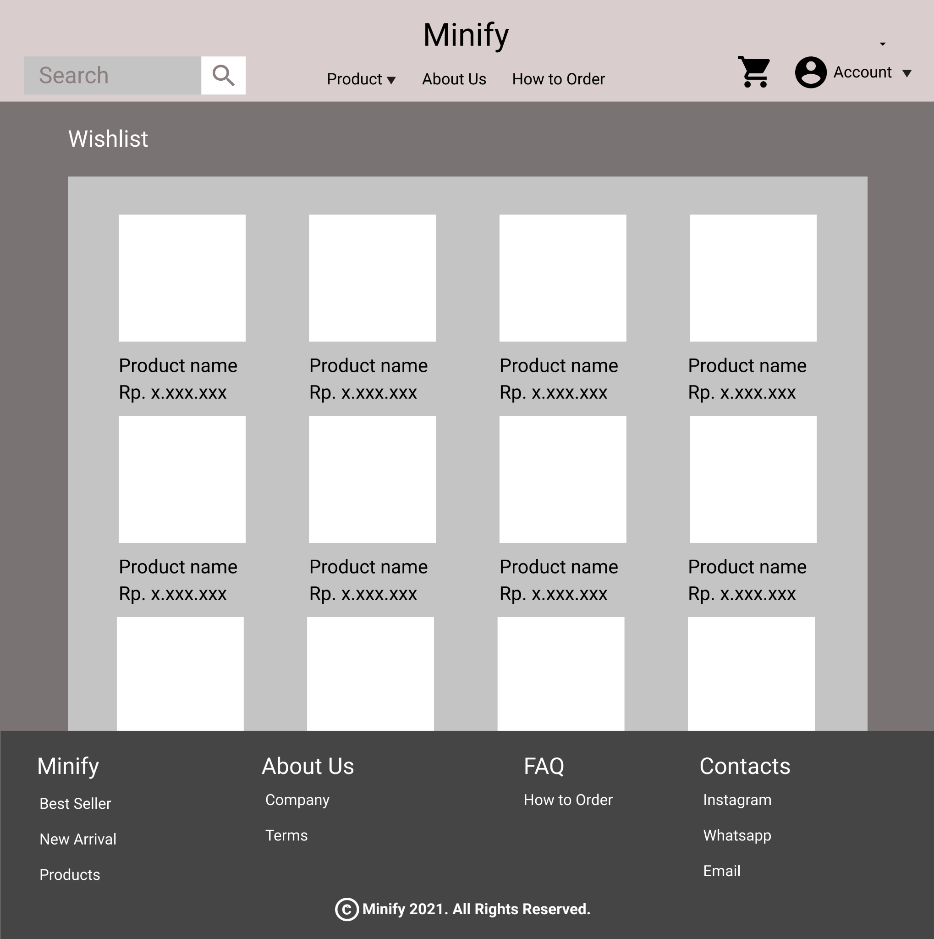

**Gambar 9.1 Mockup Wishlist page**

#### 9.B. Tampilan

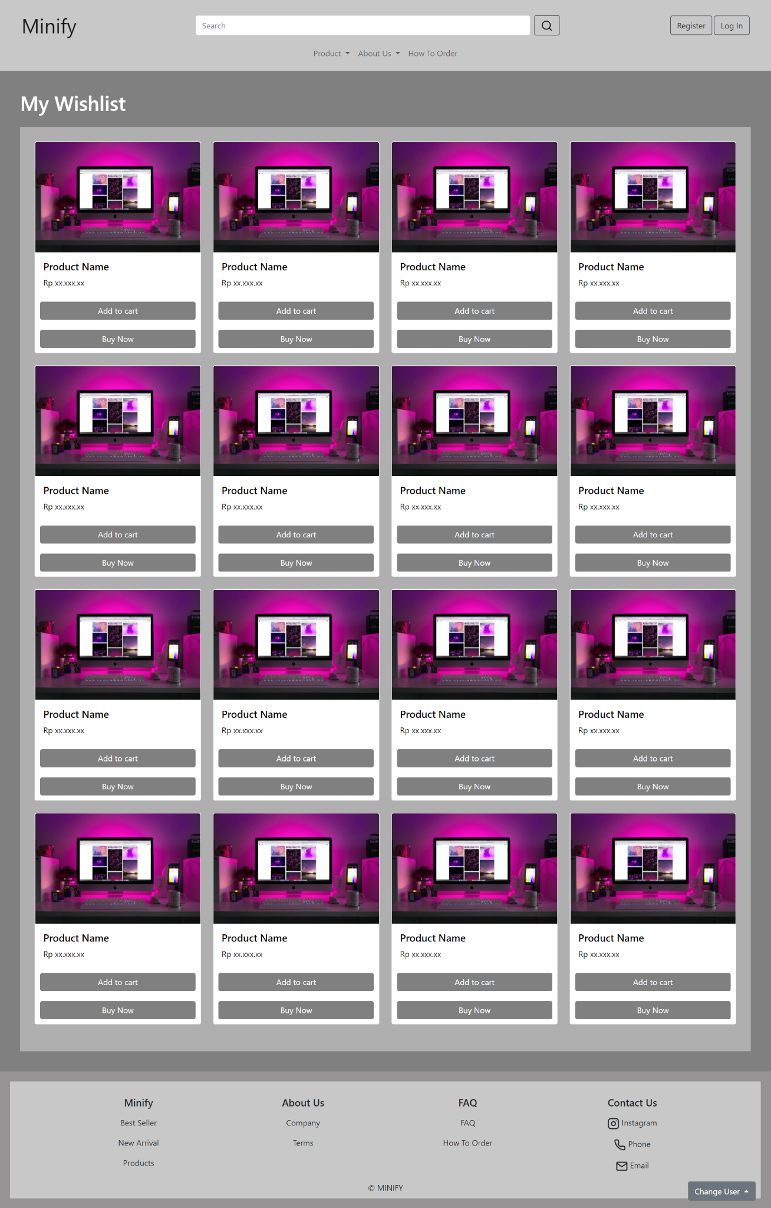

**Gambar 9.2 Tampilan Wishlist Page**

#### 9.C. Flowchart

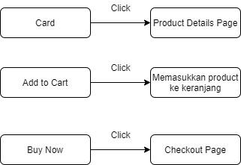

**Gambar 9.3 Flowchart Wishlist**

#### 9.D. Fitur

Pada halaman wishlist menampilkan produk yang pelanggan masukkan sebagai wishlist. Pada card product terdapat beberapa fitur yaitu :

1. Card : Di dalam card terdapat foto produk, harga produk, Add to Cart Button dan Buy Now Button. Jika card di klik maka akan menuju product details page dari produk tersebut.
2. Add to Cart Button : Jika di klik maka akan menambahkan produk ke dalam keranjang.
3. Buy Now Button : Jika di klik maka akan menuju checkout page.

#### 9.E. Source Code

##### Html

**<div>**

**<div style="padding: 40px; background-color: grey">**

**<div class="mb-4">**

**<h1 style="color: white">My Wishlist</h1>**

**</div>**

**<div style="background-color: rgb(175, 175, 175); padding: 2%">**

**<div class="row row-cols-1 row-cols-md-4">**

**<div class="col mb-4">**

**<a**

**href="details.html"**

**style="text-decoration: none; color: black"**

**>**

**<div class="card h-100">**

**<img**

**src="/image/designecologist-Pmh0UoG1vlE-unsplash.jpg"**

**class="card-img-top"**

**alt="..."**

**/>**

**<div class="card-body">**

**<h5 class="card-title">Product Name</h5>**

**<p class="card-text">Rp xx.xxx.xx</p>**

**</div>**

**<a**

**href="#"**

**class="btn btn-primary mar10"**

**style="background-color: grey; color: white; border: none"**

**>Add to cart</a**

**>**

**<a**

**href="checkout.html"**

**class="btn btn-primary mar10"**

**style="background-color: grey; color: white; border: none"**

**>Buy Now</a**

**>**

**</div>**

**</a>**

**</div>**

**<div class="col mb-4">**

**<a**

**href="details.html"**

**style="text-decoration: none; color: black"**

**>**

**<div class="card h-100">**

**<img**

**src="/image/designecologist-Pmh0UoG1vlE-unsplash.jpg"**

**class="card-img-top"**

**alt="..."**

**/>**

**<div class="card-body">**

**<h5 class="card-title">Product Name</h5>**

**<p class="card-text">Rp xx.xxx.xx</p>**

**</div>**

**<a**

**href="#"**

**class="btn btn-primary mar10"**

**style="background-color: grey; color: white; border: none"**

**>Add to cart</a**

**>**

**<a**

**href="checkout.html"**

**class="btn btn-primary mar10"**

**style="background-color: grey; color: white; border: none"**

**>Buy Now</a**

**>**

**</div>**

**</a>**

**</div>**

**<div class="col mb-4">**

**<a**

**href="details.html"**

**style="text-decoration: none; color: black"**

**>**

**<div class="card h-100">**

**<img**

**src="/image/designecologist-Pmh0UoG1vlE-unsplash.jpg"**

**class="card-img-top"**

**alt="..."**

**/>**

**<div class="card-body">**

**<h5 class="card-title">Product Name</h5>**

**<p class="card-text">Rp xx.xxx.xx</p>**

**</div>**

**<a**

**href="#"**

**class="btn btn-primary mar10"**

**style="background-color: grey; color: white; border: none"**

**>Add to cart</a**

**>**

**<a**

**href="checkout.html"**

**class="btn btn-primary mar10"**

**style="background-color: grey; color: white; border: none"**

**>Buy Now</a**

**>**

**</div>**

**</a>**

**</div>**

**<div class="col mb-4">**

**<a**

**href="details.html"**

**style="text-decoration: none; color: black"**

**>**

**<div class="card h-100">**

**<img**

**src="/image/designecologist-Pmh0UoG1vlE-unsplash.jpg"**

**class="card-img-top"**

**alt="..."**

**/>**

**<div class="card-body">**

**<h5 class="card-title">Product Name</h5>**

**<p class="card-text">Rp xx.xxx.xx</p>**

**</div>**

**<a**

**href="#"**

**class="btn btn-primary mar10"**

**style="background-color: grey; color: white; border: none"**

**>Add to cart</a**

**>**

**<a**

**href="checkout.html"**

**class="btn btn-primary mar10"**

**style="background-color: grey; color: white; border: none"**

**>Buy Now</a**

**>**

**</div>**

**</a>**

**</div>**

**<div class="col mb-4">**

**<a**

**href="details.html"**

**style="text-decoration: none; color: black"**

**>**

**<div class="card h-100">**

**<img**

**src="/image/designecologist-Pmh0UoG1vlE-unsplash.jpg"**

**class="card-img-top"**

**alt="..."**

**/>**

**<div class="card-body">**

**<h5 class="card-title">Product Name</h5>**

**<p class="card-text">Rp xx.xxx.xx</p>**

**</div>**

**<a**

**href="#"**

**class="btn btn-primary mar10"**

**style="background-color: grey; color: white; border: none"**

**>Add to cart</a**

**>**

**<a**

**href="checkout.html"**

**class="btn btn-primary mar10"**

**style="background-color: grey; color: white; border: none"**

**>Buy Now</a**

**>**

**</div>**

**</a>**

**</div>**

**<div class="col mb-4">**

**<a**

**href="details.html"**

**style="text-decoration: none; color: black"**

**>**

**<div class="card h-100">**

**<img**

**src="/image/designecologist-Pmh0UoG1vlE-unsplash.jpg"**

**class="card-img-top"**

**alt="..."**

**/>**

**<div class="card-body">**

**<h5 class="card-title">Product Name</h5>**

**<p class="card-text">Rp xx.xxx.xx</p>**

**</div>**

**<a**

**href="#"**

**class="btn btn-primary mar10"**

**style="background-color: grey; color: white; border: none"**

**>Add to cart</a**

**>**

**<a**

**href="checkout.html"**

**class="btn btn-primary mar10"**

**style="background-color: grey; color: white; border: none"**

**>Buy Now</a**

**>**

**</div>**

**</a>**

**</div>**

**<div class="col mb-4">**

**<a**

**href="details.html"**

**style="text-decoration: none; color: black"**

**>**

**<div class="card h-100">**

**<img**

**src="/image/designecologist-Pmh0UoG1vlE-unsplash.jpg"**

**class="card-img-top"**

**alt="..."**

**/>**

**<div class="card-body">**

**<h5 class="card-title">Product Name</h5>**

**<p class="card-text">Rp xx.xxx.xx</p>**

**</div>**

**<a**

**href="#"**

**class="btn btn-primary mar10"**

**style="background-color: grey; color: white; border: none"**

**>Add to cart</a**

**>**

**<a**

**href="checkout.html"**

**class="btn btn-primary mar10"**

**style="background-color: grey; color: white; border: none"**

**>Buy Now</a**

**>**

**</div>**

**</a>**

**</div>**

**<div class="col mb-4">**

**<a**

**href="details.html"**

**style="text-decoration: none; color: black"**

**>**

**<div class="card h-100">**

**<img**

**src="/image/designecologist-Pmh0UoG1vlE-unsplash.jpg"**

**class="card-img-top"**

**alt="..."**

**/>**

**<div class="card-body">**

**<h5 class="card-title">Product Name</h5>**

**<p class="card-text">Rp xx.xxx.xx</p>**

**</div>**

**<a**

**href="#"**

**class="btn btn-primary mar10"**

**style="background-color: grey; color: white; border: none"**

**>Add to cart</a**

**>**

**<a**

**href="checkout.html"**

**class="btn btn-primary mar10"**

**style="background-color: grey; color: white; border: none"**

**>Buy Now</a**

**>**

**</div>**

**</a>**

**</div>**

**<div class="col mb-4">**

**<a**

**href="details.html"**

**style="text-decoration: none; color: black"**

**>**

**<div class="card h-100">**

**<img**

**src="/image/designecologist-Pmh0UoG1vlE-unsplash.jpg"**

**class="card-img-top"**

**alt="..."**

**/>**

**<div class="card-body">**

**<h5 class="card-title">Product Name</h5>**

**<p class="card-text">Rp xx.xxx.xx</p>**

**</div>**

**<a**

**href="#"**

**class="btn btn-primary mar10"**

**style="background-color: grey; color: white; border: none"**

**>Add to cart</a**

**>**

**<a**

**href="checkout.html"**

**class="btn btn-primary mar10"**

**style="background-color: grey; color: white; border: none"**

**>Buy Now</a**

**>**

**</div>**

**</a>**

**</div>**

**<div class="col mb-4">**

**<a**

**href="details.html"**

**style="text-decoration: none; color: black"**

**>**

**<div class="card h-100">**

**<img**

**src="/image/designecologist-Pmh0UoG1vlE-unsplash.jpg"**

**class="card-img-top"**

**alt="..."**

**/>**

**<div class="card-body">**

**<h5 class="card-title">Product Name</h5>**

**<p class="card-text">Rp xx.xxx.xx</p>**

**</div>**

**<a**

**href="#"**

**class="btn btn-primary mar10"**

**style="background-color: grey; color: white; border: none"**

**>Add to cart</a**

**>**

**<a**

**href="checkout.html"**

**class="btn btn-primary mar10"**

**style="background-color: grey; color: white; border: none"**

**>Buy Now</a**

**>**

**</div>**

**</a>**

**</div>**

**<div class="col mb-4">**

**<a**

**href="details.html"**

**style="text-decoration: none; color: black"**

**>**

**<div class="card h-100">**

**<img**

**src="/image/designecologist-Pmh0UoG1vlE-unsplash.jpg"**

**class="card-img-top"**

**alt="..."**

**/>**

**<div class="card-body">**

**<h5 class="card-title">Product Name</h5>**

**<p class="card-text">Rp xx.xxx.xx</p>**

**</div>**

**<a**

**href="#"**

**class="btn btn-primary mar10"**

**style="background-color: grey; color: white; border: none"**

**>Add to cart</a**

**>**

**<a**

**href="checkout.html"**

**class="btn btn-primary mar10"**

**style="background-color: grey; color: white; border: none"**

**>Buy Now</a**

**>**

**</div>**

**</a>**

**</div>**

**<div class="col mb-4">**

**<a**

**href="details.html"**

**style="text-decoration: none; color: black"**

**>**

**<div class="card h-100">**

**<img**

**src="/image/designecologist-Pmh0UoG1vlE-unsplash.jpg"**

**class="card-img-top"**

**alt="..."**

**/>**

**<div class="card-body">**

**<h5 class="card-title">Product Name</h5>**

**<p class="card-text">Rp xx.xxx.xx</p>**

**</div>**

**<a**

**href="#"**

**class="btn btn-primary mar10"**

**style="background-color: grey; color: white; border: none"**

**>Add to cart</a**

**>**

**<a**

**href="checkout.html"**

**class="btn btn-primary mar10"**

**style="background-color: grey; color: white; border: none"**

**>Buy Now</a**

**>**

**</div>**

**</a>**

**</div>**

**<div class="col mb-4">**

**<a**

**href="details.html"**

**style="text-decoration: none; color: black"**

**>**

**<div class="card h-100">**

**<img**

**src="/image/designecologist-Pmh0UoG1vlE-unsplash.jpg"**

**class="card-img-top"**

**alt="..."**

**/>**

**<div class="card-body">**

**<h5 class="card-title">Product Name</h5>**

**<p class="card-text">Rp xx.xxx.xx</p>**

**</div>**

**<a**

**href="#"**

**class="btn btn-primary mar10"**

**style="background-color: grey; color: white; border: none"**

**>Add to cart</a**

**>**

**<a**

**href="checkout.html"**

**class="btn btn-primary mar10"**

**style="background-color: grey; color: white; border: none"**

**>Buy Now</a**

**>**

**</div>**

**</a>**

**</div>**

**<div class="col mb-4">**

**<a**

**href="details.html"**

**style="text-decoration: none; color: black"**

**>**

**<div class="card h-100">**

**<img**

**src="/image/designecologist-Pmh0UoG1vlE-unsplash.jpg"**

**class="card-img-top"**

**alt="..."**

**/>**

**<div class="card-body">**

**<h5 class="card-title">Product Name</h5>**

**<p class="card-text">Rp xx.xxx.xx</p>**

**</div>**

**<a**

**href="#"**

**class="btn btn-primary mar10"**

**style="background-color: grey; color: white; border: none"**

**>Add to cart</a**

**>**

**<a**

**href="checkout.html"**

**class="btn btn-primary mar10"**

**style="background-color: grey; color: white; border: none"**

**>Buy Now</a**

**>**

**</div>**

**</a>**

**</div>**

**<div class="col mb-4">**

**<a**

**href="details.html"**

**style="text-decoration: none; color: black"**

**>**

**<div class="card h-100">**

**<img**

**src="/image/designecologist-Pmh0UoG1vlE-unsplash.jpg"**

**class="card-img-top"**

**alt="..."**

**/>**

**<div class="card-body">**

**<h5 class="card-title">Product Name</h5>**

**<p class="card-text">Rp xx.xxx.xx</p>**

**</div>**

**<a**

**href="#"**

**class="btn btn-primary mar10"**

**style="background-color: grey; color: white; border: none"**

**>Add to cart</a**

**>**

**<a**

**href="checkout.html"**

**class="btn btn-primary mar10"**

**style="background-color: grey; color: white; border: none"**

**>Buy Now</a**

**>**

**</div>**

**</a>**

**</div>**

**<div class="col mb-4">**

**<a**

**href="details.html"**

**style="text-decoration: none; color: black"**

**>**

**<div class="card h-100">**

**<img**

**src="/image/designecologist-Pmh0UoG1vlE-unsplash.jpg"**

**class="card-img-top"**

**alt="..."**

**/>**

**<div class="card-body">**

**<h5 class="card-title">Product Name</h5>**

**<p class="card-text">Rp xx.xxx.xx</p>**

**</div>**

**<a**

**href="#"**

**class="btn btn-primary mar10"**

**style="background-color: grey; color: white; border: none"**

**>Add to cart</a**

**>**

**<a**

**href="checkout.html"**

**class="btn btn-primary mar10"**

**style="background-color: grey; color: white; border: none"**

**>Buy Now</a**

**>**

**</div>**

**</a>**

**</div>**

**</div>**

**</div>**

**</div>**

**</div>**

##### CSS

**<style>**

**.jc-sb {**

**display: flex;**

**justify-content: space-between;**

**}**

**.ta-c {**

**text-align: center;**

**}**

**.td a {**

**text-decoration: none;**

**color: black;**

**}**

**.mar10 {**

**margin: 10px;**

**}**

**@media screen and (max-width: 800px) {**

**.row-cols-md-4 > * {**

**-ms-flex: 0 0 50%;**

**flex: 0 0 50%;**

**max-width: 50%;**

**}**

**}**

**@media screen and (max-width: 450px) {**

**.row-cols-md-4 > * {**

**-ms-flex: 0 0 100%;**

**flex: 0 0 100%;**

**max-width: 100%;**

**}**

**}**

**</style>**

### My Order

#### 10.A.Mockup

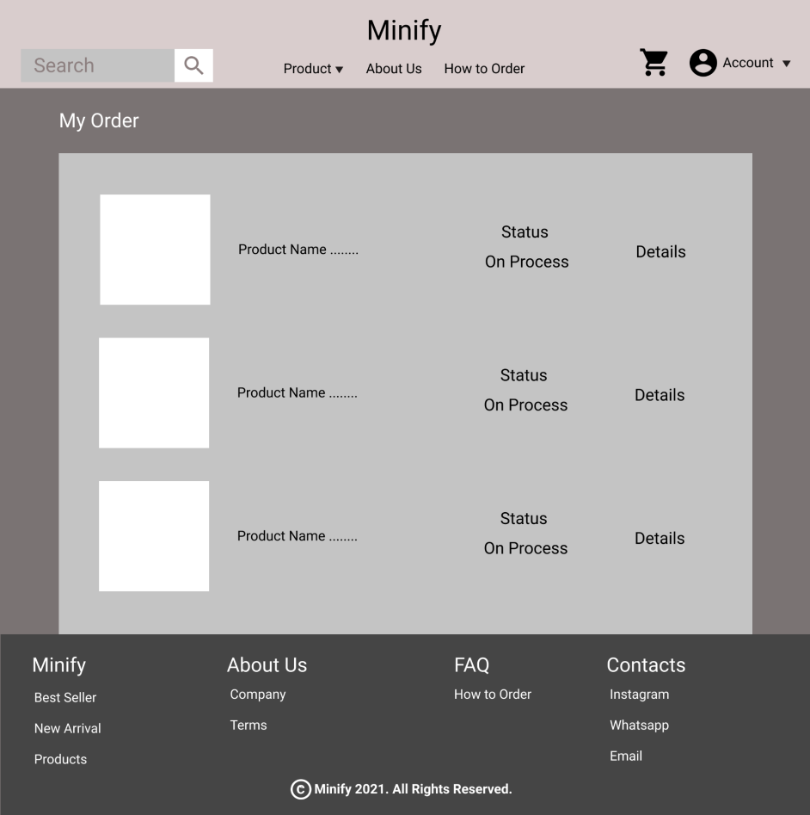

**Gambar 10.1. Mockup My Order**

#### 10.B. Tampilan

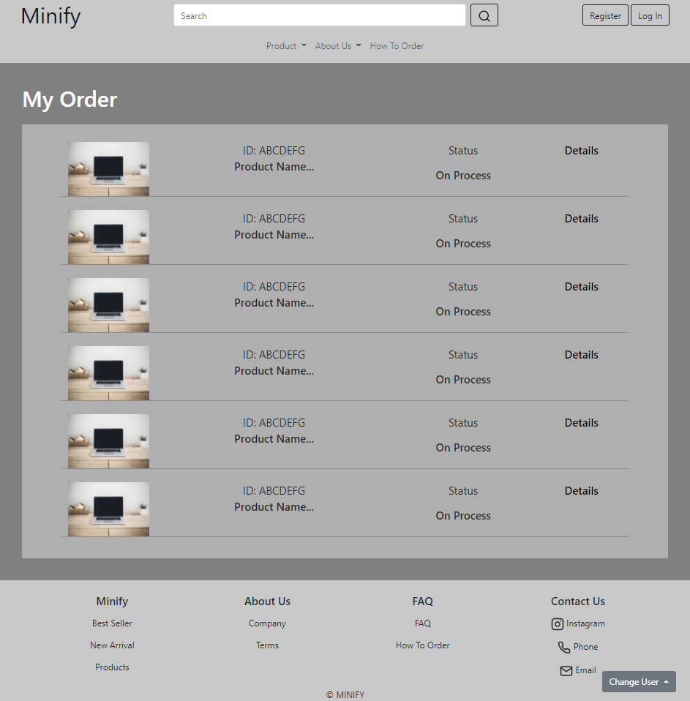

**Gambar 10.2. Tampilan My Order**

#### 10.C. Flowchart

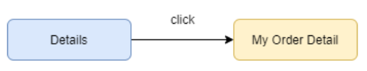

**Gambar 10.2. Flowchart My Order**

#### 10.D. Fitur

Pada halaman my order menampilkan detail pesanan singkat yang sudah berhasil dibayar seperti ID pesanan, nama produk, foto produk pertama yang dipesan, status pengiriman, dan fitur tombol Details yang dapat diklik menuju My Order Detail page.

#### 10.E. Source Code

##### Html

**<section>**

**<div style="padding: 40px; background-color: grey">**

**<div class="mb-4">**

**<h1 style="color: white">My Order</h1>**

**</div>**

**<div style="background-color: rgb(175, 175, 175); padding: 2%">**

**<div class="row mx-5 text-sm-start text-md-center">**

**<!-- Detail Produk -->**

**<div class="col-md-2 mt-2">**

**<img**

**src="https://images.unsplash.com/photo-1496181133206-80ce9b88a853?ixid=MnwxMjA3fDB8MHxzZWFyY2h8Mnx8bGFwdG9wfGVufDB8fDB8fA%3D%3D&ixlib=rb-1.2.1&auto=format&fit=crop&w=700&q=60"**

**alt="detailImg"**

**style="**

**width: 100%;**

**max-width: 250px;**

**min-width: 90px;**

**min-height: 80px;**

**"**

**/>**

**</div>**

**<div class="col-md-5 mt-2">**

**<p class="fs-5" style="font-weight: 400; margin-bottom: 0">**

**ID: ABCDEFG**

**</p>**

**<p class="fs-5" style="font-weight: 500">Product Name...</p>**

**</div>**

**<div class="col-md-3 mt-2">**

**<p class="fs-5" style="font-weight: 400">Status</p>**

**<div><p class="fs-5" style="font-weight: 500">On Process</p></div>**

**</div>**

**<div class="col-md-2 mt-2">**

**<a**

**href="myOrderDetails.html"**

**class="fs-5"**

**style="text-decoration: none; color: black; font-weight: 500"**

**>Details</a**

**>**

**</div>**

**<hr />**

**<div class="col-md-2 mt-2">**

**<img**

**src="https://images.unsplash.com/photo-1496181133206-80ce9b88a853?ixid=MnwxMjA3fDB8MHxzZWFyY2h8Mnx8bGFwdG9wfGVufDB8fDB8fA%3D%3D&ixlib=rb-1.2.1&auto=format&fit=crop&w=700&q=60"**

**alt="detailImg"**

**style="**

**width: 100%;**

**max-width: 250px;**

**min-width: 90px;**

**min-height: 80px;**

**"**

**/>**

**</div>**

**<div class="col-md-5 mt-2">**

**<p class="fs-5" style="font-weight: 400; margin-bottom: 0">**

**ID: ABCDEFG**

**</p>**

**<p class="fs-5" style="font-weight: 500">Product Name...</p>**

**</div>**

**<div class="col-md-3 mt-2">**

**<p class="fs-5" style="font-weight: 400">Status</p>**

**<div><p class="fs-5" style="font-weight: 500">On Process</p></div>**

**</div>**

**<div class="col-md-2 mt-2">**

**<a**

**href="myOrderDetails.html"**

**class="fs-5"**

**style="text-decoration: none; color: black; font-weight: 500"**

**>Details</a**

**>**

**</div>**

**<hr />**

**<div class="col-md-2 mt-2">**

**<img**

**src="https://images.unsplash.com/photo-1496181133206-80ce9b88a853?ixid=MnwxMjA3fDB8MHxzZWFyY2h8Mnx8bGFwdG9wfGVufDB8fDB8fA%3D%3D&ixlib=rb-1.2.1&auto=format&fit=crop&w=700&q=60"**

**alt="detailImg"**

**style="**

**width: 100%;**

**max-width: 250px;**

**min-width: 90px;**

**min-height: 80px;**

**"**

**/>**

**</div>**

**<div class="col-md-5 mt-2">**

**<p class="fs-5" style="font-weight: 400; margin-bottom: 0">**

**ID: ABCDEFG**

**</p>**

**<p class="fs-5" style="font-weight: 500">Product Name...</p>**

**</div>**

**<div class="col-md-3 mt-2">**

**<p class="fs-5" style="font-weight: 400">Status</p>**

**<div><p class="fs-5" style="font-weight: 500">On Process</p></div>**

**</div>**

**<div class="col-md-2 mt-2">**

**<a**

**href="myOrderDetails.html"**

**class="fs-5"**

**style="text-decoration: none; color: black; font-weight: 500"**

**>Details</a**

**>**

**</div>**

**<hr />**

**<div class="col-md-2 mt-2">**

**<img**

**src="https://images.unsplash.com/photo-1496181133206-80ce9b88a853?ixid=MnwxMjA3fDB8MHxzZWFyY2h8Mnx8bGFwdG9wfGVufDB8fDB8fA%3D%3D&ixlib=rb-1.2.1&auto=format&fit=crop&w=700&q=60"**

**alt="detailImg"**

**style="**

**width: 100%;**

**max-width: 250px;**

**min-width: 90px;**

**min-height: 80px;**

**"**

**/>**

**</div>**

**<div class="col-md-5 mt-2">**

**<p class="fs-5" style="font-weight: 400; margin-bottom: 0">**

**ID: ABCDEFG**

**</p>**

**<p class="fs-5" style="font-weight: 500">Product Name...</p>**

**</div>**

**<div class="col-md-3 mt-2">**

**<p class="fs-5" style="font-weight: 400">Status</p>**

**<div><p class="fs-5" style="font-weight: 500">On Process</p></div>**

**</div>**

**<div class="col-md-2 mt-2">**

**<a**

**href="myOrderDetails.html"**

**class="fs-5"**

**style="text-decoration: none; color: black; font-weight: 500"**

**>Details</a**

**>**

**</div>**

**<hr />**

**<div class="col-md-2 mt-2">**

**<img**

**src="https://images.unsplash.com/photo-1496181133206-80ce9b88a853?ixid=MnwxMjA3fDB8MHxzZWFyY2h8Mnx8bGFwdG9wfGVufDB8fDB8fA%3D%3D&ixlib=rb-1.2.1&auto=format&fit=crop&w=700&q=60"**

**alt="detailImg"**

**style="**

**width: 100%;**

**max-width: 250px;**

**min-width: 90px;**

**min-height: 80px;**

**"**

**/>**

**</div>**

**<div class="col-md-5 mt-2">**

**<p class="fs-5" style="font-weight: 400; margin-bottom: 0">**

**ID: ABCDEFG**

**</p>**

**<p class="fs-5" style="font-weight: 500">Product Name...</p>**

**</div>**

**<div class="col-md-3 mt-2">**

**<p class="fs-5" style="font-weight: 400">Status</p>**

**<div><p class="fs-5" style="font-weight: 500">On Process</p></div>**

**</div>**

**<div class="col-md-2 mt-2">**

**<a**

**href="myOrderDetails.html"**

**class="fs-5"**

**style="text-decoration: none; color: black; font-weight: 500"**

**>Details</a**

**>**

**</div>**

**<hr />**

**<div class="col-md-2 mt-2">**

**<img**

**src="https://images.unsplash.com/photo-1496181133206-80ce9b88a853?ixid=MnwxMjA3fDB8MHxzZWFyY2h8Mnx8bGFwdG9wfGVufDB8fDB8fA%3D%3D&ixlib=rb-1.2.1&auto=format&fit=crop&w=700&q=60"**

**alt="detailImg"**

**style="**

**width: 100%;**

**max-width: 250px;**

**min-width: 90px;**

**min-height: 80px;**

**"**

**/>**

**</div>**

**<div class="col-md-5 mt-2">**

**<p class="fs-5" style="font-weight: 400; margin-bottom: 0">**

**ID: ABCDEFG**

**</p>**

**<p class="fs-5" style="font-weight: 500">Product Name...</p>**

**</div>**

**<div class="col-md-3 mt-2">**

**<p class="fs-5" style="font-weight: 400">Status</p>**

**<div><p class="fs-5" style="font-weight: 500">On Process</p></div>**

**</div>**

**<div class="col-md-2 mt-2">**

**<a**

**href="myOrderDetails.html"**

**class="fs-5"**

**style="text-decoration: none; color: black; font-weight: 500"**

**>Details</a**

**>**

**</div>**

**<hr />**

**</div>**

**</div>**

**</div>**

**</section>**

### My Order Detail

#### 11.A. Tampilan

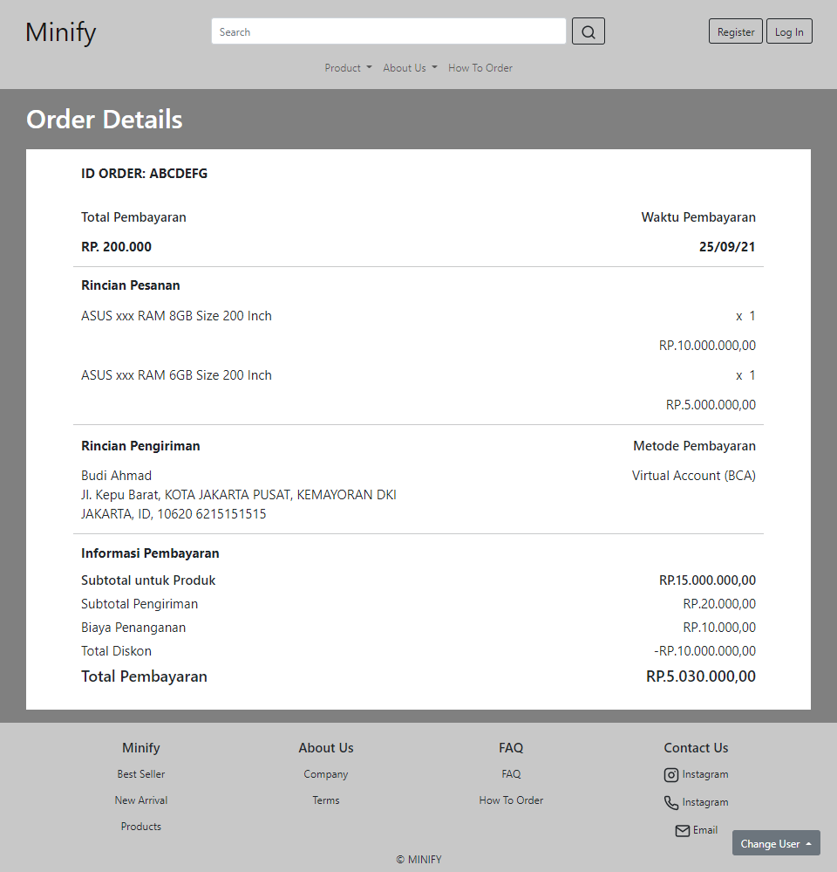

**Gambar 11.1. My Order Detail**

#### 11.B. Flowchart

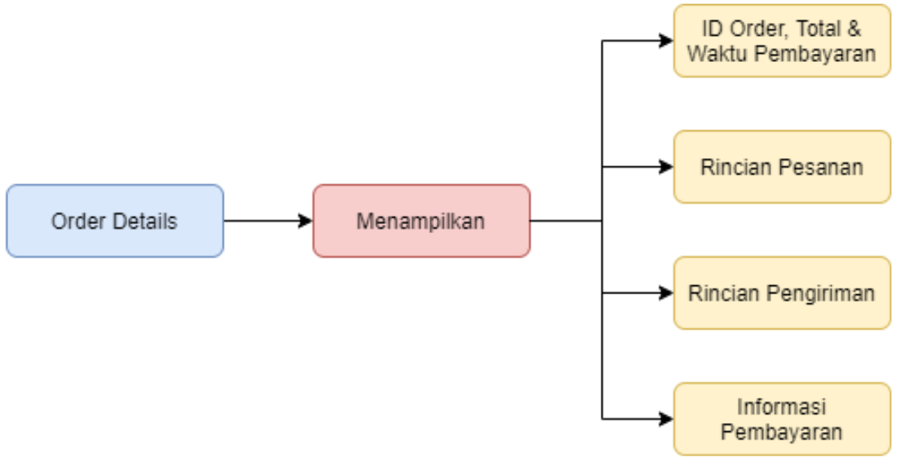

**Gambar 11.2. Flowchart My Order Detail**

#### 11.C. Fitur

Pada halaman my order detail menampilkan rincian pesanan yang terbagi atas 4 bagian, yaitu:

1. Bagian awal : Menampilkan ID Order, Total & Waktu Pembayaran. B
2. Rincian Pesanan : Menampilkan nama, jumlah dan harga produk yang dipesan.
3. Rincian Pengiriman : Menampilkan alamat pengiriman dan metode pembayaran yang dipilih.
4. Informasi Pembayaran : Menampilkan subtotal produk, subtotal pengiriman, biaya penanganan, total diskon dan total pembayaran.

#### 11.D. Source Code

#### Html

**<section>**

**<div style="padding: 20px 40px; background-color: grey">**

**<div class="mb-4">**

**<h1 style="color: white">Order Details</h1>**

**</div>**

**<div style="background-color: white; padding: 2%">**

**<div class="row mx-5 text-sm-start text-md-center">**

**<h5**

**class="text-start fs-5"**

**style="font-weight: bold; margin-bottom: 40px"**

**>**

**ID ORDER: ABCDEFG**

**</h5>**

**<div class="col-6 text-start fs-5">**

**<p style="font-weight: 500">Total Pembayaran</p>**

**<p class="fs-5" style="font-weight: bold">RP. 200.000</p>**

**</div>**

**<div class="col-6 text-end fs-5">**

**<p style="font-weight: 500">Waktu Pembayaran</p>**

**<p class="fs-5" style="font-weight: bold">25/09/21</p>**

**</div>**

**<hr />**

**<!--Rincian Pesanan-->**

**<h5**

**class="text-start fs-5"**

**style="font-weight: bold; margin-bottom: 20px"**

**>**

**Rincian Pesanan**

**</h5>**

**<div class="col-6 text-start fs-5">**

**<p class="fs-5">ASUS xxx RAM 8GB Size 200 Inch</p>**

**</div>**

**<div class="col-6 text-end fs-5">**

**<p class="fs-5" style="word-spacing: 5px">x 1</p>**

**<p class="fs-5">RP.10.000.000,00</p>**

**</div>**

**<div class="col-6 text-start fs-5">**

**<p class="fs-5">ASUS xxx RAM 6GB Size 200 Inch</p>**

**</div>**

**<div class="col-6 text-end fs-5">**

**<p class="fs-5" style="word-spacing: 5px">x 1</p>**

**<p class="fs-5">RP.5.000.000,00</p>**

**</div>**

**<hr />**

**<!--Rincian Pengiriman-->**

**<div class="col-6 text-start fs-5">**

**<p style="font-weight: bold">Rincian Pengiriman</p>**

**<p class="fs-5">**

**Budi Ahmad <br />**

**Jl. Kepu Barat, KOTA JAKARTA PUSAT, KEMAYORAN DKI JAKARTA, ID,**

**10620 6215151515**

**</p>**

**</div>**

**<div class="col-6 text-end fs-5">**

**<p style="font-weight: 500">Metode Pembayaran</p>**

**<p class="fs-5">Virtual Account (BCA)</p>**

**</div>**

**<hr />**

**<!--Informasi Pembayaran-->**

**<h5**

**class="text-start fs-5"**

**style="font-weight: bold; margin-bottom: 20px"**

**>**

**Informasi Pembayaran**

**</h5>**

**<div class="col-6 text-start fs-5" style="line-height: 1">**

**<p class="fs-5" style="font-weight: 500">Subtotal untuk Produk</p>**

**</div>**

**<div class="col-6 text-end fs-5" style="line-height: 1">**

**<p class="fs-5" style="font-weight: 500">RP.15.000.000,00</p>**

**</div>**

**<div class="col-6 text-start fs-5" style="line-height: 1">**

**<p class="fs-5">Subtotal Pengiriman</p>**

**</div>**

**<div class="col-6 text-end fs-5" style="line-height: 1">**

**<p class="fs-5">RP.20.000,00</p>**

**</div>**

**<div class="col-6 text-start fs-5" style="line-height: 1">**

**<p class="fs-5">Biaya Penanganan</p>**

**</div>**

**<div class="col-6 text-end fs-5" style="line-height: 1">**

**<p class="fs-5">RP.10.000,00</p>**

**</div>**

**<div class="col-6 text-start fs-5" style="line-height: 1">**

**<p class="fs-5">Total Diskon</p>**

**</div>**

**<div class="col-6 text-end fs-5" style="line-height: 1">**

**<p class="fs-5">-RP.10.000.000,00</p>**

**</div>**

**<div class="col-6 text-start fs-5" style="line-height: 1">**

**<p class="fs-4" style="font-weight: 500">Total Pembayaran</p>**

**</div>**

**<div class="col-6 text-end fs-5" style="line-height: 1">**

**<p class="fs-4" style="font-weight: 500">RP.5.030.000,00</p>**

**</div>**

**</div>**

**</div>**

**</div>**

**</section>**

### Messages

#### 12.A. Mockup

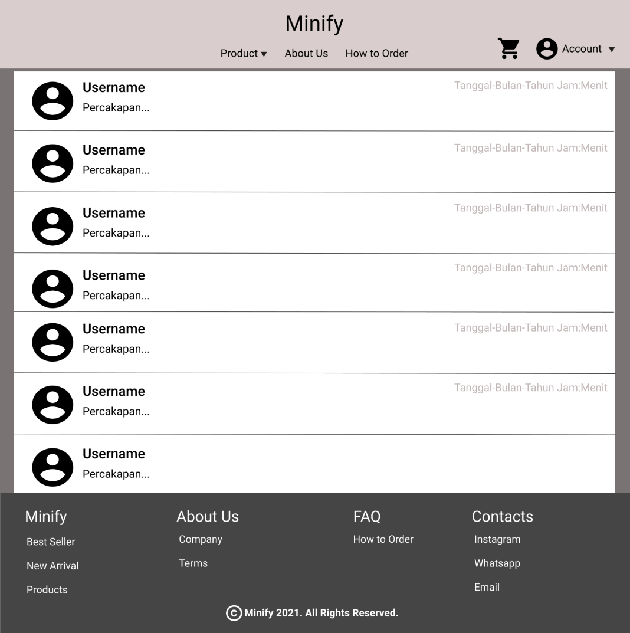

**Gambar 12.1. Mockup Messages**

#### 12.B. Tampilan

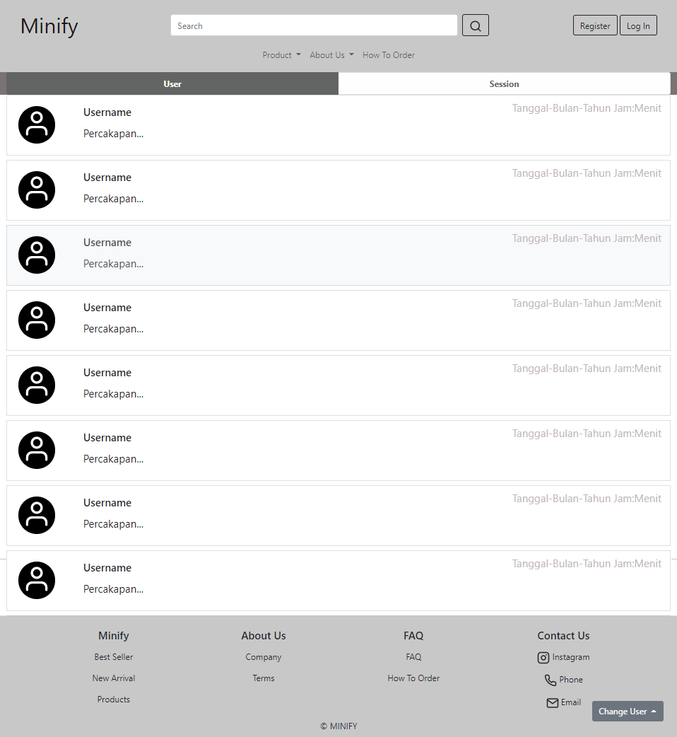

**Gambar 12.2. Tampilan Messages - User**

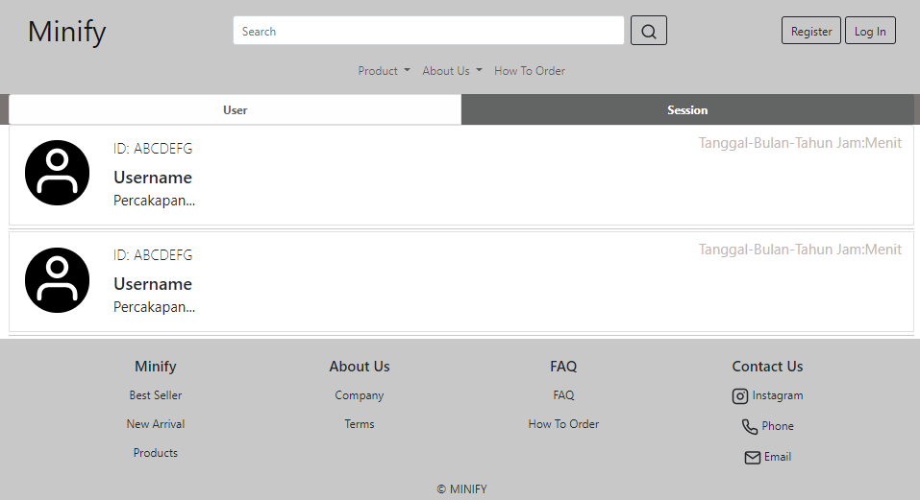

**Gambar 12.3. Tampilan Messages - Session**

#### 12.C. Flowchart

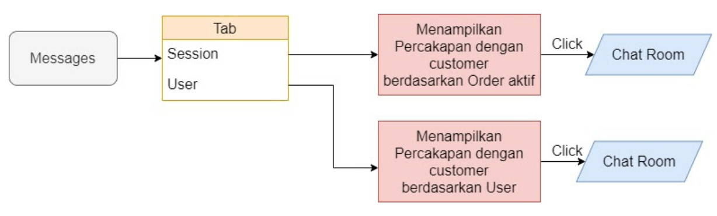

**Gambar 12.3. Flowchart Messages**

#### 12.D. Fitur

Pada halaman Messages menampilkan kontak penjual yang dapat digunakan pembeli untuk melakukan percakapan. Fitur yang terdapat dalam Messages adalah fitur tab yang memungkinkan pembeli untuk memilih bagaimana pembeli mengirim pesan ke penjual, yaitu :

1. User : Fitur tab yang disediakan Messages untuk melakukan percakapan berdasarkan kontak penjual tertentu.
2. Session : Fitur tab yang disediakan Messages untuk melakukan percakapan berdasarkan sesi pemesanan. Terdapat tambahan ID pesanan di bagian atas username untuk mengidentifikasi sesi pesanan.

#### 12.E. Source Code

##### Html

**<section>**

**<div style="background-color: #7a7373">**

**<div class="container-fluid" style="text-align: center">**

**<div**

**class="list-group list-group-horizontal"**

**id="list-tab"**

**role="tablist"**

**>**

**<a**

**class="**

**list-group-item list-group-item-light list-group-item-action**

**active**

**"**

**id="list-user-list"**

**data-bs-toggle="list"**

**href="#list-user"**

**role="tab"**

**aria-controls="list-user"**

**>**

**<p style="font-weight: 700; margin: 0">User</p>**

**</a>**

**<a**

**class="**

**list-group-item list-group-item-light list-group-item-action**

**"**

**id="list-session-list"**

**data-bs-toggle="list"**

**href="#list-session"**

**role="tab"**

**aria-controls="list-session"**

**>**

**<p style="font-weight: 700; margin: 0">Session</p>**

**</a>**

**</div>**

**</div>**

**<div**

**class="container-fluid"**

**id="NavContent"**

**style="background-color: white"**

**>**

**<div class="tab-content" id="nav-tabContent">**

**<div**

**class="tab-pane fade show active"**

**id="list-user"**

**role="tabpanel"**

**aria-labelledby="list-user-list"**

**>**

**<div class="list-group" style="max-height: 875px; overflow: auto">**

**<a**

**href="chatRoom.html"**

**class="list-group-item list-group-item-action"**

**>**

**<div class="row">**

**<div class="col-sm-1 my-2">**

**<span**

**class="rounded-circle"**

**style="**

**display: inline-block;**

**width: 70px;**

**height: 70px;**

**margin: 5px;**

**background-color: black;**

**z-index: -1;**

**"**

**><i**

**data-feather="user"**

**style="**

**color: white;**

**width: 70px;**

**height: 55px;**

**margin-top: 5px;**

**"**

**></i**

**></span>**

**</div>**

**<div class="col-sm-7">**

**<p class="mt-2 fs-5 mx-4" style="font-weight: 600">**

**Username**

**</p>**

**<p class="lh-1 mx-4" style="font-size: 20px">**

**Percakapan...**

**</p>**

**</div>**

**<div class="col-sm-4">**

**<p class="fs-5 text-end" style="color: #c2b7b7">**

**Tanggal-Bulan-Tahun Jam:Menit**

**</p>**

**</div>**

**</div>**

**</a>**

**<hr class="my-1" />**

**<a**

**href="chatRoom.html"**

**class="list-group-item list-group-item-action"**

**>**

**<div class="row">**

**<div class="col-sm-1 my-2">**

**<span**

**class="rounded-circle"**

**style="**

**display: inline-block;**

**width: 70px;**

**height: 70px;**

**margin: 5px;**

**background-color: black;**

**z-index: -1;**

**"**

**><i**

**data-feather="user"**

**style="**

**color: white;**

**width: 70px;**

**height: 55px;**

**margin-top: 5px;**

**"**

**></i**

**></span>**

**</div>**

**<div class="col-sm-7">**

**<p class="mt-2 fs-5 mx-4" style="font-weight: 600">**

**Username**

**</p>**

**<p class="lh-1 mx-4" style="font-size: 20px">**

**Percakapan...**

**</p>**

**</div>**

**<div class="col-sm-4">**

**<p class="fs-5 text-end" style="color: #c2b7b7">**

**Tanggal-Bulan-Tahun Jam:Menit**

**</p>**

**</div>**

**</div>**

**</a>**

**<hr class="my-1" />**

**<a**

**href="chatRoom.html"**

**class="list-group-item list-group-item-action"**

**>**

**<div class="row">**

**<div class="col-sm-1 my-2">**

**<span**

**class="rounded-circle"**

**style="**

**display: inline-block;**

**width: 70px;**

**height: 70px;**

**margin: 5px;**

**background-color: black;**

**z-index: -1;**

**"**

**><i**

**data-feather="user"**

**style="**

**color: white;**

**width: 70px;**

**height: 55px;**

**margin-top: 5px;**

**"**

**></i**

**></span>**

**</div>**

**<div class="col-sm-7">**

**<p class="mt-2 fs-5 mx-4" style="font-weight: 600">**

**Username**

**</p>**

**<p class="lh-1 mx-4" style="font-size: 20px">**

**Percakapan...**

**</p>**

**</div>**

**<div class="col-sm-4">**

**<p class="fs-5 text-end" style="color: #c2b7b7">**

**Tanggal-Bulan-Tahun Jam:Menit**

**</p>**

**</div>**

**</div>**

**</a>**

**<hr class="my-1" />**

**<a**

**href="chatRoom.html"**

**class="list-group-item list-group-item-action"**

**>**

**<div class="row">**

**<div class="col-sm-1 my-2">**

**<span**

**class="rounded-circle"**

**style="**

**display: inline-block;**

**width: 70px;**

**height: 70px;**

**margin: 5px;**

**background-color: black;**

**z-index: -1;**

**"**

**><i**

**data-feather="user"**

**style="**

**color: white;**

**width: 70px;**

**height: 55px;**

**margin-top: 5px;**

**"**

**></i**

**></span>**

**</div>**

**<div class="col-sm-7">**

**<p class="mt-2 fs-5 mx-4" style="font-weight: 600">**

**Username**

**</p>**

**<p class="lh-1 mx-4" style="font-size: 20px">**

**Percakapan...**

**</p>**

**</div>**

**<div class="col-sm-4">**

**<p class="fs-5 text-end" style="color: #c2b7b7">**

**Tanggal-Bulan-Tahun Jam:Menit**

**</p>**

**</div>**

**</div>**

**</a>**

**<hr class="my-1" />**

**<a**

**href="chatRoom.html"**

**class="list-group-item list-group-item-action"**

**>**

**<div class="row">**

**<div class="col-sm-1 my-2">**

**<span**

**class="rounded-circle"**

**style="**

**display: inline-block;**

**width: 70px;**

**height: 70px;**

**margin: 5px;**

**background-color: black;**

**z-index: -1;**

**"**

**><i**

**data-feather="user"**

**style="**

**color: white;**

**width: 70px;**

**height: 55px;**

**margin-top: 5px;**

**"**

**></i**

**></span>**

**</div>**

**<div class="col-sm-7">**

**<p class="mt-2 fs-5 mx-4" style="font-weight: 600">**

**Username**

**</p>**

**<p class="lh-1 mx-4" style="font-size: 20px">**

**Percakapan...**

**</p>**

**</div>**

**<div class="col-sm-4">**

**<p class="fs-5 text-end" style="color: #c2b7b7">**

**Tanggal-Bulan-Tahun Jam:Menit**

**</p>**

**</div>**

**</div>**

**</a>**

**<hr class="my-1" />**

**<a**

**href="chatRoom.html"**

**class="list-group-item list-group-item-action"**

**>**

**<div class="row">**

**<div class="col-sm-1 my-2">**

**<span**

**class="rounded-circle"**

**style="**

**display: inline-block;**

**width: 70px;**

**height: 70px;**

**margin: 5px;**

**background-color: black;**

**z-index: -1;**

**"**

**><i**

**data-feather="user"**

**style="**

**color: white;**

**width: 70px;**

**height: 55px;**

**margin-top: 5px;**

**"**

**></i**

**></span>**

**</div>**

**<div class="col-sm-7">**

**<p class="mt-2 fs-5 mx-4" style="font-weight: 600">**

**Username**

**</p>**

**<p class="lh-1 mx-4" style="font-size: 20px">**

**Percakapan...**

**</p>**

**</div>**

**<div class="col-sm-4">**

**<p class="fs-5 text-end" style="color: #c2b7b7">**

**Tanggal-Bulan-Tahun Jam:Menit**

**</p>**

**</div>**

**</div>**

**</a>**

**<hr class="my-1" />**

**<a**

**href="chatRoom.html"**

**class="list-group-item list-group-item-action"**

**>**

**<div class="row">**

**<div class="col-sm-1 my-2">**

**<span**

**class="rounded-circle"**

**style="**

**display: inline-block;**

**width: 70px;**

**height: 70px;**

**margin: 5px;**

**background-color: black;**

**z-index: -1;**

**"**

**><i**

**data-feather="user"**

**style="**

**color: white;**

**width: 70px;**

**height: 55px;**

**margin-top: 5px;**

**"**

**></i**

**></span>**

**</div>**

**<div class="col-sm-7">**

**<p class="mt-2 fs-5 mx-4" style="font-weight: 600">**

**Username**

**</p>**

**<p class="lh-1 mx-4" style="font-size: 20px">**

**Percakapan...**

**</p>**

**</div>**

**<div class="col-sm-4">**

**<p class="fs-5 text-end" style="color: #c2b7b7">**

**Tanggal-Bulan-Tahun Jam:Menit**

**</p>**

**</div>**

**</div>**

**</a>**

**<hr class="my-1" />**

**<a**

**href="chatRoom.html"**

**class="list-group-item list-group-item-action"**

**>**

**<div class="row">**

**<div class="col-sm-1 my-2">**

**<span**

**class="rounded-circle"**

**style="**

**display: inline-block;**

**width: 70px;**

**height: 70px;**

**margin: 5px;**

**background-color: black;**

**z-index: -1;**

**"**

**><i**

**data-feather="user"**

**style="**

**color: white;**

**width: 70px;**

**height: 55px;**

**margin-top: 5px;**

**"**

**></i**

**></span>**

**</div>**

**<div class="col-sm-7">**

**<p class="mt-2 fs-5 mx-4" style="font-weight: 600">**

**Username**

**</p>**

**<p class="lh-1 mx-4" style="font-size: 20px">**

**Percakapan...**

**</p>**

**</div>**

**<div class="col-sm-4">**

**<p class="fs-5 text-end" style="color: #c2b7b7">**

**Tanggal-Bulan-Tahun Jam:Menit**

**</p>**

**</div>**

**</div>**

**</a>**

**<hr class="my-1" />**

**</div>**

**</div>**

**<div**

**class="tab-pane fade"**

**id="list-session"**

**role="tabpanel"**

**aria-labelledby="list-session-list"**

**>**

**<div class="list-group" style="max-height: 875px; overflow: auto">**

**<a href="#" class="list-group-item list-group-item-action">**

**<div class="row">**

**<div class="col-sm-1 my-2">**

**<span**

**class="rounded-circle"**

**style="**

**display: inline-block;**

**width: 90px;**

**height: 90px;**

**margin: 5px;**

**background-color: black;**

**z-index: -1;**

**"**

**><i**

**data-feather="user"**

**style="**

**color: white;**

**width: 90px;**

**height: 75px;**

**margin-top: 5px;**

**"**

**></i**

**></span>**

**</div>**

**<div class="col-sm-7">**

**<p**

**class="mt-2 fs-5 mx-4"**

**style="font-weight: 200; margin-bottom: 20px"**

**>**

**ID: ABCDEFG**

**</p>**

**<p**

**class="mt-2 fs-4 mx-4"**

**style="font-weight: 600; line-height: 0.5"**

**>**

**Username**

**</p>**

**<p class="lh-1 mx-4" style="font-size: 20px">**

**Percakapan...**

**</p>**

**</div>**

**<div class="col-sm-4">**

**<p class="fs-5 text-end" style="color: #c2b7b7">**

**Tanggal-Bulan-Tahun Jam:Menit**

**</p>**

**</div>**

**</div>**

**</a>**

**<hr class="my-1" />**

**<a href="#" class="list-group-item list-group-item-action">**

**<div class="row">**

**<div class="col-sm-1 my-2">**

**<span**

**class="rounded-circle"**

**style="**

**display: inline-block;**

**width: 90px;**

**height: 90px;**

**margin: 5px;**

**background-color: black;**

**z-index: -1;**

**"**

**><i**

**data-feather="user"**

**style="**

**color: white;**

**width: 90px;**

**height: 75px;**

**margin-top: 5px;**

**"**

**></i**

**></span>**

**</div>**

**<div class="col-sm-7">**

**<p**

**class="mt-2 fs-5 mx-4"**

**style="font-weight: 200; margin-bottom: 20px"**

**>**

**ID: ABCDEFG**

**</p>**

**<p**

**class="mt-2 fs-4 mx-4"**

**style="font-weight: 600; line-height: 0.5"**

**>**

**Username**

**</p>**

**<p class="lh-1 mx-4" style="font-size: 20px">**

**Percakapan...**

**</p>**

**</div>**

**<div class="col-sm-4">**

**<p class="fs-5 text-end" style="color: #c2b7b7">**

**Tanggal-Bulan-Tahun Jam:Menit**

**</p>**

**</div>**

**</div>**

**</a>**

**<hr class="my-1" />**

**</div>**

**</div>**

**</div>**

**</div>**

**</div>**

**</section>**

### Chat Room

#### 13.A. Mockup

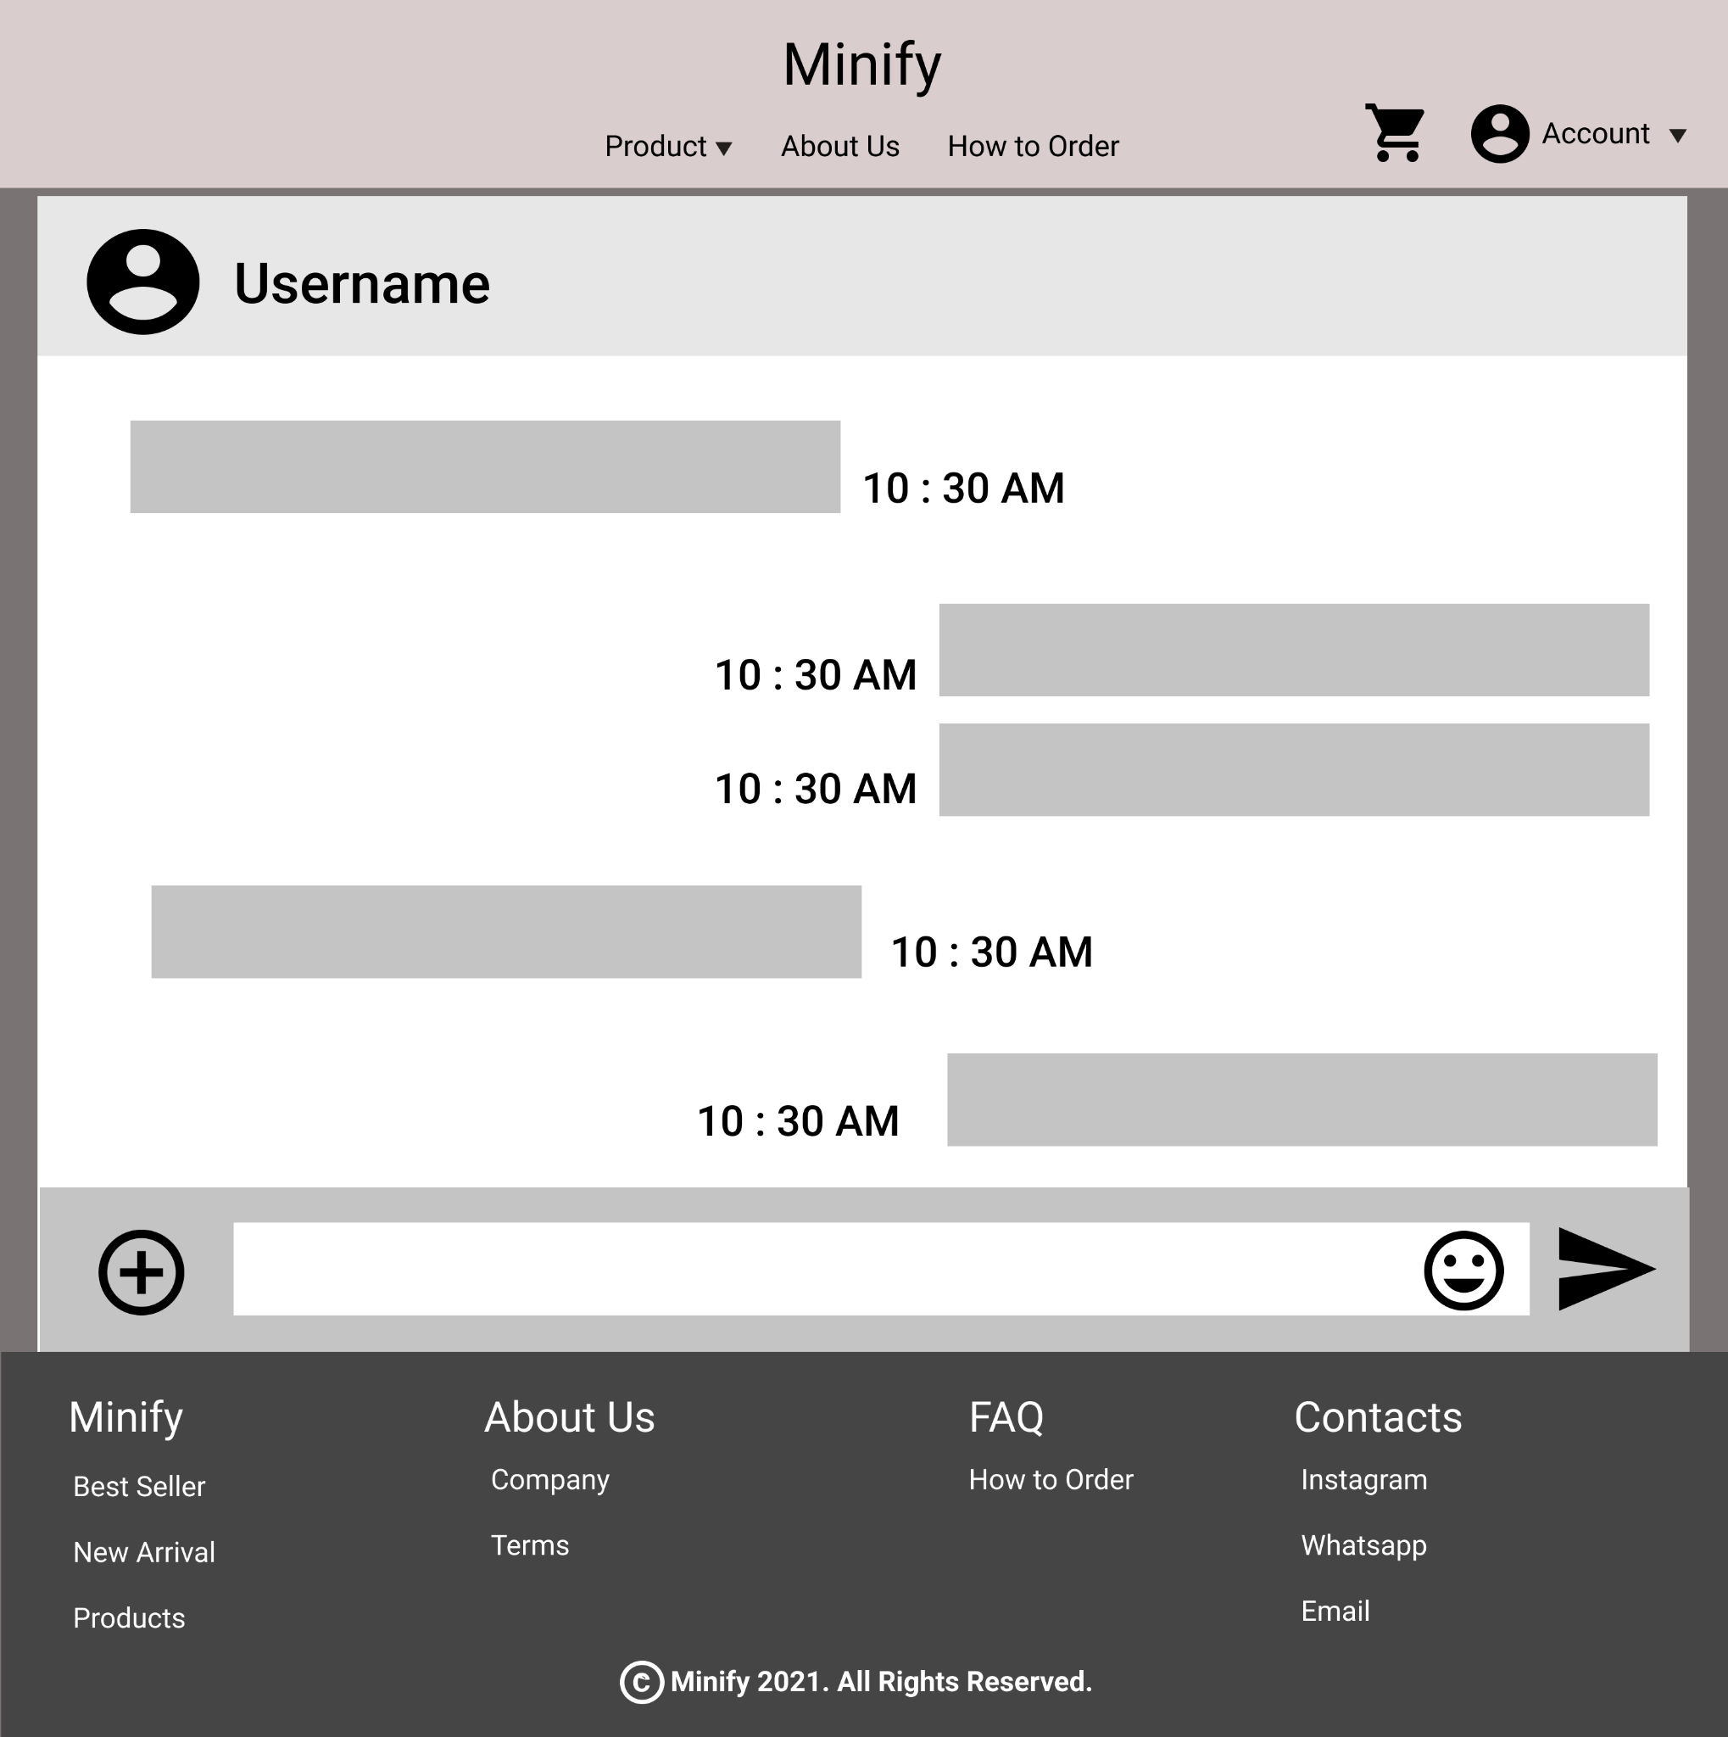

**Gambar 13.1. Mockup Chat Room**

#### 13.B. Tampilan

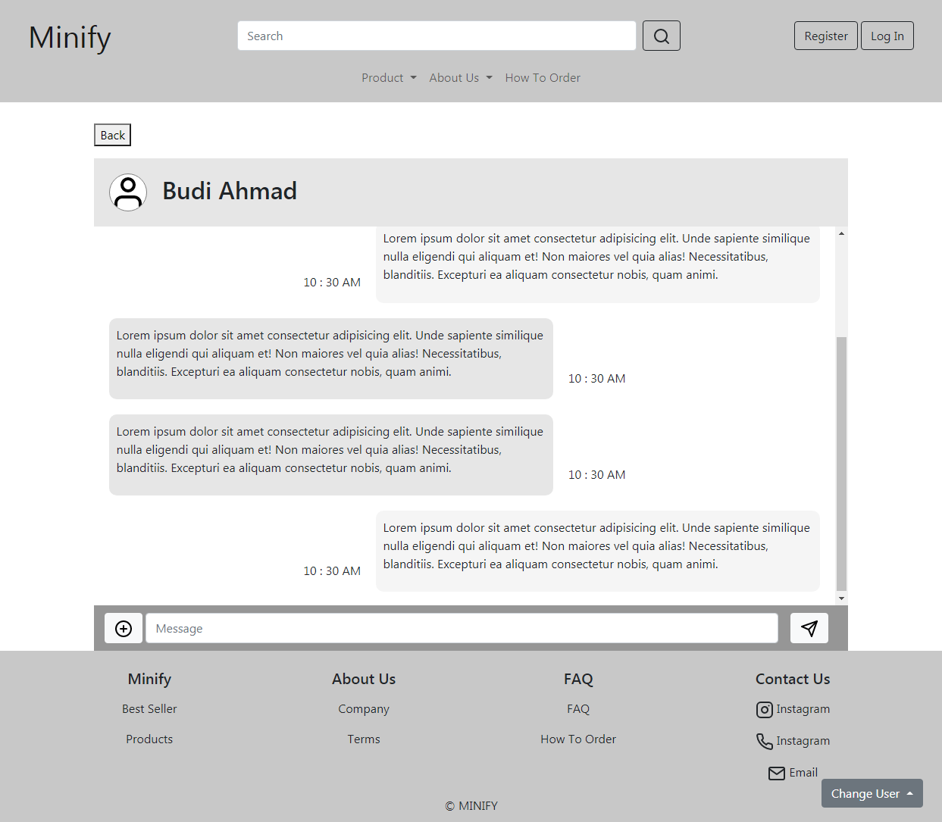

**Gambar 13.2. Tampilan Chat Room**

#### 13.C. Flowchart

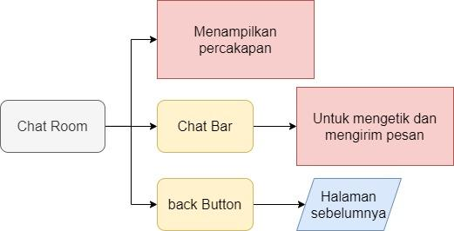

**Gambar 13.3. Flowchart Chat Room**

#### 13.D. Fitur

Pada bagian atas ditampilkan foto profil dan Username. Dibawahnya terdapat panel untuk menampilkan percakapan dalam bentuk chat bubble, di sebelah chat bubble ditampilkan waktu pesan tersebut diterima. Di Bagian bawah terdapat chat bar yang digunakan untuk mengetik pesan dan mengirimkannya. Tombol back jika ditekan akan mengarahkan pengguna kembali ke halaman sebelumnya.

#### 13.E. Source Code

##### Html

**<section>**

**<div style="height: fit-content; width: 80%; margin: 1% auto 0;">**

**<button type="button" onclick="history.back();" class="my-3">Back</button>**

**<div style="height: fit-content; background-color: rgb(230, 230, 230); display: flex; align-items: center;">**

**<img src="image/user.svg" class="chat-avatar" alt="...">**

**<h2>Budi Ahmad</h2>**

**</div>**

**<div id="chatPanel" >**

**<div class="chat-date">**

**<p>-20 sep-</p>**

**</div>**

**<div class="chat-bubble-left">**

**<div >**

**<p>Lorem ipsum dolor sit amet consectetur adipisicing elit. Unde sapiente similique nulla eligendi qui aliquam et! Non maiores vel quia alias! Necessitatibus, blanditiis. Excepturi ea aliquam consectetur nobis, quam animi.</p>**

**</div>**

**<p>10 : 30 AM</p>**

**</div>**

**<div class="chat-bubble-right">**

**<p>10 : 30 AM</p>**

**<div>**

**<p>Lorem ipsum dolor sit amet consectetur adipisicing elit. Unde sapiente similique nulla eligendi qui aliquam et! Non maiores vel quia alias! Necessitatibus, blanditiis. Excepturi ea aliquam consectetur nobis, quam animi.</p>**

**</div>**

**</div>**

**<div class="chat-bubble-left">**

**<div>**

**<p>Lorem ipsum dolor sit amet consectetur adipisicing elit. Unde sapiente similique nulla eligendi qui aliquam et! Non maiores vel quia alias! Necessitatibus, blanditiis. Excepturi ea aliquam consectetur nobis, quam animi.</p>**

**</div>**

**<p>10 : 30 AM</p>**

**</div>**

**<div class="chat-bubble-left">**

**<div>**

**<p>Lorem ipsum dolor sit amet consectetur adipisicing elit. Unde sapiente similique nulla eligendi qui aliquam et! Non maiores vel quia alias! Necessitatibus, blanditiis. Excepturi ea aliquam consectetur nobis, quam animi.</p>**

**</div>**

**<p>10 : 30 AM</p>**

**</div>**

**<div class="chat-bubble-right">**

**<p>10 : 30 AM</p>**

**<div>**

**<p>Lorem ipsum dolor sit amet consectetur adipisicing elit. Unde sapiente similique nulla eligendi qui aliquam et! Non maiores vel quia alias! Necessitatibus, blanditiis. Excepturi ea aliquam consectetur nobis, quam animi.</p>**

**</div>**

**</div>**

**</div>**

**<form id="chatBar">**

**<button class="btn btn-light mx-1" type="submit"><i data-feather="plus-circle"></i></button>**

**<input class="form-control" type="Message" placeholder="Message" aria-label="Message">**

**<button class="btn btn-light mx-3" type="submit"><i data-feather="send"></i></button>**

**</form>**

**<button id="backToBottom" class="btn btn-dark"><i data-feather="arrow-down"></i></button>**

**</div>**

**</section>**

##### CSS

**<style>**

**html{**

**scroll-behavior: smooth;**

**}**

**.chat-avatar{**

**width: 5%;**

**margin: 2%;**

**border-radius: 100%;**

**border: 1px solid gray;**

**background-color: white;**

**}**

**#chatPanel{**

**padding-top: 2%;**

**height: 500px;**

**background-color: white;**

**overflow: auto;**

**}**

**.chat-bubble-left{**

**display: flex;**

**align-items:flex-end ;**

**justify-content:flex-start;**

**margin: 0 0 2%;**

**}**

**.chat-bubble-left div{**

**border-radius: 10px;**

**background-color: rgb(230, 230, 230);**

**max-width: 60%;**

**padding: 1%;**

**margin: 0 2%;**

**}**

**.chat-bubble-right{**

**display: flex;**

**align-items:flex-end ;**

**justify-content: flex-end;**

**margin: 0 0 2%;**

**}**

**.chat-bubble-right div{**

**border-radius: 10px;**

**background-color: whitesmoke;**

**max-width: 60%;**

**padding: 1%;**

**margin: 0 2%;**

**}**

**#chatBar{**

**display: flex;**

**padding: 1%;**

**background-color: rgb(150, 150, 150);**

**}**

**#backToBottom{**

**position: absolute;**

**right: 15%;**

**bottom: -15%;**

**}**

**.chat-date{**

**text-align: center;**

**}**

**/* media query */**

**@media screen and (max-width: 770px) {**

**.chat-avatar{**

**width: 12%;**

**margin: 3%;**

**}**

**.chat-bubble-right div{**

**padding: 3%;**

**}**

**.chat-bubble-left div{**

**padding: 3%;**

**}**

**}**

**</style>**

##### Javascript

**<script>**

**var chatPanel = document.getElementById('chatPanel');**

**var backToBottom = document.getElementById('backToBottom');**

**function scrollToBottom (){**

**chatPanel.scrollTop = chatPanel.scrollHeight;**

**backToBottom.style.display = "none"**

**};**

**scrollToBottom();**

**backToBottom.onclick = scrollToBottom;**

**chatPanel.addEventListener('scroll', function(){**

**const minScroll = chatPanel.scrollHeight-chatPanel.clientHeight-50;**

**if(chatPanel.scrollTop < minScroll){**

**backToBottom.style.display = "initial"**

**}else[**

**backToBottom.style.display = "none"**

**]**

**});**

**</script>**

### Cart

#### 14.A. Mockup

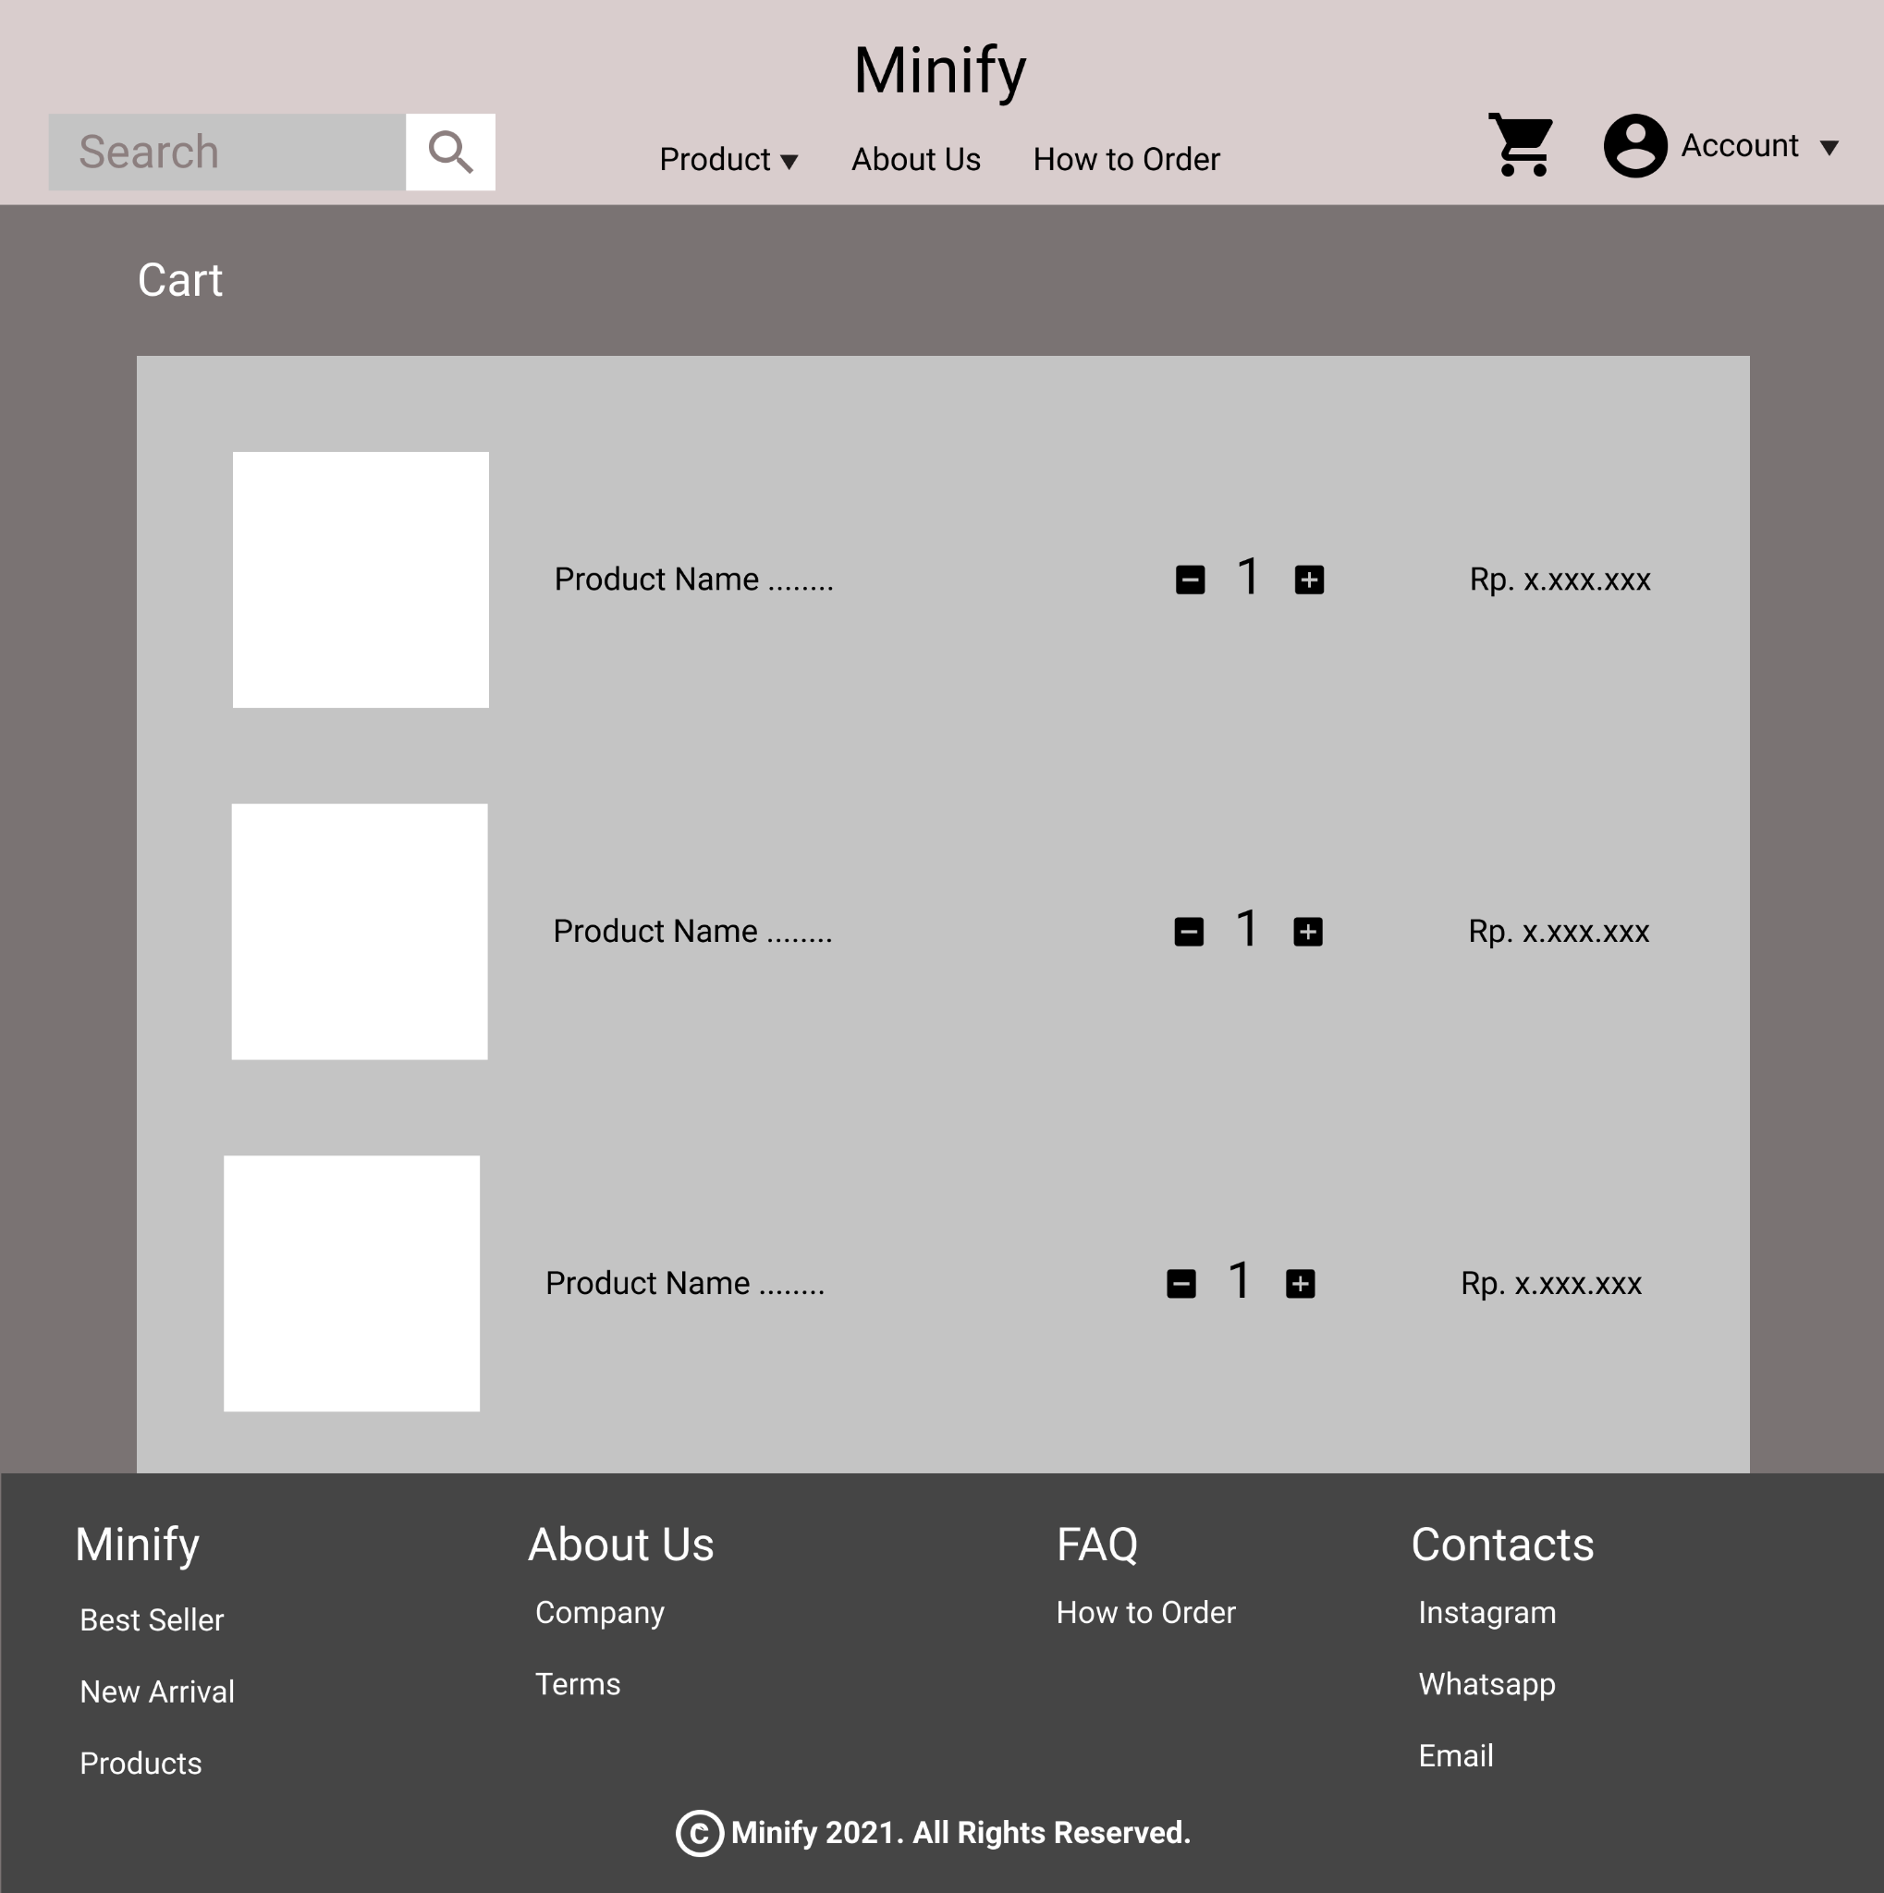

**14.1. Mock Up Cart Page**

#### 14.B. Tampilan

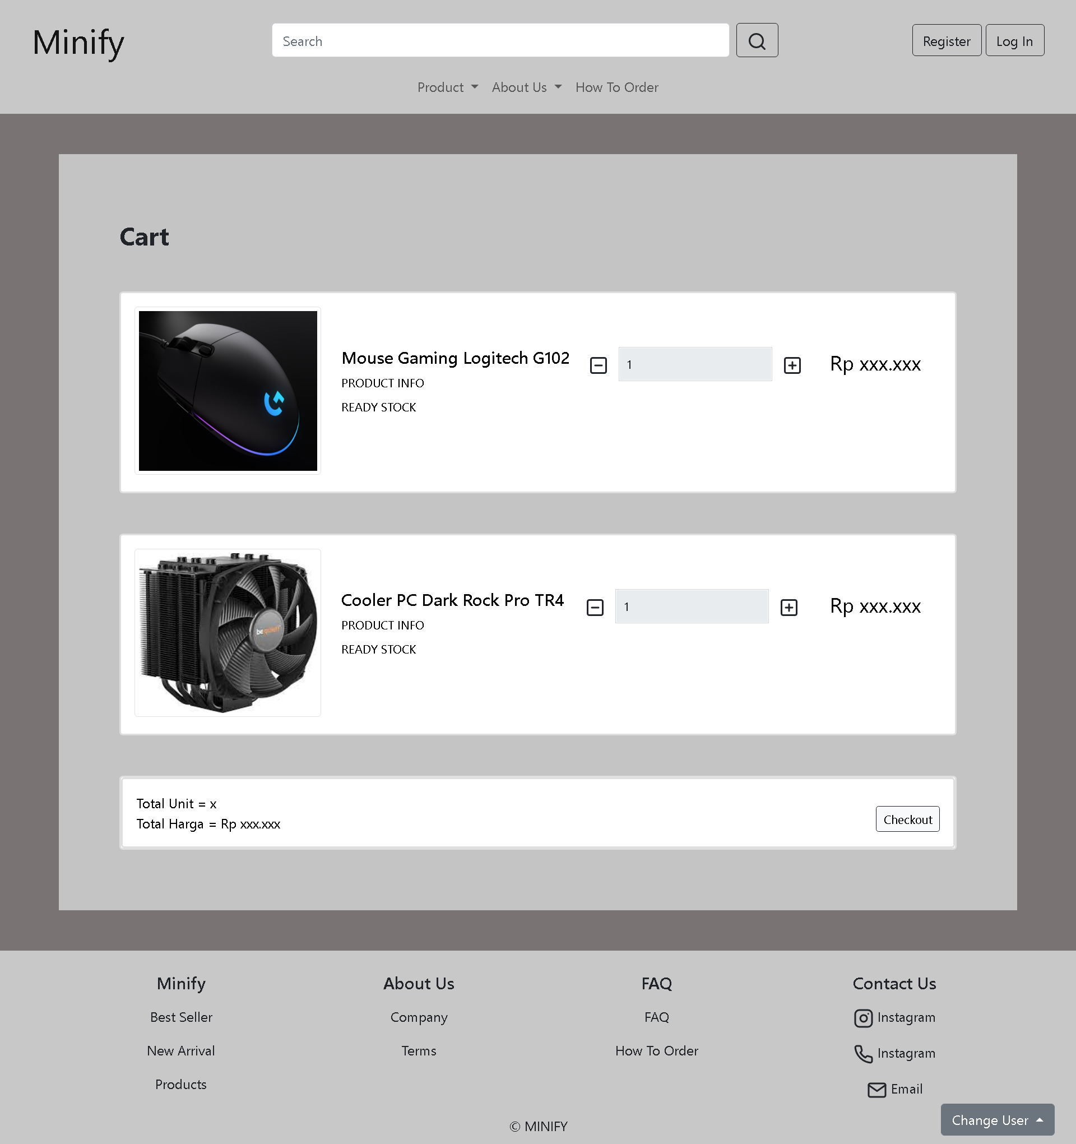

**14.2. Tampilan Cart Page**

#### 14.C. Flowchart

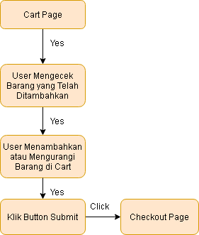

**14.3. Flowchart Cart Page**

#### 14.D. Fitur

Halaman Cart adalah halaman dimana barang-barang yang akan dibeli oleh user disimpan sementara

1. Judul : Cart
2. Image : Gambar dari produk yang dimasukkan ke cart
3. Nama Produk : Nama dari produk yang dimasukkan ke cart
4. Deskripsi : Penjelasan singkat mengenai produk seperti spesifikasi dan pengemasan
5. Button + dan - : Berguna untuk menambah atau mengurangi barang yang akan di checkout
6. Harga : Harga dari barang secara spesifik
7. Total Unit : Jumlah seluruh produk yang dimasukkan ke cart dalam unit
8. Total Harga : Jumlah harga seluruh produk yang dimasukkan ke cart dalam rupiah
9. Button Checkout : Jika diklik, akan dilanjutkan ke page checkout

#### 14.E. Source Code

##### Html

**<section>**

**<div style="background-color: #7a7373">**

**<br /><br />**

**<div class="container-sm py-4" style="background-color: #c4c4c4">**

**<div class="row mx-5">**

**<div**

**class="text-left"**

**style="margin-top: 50px; font-size: 30px; font-weight: bold"**

**>**

**<label for="headerText">Cart</label>**

**<br /><br />**

**</div>**

**</div>**

**<div class="row mx-5">**

**<div class="col-lg-12">**

**<div class="card mb-5">**

**<div class="card-body">**

**<div class="row mb-1">**

**<div class="col-md-5 col-lg-3 col-xl-3">**

**<div**

**class="view zoom overlay z-depth-1 rounded mb-3 mb-md-0"**

**>**

**<img**

**src="imgstephen/img1.jpg"**

**alt=""**

**class="img-thumbnail"**

**/>**

**</div>**

**</div>**

**<div class="col-md-7 col-lg-9 col-xl-9">**

**<div>**

**<div class="d-flex justify-content-between">**

**<div class="mt-5">**

**<h5>Mouse Gaming Logitech G102</h5>**

**<p class="mb-2 text-uppercase small">**

**Product Info**

**</p>**

**<p class="mb-3 text-uppercase small">Ready Stock</p>**

**</div>**

**<!--Button Kanan-->**

**<div class="row mt-5 me-0 m">**

**<div class="mb-0 w-100">**

**<div class="input-group">**

**<span class="input-group-btn">**

**<button**

**type="button"**

**class="btn btn-default btn-number"**

**onclick="minus('inputNum1')"**

**>**

**<i data-feather="minus-square"></i></button**

**></span>**

**<input**

**type="text"**

**disabled="disabled"**

**value="1"**

**class="**

**form-control**

**input-number**

**form-select-sm**

**"**

**id="inputNum1"**

**/>**

**<span class="input-group-btn">**

**<button**

**type="button"**

**class="btn btn-default btn-number"**

**onclick='add("inputNum1")'**

**>**

**<i data-feather="plus-square"></i></button**

**></span>**

**</div>**

**</div>**

**</div>**

**<div class="mt-5 me-4" style="font-size: x-large">**

**<p>Rp xxx.xxx</p>**

**</div>**

**</div>**

**</div>**

**</div>**

**</div>**

**</div>**

**</div>**

**</div>**

**</div>**

**<div class="row mx-5">**

**<div class="col-lg-12">**

**<div class="card mb-5">**

**<div class="card-body">**

**<div class="row mb-1">**

**<div class="col-md-5 col-lg-3 col-xl-3">**

**<div**

**class="view zoom overlay z-depth-1 rounded mb-3 mb-md-0"**

**>**

**<img**

**src="imgstephen/img2.jpg"**

**alt=""**

**class="img-thumbnail"**

**/>**

**</div>**

**</div>**

**<div class="col-md-7 col-lg-9 col-xl-9">**

**<div>**

**<div class="d-flex justify-content-between">**

**<div class="mt-5">**

**<h5>Cooler PC Dark Rock Pro TR4</h5>**

**<p class="mb-2 text-uppercase small">**

**Product Info**

**</p>**

**<p class="mb-3 text-uppercase small">Ready Stock</p>**

**</div>**

**<!--Button Kanan-->**

**<div class="row mt-5 me-lg-0">**

**<div class="mb-0 w-100">**

**<div class="input-group">**

**<span class="input-group-btn">**

**<button**

**type="button"**

**class="btn btn-default btn-number"**

**onclick="minus('inputNum2')"**

**>**

**<i data-feather="minus-square"></i></button**

**></span>**

**<input**

**type="text"**

**disabled="disabled"**

**value="1"**

**class="**

**form-control**

**input-number**

**form-select-sm**

**"**

**id="inputNum2"**

**/>**

**<span class="input-group-btn">**

**<button**

**type="button"**

**class="btn btn-default btn-number"**

**onclick='add("inputNum2")'**

**>**

**<i data-feather="plus-square"></i></button**

**></span>**

**</div>**

**</div>**

**</div>**

**<div class="mt-5 me-4" style="font-size: x-large">**

**<p>Rp xxx.xxx</p>**

**</div>**

**</div>**

**</div>**

**</div>**

**</div>**

**</div>**

**</div>**

**</div>**

**</div>**

**<div class="row mx-5">**

**<div class="col-lg-12">**

**<div class="card mb-5">**

**<div class="card">**

**<div class="card-body row">**

**<div class="col-sm-6">**

**Total Unit = x**

**<br />**

**Total Harga = Rp xxx.xxx**

**</div>**

**<div class="text-end col-sm-6 mt-3">**

**<a href="checkout.html">**

**<button**

**type="submit"**

**class="btn btn-light btn-sm border-dark"**

**>**

**Checkout**

**</button>**

**</a>**

**</div>**

**</div>**

**</div>**

**</div>**

**</div>**

**</div>**

**</div>**

**<br /><br />**

**</div>**

**</section>**

##### Javascript

**<script>**

**function add(id) {**

**var inputCount = document.getElementById(id);**

**console.log("I got clicked");**

**if (inputCount.value < 100) {**

**inputCount.value++;**

**} else {**

**alert("Maksimal Pemesanan");**

**}**

**}**

**function minus(id) {**

**var inputCount = document.getElementById(id);**

**console.log("Minus got clicked");**

**if (inputCount.value > 1) {**

**inputCount.value--;**

**} else {**

**alert("Remove item please");**

**}**

**}**

**feather.replace();**

**</script>**

### Checkout

#### 15.A. Mockup

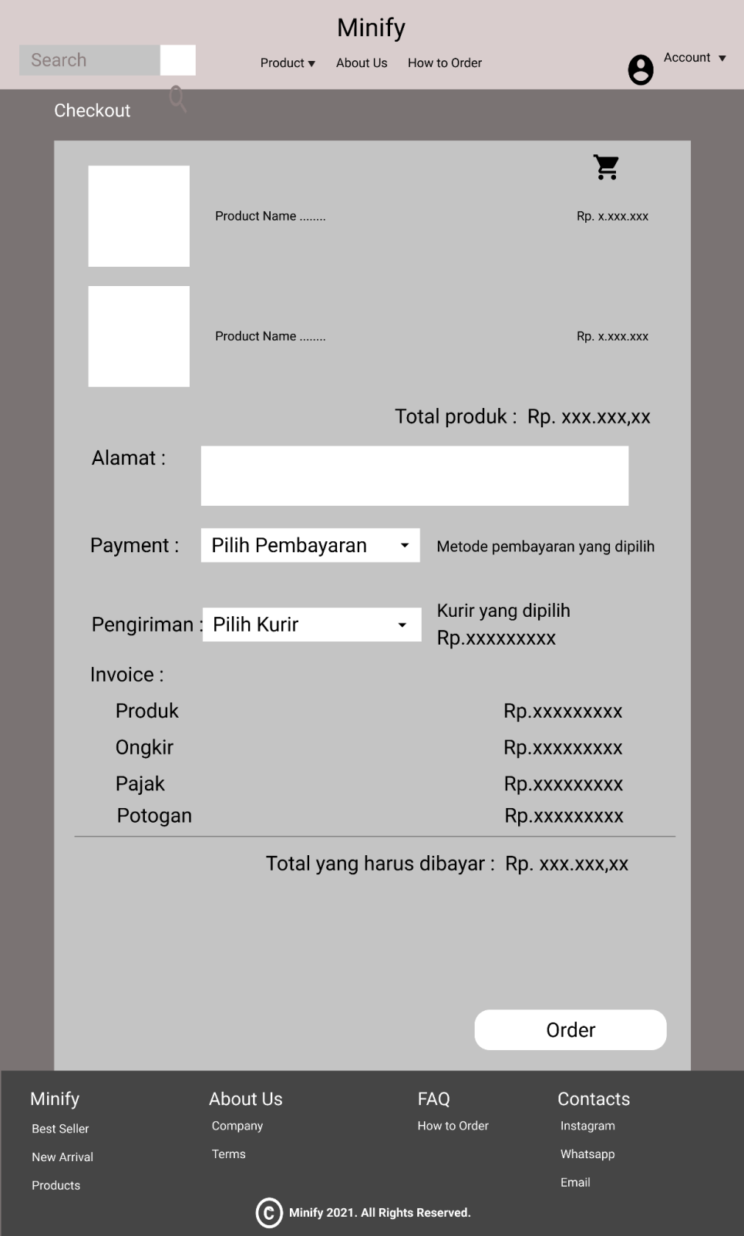

**Gambar 15.1. Mockup Checkout**

#### 15.B. Tampilan

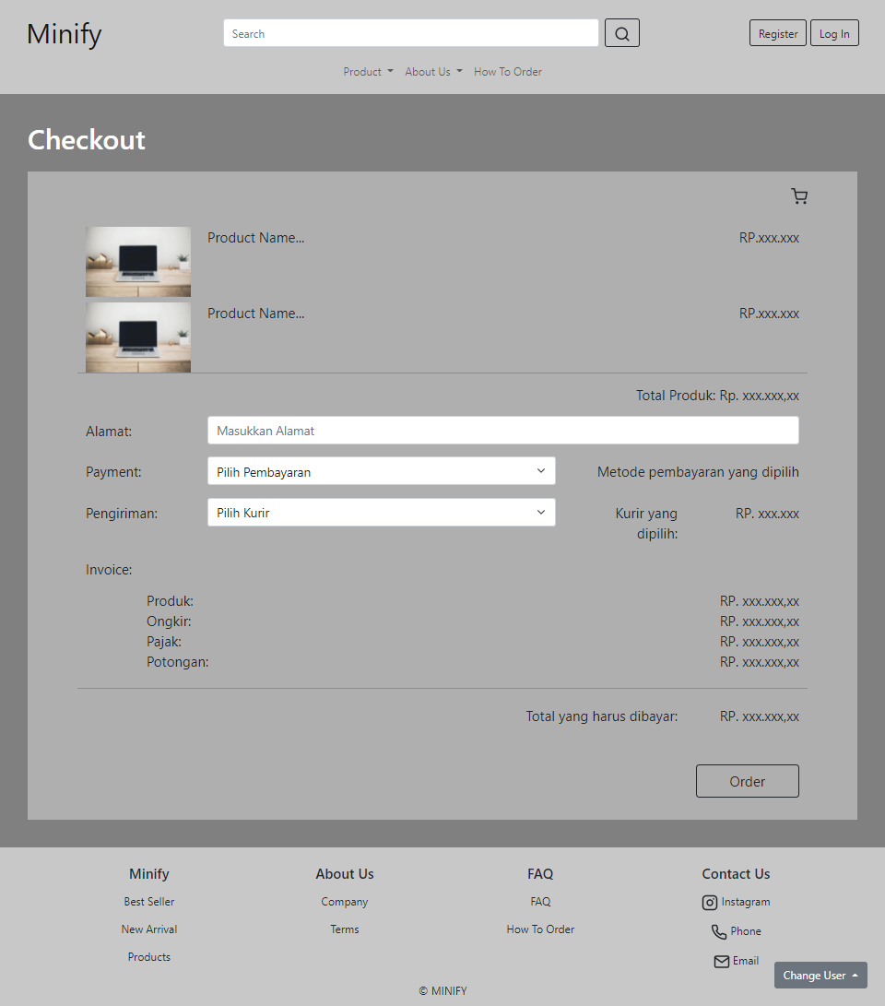

**Gambar 15.2. Tampilan Checkout**

#### 15.C. Flowchart

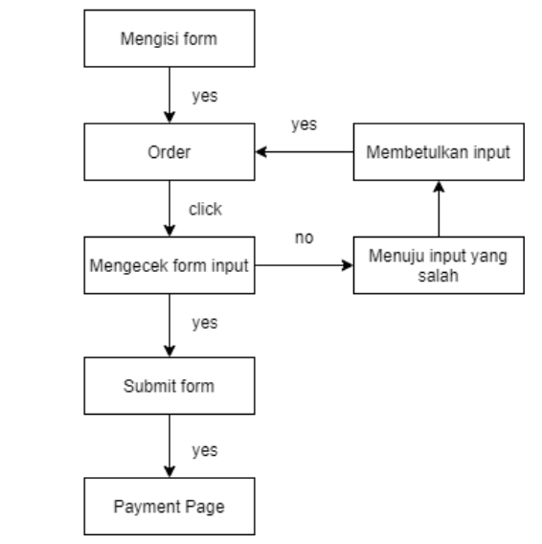

**Gambar 15.3. Flowchart Checkout**

#### 15.D. Fitur

Pada halaman Checkout menampilkan detail singkat produk seperti foto dari produk pertama yang dipesan, nama produk, harga produk dan total harga produk. Selain itu, terdapat form input yang meminta informasi berikut :

* Alamat : Alamat pengiriman yang dapat diisi dengan menggunakan alamat dari profil pembeli atau alamat yang lain.
* Payment : Metode pembayaran yang tersedia.
* Pengiriman : Cara pengiriman melalui kurir yang tersedia.

Jika ada informasi yang tidak diisi, maka akan menampilkan sebuah pemberitahuan bahwa bagian tersebut harus diisi terlebih dahulu. Jika sudah diisi semua, maka akan menampilkan Invoice yang berisi detail harga yang akan dibayar dan total harganya. Terdapat tombol Order yang digunakan untuk melakukan proses pembayaran lebih lanjut menuju Payment page

#### 15.E. Source Code

##### Html

**<section>**

**<div style="padding: 40px; background-color: grey">**

**<div class="mb-4">**

**<h1 style="color: white">Checkout</h1>**

**</div>**

**<div style="background-color: rgb(175, 175, 175); padding: 2%">**

**<i data-feather="shopping-cart" class="mx-5" style="float: right"></i**

**><br /><br />**

**<div class="row mx-5">**

**<!-- Detail Produk -->**

**<div class="col-md-2 mt-2">**

**<img**

**src="https://images.unsplash.com/photo-1496181133206-80ce9b88a853?ixid=MnwxMjA3fDB8MHxzZWFyY2h8Mnx8bGFwdG9wfGVufDB8fDB8fA%3D%3D&ixlib=rb-1.2.1&auto=format&fit=crop&w=700&q=60"**

**alt="detailImg"**

**style="**

**width: 100%;**

**max-width: 250px;**

**min-width: 90px;**

**min-height: 80px;**

**"**

**/>**

**</div>**

**<div class="col-md-8 mt-2">**

**<p class="fs-5">Product Name...</p>**

**</div>**

**<div class="col-md-2 mt-2">**

**<p class="fs-5 text-md-end text-sm-start">RP.xxx.xxx</p>**

**</div>**

**<div class="col-md-2 mt-2">**

**<img**

**src="https://images.unsplash.com/photo-1496181133206-80ce9b88a853?ixid=MnwxMjA3fDB8MHxzZWFyY2h8Mnx8bGFwdG9wfGVufDB8fDB8fA%3D%3D&ixlib=rb-1.2.1&auto=format&fit=crop&w=700&q=60"**

**alt="detailImg"**

**style="**

**width: 100%;**

**max-width: 250px;**

**min-width: 90px;**

**min-height: 80px;**

**"**

**/>**

**</div>**

**<div class="col-md-8 mt-2">**

**<p class="fs-5">Product Name...</p>**

**</div>**

**<div class="col-md-2 mt-2">**

**<p class="fs-5 text-md-end text-sm-start">RP.xxx.xxx</p>**

**</div>**

**<br />**

**<hr />**

**<p class="fs-5 text-md-end text-sm-start">**

**Total Produk: Rp. xxx.xxx,xx**

**</p>**

**<!-- Form Pembayaran & Pengiriman -->**

**<form action="payment.html" class="needs-validation" novalidate>**

**<div class="row mb-3">**

**<label**

**for="address"**

**class="col-sm-12 col-md-2 col-form-label fs-5"**

**>Alamat:</label**

**>**

**<div class="col-sm-12 col-md-10">**

**<input**

**type="text"**

**class="form-control"**

**id="address"**

**style="font-size: large"**

**placeholder="Masukkan Alamat"**

**required**

**/>**

**<div class="invalid-feedback">**

**Masukkan alamat pengiriman anda.**

**</div>**

**</div>**

**</div>**

**<div class="row mb-3">**

**<label**

**for="payment"**

**class="col-sm-12 col-md-2 col-form-label fs-5"**

**>Payment:</label**

**>**

**<div class="col-sm col-md-6">**

**<select**

**name="pembayaran"**

**class="form-select"**

**style="font-size: large"**

**required**

**>**

**<option value>Pilih Pembayaran</option>**

**<option value="bayar1">Opsi 1</option>**

**<option value="bayar2">Opsi 2</option>**

**</select>**

**<div class="invalid-feedback">**

**Pilih metode pembayaran anda.**

**</div>**

**</div>**

**<label**

**for="payment"**

**class="col-sm-6 col-md-4 col-form-label fs-5 text-end"**

**>Metode pembayaran yang dipilih</label**

**>**

**</div>**

**<div class="row mb-3">**

**<label**

**for="pengiriman"**

**class="col-sm-12 col-md-2 col-form-label fs-5"**

**>Pengiriman:</label**

**>**

**<div class="col-sm col-md-6">**

**<select**

**name="pengiriman"**

**class="form-select"**

**style="font-size: large"**

**required**

**>**

**<option value>Pilih Kurir</option>**

**<option value="kurir1">Opsi 1</option>**

**<option value="kurir2">Opsi 2</option>**

**</select>**

**<div class="invalid-feedback">**

**Pilih kurir pengiriman anda.**

**</div>**

**</div>**

**<label**

**for="payment"**

**class="col-sm-5 col-md-2 col-form-label fs-5 text-end"**

**>Kurir yang dipilih:**

**</label>**

**<label**

**for="payment"**

**class="col-sm col-md-2 col-form-label fs-5 text-end"**

**>RP. xxx.xxx</label**

**>**

**</div>**

**<!-- Detail Harga -->**

**<div class="col-12">**

**<p class="fs-5">Invoice:</p>**

**</div>**

**<div class="row">**

**<div class="col-sm-1"></div>**

**<div class="col-sm-7 fs-5">Produk:</div>**

**<div class="col-sm-4 fs-5 text-end">RP. xxx.xxx,xx</div>**

**<div class="col-sm-1"></div>**

**<div class="col-sm-7 fs-5">Ongkir:</div>**

**<div class="col-sm-4 fs-5 text-end">RP. xxx.xxx,xx</div>**

**<div class="col-sm-1"></div>**

**<div class="col-sm-7 fs-5">Pajak:</div>**

**<div class="col-sm-4 fs-5 text-end">RP. xxx.xxx,xx</div>**

**<div class="col-sm-1"></div>**

**<div class="col-sm-7 fs-5">Potongan:</div>**

**<div class="col-sm-4 fs-5 text-end">RP. xxx.xxx,xx</div>**

**<hr class="my-4" />**

**<div class="col-sm-1 col-md-2"></div>**

**<div class="col-sm-7 col-md-8 fs-5 mb-5 text-end">**

**Total yang harus dibayar:**

**</div>**

**<div class="col-sm-4 col-md-2 fs-5 text-end">**

**RP. xxx.xxx,xx**

**</div>**

**</div>**

**<!-- Tombol Order -->**

**<button**

**class="btn btn-outline-dark btn-lg my-2"**

**style="width: 150px; float: right"**

**type="submit"**

**>**

**Order**

**</button>**

**</form>**

**</div>**

**</div>**

**</div>**

**</section>**

Pada bagian bawah sebelum tag penutup body, digunakan fungsi untuk mengecek isi form.

##### Javascript

<script>

// Disable form submissions if there are invalid fields

(function () {

"use strict";

window.addEventListener(

"load",

function () {

// Get the forms we want to add validation styles to

var forms = document.getElementsByClassName("needs-validation");

// Loop over them and prevent submission

var validation = Array.prototype.filter.call(

forms,

function (form) {

form.addEventListener(

"submit",

function (event) {

if (form.checkValidity() === false) {

event.preventDefault();

event.stopPropagation();

}

form.classList.add("was-validated");

},

false

);

}

);

},

false

);

})();

</script>

### Payment

#### 16.A. Mockup

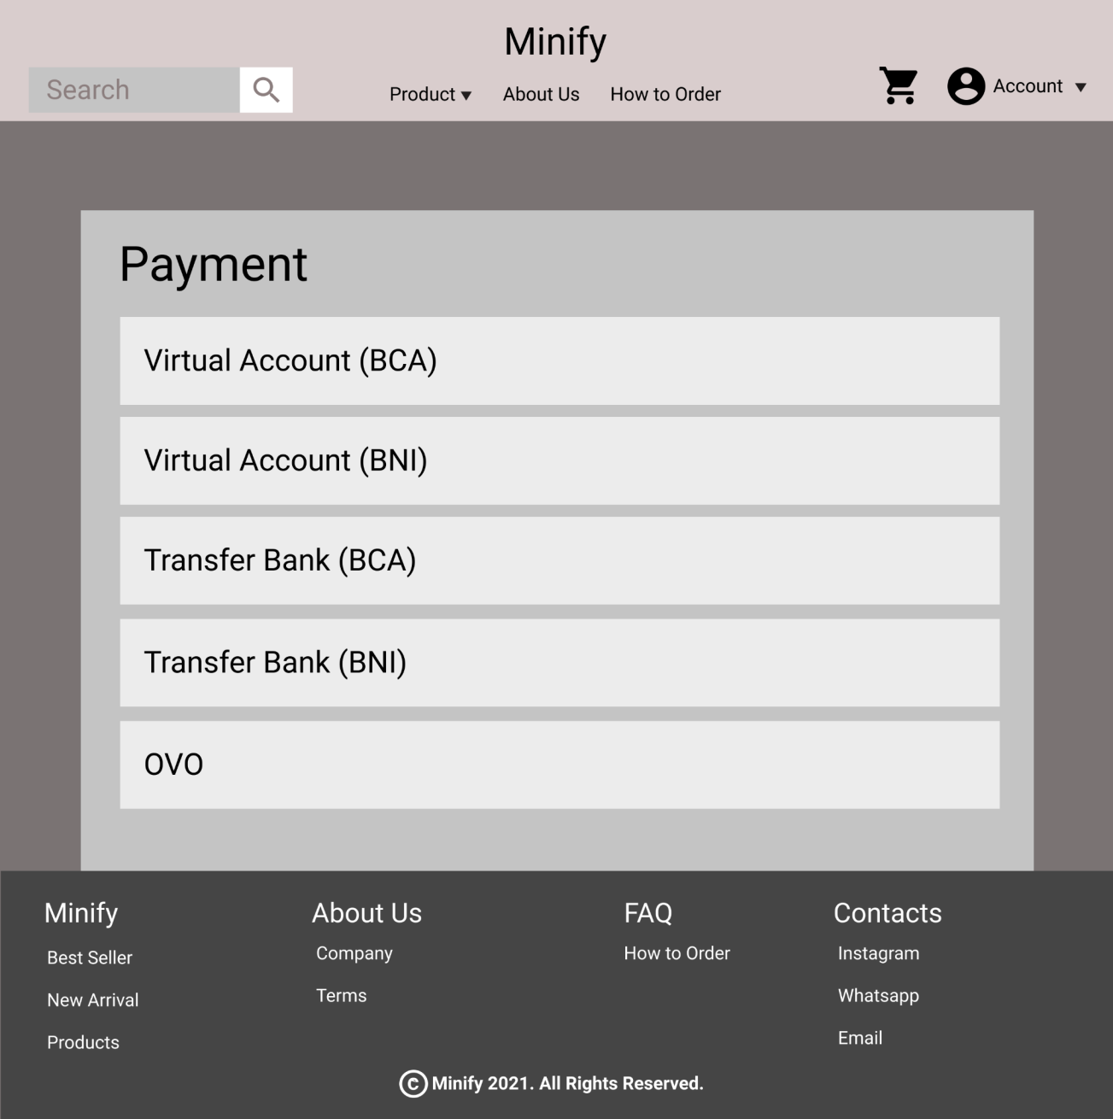

**Gambar 16.1 Mockup Payment**

#### 16.A. Tampilan

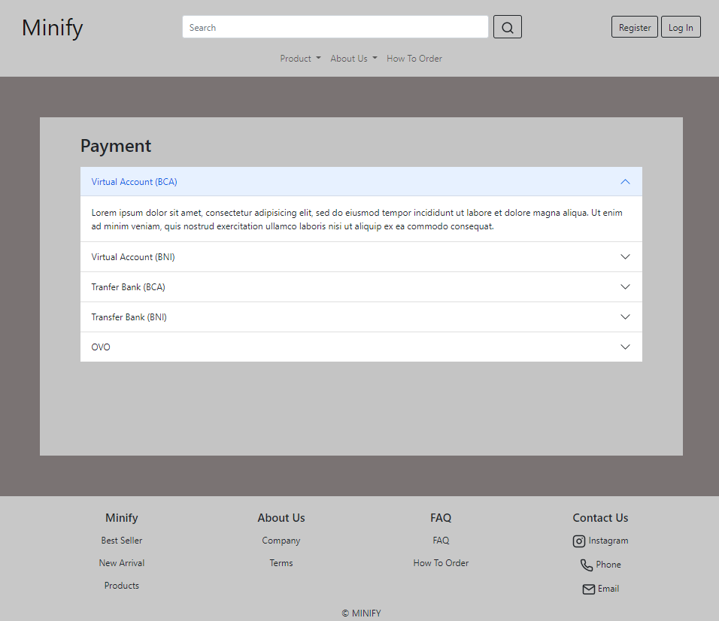

**Gambar 16.2. Tampilan Payment**

#### 16.B. Flowchart

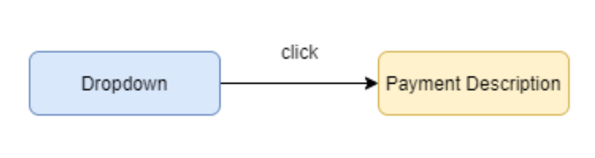

**Gambar 16.3. Flowchart Payment**

#### 16.C. Fitur

Pada halaman Payment menampilkan metode pembayaran yang tersedia dan memiliki fitur drop down yang jika salah satu metode pembayaran diklik, maka akan menampilkan deskripsi berupa langkah-langkah yang harus dilakukan untuk menyelesaikan pembayaran berdasarkan metode pembayaran yang dipilih.

#### 16.D. Source Code

##### Html

**<section>**

**<div style="background-color: #7a7373">**

**<br /><br /><br />**

**<div**

**class="container py-4"**

**style="background-color: #c4c4c4; height: 600px"**

**>**

**<div class="row mx-5">**

**<div class="col-sm-5">**

**<p class="fs-2" style="font-weight: 500">Payment</p>**

**</div>**

**<div class="accordion accordion-flush" id="accordionFlushExample">**

**<div class="accordion" id="accordionExample">**

**<div class="accordion-item">**

**<h2 class="accordion-header" id="headingOne">**

**<button**

**class="accordion-button collapsed"**

**type="button"**

**data-bs-toggle="collapse"**

**data-bs-target="#collapseOne"**

**aria-expanded="false"**

**aria-controls="collapseOne"**

**>**

**Virtual Account (BCA)**

**</button>**

**</h2>**

**<div**

**id="collapseOne"**

**class="accordion-collapse collapse"**

**aria-labelledby="headingOne"**

**data-bs-parent="#accordionExample"**

**>**

**<div class="accordion-body">**

**Lorem ipsum dolor sit amet, consectetur adipisicing elit,**

**sed do eiusmod tempor incididunt ut labore et dolore magna**

**aliqua. Ut enim ad minim veniam, quis nostrud exercitation**

**ullamco laboris nisi ut aliquip ex ea commodo consequat.**

**</div>**

**</div>**

**</div>**

**<div class="accordion-item">**

**<h2 class="accordion-header" id="headingTwo">**

**<button**

**class="accordion-button collapsed"**

**type="button"**

**data-bs-toggle="collapse"**

**data-bs-target="#collapseTwo"**

**aria-expanded="false"**

**aria-controls="collapseTwo"**

**>**

**Virtual Account (BNI)**

**</button>**

**</h2>**

**<div**

**id="collapseTwo"**

**class="accordion-collapse collapse"**

**aria-labelledby="headingTwo"**

**data-bs-parent="#accordionExample"**

**>**

**<div class="accordion-body">**

**Lorem ipsum dolor sit amet, consectetur adipisicing elit,**

**sed do eiusmod tempor incididunt ut labore et dolore magna**

**aliqua. Ut enim ad minim veniam, quis nostrud exercitation**

**ullamco laboris nisi ut aliquip ex ea commodo consequat.**

**</div>**

**</div>**

**</div>**

**<div class="accordion-item">**

**<h2 class="accordion-header" id="headingThree">**

**<button**

**class="accordion-button collapsed"**

**type="button"**

**data-bs-toggle="collapse"**

**data-bs-target="#collapseThree"**

**aria-expanded="false"**

**aria-controls="collapseThree"**

**>**

**Transfer Bank (BCA)**

**</button>**

**</h2>**

**<div**

**id="collapseThree"**

**class="accordion-collapse collapse"**

**aria-labelledby="headingThree"**

**data-bs-parent="#accordionExample"**

**>**

**<div class="accordion-body">**

**Lorem ipsum dolor sit amet, consectetur adipisicing elit,**

**sed do eiusmod tempor incididunt ut labore et dolore magna**

**aliqua. Ut enim ad minim veniam, quis nostrud exercitation**

**ullamco laboris nisi ut aliquip ex ea commodo consequat.**

**</div>**

**</div>**

**</div>**

**<div class="accordion-item">**

**<h2 class="accordion-header" id="headingFour">**

**<button**

**class="accordion-button collapsed"**

**type="button"**

**data-bs-toggle="collapse"**

**data-bs-target="#collapseFour"**

**aria-expanded="false"**

**aria-controls="collapseFour"**

**>**

**Transfer Bank (BNI)**

**</button>**

**</h2>**

**<div**

**id="collapseFour"**

**class="accordion-collapse collapse"**

**aria-labelledby="headingFour"**

**data-bs-parent="#accordionExample"**

**>**

**<div class="accordion-body">**

**Lorem ipsum dolor sit amet, consectetur adipisicing elit,**

**sed do eiusmod tempor incididunt ut labore et dolore magna**

**aliqua. Ut enim ad minim veniam, quis nostrud exercitation**

**ullamco laboris nisi ut aliquip ex ea commodo consequat.**

**</div>**

**</div>**

**</div>**

**<div class="accordion-item">**

**<h2 class="accordion-header" id="headingFive">**

**<button**

**class="accordion-button collapsed"**

**type="button"**

**data-bs-toggle="collapse"**

**data-bs-target="#collapseFive"**

**aria-expanded="false"**

**aria-controls="collapseFive"**

**>**

**OVO**

**</button>**

**</h2>**

**<div**

**id="collapseFive"**

**class="accordion-collapse collapse"**

**aria-labelledby="headingFive"**

**data-bs-parent="#accordionExample"**

**>**

**<div class="accordion-body">**

**Lorem ipsum dolor sit amet, consectetur adipisicing elit,**

**sed do eiusmod tempor incididunt ut labore et dolore magna**

**aliqua. Ut enim ad minim veniam, quis nostrud exercitation**

**ullamco laboris nisi ut aliquip ex ea commodo consequat.**

**</div>**

**</div>**

**</div>**

**</div>**

**</div>**

**</div>**

**</div>**

**<br /><br /><br />**

**</div>**

**</section>**

### Best Seller

#### 17.A. Mockup

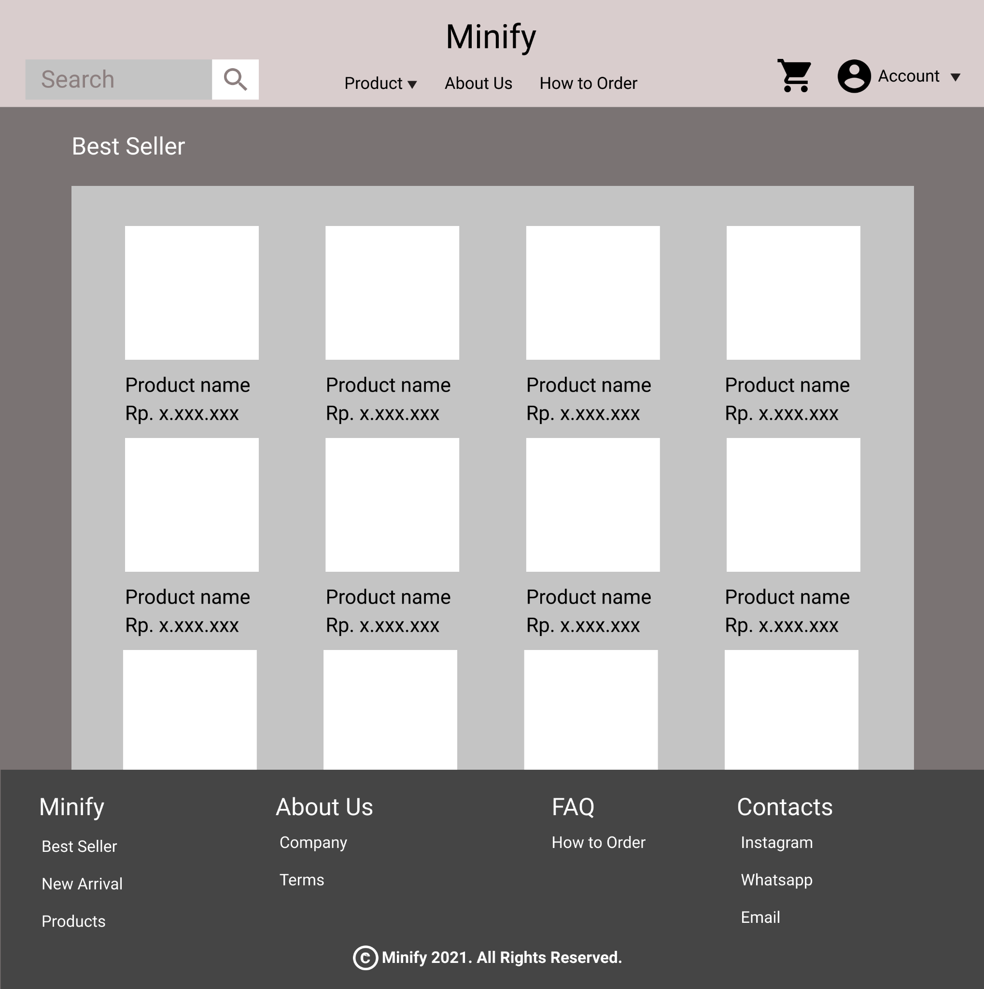

**Gambar 17.1 Mockup Best Seller Page**

#### 17.B. Tampilan

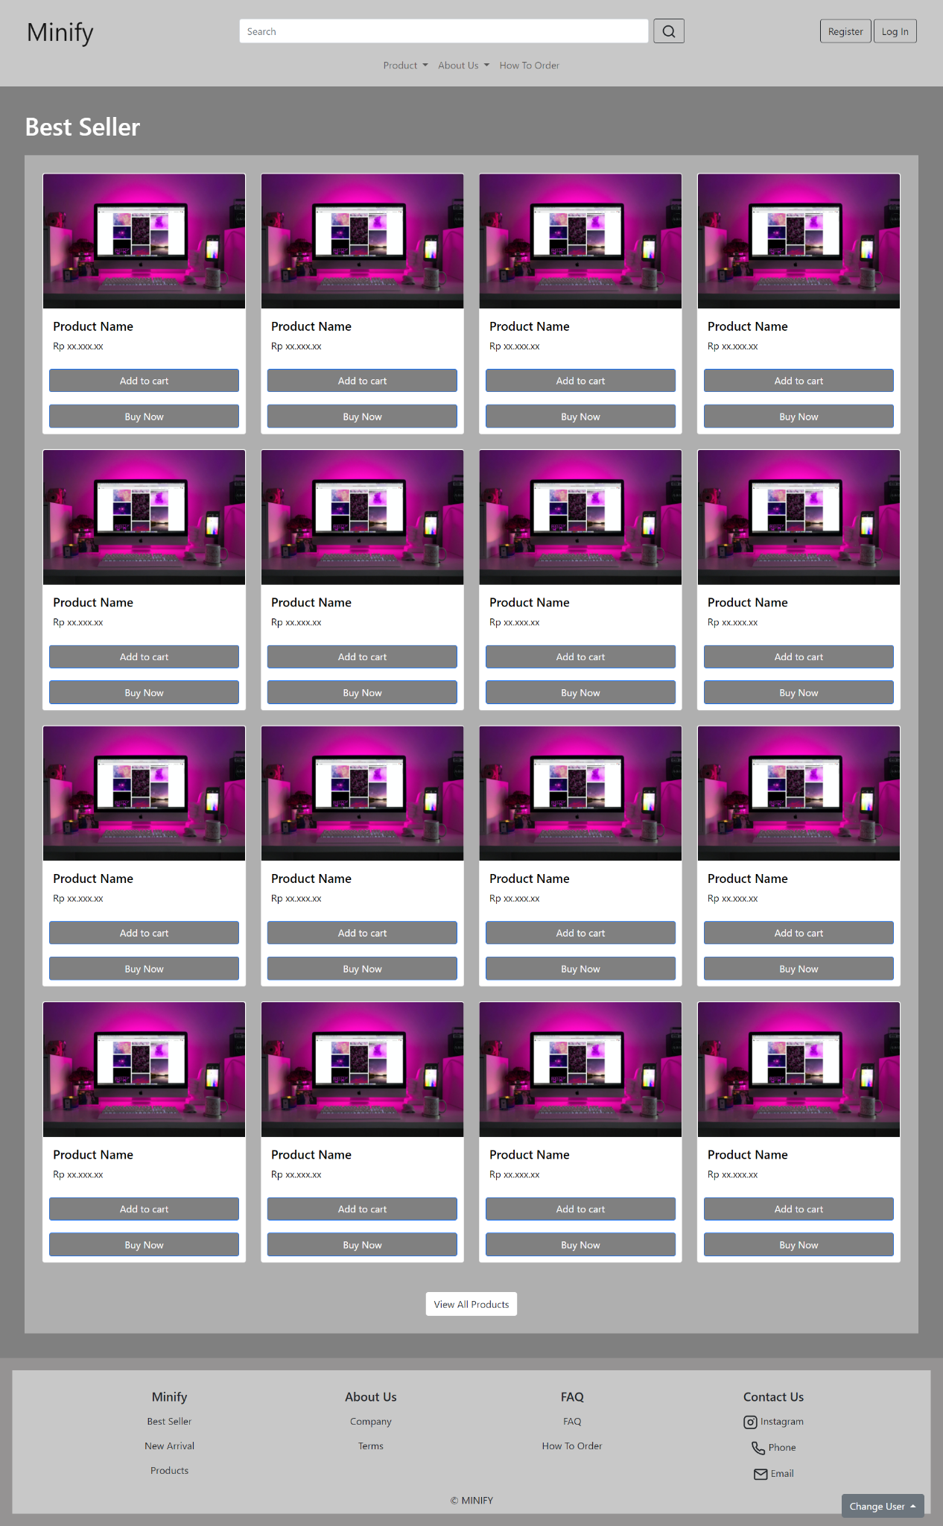

**Gambar 17.2 Tampilan Best Seller Page**

#### 17.C. Flowchart

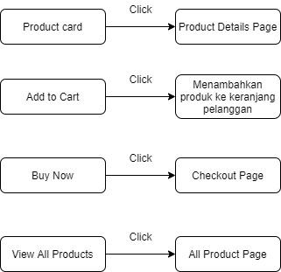

**Gambar 17.1 Flowchart Best Seller Page**

#### 17.D. Fitur

Pada halaman best seller menampilkan produk-produk yang paling banyak terjual/memiliki rating yang tinggi. Beberapa fitur yang terdapat pada halaman best seller yaitu :

1. Card : Di dalam card terdapat foto produk, harga produk, Add to Cart Button dan Buy Now Button. Jika card di klik maka akan menuju product details page dari produk tersebut.
2. Add to Cart : Jika di klik maka akan menambahkan produk ke dalam keranjang.
3. Buy Now : Jika di klik maka akan menuju checkout page.
4. View All Products : Jika di klik maka akan menuju ke halaman all products.

#### 17.E. Source Code

##### Html

**<div>**

**<div style="padding: 40px; background-color: grey">**

**<div class="mb-4">**

**<h1 style="color: white">Best Seller</h1>**

**</div>**

**<div style="background-color: rgb(175, 175, 175); padding: 2%">**

**<div class="row row-cols-1 row-cols-md-4">**

**<div class="col mb-4">**

**<a**

**href="details.html"**

**style="text-decoration: none; color: black"**

**>**

**<div class="card h-100">**

**<img**

**src="/image/designecologist-Pmh0UoG1vlE-unsplash.jpg"**

**class="card-img-top"**

**alt="..."**

**/>**

**<div class="card-body">**

**<h5 class="card-title">Product Name</h5>**

**<p class="card-text">Rp xx.xxx.xx</p>**

**</div>**

**<a**

**href="#"**

**class="btn btn-primary mar10"**

**style="background-color: grey; color: white"**

**>Add to cart</a**

**>**

**<a**

**href="checkout.html"**

**class="btn btn-primary mar10"**

**style="background-color: grey; color: white"**

**>Buy Now</a**

**>**

**</div>**

**</a>**

**</div>**

**<div class="col mb-4">**

**<a**

**href="details.html"**

**style="text-decoration: none; color: black"**

**>**

**<div class="card h-100">**

**<img**

**src="/image/designecologist-Pmh0UoG1vlE-unsplash.jpg"**

**class="card-img-top"**

**alt="..."**

**/>**

**<div class="card-body">**

**<h5 class="card-title">Product Name</h5>**

**<p class="card-text">Rp xx.xxx.xx</p>**

**</div>**

**<a**

**href="#"**

**class="btn btn-primary mar10"**

**style="background-color: grey; color: white"**

**>Add to cart</a**

**>**

**<a**

**href="checkout.html"**

**class="btn btn-primary mar10"**

**style="background-color: grey; color: white"**

**>Buy Now</a**

**>**

**</div>**

**</a>**

**</div>**

**<div class="col mb-4">**

**<a**

**href="details.html"**

**style="text-decoration: none; color: black"**

**>**

**<div class="card h-100">**

**<img**

**src="/image/designecologist-Pmh0UoG1vlE-unsplash.jpg"**

**class="card-img-top"**

**alt="..."**

**/>**

**<div class="card-body">**

**<h5 class="card-title">Product Name</h5>**

**<p class="card-text">Rp xx.xxx.xx</p>**

**</div>**

**<a**

**href="#"**

**class="btn btn-primary mar10"**

**style="background-color: grey; color: white"**

**>Add to cart</a**

**>**

**<a**

**href="checkout.html"**

**class="btn btn-primary mar10"**

**style="background-color: grey; color: white"**

**>Buy Now</a**

**>**

**</div>**

**</a>**

**</div>**

**<div class="col mb-4">**

**<a**

**href="details.html"**

**style="text-decoration: none; color: black"**

**>**

**<div class="card h-100">**

**<img**

**src="/image/designecologist-Pmh0UoG1vlE-unsplash.jpg"**

**class="card-img-top"**

**alt="..."**

**/>**

**<div class="card-body">**

**<h5 class="card-title">Product Name</h5>**

**<p class="card-text">Rp xx.xxx.xx</p>**

**</div>**

**<a**

**href="#"**

**class="btn btn-primary mar10"**

**style="background-color: grey; color: white"**

**>Add to cart</a**

**>**

**<a**

**href="checkout.html"**

**class="btn btn-primary mar10"**

**style="background-color: grey; color: white"**

**>Buy Now</a**

**>**

**</div>**

**</a>**

**</div>**

**<div class="col mb-4">**

**<a**

**href="details.html"**

**style="text-decoration: none; color: black"**

**>**

**<div class="card h-100">**

**<img**

**src="/image/designecologist-Pmh0UoG1vlE-unsplash.jpg"**

**class="card-img-top"**

**alt="..."**

**/>**

**<div class="card-body">**

**<h5 class="card-title">Product Name</h5>**

**<p class="card-text">Rp xx.xxx.xx</p>**

**</div>**

**<a**

**href="#"**

**class="btn btn-primary mar10"**

**style="background-color: grey; color: white"**

**>Add to cart</a**

**>**

**<a**

**href="checkout.html"**

**class="btn btn-primary mar10"**

**style="background-color: grey; color: white"**

**>Buy Now</a**

**>**

**</div>**

**</a>**

**</div>**

**<div class="col mb-4">**

**<a**

**href="details.html"**

**style="text-decoration: none; color: black"**

**>**

**<div class="card h-100">**

**<img**

**src="/image/designecologist-Pmh0UoG1vlE-unsplash.jpg"**

**class="card-img-top"**

**alt="..."**

**/>**

**<div class="card-body">**

**<h5 class="card-title">Product Name</h5>**

**<p class="card-text">Rp xx.xxx.xx</p>**

**</div>**

**<a**

**href="#"**

**class="btn btn-primary mar10"**

**style="background-color: grey; color: white"**

**>Add to cart</a**

**>**

**<a**

**href="checkout.html"**

**class="btn btn-primary mar10"**

**style="background-color: grey; color: white"**

**>Buy Now</a**

**>**

**</div>**

**</a>**

**</div>**

**<div class="col mb-4">**

**<a**

**href="details.html"**

**style="text-decoration: none; color: black"**

**>**

**<div class="card h-100">**

**<img**

**src="/image/designecologist-Pmh0UoG1vlE-unsplash.jpg"**

**class="card-img-top"**

**alt="..."**

**/>**

**<div class="card-body">**

**<h5 class="card-title">Product Name</h5>**

**<p class="card-text">Rp xx.xxx.xx</p>**

**</div>**

**<a**

**href="#"**

**class="btn btn-primary mar10"**

**style="background-color: grey; color: white"**

**>Add to cart</a**

**>**

**<a**

**href="checkout.html"**

**class="btn btn-primary mar10"**

**style="background-color: grey; color: white"**

**>Buy Now</a**

**>**

**</div>**

**</a>**

**</div>**

**<div class="col mb-4">**

**<a**

**href="details.html"**

**style="text-decoration: none; color: black"**

**>**

**<div class="card h-100">**

**<img**

**src="/image/designecologist-Pmh0UoG1vlE-unsplash.jpg"**

**class="card-img-top"**

**alt="..."**

**/>**

**<div class="card-body">**

**<h5 class="card-title">Product Name</h5>**

**<p class="card-text">Rp xx.xxx.xx</p>**

**</div>**

**<a**

**href="#"**

**class="btn btn-primary mar10"**

**style="background-color: grey; color: white"**

**>Add to cart</a**

**>**

**<a**

**href="checkout.html"**

**class="btn btn-primary mar10"**

**style="background-color: grey; color: white"**

**>Buy Now</a**

**>**

**</div>**

**</a>**

**</div>**

**<div class="col mb-4">**

**<a**

**href="details.html"**

**style="text-decoration: none; color: black"**

**>**

**<div class="card h-100">**

**<img**

**src="/image/designecologist-Pmh0UoG1vlE-unsplash.jpg"**

**class="card-img-top"**

**alt="..."**

**/>**

**<div class="card-body">**

**<h5 class="card-title">Product Name</h5>**

**<p class="card-text">Rp xx.xxx.xx</p>**

**</div>**

**<a**

**href="#"**

**class="btn btn-primary mar10"**

**style="background-color: grey; color: white"**

**>Add to cart</a**

**>**

**<a**

**href="checkout.html"**

**class="btn btn-primary mar10"**

**style="background-color: grey; color: white"**

**>Buy Now</a**

**>**

**</div>**

**</a>**

**</div>**

**<div class="col mb-4">**

**<a**

**href="details.html"**

**style="text-decoration: none; color: black"**

**>**

**<div class="card h-100">**

**<img**

**src="/image/designecologist-Pmh0UoG1vlE-unsplash.jpg"**

**class="card-img-top"**

**alt="..."**

**/>**

**<div class="card-body">**

**<h5 class="card-title">Product Name</h5>**

**<p class="card-text">Rp xx.xxx.xx</p>**

**</div>**

**<a**

**href="#"**

**class="btn btn-primary mar10"**

**style="background-color: grey; color: white"**

**>Add to cart</a**

**>**

**<a**

**href="checkout.html"**

**class="btn btn-primary mar10"**

**style="background-color: grey; color: white"**

**>Buy Now</a**

**>**

**</div>**

**</a>**

**</div>**

**<div class="col mb-4">**

**<a**

**href="details.html"**

**style="text-decoration: none; color: black"**

**>**

**<div class="card h-100">**

**<img**

**src="/image/designecologist-Pmh0UoG1vlE-unsplash.jpg"**

**class="card-img-top"**

**alt="..."**

**/>**

**<div class="card-body">**

**<h5 class="card-title">Product Name</h5>**

**<p class="card-text">Rp xx.xxx.xx</p>**

**</div>**

**<a**

**href="#"**

**class="btn btn-primary mar10"**

**style="background-color: grey; color: white"**

**>Add to cart</a**

**>**

**<a**

**href="checkout.html"**

**class="btn btn-primary mar10"**

**style="background-color: grey; color: white"**

**>Buy Now</a**

**>**

**</div>**

**</a>**

**</div>**

**<div class="col mb-4">**

**<a**

**href="details.html"**

**style="text-decoration: none; color: black"**

**>**

**<div class="card h-100">**

**<img**

**src="/image/designecologist-Pmh0UoG1vlE-unsplash.jpg"**

**class="card-img-top"**

**alt="..."**

**/>**

**<div class="card-body">**

**<h5 class="card-title">Product Name</h5>**

**<p class="card-text">Rp xx.xxx.xx</p>**

**</div>**

**<a**

**href="#"**

**class="btn btn-primary mar10"**

**style="background-color: grey; color: white"**

**>Add to cart</a**

**>**

**<a**

**href="checkout.html"**

**class="btn btn-primary mar10"**

**style="background-color: grey; color: white"**

**>Buy Now</a**

**>**

**</div>**

**</a>**

**</div>**

**<div class="col mb-4">**

**<a**

**href="details.html"**

**style="text-decoration: none; color: black"**

**>**

**<div class="card h-100">**

**<img**

**src="/image/designecologist-Pmh0UoG1vlE-unsplash.jpg"**

**class="card-img-top"**

**alt="..."**

**/>**

**<div class="card-body">**

**<h5 class="card-title">Product Name</h5>**

**<p class="card-text">Rp xx.xxx.xx</p>**

**</div>**

**<a**

**href="#"**

**class="btn btn-primary mar10"**

**style="background-color: grey; color: white"**

**>Add to cart</a**

**>**

**<a**

**href="checkout.html"**

**class="btn btn-primary mar10"**

**style="background-color: grey; color: white"**

**>Buy Now</a**

**>**

**</div>**

**</a>**

**</div>**

**<div class="col mb-4">**

**<a**

**href="details.html"**

**style="text-decoration: none; color: black"**

**>**

**<div class="card h-100">**

**<img**

**src="/image/designecologist-Pmh0UoG1vlE-unsplash.jpg"**

**class="card-img-top"**

**alt="..."**

**/>**

**<div class="card-body">**

**<h5 class="card-title">Product Name</h5>**

**<p class="card-text">Rp xx.xxx.xx</p>**

**</div>**

**<a**

**href="#"**

**class="btn btn-primary mar10"**

**style="background-color: grey; color: white"**

**>Add to cart</a**

**>**

**<a**

**href="checkout.html"**

**class="btn btn-primary mar10"**

**style="background-color: grey; color: white"**

**>Buy Now</a**

**>**

**</div>**

**</a>**

**</div>**

**<div class="col mb-4">**

**<a**

**href="details.html"**

**style="text-decoration: none; color: black"**

**>**

**<div class="card h-100">**

**<img**

**src="/image/designecologist-Pmh0UoG1vlE-unsplash.jpg"**

**class="card-img-top"**

**alt="..."**

**/>**

**<div class="card-body">**

**<h5 class="card-title">Product Name</h5>**

**<p class="card-text">Rp xx.xxx.xx</p>**

**</div>**

**<a**

**href="#"**

**class="btn btn-primary mar10"**

**style="background-color: grey; color: white"**

**>Add to cart</a**

**>**

**<a**

**href="checkout.html"**

**class="btn btn-primary mar10"**

**style="background-color: grey; color: white"**

**>Buy Now</a**

**>**

**</div>**

**</a>**

**</div>**

**<div class="col mb-4">**

**<a**

**href="details.html"**

**style="text-decoration: none; color: black"**

**>**

**<div class="card h-100">**

**<img**

**src="/image/designecologist-Pmh0UoG1vlE-unsplash.jpg"**

**class="card-img-top"**

**alt="..."**

**/>**

**<div class="card-body">**

**<h5 class="card-title">Product Name</h5>**

**<p class="card-text">Rp xx.xxx.xx</p>**

**</div>**

**<a**

**href="#"**

**class="btn btn-primary mar10"**

**style="background-color: grey; color: white"**

**>Add to cart</a**

**>**

**<a**

**href="checkout.html"**

**class="btn btn-primary mar10"**

**style="background-color: grey; color: white"**

**>Buy Now</a**

**>**

**</div>**

**</a>**

**</div>**

**</div>**

**<br />**

**<div class="ta-c">**

**<a href="product.html" class="btn" style="background-color: white"**

**>View All Products</a**

**>**

**</div>**

**</div>**

**</div>**

**</div>**

##### CSS

**<style>**

**.jc-sb {**

**display: flex;**

**justify-content: space-between;**

**}**

**.ta-c {**

**text-align: center;**

**}**

**.td a {**

**text-decoration: none;**

**color: black;**

**}**

**.mar10 {**

**margin: 10px;**

**}**

**@media screen and (max-width: 800px) {**

**.row-cols-md-4 > * {**

**-ms-flex: 0 0 50%;**

**flex: 0 0 50%;**

**max-width: 50%;**

**}**

**}**

**@media screen and (max-width: 450px) {**

**.row-cols-md-4 > * {**

**-ms-flex: 0 0 100%;**

**flex: 0 0 100%;**

**max-width: 100%;**

**}**

**}**

**</style>**

### New Arrival

#### 18.A. Tampilan

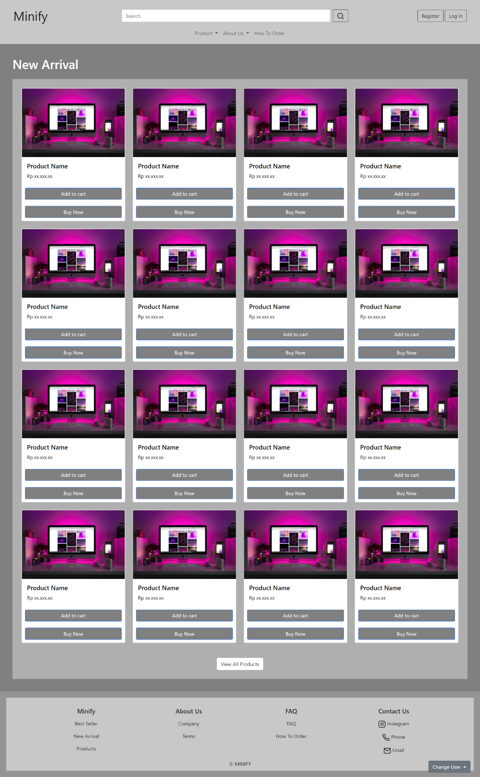

**Gambar 18.1 Mockup New Arrival Page**

#### 18.B. Flowchart



**Gambar 18.2 Flowchart New Arrival Page**

#### 18.C. Fitur

Pada halaman new arrival menampilkan produk-produk yang baru saja upload. Beberapa fitur yang terdapat pada halaman best seller yaitu :

1. Card : Di dalam card terdapat foto produk, harga produk, Add to Cart Button dan Buy Now Button. Jika card di klik maka akan menuju product details page dari produk tersebut.
2. Add to Cart : Jika di klik maka akan menambahkan produk ke dalam keranjang.
3. Buy Now : Jika di klik maka akan menuju checkout page.
4. View All Products : Jika di klik maka akan menuju ke halaman all products.

#### 18.D. Source Code

##### **Html**

**<div>**

**<div style="padding: 40px; background-color: grey">**

**<div class="mb-4">**

**<h1 style="color: white">Best Seller</h1>**

**</div>**

**<div style="background-color: rgb(175, 175, 175); padding: 2%">**

**<div class="row row-cols-1 row-cols-md-4">**

**<div class="col mb-4">**

**<a**

**href="details.html"**

**style="text-decoration: none; color: black"**

**>**

**<div class="card h-100">**

**<img**

**src="/image/designecologist-Pmh0UoG1vlE-unsplash.jpg"**

**class="card-img-top"**

**alt="..."**

**/>**

**<div class="card-body">**

**<h5 class="card-title">Product Name</h5>**

**<p class="card-text">Rp xx.xxx.xx</p>**

**</div>**

**<a**

**href="#"**

**class="btn btn-primary mar10"**

**style="background-color: grey; color: white"**

**>Add to cart</a**

**>**

**<a**

**href="checkout.html"**

**class="btn btn-primary mar10"**

**style="background-color: grey; color: white"**

**>Buy Now</a**

**>**

**</div>**

**</a>**

**</div>**

**<div class="col mb-4">**

**<a**

**href="details.html"**

**style="text-decoration: none; color: black"**

**>**

**<div class="card h-100">**

**<img**

**src="/image/designecologist-Pmh0UoG1vlE-unsplash.jpg"**

**class="card-img-top"**

**alt="..."**

**/>**

**<div class="card-body">**

**<h5 class="card-title">Product Name</h5>**

**<p class="card-text">Rp xx.xxx.xx</p>**

**</div>**

**<a**

**href="#"**

**class="btn btn-primary mar10"**

**style="background-color: grey; color: white"**

**>Add to cart</a**

**>**

**<a**

**href="checkout.html"**

**class="btn btn-primary mar10"**

**style="background-color: grey; color: white"**

**>Buy Now</a**

**>**

**</div>**

**</a>**

**</div>**

**<div class="col mb-4">**

**<a**

**href="details.html"**

**style="text-decoration: none; color: black"**

**>**

**<div class="card h-100">**

**<img**

**src="/image/designecologist-Pmh0UoG1vlE-unsplash.jpg"**

**class="card-img-top"**

**alt="..."**

**/>**

**<div class="card-body">**

**<h5 class="card-title">Product Name</h5>**

**<p class="card-text">Rp xx.xxx.xx</p>**

**</div>**

**<a**

**href="#"**

**class="btn btn-primary mar10"**

**style="background-color: grey; color: white"**

**>Add to cart</a**

**>**

**<a**

**href="checkout.html"**

**class="btn btn-primary mar10"**

**style="background-color: grey; color: white"**

**>Buy Now</a**

**>**

**</div>**

**</a>**

**</div>**

**<div class="col mb-4">**

**<a**

**href="details.html"**

**style="text-decoration: none; color: black"**

**>**

**<div class="card h-100">**

**<img**

**src="/image/designecologist-Pmh0UoG1vlE-unsplash.jpg"**

**class="card-img-top"**

**alt="..."**

**/>**

**<div class="card-body">**

**<h5 class="card-title">Product Name</h5>**

**<p class="card-text">Rp xx.xxx.xx</p>**

**</div>**

**<a**

**href="#"**

**class="btn btn-primary mar10"**

**style="background-color: grey; color: white"**

**>Add to cart</a**

**>**

**<a**

**href="checkout.html"**

**class="btn btn-primary mar10"**

**style="background-color: grey; color: white"**

**>Buy Now</a**

**>**

**</div>**

**</a>**

**</div>**

**<div class="col mb-4">**

**<a**

**href="details.html"**

**style="text-decoration: none; color: black"**

**>**

**<div class="card h-100">**

**<img**

**src="/image/designecologist-Pmh0UoG1vlE-unsplash.jpg"**

**class="card-img-top"**

**alt="..."**

**/>**

**<div class="card-body">**

**<h5 class="card-title">Product Name</h5>**

**<p class="card-text">Rp xx.xxx.xx</p>**

**</div>**

**<a**

**href="#"**

**class="btn btn-primary mar10"**

**style="background-color: grey; color: white"**

**>Add to cart</a**

**>**

**<a**

**href="checkout.html"**

**class="btn btn-primary mar10"**

**style="background-color: grey; color: white"**

**>Buy Now</a**

**>**

**</div>**

**</a>**

**</div>**

**<div class="col mb-4">**

**<a**

**href="details.html"**

**style="text-decoration: none; color: black"**

**>**

**<div class="card h-100">**

**<img**

**src="/image/designecologist-Pmh0UoG1vlE-unsplash.jpg"**

**class="card-img-top"**

**alt="..."**

**/>**

**<div class="card-body">**

**<h5 class="card-title">Product Name</h5>**

**<p class="card-text">Rp xx.xxx.xx</p>**

**</div>**

**<a**

**href="#"**

**class="btn btn-primary mar10"**

**style="background-color: grey; color: white"**

**>Add to cart</a**

**>**

**<a**

**href="checkout.html"**

**class="btn btn-primary mar10"**

**style="background-color: grey; color: white"**

**>Buy Now</a**

**>**

**</div>**

**</a>**

**</div>**

**<div class="col mb-4">**

**<a**

**href="details.html"**

**style="text-decoration: none; color: black"**

**>**

**<div class="card h-100">**

**<img**

**src="/image/designecologist-Pmh0UoG1vlE-unsplash.jpg"**

**class="card-img-top"**

**alt="..."**

**/>**

**<div class="card-body">**

**<h5 class="card-title">Product Name</h5>**

**<p class="card-text">Rp xx.xxx.xx</p>**

**</div>**

**<a**

**href="#"**

**class="btn btn-primary mar10"**

**style="background-color: grey; color: white"**

**>Add to cart</a**

**>**

**<a**

**href="checkout.html"**

**class="btn btn-primary mar10"**

**style="background-color: grey; color: white"**

**>Buy Now</a**

**>**

**</div>**

**</a>**

**</div>**

**<div class="col mb-4">**

**<a**

**href="details.html"**

**style="text-decoration: none; color: black"**

**>**

**<div class="card h-100">**

**<img**

**src="/image/designecologist-Pmh0UoG1vlE-unsplash.jpg"**

**class="card-img-top"**

**alt="..."**

**/>**

**<div class="card-body">**

**<h5 class="card-title">Product Name</h5>**

**<p class="card-text">Rp xx.xxx.xx</p>**

**</div>**

**<a**

**href="#"**

**class="btn btn-primary mar10"**

**style="background-color: grey; color: white"**

**>Add to cart</a**

**>**

**<a**

**href="checkout.html"**

**class="btn btn-primary mar10"**

**style="background-color: grey; color: white"**

**>Buy Now</a**

**>**

**</div>**

**</a>**

**</div>**

**<div class="col mb-4">**

**<a**

**href="details.html"**

**style="text-decoration: none; color: black"**

**>**

**<div class="card h-100">**

**<img**

**src="/image/designecologist-Pmh0UoG1vlE-unsplash.jpg"**

**class="card-img-top"**

**alt="..."**

**/>**

**<div class="card-body">**

**<h5 class="card-title">Product Name</h5>**

**<p class="card-text">Rp xx.xxx.xx</p>**

**</div>**

**<a**

**href="#"**

**class="btn btn-primary mar10"**

**style="background-color: grey; color: white"**

**>Add to cart</a**

**>**

**<a**

**href="checkout.html"**

**class="btn btn-primary mar10"**

**style="background-color: grey; color: white"**

**>Buy Now</a**

**>**

**</div>**

**</a>**

**</div>**

**<div class="col mb-4">**

**<a**

**href="details.html"**

**style="text-decoration: none; color: black"**

**>**

**<div class="card h-100">**

**<img**

**src="/image/designecologist-Pmh0UoG1vlE-unsplash.jpg"**

**class="card-img-top"**

**alt="..."**

**/>**

**<div class="card-body">**

**<h5 class="card-title">Product Name</h5>**

**<p class="card-text">Rp xx.xxx.xx</p>**

**</div>**

**<a**

**href="#"**

**class="btn btn-primary mar10"**

**style="background-color: grey; color: white"**

**>Add to cart</a**

**>**

**<a**

**href="checkout.html"**

**class="btn btn-primary mar10"**

**style="background-color: grey; color: white"**

**>Buy Now</a**

**>**

**</div>**

**</a>**

**</div>**

**<div class="col mb-4">**

**<a**

**href="details.html"**

**style="text-decoration: none; color: black"**

**>**

**<div class="card h-100">**

**<img**

**src="/image/designecologist-Pmh0UoG1vlE-unsplash.jpg"**

**class="card-img-top"**

**alt="..."**

**/>**

**<div class="card-body">**

**<h5 class="card-title">Product Name</h5>**

**<p class="card-text">Rp xx.xxx.xx</p>**

**</div>**

**<a**

**href="#"**

**class="btn btn-primary mar10"**

**style="background-color: grey; color: white"**

**>Add to cart</a**

**>**

**<a**

**href="checkout.html"**

**class="btn btn-primary mar10"**

**style="background-color: grey; color: white"**

**>Buy Now</a**

**>**

**</div>**

**</a>**

**</div>**

**<div class="col mb-4">**

**<a**

**href="details.html"**

**style="text-decoration: none; color: black"**

**>**

**<div class="card h-100">**

**<img**

**src="/image/designecologist-Pmh0UoG1vlE-unsplash.jpg"**

**class="card-img-top"**

**alt="..."**

**/>**

**<div class="card-body">**

**<h5 class="card-title">Product Name</h5>**

**<p class="card-text">Rp xx.xxx.xx</p>**

**</div>**

**<a**

**href="#"**

**class="btn btn-primary mar10"**

**style="background-color: grey; color: white"**

**>Add to cart</a**

**>**

**<a**

**href="checkout.html"**

**class="btn btn-primary mar10"**

**style="background-color: grey; color: white"**

**>Buy Now</a**

**>**

**</div>**

**</a>**

**</div>**

**<div class="col mb-4">**

**<a**

**href="details.html"**

**style="text-decoration: none; color: black"**

**>**

**<div class="card h-100">**

**<img**

**src="/image/designecologist-Pmh0UoG1vlE-unsplash.jpg"**

**class="card-img-top"**

**alt="..."**

**/>**

**<div class="card-body">**

**<h5 class="card-title">Product Name</h5>**

**<p class="card-text">Rp xx.xxx.xx</p>**

**</div>**

**<a**

**href="#"**

**class="btn btn-primary mar10"**

**style="background-color: grey; color: white"**

**>Add to cart</a**

**>**

**<a**

**href="checkout.html"**

**class="btn btn-primary mar10"**

**style="background-color: grey; color: white"**

**>Buy Now</a**

**>**

**</div>**

**</a>**

**</div>**

**<div class="col mb-4">**

**<a**

**href="details.html"**

**style="text-decoration: none; color: black"**

**>**

**<div class="card h-100">**

**<img**

**src="/image/designecologist-Pmh0UoG1vlE-unsplash.jpg"**

**class="card-img-top"**

**alt="..."**

**/>**

**<div class="card-body">**

**<h5 class="card-title">Product Name</h5>**

**<p class="card-text">Rp xx.xxx.xx</p>**

**</div>**

**<a**

**href="#"**

**class="btn btn-primary mar10"**

**style="background-color: grey; color: white"**

**>Add to cart</a**

**>**

**<a**

**href="checkout.html"**

**class="btn btn-primary mar10"**

**style="background-color: grey; color: white"**

**>Buy Now</a**

**>**

**</div>**

**</a>**

**</div>**

**<div class="col mb-4">**

**<a**

**href="details.html"**

**style="text-decoration: none; color: black"**

**>**

**<div class="card h-100">**

**<img**

**src="/image/designecologist-Pmh0UoG1vlE-unsplash.jpg"**

**class="card-img-top"**

**alt="..."**

**/>**

**<div class="card-body">**

**<h5 class="card-title">Product Name</h5>**

**<p class="card-text">Rp xx.xxx.xx</p>**

**</div>**

**<a**

**href="#"**

**class="btn btn-primary mar10"**

**style="background-color: grey; color: white"**

**>Add to cart</a**

**>**

**<a**

**href="checkout.html"**

**class="btn btn-primary mar10"**

**style="background-color: grey; color: white"**

**>Buy Now</a**

**>**

**</div>**

**</a>**

**</div>**

**<div class="col mb-4">**

**<a**

**href="details.html"**

**style="text-decoration: none; color: black"**

**>**

**<div class="card h-100">**

**<img**

**src="/image/designecologist-Pmh0UoG1vlE-unsplash.jpg"**

**class="card-img-top"**

**alt="..."**

**/>**

**<div class="card-body">**

**<h5 class="card-title">Product Name</h5>**

**<p class="card-text">Rp xx.xxx.xx</p>**

**</div>**

**<a**

**href="#"**

**class="btn btn-primary mar10"**

**style="background-color: grey; color: white"**

**>Add to cart</a**

**>**

**<a**

**href="checkout.html"**

**class="btn btn-primary mar10"**

**style="background-color: grey; color: white"**

**>Buy Now</a**

**>**

**</div>**

**</a>**

**</div>**

**</div>**

**<br />**

**<div class="ta-c">**

**<a href="product.html" class="btn" style="background-color: white"**

**>View All Products</a**

**>**

**</div>**

**</div>**

**</div>**

**</div>**

##### **CSS**

**<style>**

**.jc-sb {**

**display: flex;**

**justify-content: space-between;**

**}**

**.ta-c {**

**text-align: center;**

**}**

**.td a {**

**text-decoration: none;**

**color: black;**

**}**

**.mar10 {**

**margin: 10px;**

**}**

**@media screen and (max-width: 800px) {**

**.row-cols-md-4 > * {**

**-ms-flex: 0 0 50%;**

**flex: 0 0 50%;**

**max-width: 50%;**

**}**

**}**

**@media screen and (max-width: 450px) {**

**.row-cols-md-4 > * {**

**-ms-flex: 0 0 100%;**

**flex: 0 0 100%;**

**max-width: 100%;**

**}**

**}**

**</style>**

### Products

#### 19.A. Mockup

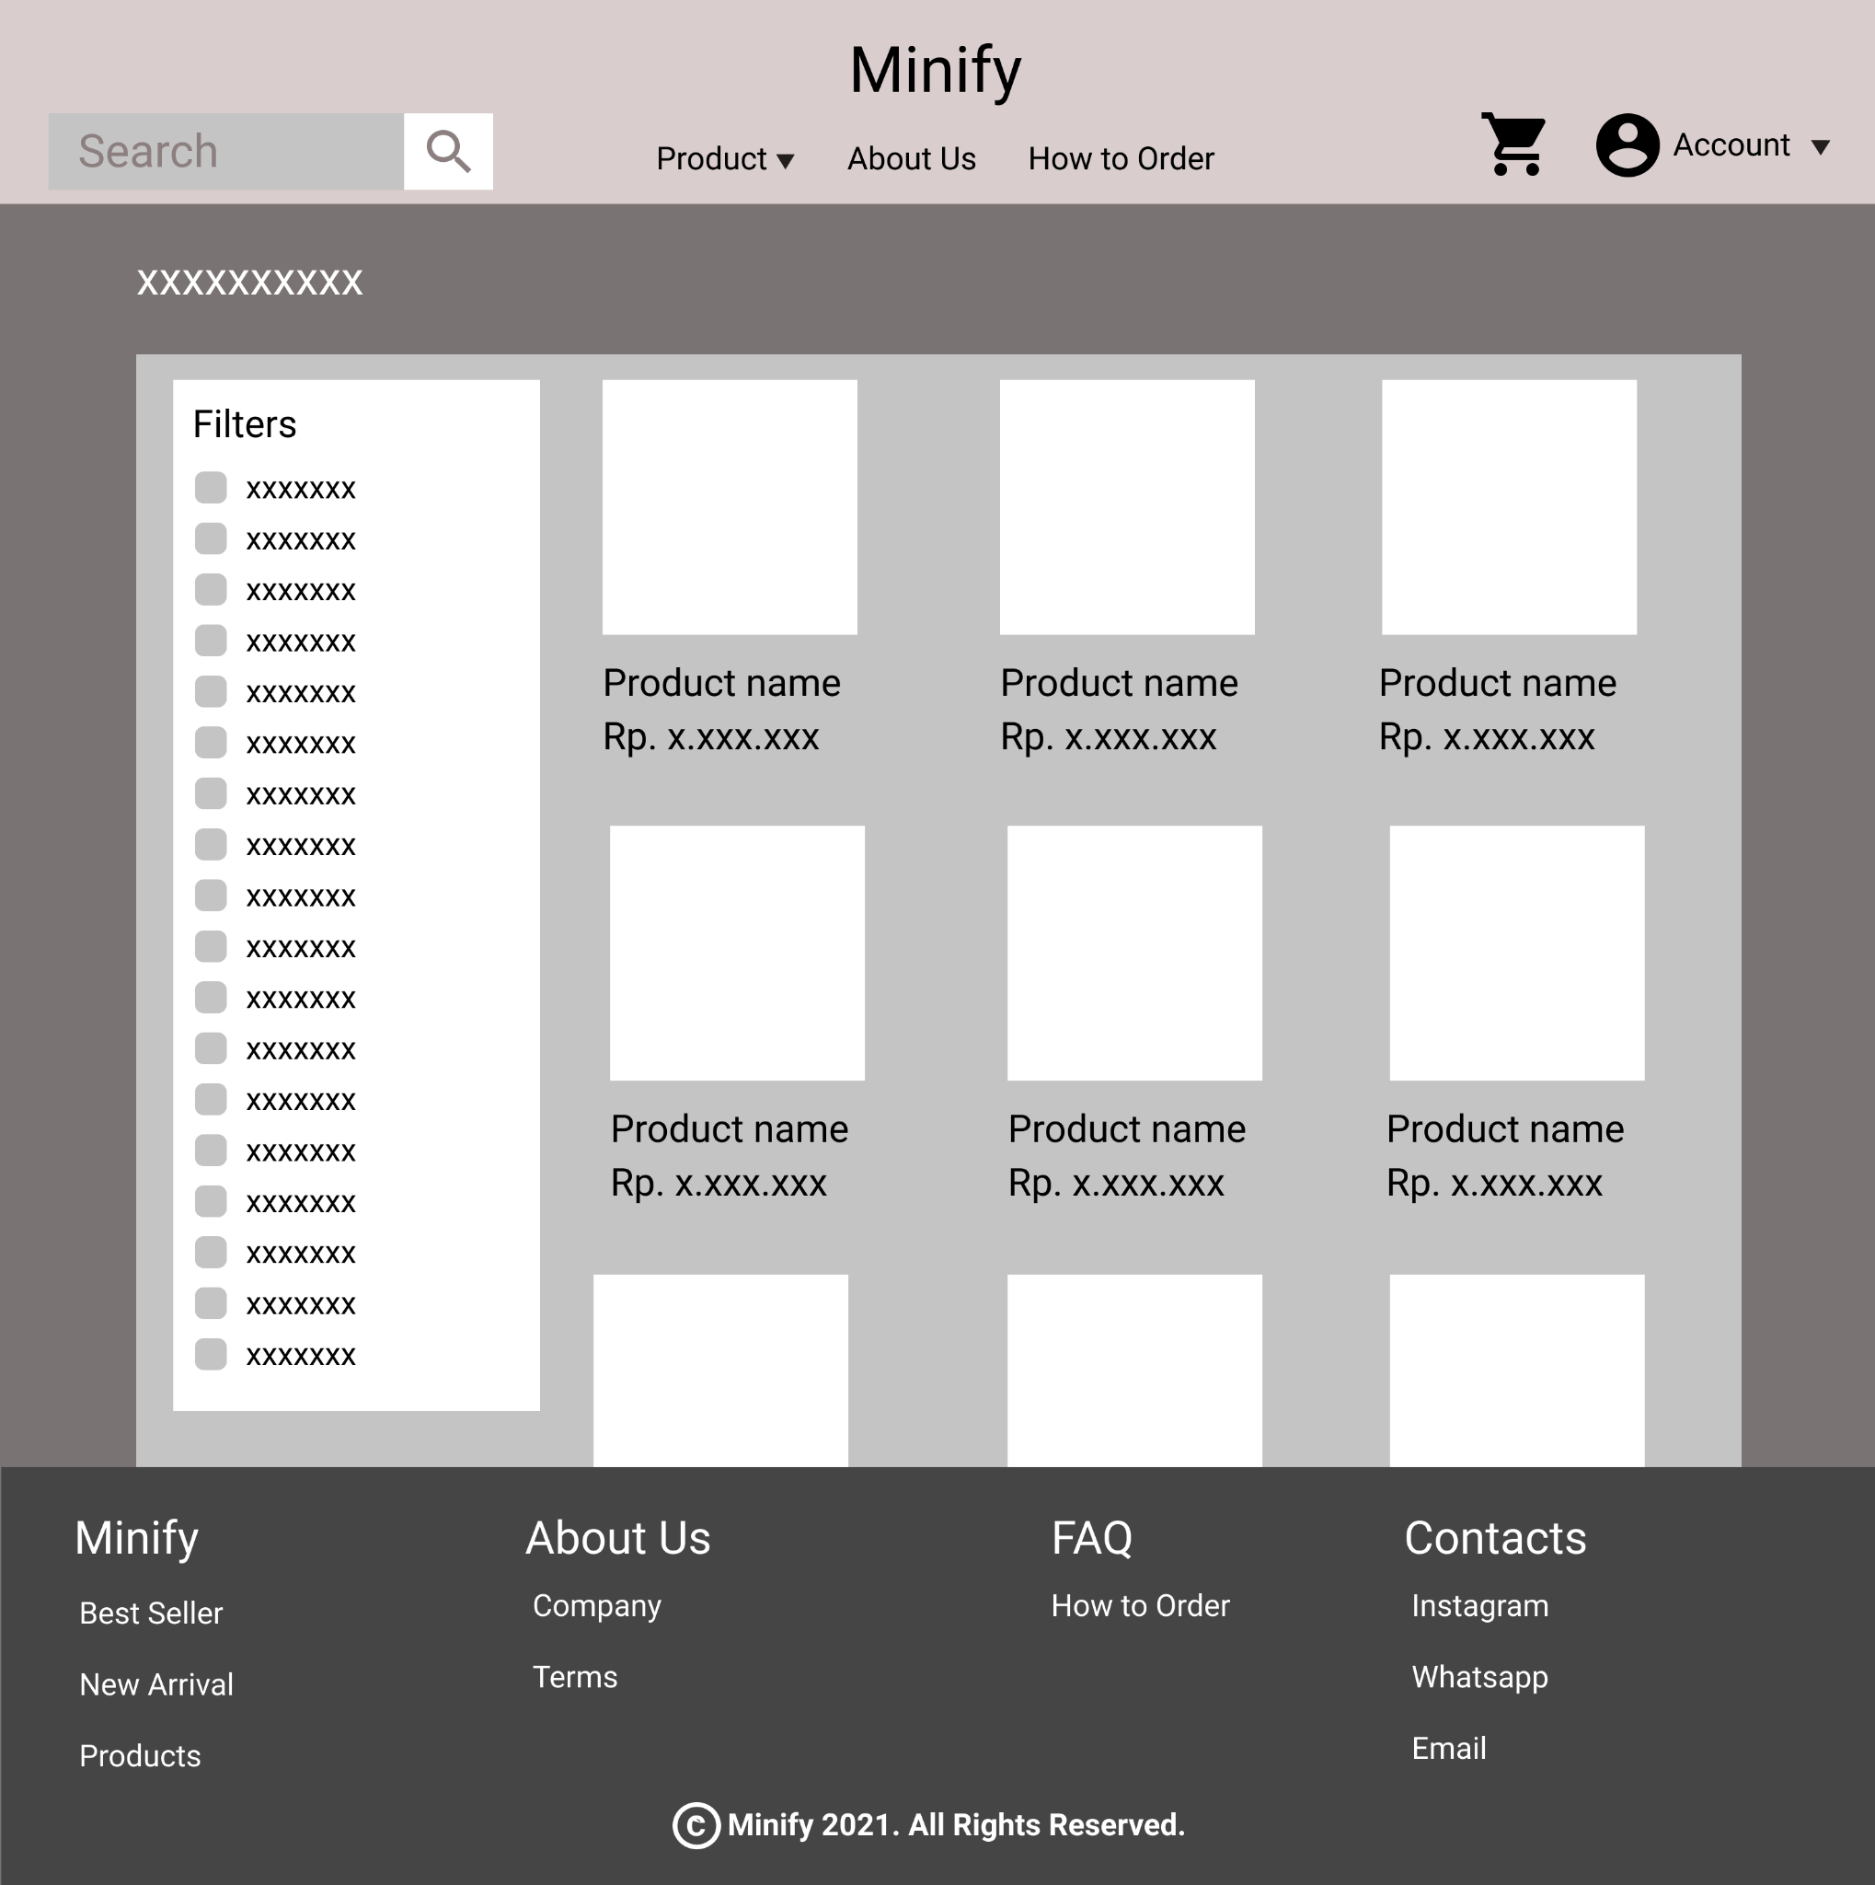

**Gambar 19.1 Mockup Products Page**

#### 19.B. Tampilan

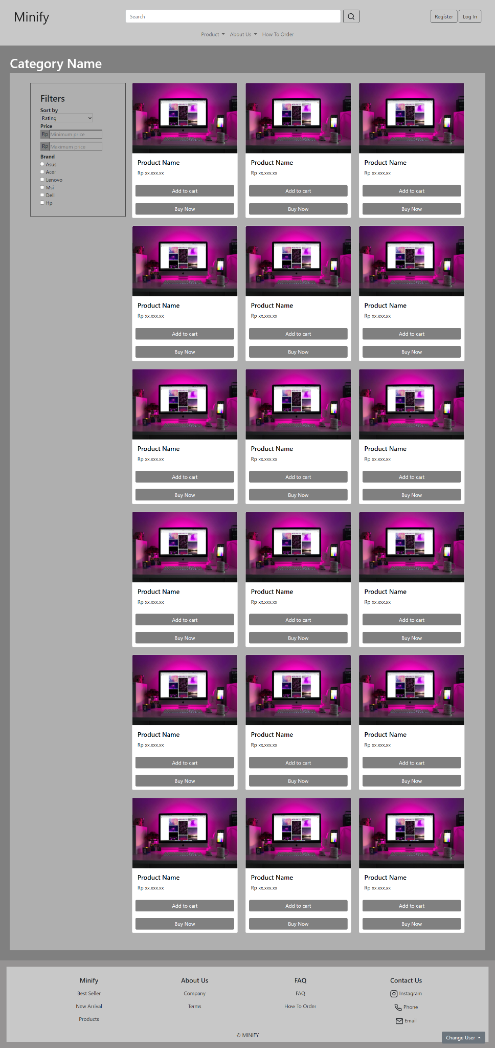

**Gambar 19.2 Tampilan Products Page**

#### 19.C. Flowchart

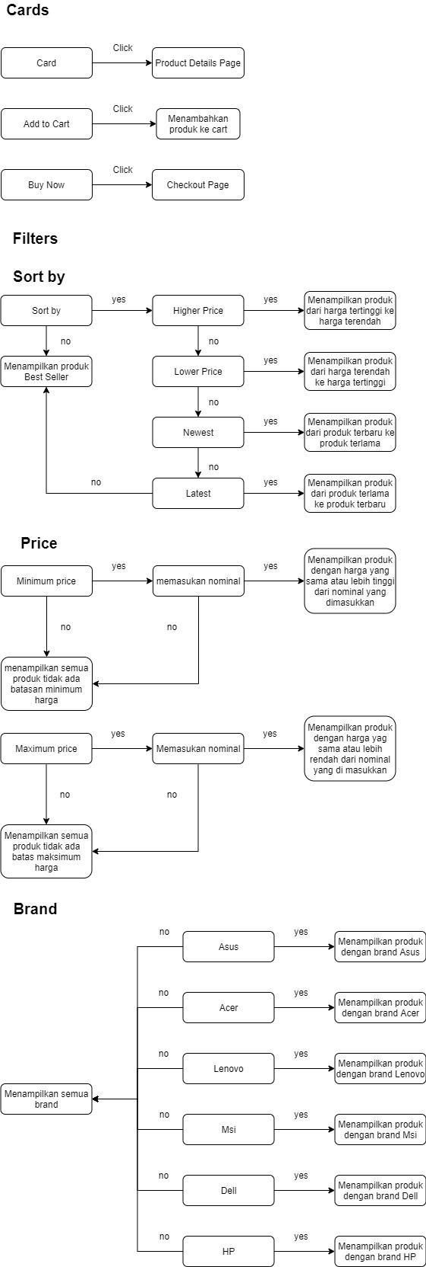

**Gambar 19.3 Flowchart Products Page Cards**



**Gambar 19.4 Flowchart Products Page Sort by**



**Gambar 19.5 Flowchart Products Page Price**



**Gambar 19.6 Flowchart Products Page Brand**

#### 19.D. Fitur

Pada halaman product ini menampilkan produk sesuai dengan kategorinya seperti, laptop, Komputer, Aksesoris, lain-lain, dan semua produk. Pada halaman product ini terdapat beberapa fitur yaitu :

1. Card : Di dalam card terdapat foto produk, harga produk, Add to Cart Button dan Buy Now Button. Jika card di klik maka akan menuju product details page dari produk tersebut.
2. Add to Cart : Jika di klik maka akan menambahkan produk ke dalam keranjang.
3. Buy Now : Jika di klik maka akan menuju checkout page.
4. Filters : Filters ini berguna untuk pelanggan lebih mudah menemukan barang yang ingin dibelinya. Berikut adalah filter yang bisa diterapkan :

* Sort by : Filter ini dapat diatur untuk mengurutkan produk berdasarkan harga tertinggi, harga terendah, produk terbaru, atau produk terlama. Tapi defaultnya adalah mengurutkan berdasarkan rating. Cara menggunakannya cukup klik kotak yang terdapat panah ke bawah dan nanti akan muncul drop-down yang berisi pilihan untuk mengurutkan produk.
* Price : Filter ini terdapat 2 bagian yaitu minimum price untuk mengatur harga terendah produk yang ingin ditampilkan dan yang kedua adalah maximum price untuk mengatur harga tertinggi produk yang ingin ditampilkan. Cara menggunakannya cukup masukkan nominal di bagian yang di inginkan.
* Brand : Filter ini berisi checkbox nama-nama brand. Filter ini berguna untuk menampilkan brand yang dipilih saja, tetapi jika tidak ada brand yang di pilih maka akan ditampilkan produk dari semua brand.

#### 19.E. Source Code

##### HTML

**<section style="background-color: grey; padding: 2%">**

**<h1 style="color: white">Category Name</h1>**

**<div class="dropdown filter-menu">**

**<button**

**class="btn btn-secondary dropdown-toggle"**

**type="button"**

**id="dropdownMenuButton1"**

**data-bs-toggle="dropdown"**

**aria-expanded="false"**

**>**

**Filters**

**</button>**

**<ul class="dropdown-menu" aria-labelledby="dropdownMenuButton1">**

**<li>**

**<div>**

**<p><b>Sort by</b></p>**

**<select class="custom-select" style="width: 70%">**

**<option selected>Rating</option>**

**<option value="1">Higher price</option>**

**<option value="2">Lower price</option>**

**<option value="3">Newest</option>**

**<option value="4">Latest</option>**

**</select>**

**</div>**

**</li>**

**<li>**

**<div>**

**<p><b>Price</b></p>**

**<div style="display: flex; margin-bottom: 10px">**

**<p style="background-color: grey; padding: 0 5px">Rp</p>**

**<input**

**type="text"**

**name=""**

**id=""**

**style="width: 70%"**

**placeholder="Minimum price"**

**/>**

**</div>**

**<div style="display: flex">**

**<p style="background-color: grey; padding: 0 5px">Rp</p>**

**<input**

**type="text"**

**name=""**

**id=""**

**style="width: 70%"**

**placeholder="Maximum price"**

**/>**

**</div>**

**</div>**

**</li>**

**<li>**

**<div style="margin-top: 5px">**

**<p><b>Brand</b></p>**

**<p><input type="checkbox" name="" id="" /> Asus</p>**

**<p><input type="checkbox" name="" id="" /> Acer</p>**

**<p><input type="checkbox" name="" id="" /> Lenovo</p>**

**<p><input type="checkbox" name="" id="" /> Msi</p>**

**<p><input type="checkbox" name="" id="" /> Dell</p>**

**<p><input type="checkbox" name="" id="" /> Hp</p>**

**</div>**

**</li>**

**<!-- <li><a class="dropdown-item" href="#">Something else here</a></li> -->**

**</ul>**

**</div>**

**<div class="product">**

**<div class="filter">**

**<h3>Filters</h3>**

**<div>**

**<p><b>Sort by</b></p>**

**<select class="custom-select" style="width: 70%">**

**<option selected>Rating</option>**

**<option value="1">Higher price</option>**

**<option value="2">Lower price</option>**

**<option value="3">Newest</option>**

**<option value="4">Latest</option>**

**</select>**

**</div>**

**<div>**

**<p><b>Price</b></p>**

**<div style="display: flex; margin-bottom: 10px">**

**<p style="background-color: grey; padding: 0 5px">Rp</p>**

**<input**

**type="text"**

**name=""**

**id=""**

**style="width: 70%"**

**placeholder="Minimum price"**

**/>**

**</div>**

**<div style="display: flex">**

**<p style="background-color: grey; padding: 0 5px">Rp</p>**

**<input**

**type="text"**

**name=""**

**id=""**

**style="width: 70%"**

**placeholder="Maximum price"**

**/>**

**</div>**

**</div>**

**<div style="margin-top: 5px">**

**<p><b>Brand</b></p>**

**<p><input type="checkbox" name="" id="" /> Asus</p>**

**<p><input type="checkbox" name="" id="" /> Acer</p>**

**<p><input type="checkbox" name="" id="" /> Lenovo</p>**

**<p><input type="checkbox" name="" id="" /> Msi</p>**

**<p><input type="checkbox" name="" id="" /> Dell</p>**

**<p><input type="checkbox" name="" id="" /> Hp</p>**

**</div>**

**</div>**

**<div class="prod">**

**<div>**

**<div class="row row-cols-1 row-cols-md-3">**

**<div class="col mb-4">**

**<a**

**href="details.html"**

**style="text-decoration: none; color: black"**

**>**

**<div class="card h-100">**

**<img**

**src="/image/designecologist-Pmh0UoG1vlE-unsplash.jpg"**

**class="card-img-top"**

**alt="..."**

**/>**

**<div class="card-body">**

**<h5 class="card-title">Product Name</h5>**

**<p class="card-text">Rp xx.xxx.xx</p>**

**</div>**

**<a**

**href="#"**

**class="btn btn-primary mar10"**

**style="background-color: grey; color: white; border: none"**

**>Add to cart</a**

**>**

**<a**

**href="checkout.html"**

**class="btn btn-primary mar10"**

**style="background-color: grey; color: white; border: none"**

**>Buy Now</a**

**>**

**</div>**

**</a>**

**</div>**

**<div class="col mb-4">**

**<a**

**href="details.html"**

**style="text-decoration: none; color: black"**

**>**

**<div class="card h-100">**

**<img**

**src="/image/designecologist-Pmh0UoG1vlE-unsplash.jpg"**

**class="card-img-top"**

**alt="..."**

**/>**

**<div class="card-body">**

**<h5 class="card-title">Product Name</h5>**

**<p class="card-text">Rp xx.xxx.xx</p>**

**</div>**

**<a**

**href="#"**

**class="btn btn-primary mar10"**

**style="background-color: grey; color: white; border: none"**

**>Add to cart</a**

**>**

**<a**

**href="checkout.html"**

**class="btn btn-primary mar10"**

**style="background-color: grey; color: white; border: none"**

**>Buy Now</a**

**>**

**</div>**

**</a>**

**</div>**

**<div class="col mb-4">**

**<a**

**href="details.html"**

**style="text-decoration: none; color: black"**

**>**

**<div class="card h-100">**

**<img**

**src="/image/designecologist-Pmh0UoG1vlE-unsplash.jpg"**

**class="card-img-top"**

**alt="..."**

**/>**

**<div class="card-body">**

**<h5 class="card-title">Product Name</h5>**

**<p class="card-text">Rp xx.xxx.xx</p>**

**</div>**

**<a**

**href="#"**

**class="btn btn-primary mar10"**

**style="background-color: grey; color: white; border: none"**

**>Add to cart</a**

**>**

**<a**

**href="checkout.html"**

**class="btn btn-primary mar10"**

**style="background-color: grey; color: white; border: none"**

**>Buy Now</a**

**>**

**</div>**

**</a>**

**</div>**

**<div class="col mb-4">**

**<a**

**href="details.html"**

**style="text-decoration: none; color: black"**

**>**

**<div class="card h-100">**

**<img**

**src="/image/designecologist-Pmh0UoG1vlE-unsplash.jpg"**

**class="card-img-top"**

**alt="..."**

**/>**

**<div class="card-body">**

**<h5 class="card-title">Product Name</h5>**

**<p class="card-text">Rp xx.xxx.xx</p>**

**</div>**

**<a**

**href="#"**

**class="btn btn-primary mar10"**

**style="background-color: grey; color: white; border: none"**

**>Add to cart</a**

**>**

**<a**

**href="checkout.html"**

**class="btn btn-primary mar10"**

**style="background-color: grey; color: white; border: none"**

**>Buy Now</a**

**>**

**</div>**

**</a>**

**</div>**

**<div class="col mb-4">**

**<a**

**href="details.html"**

**style="text-decoration: none; color: black"**

**>**

**<div class="card h-100">**

**<img**

**src="/image/designecologist-Pmh0UoG1vlE-unsplash.jpg"**

**class="card-img-top"**

**alt="..."**

**/>**

**<div class="card-body">**

**<h5 class="card-title">Product Name</h5>**

**<p class="card-text">Rp xx.xxx.xx</p>**

**</div>**

**<a**

**href="#"**

**class="btn btn-primary mar10"**

**style="background-color: grey; color: white; border: none"**

**>Add to cart</a**

**>**

**<a**

**href="checkout.html"**

**class="btn btn-primary mar10"**

**style="background-color: grey; color: white; border: none"**

**>Buy Now</a**

**>**

**</div>**

**</a>**

**</div>**

**<div class="col mb-4">**

**<a**

**href="details.html"**

**style="text-decoration: none; color: black"**

**>**

**<div class="card h-100">**

**<img**

**src="/image/designecologist-Pmh0UoG1vlE-unsplash.jpg"**

**class="card-img-top"**

**alt="..."**

**/>**

**<div class="card-body">**

**<h5 class="card-title">Product Name</h5>**

**<p class="card-text">Rp xx.xxx.xx</p>**

**</div>**

**<a**

**href="#"**

**class="btn btn-primary mar10"**

**style="background-color: grey; color: white; border: none"**

**>Add to cart</a**

**>**

**<a**

**href="checkout.html"**

**class="btn btn-primary mar10"**

**style="background-color: grey; color: white; border: none"**

**>Buy Now</a**

**>**

**</div>**

**</a>**

**</div>**

**<div class="col mb-4">**

**<a**

**href="details.html"**

**style="text-decoration: none; color: black"**

**>**

**<div class="card h-100">**

**<img**

**src="/image/designecologist-Pmh0UoG1vlE-unsplash.jpg"**

**class="card-img-top"**

**alt="..."**

**/>**

**<div class="card-body">**

**<h5 class="card-title">Product Name</h5>**

**<p class="card-text">Rp xx.xxx.xx</p>**

**</div>**

**<a**

**href="#"**

**class="btn btn-primary mar10"**

**style="background-color: grey; color: white; border: none"**

**>Add to cart</a**

**>**

**<a**

**href="checkout.html"**

**class="btn btn-primary mar10"**

**style="background-color: grey; color: white; border: none"**

**>Buy Now</a**

**>**

**</div>**

**</a>**

**</div>**

**<div class="col mb-4">**

**<a**

**href="details.html"**

**style="text-decoration: none; color: black"**

**>**

**<div class="card h-100">**

**<img**

**src="/image/designecologist-Pmh0UoG1vlE-unsplash.jpg"**

**class="card-img-top"**

**alt="..."**

**/>**

**<div class="card-body">**

**<h5 class="card-title">Product Name</h5>**

**<p class="card-text">Rp xx.xxx.xx</p>**

**</div>**

**<a**

**href="#"**

**class="btn btn-primary mar10"**

**style="background-color: grey; color: white; border: none"**

**>Add to cart</a**

**>**

**<a**

**href="checkout.html"**

**class="btn btn-primary mar10"**

**style="background-color: grey; color: white; border: none"**

**>Buy Now</a**

**>**

**</div>**

**</a>**

**</div>**

**<div class="col mb-4">**

**<a**

**href="details.html"**

**style="text-decoration: none; color: black"**

**>**

**<div class="card h-100">**

**<img**

**src="/image/designecologist-Pmh0UoG1vlE-unsplash.jpg"**

**class="card-img-top"**

**alt="..."**

**/>**

**<div class="card-body">**

**<h5 class="card-title">Product Name</h5>**

**<p class="card-text">Rp xx.xxx.xx</p>**

**</div>**

**<a**

**href="#"**

**class="btn btn-primary mar10"**

**style="background-color: grey; color: white; border: none"**

**>Add to cart</a**

**>**

**<a**

**href="checkout.html"**

**class="btn btn-primary mar10"**

**style="background-color: grey; color: white; border: none"**

**>Buy Now</a**

**>**

**</div>**

**</a>**

**</div>**

**<div class="col mb-4">**

**<a**

**href="details.html"**

**style="text-decoration: none; color: black"**

**>**

**<div class="card h-100">**

**<img**

**src="/image/designecologist-Pmh0UoG1vlE-unsplash.jpg"**

**class="card-img-top"**

**alt="..."**

**/>**

**<div class="card-body">**

**<h5 class="card-title">Product Name</h5>**

**<p class="card-text">Rp xx.xxx.xx</p>**

**</div>**

**<a**

**href="#"**

**class="btn btn-primary mar10"**

**style="background-color: grey; color: white; border: none"**

**>Add to cart</a**

**>**

**<a**

**href="checkout.html"**

**class="btn btn-primary mar10"**

**style="background-color: grey; color: white; border: none"**

**>Buy Now</a**

**>**

**</div>**

**</a>**

**</div>**

**<div class="col mb-4">**

**<a**

**href="details.html"**

**style="text-decoration: none; color: black"**

**>**

**<div class="card h-100">**

**<img**

**src="/image/designecologist-Pmh0UoG1vlE-unsplash.jpg"**

**class="card-img-top"**

**alt="..."**

**/>**

**<div class="card-body">**

**<h5 class="card-title">Product Name</h5>**

**<p class="card-text">Rp xx.xxx.xx</p>**

**</div>**

**<a**

**href="#"**

**class="btn btn-primary mar10"**

**style="background-color: grey; color: white; border: none"**

**>Add to cart</a**

**>**

**<a**

**href="checkout.html"**

**class="btn btn-primary mar10"**

**style="background-color: grey; color: white; border: none"**

**>Buy Now</a**

**>**

**</div>**

**</a>**

**</div>**

**<div class="col mb-4">**

**<a**

**href="details.html"**

**style="text-decoration: none; color: black"**

**>**

**<div class="card h-100">**

**<img**

**src="/image/designecologist-Pmh0UoG1vlE-unsplash.jpg"**

**class="card-img-top"**

**alt="..."**

**/>**

**<div class="card-body">**

**<h5 class="card-title">Product Name</h5>**

**<p class="card-text">Rp xx.xxx.xx</p>**

**</div>**

**<a**

**href="#"**

**class="btn btn-primary mar10"**

**style="background-color: grey; color: white; border: none"**

**>Add to cart</a**

**>**

**<a**

**href="checkout.html"**

**class="btn btn-primary mar10"**

**style="background-color: grey; color: white; border: none"**

**>Buy Now</a**

**>**

**</div>**

**</a>**

**</div>**

**<div class="col mb-4">**

**<a**

**href="details.html"**

**style="text-decoration: none; color: black"**

**>**

**<div class="card h-100">**

**<img**

**src="/image/designecologist-Pmh0UoG1vlE-unsplash.jpg"**

**class="card-img-top"**

**alt="..."**

**/>**

**<div class="card-body">**

**<h5 class="card-title">Product Name</h5>**

**<p class="card-text">Rp xx.xxx.xx</p>**

**</div>**

**<a**

**href="#"**

**class="btn btn-primary mar10"**

**style="background-color: grey; color: white; border: none"**

**>Add to cart</a**

**>**

**<a**

**href="checkout.html"**

**class="btn btn-primary mar10"**

**style="background-color: grey; color: white; border: none"**

**>Buy Now</a**

**>**

**</div>**

**</a>**

**</div>**

**<div class="col mb-4">**

**<a**

**href="details.html"**

**style="text-decoration: none; color: black"**

**>**

**<div class="card h-100">**

**<img**

**src="/image/designecologist-Pmh0UoG1vlE-unsplash.jpg"**

**class="card-img-top"**

**alt="..."**

**/>**

**<div class="card-body">**

**<h5 class="card-title">Product Name</h5>**

**<p class="card-text">Rp xx.xxx.xx</p>**

**</div>**

**<a**

**href="#"**

**class="btn btn-primary mar10"**

**style="background-color: grey; color: white; border: none"**

**>Add to cart</a**

**>**

**<a**

**href="checkout.html"**

**class="btn btn-primary mar10"**

**style="background-color: grey; color: white; border: none"**

**>Buy Now</a**

**>**

**</div>**

**</a>**

**</div>**

**<div class="col mb-4">**

**<a**

**href="details.html"**

**style="text-decoration: none; color: black"**

**>**

**<div class="card h-100">**

**<img**

**src="/image/designecologist-Pmh0UoG1vlE-unsplash.jpg"**

**class="card-img-top"**

**alt="..."**

**/>**

**<div class="card-body">**

**<h5 class="card-title">Product Name</h5>**

**<p class="card-text">Rp xx.xxx.xx</p>**

**</div>**

**<a**

**href="#"**

**class="btn btn-primary mar10"**

**style="background-color: grey; color: white; border: none"**

**>Add to cart</a**

**>**

**<a**

**href="checkout.html"**

**class="btn btn-primary mar10"**

**style="background-color: grey; color: white; border: none"**

**>Buy Now</a**

**>**

**</div>**

**</a>**

**</div>**

**<div class="col mb-4">**

**<a**

**href="details.html"**

**style="text-decoration: none; color: black"**

**>**

**<div class="card h-100">**

**<img**

**src="/image/designecologist-Pmh0UoG1vlE-unsplash.jpg"**

**class="card-img-top"**

**alt="..."**

**/>**

**<div class="card-body">**

**<h5 class="card-title">Product Name</h5>**

**<p class="card-text">Rp xx.xxx.xx</p>**

**</div>**

**<a**

**href="#"**

**class="btn btn-primary mar10"**

**style="background-color: grey; color: white; border: none"**

**>Add to cart</a**

**>**

**<a**

**href="checkout.html"**

**class="btn btn-primary mar10"**

**style="background-color: grey; color: white; border: none"**

**>Buy Now</a**

**>**

**</div>**

**</a>**

**</div>**

**<div class="col mb-4">**

**<a**

**href="details.html"**

**style="text-decoration: none; color: black"**

**>**

**<div class="card h-100">**

**<img**

**src="/image/designecologist-Pmh0UoG1vlE-unsplash.jpg"**

**class="card-img-top"**

**alt="..."**

**/>**

**<div class="card-body">**

**<h5 class="card-title">Product Name</h5>**

**<p class="card-text">Rp xx.xxx.xx</p>**

**</div>**

**<a**

**href="#"**

**class="btn btn-primary mar10"**

**style="background-color: grey; color: white; border: none"**

**>Add to cart</a**

**>**

**<a**

**href="checkout.html"**

**class="btn btn-primary mar10"**

**style="background-color: grey; color: white; border: none"**

**>Buy Now</a**

**>**

**</div>**

**</a>**

**</div>**

**<div class="col mb-4">**

**<a**

**href="details.html"**

**style="text-decoration: none; color: black"**

**>**

**<div class="card h-100">**

**<img**

**src="/image/designecologist-Pmh0UoG1vlE-unsplash.jpg"**

**class="card-img-top"**

**alt="..."**

**/>**

**<div class="card-body">**

**<h5 class="card-title">Product Name</h5>**

**<p class="card-text">Rp xx.xxx.xx</p>**

**</div>**

**<a**

**href="#"**

**class="btn btn-primary mar10"**

**style="background-color: grey; color: white; border: none"**

**>Add to cart</a**

**>**

**<a**

**href="checkout.html"**

**class="btn btn-primary mar10"**

**style="background-color: grey; color: white; border: none"**

**>Buy Now</a**

**>**

**</div>**

**</a>**

**</div>**

**</div>**

**</div>**

**</div>**

**</div>**

**</section>**

##### CSS

**<style>**

**.jc-sb {**

**display: flex;**

**justify-content: space-between;**

**}**

**.ta-c {**

**text-align: center;**

**}**

**.td a {**

**text-decoration: none;**

**color: black;**

**}**

**.mar10 {**

**margin: 10px;**

**}**

**\* {**

**margin: 0;**

**padding: 0;**

**}**

**.min-back {**

**background-color: rgb(175, 175, 175);**

**}**

**.filter {**

**width: 20%;**

**border: 1px solid black;**

**margin-right: 20px;**

**padding: 2%;**

**height: 25%;**

**}**

**.product {**

**background-color: rgb(175, 175, 175);**

**display: flex;**

**justify-content: center;**

**padding: 2% 0;**

**}**

**.prod {**

**width: 70%;**

**}**

**p {**

**margin-bottom: 0;**

**}**

**.filter *,**

**.filter-menu * {**

**background-color: rgb(175, 175, 175);**

**}**

**.filter-menu {**

**display: none;**

**}**

**@media screen and (max-width: 767px) {**

**.filter-menu {**

**display: block;**

**margin: 5%;**

**}**

**.filter {**

**display: none;**

**}**

**.row-cols-md-3 > * {**

**-ms-flex: 0 0 50%;**

**flex: 0 0 50%;**

**max-width: 50%;**

**}**

**}**

**@media screen and (max-width: 550px) {**

**.row-cols-md-3 > * {**

**-ms-flex: 0 0 100%;**

**flex: 0 0 100%;**

**max-width: 100%;**

**}**

**}**

**</style>**

### Product Details

#### 20.A. Tampilan

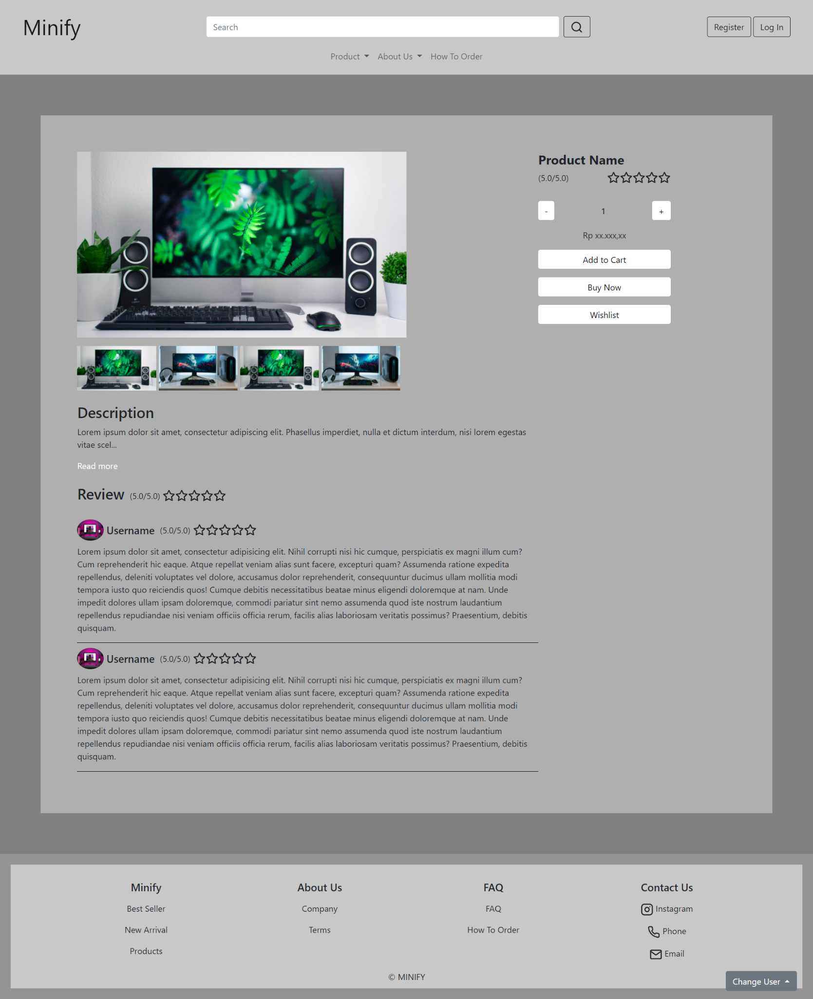

**Gambar 20.1 Tampilan Product Details Page**

#### 20.B. Flowchart

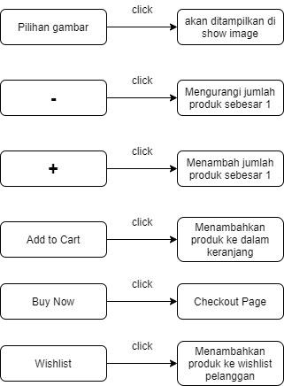

**Gambar 20.1 Flowchart Product Details Page**

#### 20.C. Fitur

Pada halaman product details menampilkan details dari produk tersebut seperti foto produk, rating, harga, deskripsi, dan review. Di halaman ini juga pelanggan bisa membeli, memasukan produk ke dalam keranjang, dan memasukkan produk ke dalam wishlist. Fitur yang terdapat dalam halaman ini yaitu :

1. Foto produk : Pada bagian ini terdapat 2 bagian yaitu image view dan image option. Image view berguna untuk menampilkan gambar image option yang dipilih. Sedangkan image option adalah gambar-gambar dari produk yang dapat di lihat.
2. Ratings : Pada bagian ini menampilkan rating dari produk tersebut.
3. Tombol minus : Tombol ini berguna untuk mengurangi jumlah produk yang ingin dibeli sebesar 1.
4. Total produk : Bagian ini adalah untuk jumlah produk yang ingin dibeli yang bisa diatur dengan tombol plus dan minus, atau juga bisa dengan cara diketik
5. Tombol plus : Tombol ini berguna untuk mengurangi jumlah produk yang ingin dibeli sebanyak 1.
6. Harga produk : Pada bagian ini menampilkan harga dari produk tersebut.
7. Add to Cart Button : Tombol ini jika di klik akan menambahkan produk ke dalam keranjang pelanggan.
8. Buy Now Button : Tombol ini jika di klik maka pelanggan akan langsung diarahkan ke checkout page untuk melakukan pemesanan produk tersebut.
9. Wishlist Button : Tombol ini jika di klik maka produk akan masuk kedalam wishlist pelanggan.
10. Description : Bagian ini berisi deskripsi dari produk. Pada bagian ini terdapat read more button untuk melihat deskripsi lengkap tentang produk.
11. Review : Bagian ini berisi review dari pelanggan yang pernah membeli produk.

#### 20.D. Source Code

##### Html

**<section style="background-color: grey; padding: 5%">**

**<div class="secmargin">**

**<div class="mb-4 product">**

**<!-- Image -->**

**<div class="prodimage">**

**<!-- Image view -->**

**<section>**

**<div class="mb-3">**

**<img**

**src="/image/niclas-illg-gyRa86ExKTw-unsplash.jpg"**

**alt="image"**

**class="main-image"**

**id="expandedImg"**

**/>**

**</div>**

**</section>**

**<!-- Image Option -->**

**<div>**

**<img**

**src="/image/niclas-illg-gyRa86ExKTw-unsplash.jpg"**

**alt="image"**

**class="image-option"**

**onclick="image(this);"**

**/>**

**<img**

**src="/image/alienware-Bp3KmTZQlfw-unsplash.jpg"**

**alt="image"**

**class="image-option"**

**onclick="image(this);"**

**/>**

**<img**

**src="/image/niclas-illg-gyRa86ExKTw-unsplash.jpg"**

**alt="image"**

**class="image-option"**

**onclick="image(this);"**

**/>**

**<img**

**src="/image/alienware-Bp3KmTZQlfw-unsplash.jpg"**

**alt="image"**

**class="image-option"**

**onclick="image(this);"**

**/>**

**</div>**

**</div>**

**<!-- Product Details -->**

**<div class="prodetail">**

**<h4><b>Product Name</b></h4>**

**<div class="jc-sb mb-3">**

**<p>(5.0/5.0)</p>**

**<div style="display: flex; margin-left: 5px">**

**<i data-feather="star"></i>**

**<i data-feather="star"></i>**

**<i data-feather="star"></i>**

**<i data-feather="star"></i>**

**<i data-feather="star"></i>**

**</div>**

**</div>**

**<div class="jc-sb mb-3">**

**<input**

**class="btn btn-primary"**

**type="button"**

**onclick="downFunc()"**

**value="-"**

**style="background-color: white; color: black; border: none"**

**/>**

**<input**

**type="number"**

**value="1"**

**id="count"**

**style="**

**width: 25%;**

**background-color: rgb(175, 175, 175);**

**border: none;**

**text-align: center;**

**"**

**/>**

**<input**

**class="btn btn-primary"**

**type="button"**

**onclick="upFunc()"**

**value="+"**

**style="background-color: white; color: black; border: none"**

**/>**

**</div>**

**<!-- Price -->**

**<div style="text-align: center">**

**<p>Rp xx.xxx,xx</p>**

**</div>**

**<div class="mb-3">**

**<input**

**class="btn btn-primary"**

**type="submit"**

**value="Add to Cart"**

**style="**

**width: 100%;**

**background-color: white;**

**color: black;**

**border: none;**

**"**

**/>**

**</div>**

**<div class="mb-3">**

**<a**

**id="check"**

**class="btn btn-primary"**

**type="submit"**

**value="Buy Now"**

**href="checkout.html"**

**style="**

**width: 100%;**

**background-color: white;**

**color: black;**

**border: none;**

**"**

**>Buy Now</a**

**>**

**</div>**

**<div class="mb-3">**

**<input**

**class="btn btn-primary"**

**type="submit"**

**value="Wishlist"**

**style="**

**width: 100%;**

**background-color: white;**

**color: black;**

**border: none;**

**"**

**/>**

**</div>**

**</div>**

**</div>**

**<!-- Product Description -->**

**<div>**

**<div class="mb-4">**

**<h3>Description</h3>**

**<div class="descbox">**

**<div class="proddesc">**

**<p>**

**Lorem ipsum dolor sit amet, consectetur adipiscing elit.**

**Phasellus imperdiet, nulla et dictum interdum, nisi lorem**

**egestas vitae scel<span id="dots">...</span**

**><span id="showmore"**

**>erisque enim ligula venenatis dolor. Maecenas nisl est,**

**ultrices nec congue eget, auctor vitae massa. Fusce luctus**

**vestibulum augue ut aliquet. Nunc sagittis dictum nisi, sed**

**ullamcorper ipsum dignissim ac. In at libero sed nunc**

**venenatis imperdiet sed ornare turpis. Donec vitae dui eget**

**tellus gravida venenatis. Integer fringilla congue eros non**

**fermentum. Sed dapibus pulvinar nibh tempor porta.</span**

**>**

**</p>**

**<a**

**onclick="readMore()"**

**id="myBtn"**

**style="cursor: pointer; color: white"**

**>**

**Read more**

**</a>**

**</div>**

**</div>**

**</div>**

**<!-- Product Review -->**

**<div>**

**<div>**

**<div style="display: flex; align-items: center">**

**<h3>Review</h3>**

**<div class="jc-sb" style="margin-left: 10px">**

**<div style="margin-bottom: 0">**

**<p style="margin-bottom: 0">(5.0/5.0)</p>**

**</div>**

**<div**

**style="display: flex; margin-left: 5px; align-items: center"**

**>**

**<i data-feather="star"></i>**

**<i data-feather="star"></i>**

**<i data-feather="star"></i>**

**<i data-feather="star"></i>**

**<i data-feather="star"></i>**

**</div>**

**</div>**

**</div>**

**<br />**

**<div class="reviewbox">**

**<div class="prodreview">**

**<div class="mb-2" style="display: flex">**

**<img**

**src="/image/designecologist-Pmh0UoG1vlE-unsplash.jpg"**

**alt="image"**

**style="border-radius: 50%; height: 40px; width: 50px"**

**/>**

**<h5**

**style="**

**margin-bottom: 0;**

**align-items: center;**

**display: flex;**

**margin-left: 5px;**

**"**

**>**

**Username**

**</h5>**

**<div class="jc-sb" style="margin-left: 10px">**

**<div**

**style="**

**margin-bottom: 0;**

**align-items: center;**

**display: flex;**

**"**

**>**

**<p style="margin-bottom: 0">(5.0/5.0)</p>**

**</div>**

**<div**

**style="**

**display: flex;**

**margin-left: 5px;**

**align-items: center;**

**"**

**>**

**<i data-feather="star"></i>**

**<i data-feather="star"></i>**

**<i data-feather="star"></i>**

**<i data-feather="star"></i>**

**<i data-feather="star"></i>**

**</div>**

**</div>**

**</div>**

**<p>**

**Lorem ipsum dolor sit amet, consectetur adipisicing elit.**

**Nihil corrupti nisi hic cumque, perspiciatis ex magni illum**

**cum? Cum reprehenderit hic eaque. Atque repellat veniam**

**alias sunt facere, excepturi quam? Assumenda ratione**

**expedita repellendus, deleniti voluptates vel dolore,**

**accusamus dolor reprehenderit, consequuntur ducimus ullam**

**mollitia modi tempora iusto quo reiciendis quos! Cumque**

**debitis necessitatibus beatae minus eligendi doloremque at**

**nam. Unde impedit dolores ullam ipsam doloremque, commodi**

**pariatur sint nemo assumenda quod iste nostrum laudantium**

**repellendus repudiandae nisi veniam officiis officia rerum,**

**facilis alias laboriosam veritatis possimus? Praesentium,**

**debitis quisquam.**

**</p>**

**</div>**

**</div>**

**<div class="reviewbox">**

**<div class="prodreview">**

**<div class="mb-2" style="display: flex">**

**<img**

**src="/image/designecologist-Pmh0UoG1vlE-unsplash.jpg"**

**alt="image"**

**style="border-radius: 50%; height: 40px; width: 50px"**

**/>**

**<h5**

**style="**

**margin-bottom: 0;**

**align-items: center;**

**display: flex;**

**margin-left: 5px;**

**"**

**>**

**Username**

**</h5>**

**<div class="jc-sb" style="margin-left: 10px">**

**<div**

**style="**

**margin-bottom: 0;**

**align-items: center;**

**display: flex;**

**"**

**>**

**<p style="margin-bottom: 0">(5.0/5.0)</p>**

**</div>**

**<div**

**style="**

**display: flex;**

**margin-left: 5px;**

**align-items: center;**

**"**

**>**

**<i data-feather="star"></i>**

**<i data-feather="star"></i>**

**<i data-feather="star"></i>**

**<i data-feather="star"></i>**

**<i data-feather="star"></i>**

**</div>**

**</div>**

**</div>**

**<p>**

**Lorem ipsum dolor sit amet, consectetur adipisicing elit.**

**Nihil corrupti nisi hic cumque, perspiciatis ex magni illum**

**cum? Cum reprehenderit hic eaque. Atque repellat veniam**

**alias sunt facere, excepturi quam? Assumenda ratione**

**expedita repellendus, deleniti voluptates vel dolore,**

**accusamus dolor reprehenderit, consequuntur ducimus ullam**

**mollitia modi tempora iusto quo reiciendis quos! Cumque**

**debitis necessitatibus beatae minus eligendi doloremque at**

**nam. Unde impedit dolores ullam ipsam doloremque, commodi**

**pariatur sint nemo assumenda quod iste nostrum laudantium**

**repellendus repudiandae nisi veniam officiis officia rerum,**

**facilis alias laboriosam veritatis possimus? Praesentium,**

**debitis quisquam.**

**</p>**

**</div>**

**</div>**

**</div>**

**</div>**

**</div>**

**</div>**

**</section>**

##### CSS

**<style>**

**.jc-sb {**

**display: flex;**

**justify-content: space-between;**

**}**

**.ta-c {**

**text-align: center;**

**}**

**.td a {**

**text-decoration: none;**

**color: black;**

**}**

**.product {**

**display: flex;**

**/* justify-content: space-between; */**

**}**

**.prodimage {**

**width: 50%;**

**}**

**.main-image {**

**width: 100%;**

**height: 80%;**

**object-fit: cover;**

**}**

**.image-option {**

**width: 24%;**

**}**

**.reviewbox,**

**.descbox {**

**width: 100%;**

**}**

**.prodreview {**

**border-bottom: 1px solid black;**

**margin-bottom: 10px;**

**}**

**.prodreview,**

**.proddesc {**

**width: 70%;**

**}**

**.prodetail {**

**margin-left: 20%;**

**}**

**.secmargin {**

**background-color: rgb(175, 175, 175);**

**padding: 5%;**

**}**

**.image-option:hover {**

**opacity: 0.7;**

**cursor: pointer;**

**}**

**.next {**

**position: absolute;**

**border-radius: 100%;**

**width: 30px;**

**height: 30px;**

**transform: translate(-120%, 250%);**

**border: none;**

**font-weight: bold;**

**}**

**.prev {**

**position: absolute;**

**border-radius: 100%;**

**width: 30px;**

**height: 30px;**

**transform: translate(-1050%, 250%);**

**border: none;**

**font-weight: bold;**

**}**

**#showmore {**

**display: none;**

**}**

**input::-webkit-outer-spin-button,**

**input::-webkit-inner-spin-button {**

**-webkit-appearance: none;**

**margin: 0;**

**}**

**input[type="number"] {**

**-moz-appearance: textfield;**

**}**

**@media screen and (max-width: 800px) {**

**.product {**

**display: block;**

**}**

**.prodimage {**

**width: 100%;**

**margin-bottom: 5%;**

**}**

**.reviewbox,**

**.descbox {**

**width: 100%;**

**}**

**.prodreview,**

**.proddesc {**

**width: 100%;**

**}**

**.main-image {**

**width: 100%;**

**}**

**.prodetail {**

**margin-left: 0;**

**}**

**.secmargin {**

**margin: 10% 10%;**

**}**

**}**

**</style>**

##### Javascript

**<script>**

**feather.replace();**

**function image(imgs) {**

**var expandImg = document.getElementById("expandedImg");**

**expandImg.src = imgs.src;**

**expandImg.parentElement.style.display = "block";**

**}**

**function upFunc() {**

**document.getElementById("count").stepUp(1);**

**console.log("work up");**

**}**

**function downFunc() {**

**var down = document.getElementById("count");**

**if (down.value > 1) {**

**down.stepDown(1);**

**console.log("work down");**

**}**

**}**

**function readMore() {**

**var dots = document.getElementById("dots");**

**var moreText = document.getElementById("showmore");**

**var btnText = document.getElementById("myBtn");**

**if (dots.style.display === "none") {**

**dots.style.display = "inline";**

**btnText.innerHTML = "Read more";**

**moreText.style.display = "none";**

**} else {**

**dots.style.display = "none";**

**btnText.innerHTML = "Read less";**

**moreText.style.display = "inline";**

**}**

**}**

**</script>**

### Company

#### 21. A. Mock Up

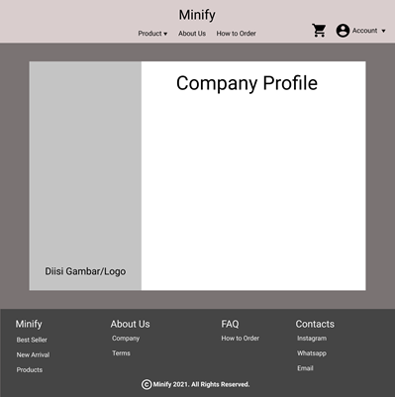

**Gambar 21.A. Mock Up Company Page**

#### 21. B. Tampilan

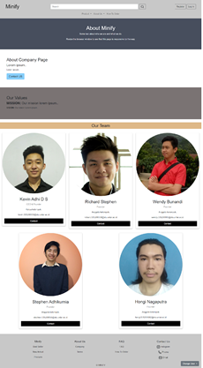

**Gambar 21.B. Tampilan Company Page**

#### 21. C. Flowchart

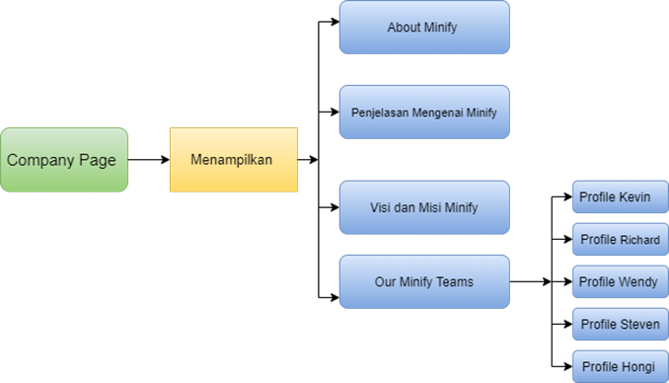

**Gambar 21.C. Flowchart Company Page**

#### 21. D. Fitur

Company Page adalah page yang menampilkan Informasi mengenai perusahaan Minfiy termasuk informasi mengenai sejarah Minify, visi dan misi Minify, dan team pendiri dan pembuat website MInify .

Berikut fitur yang ada pada halaman Company:

1. About Minify: bagian ini adalah bagian paling atas About Minify
2. About Minify: bagian ini terdapat penjelasan mengenai Minify dan sejarahnya Minify
3. Visi dan misi Minify: bagian ini terdapat visi dan misi Minify
4. Our Team: bagian ini terdapat informasi mengenai pendiri dan pembuat website Minify

#### 21. E. Source Code

##### Html

**<div class="about-section">**

**<h1>About Minify</h1>**

**<p>Some text about who we are and what we do.</p>**

**<p>Resize the browser window to see that this page is responsive by the way.</p>**

**</div>**

**<div class="containerabout-fluid ">**

**<h2>About Company Page</h2>**

**<h4>Lorem ipsum..</h4>**

**<p>Lorem ipsum..</p>**

**</div>**

**<div class="containerabout-fluid bg-grey">**

**<h2>Our Values</h2>**

**<h4><strong>MISSION:</strong> Our mission lorem ipsum..</h4>**

**<p><strong>VISION:</strong> Our vision Lorem ipsum..</p>**

**</div>**

**<br>**

**<h2 style="text-align:center" class="courteam">Our Team</h2>**

**<div class="row" >**

**<div class="column">**

**<div class="card">**

**<img src="image/imgteams/Kevin.jpg" alt="Kevin" style="width:100%; border-radius:50%;">**

**<div class="container">**

**<h2>Kevin Adhi D S </h2>**

**<p class="title">CEO & Founder</p>**

**<p>Ketua kelompok.</p>**

**<p>kevin.535200050@stu.untar.ac.id</p>**

**<p><a href="mailto:kevin.535200050@stu.untar.ac.id" class="button" style="text-decoration: none; background-color: lightskyblue;">Contact</a></p>**

**</div>**

**</div>**

**</div>**

**<div class="column">**

**<div class="card">**

**<img src="image/imgteams/Richard.jpg" alt="Richard" style="width:100%; border-radius:50%;">**

**<div class="container">**

**<h2>Richard Stephen </h2>**

**<p class="title">Founder</p>**

**<p>Anggota kelompok.</p>**

**<p>richard.535200058@stu.untar.ac.id</p>**

**<p><a href="mailto:richard.535200058@stu.untar.ac.id" class="button" style="text-decoration: none; background-color: lightskyblue;">Contact</a></p>**

**</div>**

**</div>**

**</div>**

**<div class="column">**

**<div class="card">**

**<img src="image/imgteams/Wendy.jpg" alt="Wendy" style="width:100%; border-radius:50%;">**

**<div class="container">**

**<h2>Wendy Bunandi </h2>**

**<p class="title">Founder</p>**

**<p>Anggota kelompok.</p>**

**<p>wendy.535200066@stu.untar.ac.id</p>**

**<p><a href="mailto:wendy.535200066@stu.untar.ac.id" class="button" style="text-decoration: none; background-color: lightskyblue;">Contact</a></p>**

**</div>**

**</div>**

**</div>**

**<div class="column">**

**<div class="card">**

**<img src="image/imgteams/Stephen.jpg" alt="Stephen" style="width:100%; border-radius:50%;">**

**<div class="container">**

**<h2>Stephen Adhikurnia </h2>**

**<p class="title">Founder</p>**

**<p>Anggota kelompok.</p>**

**<p>stephen.535200056@stu.untar.ac.id</p>**

**<p><a href="mailto:stephen.535200056@stu.untar.ac.id" class="button" style="text-decoration: none; background-color: lightskyblue;">Contact</a></p>**

**</div>**

**</div>**

**</div>**

**<div class="column">**

**<div class="card">**

**<img src="image/imgteams/Hongi.jpg" alt="Hongi" style="width:100%; border-radius:50%;">**

**<div class="container">**

**<h2>Hongi Nagaputra </h2>**

**<p class="title">Founder</p>**

**<p>Anggota kelompok.</p>**

**<p>hongi.535200082@stu.untar.ac.id</p>**

**<p><a href="mailto:hongi.535200082@stu.untar.ac.id" class="button" style="text-decoration: none; background-color: lightskyblue;">Contact</a></p>**

**</div>**

**</div>**

**</div>**

**</div>**

##### CSS

**<style>**

**body {**

**font-family: Arial, Helvetica, sans-serif;**

**margin: 0;**

**}**

**html {**

**box-sizing: border-box;**

**}**

**\*, *:before, *:after {**

**box-sizing: inherit;**

**}**

**.row {**

**padding: 15px;**

**}**

**.column {**

**float: left;**

**width: 33.3%;**

**margin-bottom: 18px;**

**padding: 0 5px;**

**margin-left: auto;**

**margin-right: auto;**

**}**

**.card {**

**box-shadow: 0 4px 8px 0 rgba(0, 0, 0, 0.2);**

**margin: 8px;**

**}**

**.about-section {**

**padding: 50px;**

**text-align: center;**

**background-color: #474e5d;**

**color: white;**

**}**

**.container {**

**padding: 0 16px;**

**}**

**.container::after, .row::after {**

**content: "";**

**clear: both;**

**display: table;**

**}**

**.title {**

**color: grey;**

**}**

**.button {**

**border: none;**

**outline: 0;**

**display: inline-block;**

**padding: 8px;**

**color: white;**

**background-color: #000;**

**text-align: center;**

**cursor: pointer;**

**width: 100%;**

**}**

**.button:hover {**

**background-color: #555;**

**}**

**.bg-grey {**

**background-color: #7A7373;**

**}**

**.containerabout-fluid {**

**padding: 60px 50px;**

**}**

**.courteam {**

**background-color: burlywood;**

**padding: 5px;**

**}**

**@media screen and (max-width: 650px) {**

**.column {**

**width: 100%;**

**display: block;**

**}**

**}**

**</style>**

### Terms

#### 22. A. Mock Up

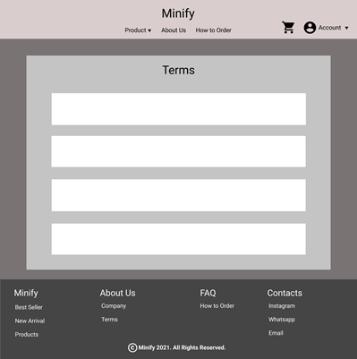

**Gambar 22.A. Mock Up Terms Page**

#### 22. B. Tampilan

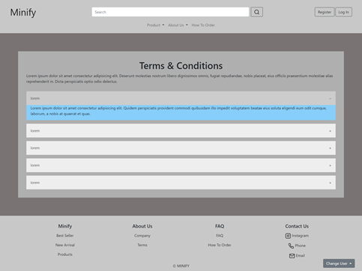

**Gambar 22.B. Tampilan Terms Page**

#### 22. C. Flowchart

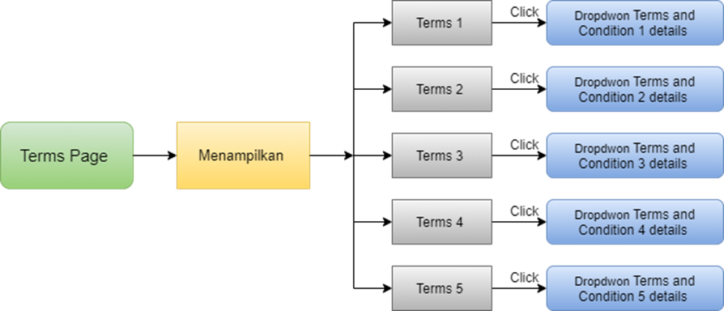

**Gambar 22.C. Flowchart Terms Page**

#### 22. D. Fitur

Terms Page adalah page yang menampilkan aturan-aturan di website MInify.

Berikut fitur yang ada pada halaman Terms:

1. Terms 1

Dropdown button yang berisikan Terms and conditions Minify pertama

1. Terms 2

Dropdown button yang berisikan Terms and conditions Minify kedua

1. Terms 3

Dropdown button yang berisikan Terms and conditions Minify ketiga

1. Terms 4

Dropdown button yang berisikan Terms and conditions Minify keempat

1. Terms 5

Dropdown button yang berisikan Terms and conditions Minify kelima

#### 22. E. Source Code

##### Html

**<div style="background-color: #7A7373; padding: 5% 5%">**

**<div class="cssterms">**

**<h1 style="text-align:center">Terms & Conditions</h1>**

**<p>Lorem ipsum dolor sit amet consectetur adipisicing elit. Deserunt molestias nostrum libero dignissimos omnis, fugiat repudiandae, nobis placeat, eius officiis praesentium molestiae alias reprehenderit in. Dicta perspiciatis optio odio delectus.</p>**

**<button class="accordion">lorem</button>**

**<div class="paneltrms">**

**<p>Lorem ipsum dolor sit amet consectetur adipisicing elit. Quidem perspiciatis provident commodi quibusdam illo impedit voluptatem beatae eius soluta eligendi eum odit cumque, laborum, a nobis at quaerat et quas.</p>**

**</div>**

**<button class="accordion">lorem</button>**

**<div class="paneltrms">**

**<p>Lorem ipsum dolor sit amet consectetur adipisicing elit. Sed minima nemo modi et non iusto quos quo deleniti odit, esse ea in, quae voluptate dicta! Sint amet laborum unde accusantium!</p>**

**</div>**

**<button class="accordion">lorem</button>**

**<div class="paneltrms">**

**<p>Lorem, ipsum dolor sit amet consectetur adipisicing elit. Perferendis odit mollitia nulla quod fugit autem exercitationem reiciendis eveniet nam temporibus, nihil distinctio voluptatem? Voluptatem cumque obcaecati possimus molestias magnam hic!</p>**

**</div>**

**<button class="accordion">lorem</button>**

**<div class="paneltrms">**

**<p>Lorem ipsum dolor sit amet consectetur adipisicing elit. A perferendis necessitatibus, aut voluptatum corporis non similique, expedita repudiandae libero temporibus rerum quod voluptates deleniti distinctio reiciendis asperiores nihil blanditiis molestias!</p>**

**</div>**

**<button class="accordion">lorem</button>**

**<div class="paneltrms">**

**<p>Lorem ipsum dolor sit amet consectetur, adipisicing elit. Quo, maiores doloribus vero tempora, est adipisci corrupti aut asperiores debitis eius inventore doloremque, facere dolor laboriosam voluptate corporis consectetur! Hic, quo!</p>**

**</div>**

**</div>**

**</div>**

##### CSS

**<style>**

**.cssterms {**

**background-color: rgb(175, 175, 175);**

**padding: 35px;**

**}**

**.accordion {**

**background-color: #eee;**

**color: #444;**

**cursor: pointer;**

**padding: 18px;**

**width: 100%;**

**border: none;**

**text-align: left;**

**outline: none;**

**font-size: 15px;**

**transition: 0.4s;**

**margin-top: 15px;**

**}**

**.active, .accordion:hover {**

**background-color: #ccc;**

**}**

**.accordion:after {**

**content: '\002B';**

**color: #777;**

**font-weight: bold;**

**float: right;**

**margin-left: 5px;**

**}**

**.active:after {**

**content: "\2212";**

**}**

**.paneltrms {**

**padding: 0 18px;**

**background-color: lightskyblue;**

**max-height: 0;**

**overflow: hidden;**

**transition: max-height 0.2s ease-out;**

**}**

**@media screen and (max-width: 480px) {**

**.accordion {**

**background-color: #eee;**

**color: #444;**

**cursor: pointer;**

**padding: 18px;**

**width: 100%;**

**border: none;**

**text-align: left;**

**outline: none;**

**font-size: 15px;**

**transition: 0.4s;**

**margin-top: 15px;**

**}**

**.paneltrms {**

**padding: 0 18px;**

**background-color: lightskyblue;**

**max-height: 0;**

**overflow: hidden;**

**transition: max-height 0.2s ease-out;**

**}**

**}**

**</style>**

##### JavaScript

**<script>**

**var acc = document.getElementsByClassName("accordion");**

**var i;**

**for (i = 0; i < acc.length; i++) {**

**acc[i].addEventListener("click", function() {**

**this.classList.toggle("active");**

**var panel = this.nextElementSibling;**

**if (panel.style.maxHeight) {**

**panel.style.maxHeight = null;**

**} else {**

**panel.style.maxHeight = panel.scrollHeight + "px";**

**}**

**});**

**}**

**</script>**

### FAQ

#### 23. A. Mock Up

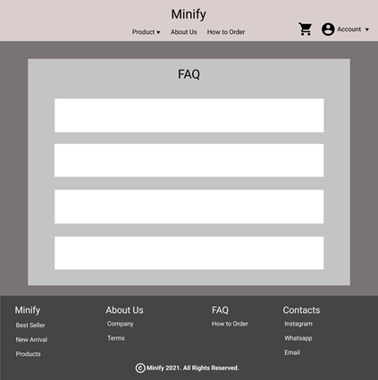

**Gambar 23.A. Mock Up FAQ Page**

#### 23. B. Tampilan

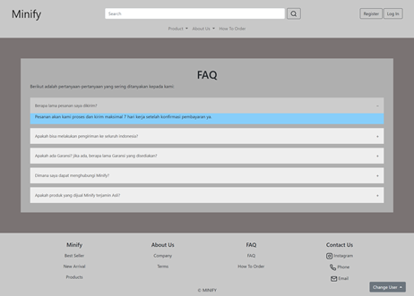

**Gambar 23.B. Tampilan FAQ Page**

#### 23. C. Flowchart

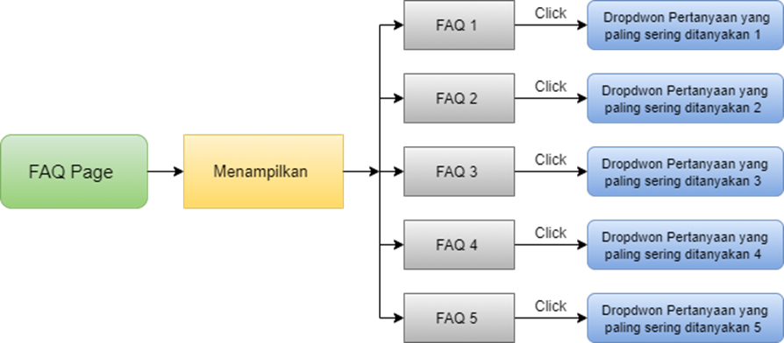

**Gambar 23.C. Flowchart FAQ Page**

#### 23. D. Fitur

FAQ Page adalah page yang menampilkan pertanyaan yang paling sering ditanyakan oleh pembeli Produk Minify yang kami Rangkum dan kami buat menjadi FAQ Page sehingga dapat memudahkan pembeli jika ingin bertanya pertanyaan umum seperti yang sering ditanyakan pembeli lainnya.

Berikut fitur yang ada pada halaman FAQ:

1. FAQ 1

Dropdown button yang berisikan pertanyaan pertama yang sering ditanyakan oleh pembeli

1. FAQ 2

Dropdown button yang berisikan pertanyaan kedua yang sering ditanyakan oleh pembeli

1. FAQ 3

Dropdown button yang berisikan pertanyaan ketiga yang sering ditanyakan oleh pembeli

1. FAQ 4

Dropdown button yang berisikan pertanyaan keempat yang sering ditanyakan oleh pembeli

1. FAQ 5

Dropdown button yang berisikan pertanyaan kelima yang sering ditanyakan oleh pembeli

#### 23. E. Source Code

##### Html

**<div style="background-color: #7A7373; padding: 5% 5%">**

**<div class="cssfaq">**

**<h1 style="text-align:center">FAQ</h1>**

**<p>Berikut adalah pertanyaan-pertanyaan yang sering ditanyakan kepada kami:</p>**

**<button class="accordion">Berapa lama pesanan saya dikirim?</button>**

**<div class="panelfaq">**

**<p>Pesanan akan kami proses dan kirim maksimal 7 hari kerja setelah konfirmasi pembayaran ya.</p>**

**</div>**

**<button class="accordion">Apakah bisa melakukan pengiriman ke seluruh indonesia?</button>**

**<div class="panelfaq">**

**<p>Tentu bisa ya! kalian dapat membeli produk kami dari seluruh indonesia.</p>**

**</div>**

**<button class="accordion">Apakah ada Garansi? jika ada, berapa lama Garansi yang disediakan?</button>**

**<div class="panelfaq">**

**<p>Tentu saja ada!!! kami menyediakan Garansi 7 hari Unit Baru dan Garansi 2 tahun service di service center Seluruh Indonesia. (untuk lokasi service center bisa dilihat di Website Resmi setiap Brand atau untuk info lebih lanjut silahkan hubungi kami ya😊)</p>**

**</div>**

**<button class="accordion">Dimana saya dapat menghubungi Minify?</button>**

**<div class="panelfaq">**

**<p>kamu punya kendala? eitss! Tenang aja. <br> kamu bisa langsung menghubungi minify melalui email, instagram, atau telepon ke 080000.</p>**

**</div>**

**<button class="accordion">Apakah produk yang dijual Minify terjamin Asli?</button>**

**<div class="panelfaq">**

**<p>Pasti Asli donk!!! Minify menjamin 100% produknya asli. <br> kamu masih ragu? Tenang saja Minify juga menyediakan Garansi UANG KEMBALI 100% jika produk yang kamu terima terbukti tidak Asli.</p>**

**</div>**

**</div>**

**</div>**

##### CSS

**<style>**

**.cssfaq {**

**background-color: rgb(175, 175, 175);**

**padding: 35px;**

**}**

**.accordion {**

**background-color: #eee;**

**color: #444;**

**cursor: pointer;**

**padding: 18px;**

**width: 100%;**

**border: none;**

**text-align: left;**

**outline: none;**

**font-size: 15px;**

**transition: 0.4s;**

**margin-top: 15px;**

**}**

**.active, .accordion:hover {**

**background-color: #ccc;**

**}**

**.accordion:after {**

**content: '\002B';**

**color: #777;**

**font-weight: bold;**

**float: right;**

**margin-left: 5px;**

**}**

**.active:after {**

**content: "\2212";**

**}**

**.panelfaq {**

**padding: 0 18px;**

**background-color: lightskyblue;**

**max-height: 0;**

**overflow: hidden;**

**transition: max-height 0.2s ease-out;**

**}**

**@media screen and (max-width: 480px) {**

**.accordion {**

**background-color: #eee;**

**color: #444;**

**cursor: pointer;**

**padding: 18px;**

**width: 100%;**

**border: none;**

**text-align: left;**

**outline: none;**

**font-size: 15px;**

**transition: 0.4s;**

**margin-top: 15px;**

**}**

**.panelfaq {**

**padding: 0 18px;**

**background-color: lightskyblue;**

**max-height: 0;**

**overflow: hidden;**

**transition: max-height 0.2s ease-out;**

**}**

**}**

**</style>**

**var acc = document.getElementsByClassName("accordion");**

**var i;**

**for (i = 0; i < acc.length; i++) {**

**acc[i].addEventListener("click", function() {**

**this.classList.toggle("active");**

**var panel = this.nextElementSibling;**

**if (panel.style.maxHeight) {**

**panel.style.maxHeight = null;**

**} else {**

**panel.style.maxHeight = panel.scrollHeight + "px";**

**}**

**});**

**}**

**</script>**

##### JavaScript

**<script>**

**var acc = document.getElementsByClassName("accordion");**

**var i;**

**for (i = 0; i < acc.length; i++) {**

**acc[i].addEventListener("click", function() {**

**this.classList.toggle("active");**

**var panel = this.nextElementSibling;**

**if (panel.style.maxHeight) {**

**panel.style.maxHeight = null;**

**} else {**

**panel.style.maxHeight = panel.scrollHeight + "px";**

**}**

**});**

**}**

**</script>**

### How To Order

#### 24. A. Mock Up

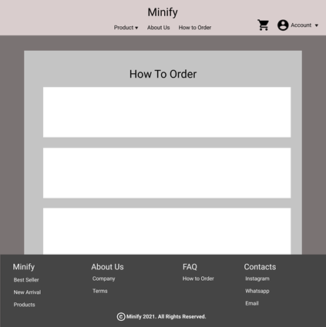

**Gambar 24.A. Mock Up How to Order**

#### 24. B. Tampilan

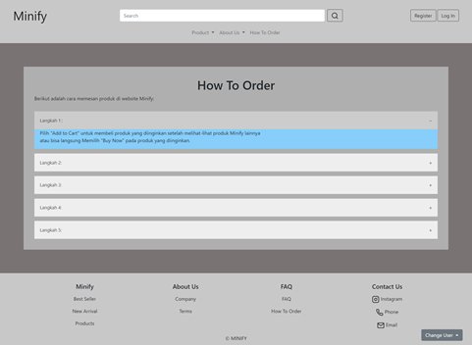

**Gambar 24.B. Tampilan How to Order**

#### 24. C. F lowchart

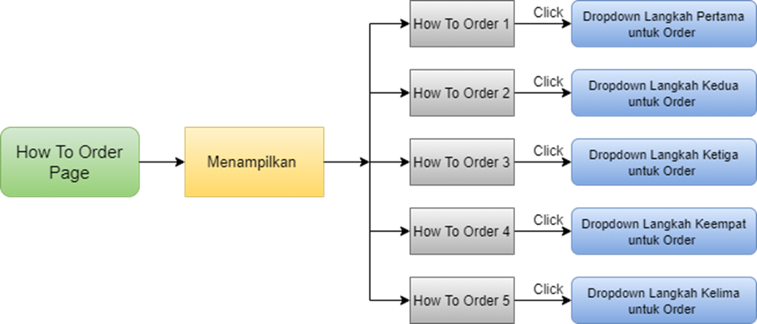

**Gambar 24.C. Flowchart How to Order**

#### 24. D. Fitur

How To Order Page adalah page yang menampilkan langkah-langkah atau proses untuk berbelanja produk Minify di website Minify.

Berikut fitur yang ada pada halaman How To Order:

1. Step 1

Dropdown button yang berisikan langkah pertama untuk melakukan pemesanan

1. Step 2

Dropdown button yang berisikan langkah kedua untuk melakukan pemesanan

1. Step 3

Dropdown button yang berisikan langkah ketiga untuk melakukan pemesanan

1. Step 4

Dropdown button yang berisikan langkah keempat untuk melakukan pemesanan

1. Step 5

Dropdown button yang berisikan langkah kelima untuk melakukan pemesanan

#### 24. E. Source Code

##### Html

**<div style="background-color: #7A7373; padding: 5% 5%">**

**<div class="csshwtord">**

**<h1 style="text-align:center">How To Order</h1>**

**<p>Berikut adalah cara memesan produk di website Minify:</p>**

**<button class="accordion">Langkah 1：</button>**

**<div class="panelhtd">**

**<p>Pilih "Add to Cart" untuk membeli produk yang diinginkan setelah melihat-lihat produk Minify lainnya <br> atau bisa langsung Memilih "Buy Now" pada produk yang diinginkan.</p>**

**</div>**

**<button class="accordion">Langkah 2: </button>**

**<div class="panelhtd">**

**<p>Setelah memilih "Add to Cart" atau "Buy Now". <br> Jika memilih "Buy Now" akan langsung diarahkan ke shopping cart. <br> Jika memilih "Add to Cart" maka silahkan ke halaman shopping cart terlebih dahulu untuk melakukan checkout.</p>**

**</div>**

**<button class="accordion">Langkah 3: </button>**

**<div class="panelhtd">**

**<p>Silahkan memilih-milih produk-produk Minify yang ingin kamu Miliki. setelah memilih produk Minify yang ingin kamu miliki, kamu dapat memilih checkout.</p>**

**</div>**

**<button class="accordion">Langkah 4: </button>**

**<div class="panelhtd">**

**<p>Pada halaman checkout kamu tinggal mengisi alamat, payment, dan pengiriman kemudian pilih order.</p>**

**</div>**

**<button class="accordion">Langkah 5: </button>**

**<div class="panelhtd">**

**<p>Setelah membuat order kamu tinggal melakukan pembayaran/konfirmasi pembayaran setelah itu produk kamu akan segera diproses dan dikemas oleh Teams Minify untuk dikirim ke alamat kamu. <br> Nah... Mudah sekali bukan untuk belanja di Minify.</p>**

**</div>**

**</div>**

**</div>**

##### CSS

**<style>**

**.csshwtord {**

**background-color: rgb(175, 175, 175);**

**padding: 35px;**

**}**

**.accordion {**

**background-color: #eee;**

**color: #444;**

**cursor: pointer;**

**padding: 18px;**

**width: 100%;**

**border: none;**

**text-align: left;**

**outline: none;**

**font-size: 15px;**

**transition: 0.4s;**

**margin-top: 15px;**

**}**

**.active, .accordion:hover {**

**background-color: #ccc;**

**}**

**.accordion:after {**

**content: '\002B';**

**color: #777;**

**font-weight: bold;**

**float: right;**

**margin-left: 5px;**

**}**

**.active:after {**

**content: "\2212";**

**}**

**.panelhtd {**

**padding: 0 18px;**

**background-color: lightskyblue;**

**max-height: 0;**

**overflow: hidden;**

**transition: max-height 0.2s ease-out;**

**}**

**@media screen and (max-width: 480px) {**

**.accordion {**

**background-color: #eee;**

**color: #444;**

**cursor: pointer;**

**padding: 18px;**

**width: 100%;**

**border: none;**

**text-align: left;**

**outline: none;**

**font-size: 15px;**

**transition: 0.4s;**

**margin-top: 15px;**

**}**

**.panelhtd {**

**padding: 0 18px;**

**background-color: lightskyblue;**

**max-height: 0;**

**overflow: hidden;**

**transition: max-height 0.2s ease-out;**

**}**

**}**

**</style>**

##### Javascript

**<script>**

**var acc = document.getElementsByClassName("accordion");**

**var i;**

**for (i = 0; i < acc.length; i++) {**

**acc[i].addEventListener("click", function() {**

**this.classList.toggle("active");**

**var panel = this.nextElementSibling;**

**if (panel.style.maxHeight) {**

**panel.style.maxHeight = null;**

**} else {**

**panel.style.maxHeight = panel.scrollHeight + "px";**

**}**

**});**

**}**

**</script>**

### Dashboard

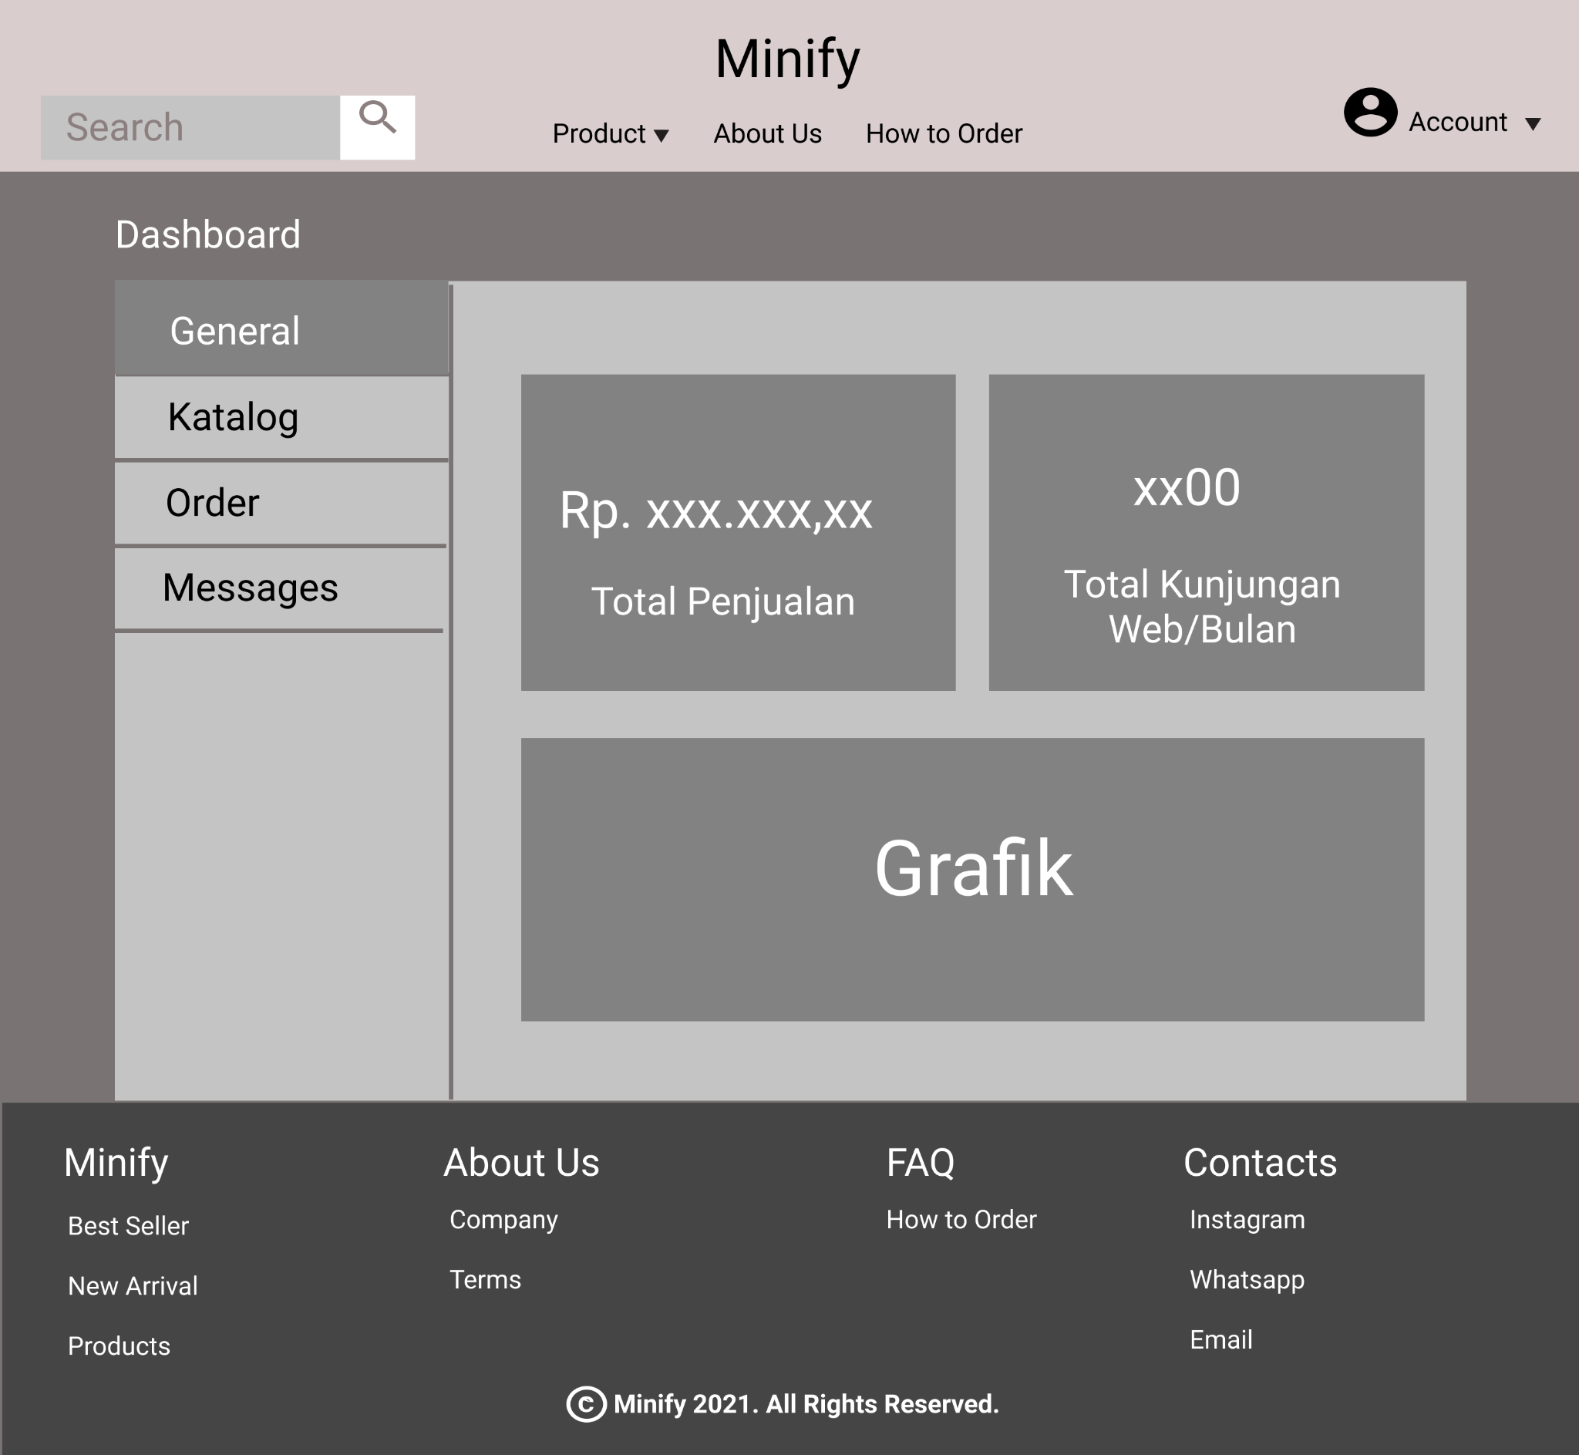

**Gambar 25.1. Mockup Dashboard**

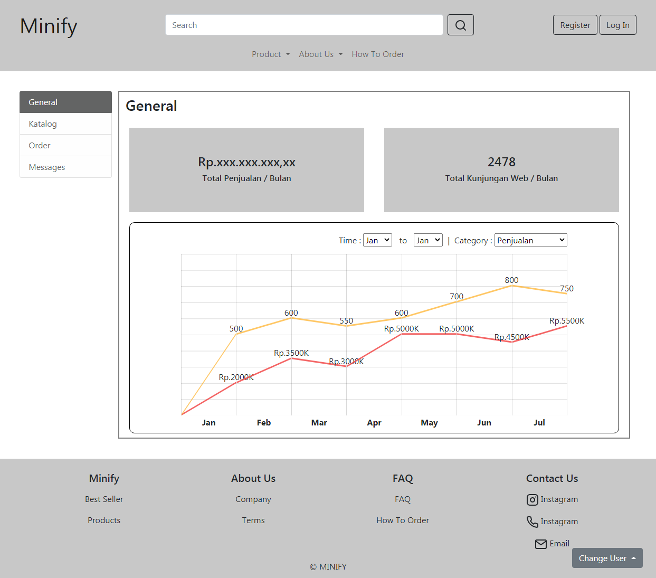

**Gambar 25.2. Tampilan Dashboard**

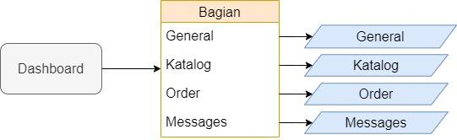

**Gambar 25.3. Flowchart Dashboard**

Dashboard hanya dapat diakses dengan akun owner. Tampilan dashboard dibagi menjadi 2 panel, panel sebelah kiri sebagai menu navigasi, dan panel sebelah kanan menampilkan isi dari bagian-bagian yang ada. Dashboard memiliki 4 bagian yaitu :

#### 25.1. General

##### 25.1.A. Mock Up



**25.1.1 Mock Up General**

##### 25.1.B. Tampilan

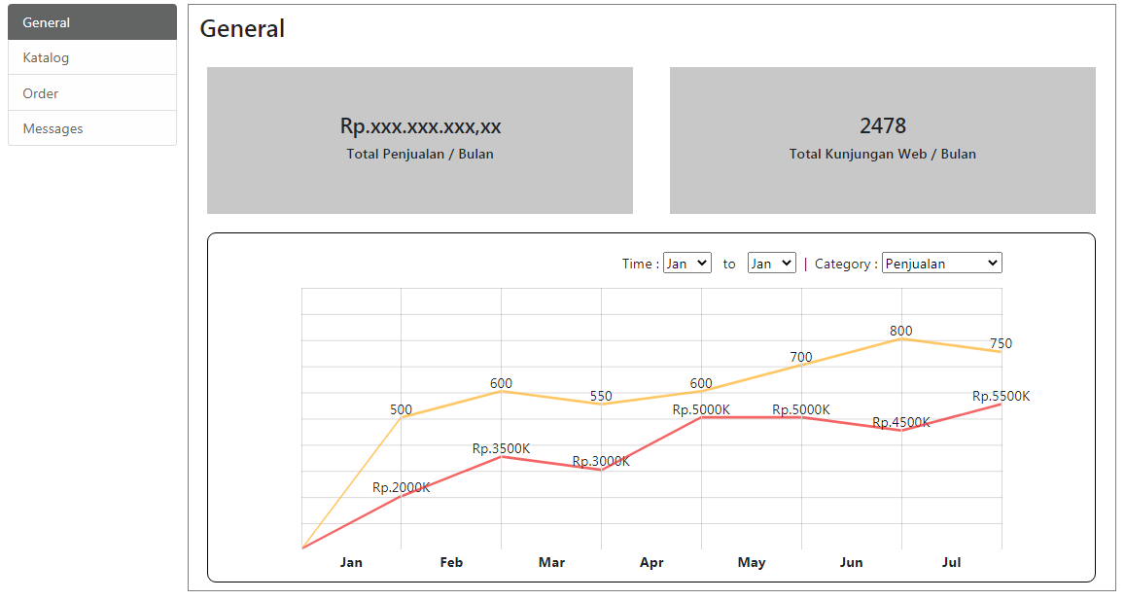

**25.1.2 Tampilan General**

##### 25.1.C. Flowchart

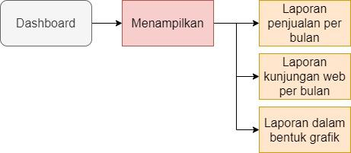

**25.1.3 Flowchart General**

##### 25.1.D. Fitur

Bagian General menampilkan laporan umum tentang web. Pada bagian kiri atas terdapat panel yang menampilkan laporan total penjualan per bulan. Pada bagian kanan atas terdapat panel yang menampilkan laporan total kunjungan web per bulan. Pada bagian bawah terdapat Diagram garis yang dapat menampilkan laporan penjualan dan kunjungan web dalam kurun waktu yang ditentukan dengan tampilan grafik garis.

#### 25.2. Katalog

##### 25.2.A. Mock Up

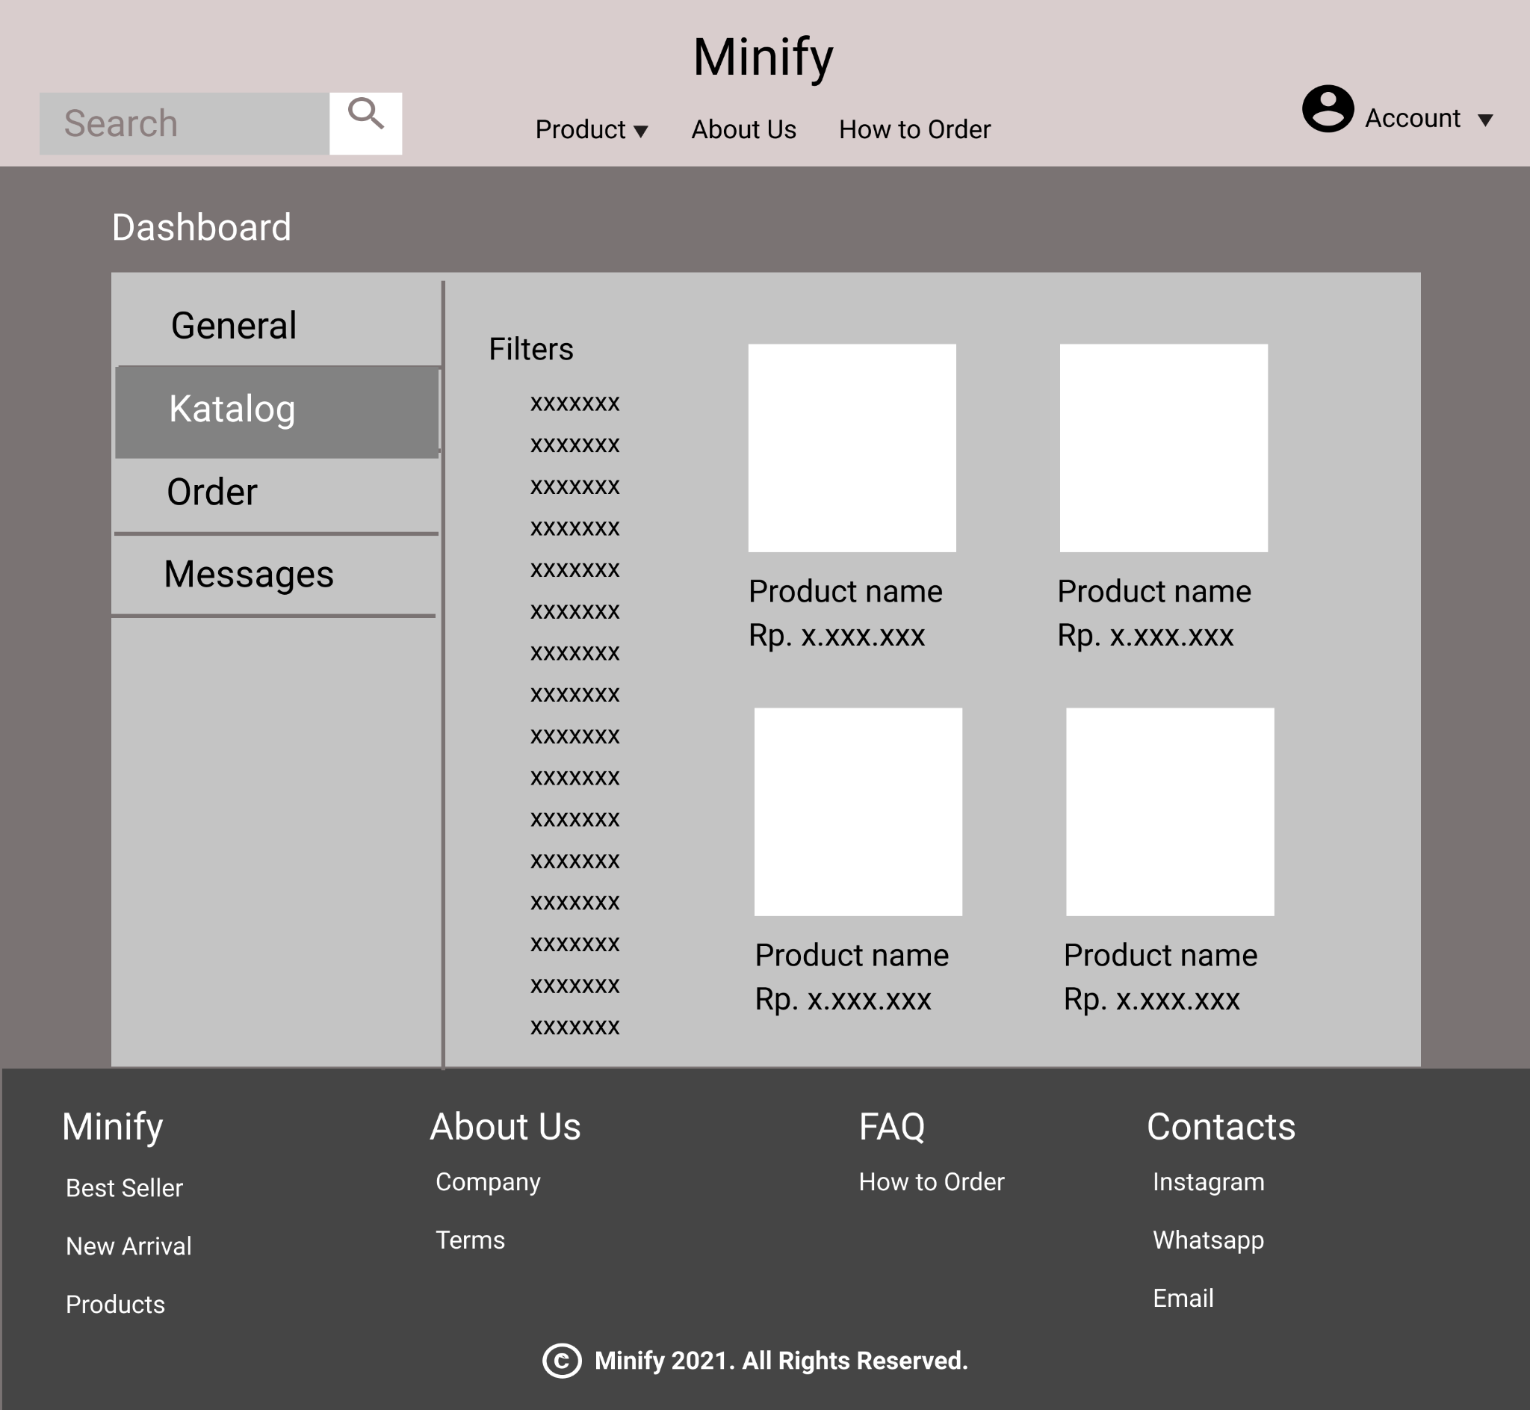

**25.2.1 Mock Up Katalog**

##### 25.2.B. Tampilan

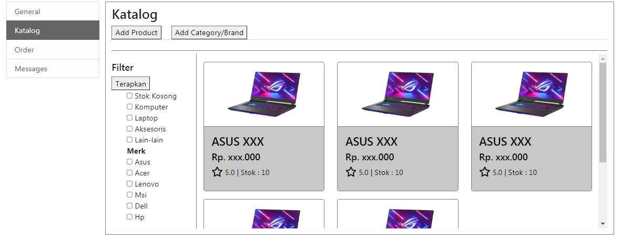

**25.2.2 Tampilan Katalog**

##### 25.2.C. Flowchart

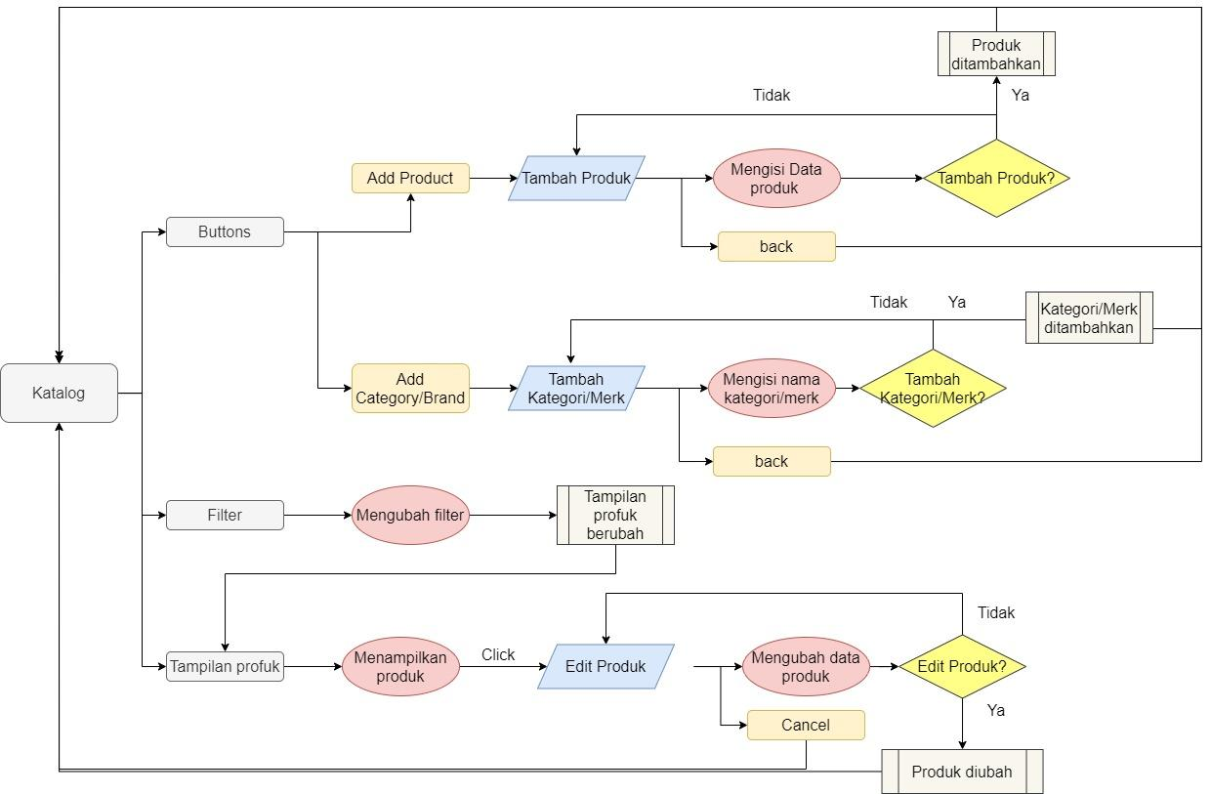

**25.2.3 Flowchart Katalog**

##### 25.2.D. Fitur

Pada page katalog terdapat beberapa bagian yaitu :

1. Buttons

Terdapat tombol add product yang jika di klik akan mengarahkan pengguna ke halaman tambah product. Juga terdapat tombol add category/brand yang akan mengarahkan pengguna ke halaman tambah kategori/merk.

1. Filter

Digunakan untuk memberi filter pada tampilan produk. Jika filter berubah maka produk yang ditampilkan akan berubah.

1. Tampilan Produk

Menampilkan produk-produk yang ada berdasarkan filter yang diterapkan. Jika tidak ada filter yang diterapkan maka semua produk akan ditampilkan.

#### 25.3. Order

##### 25.3.A. Mock Up

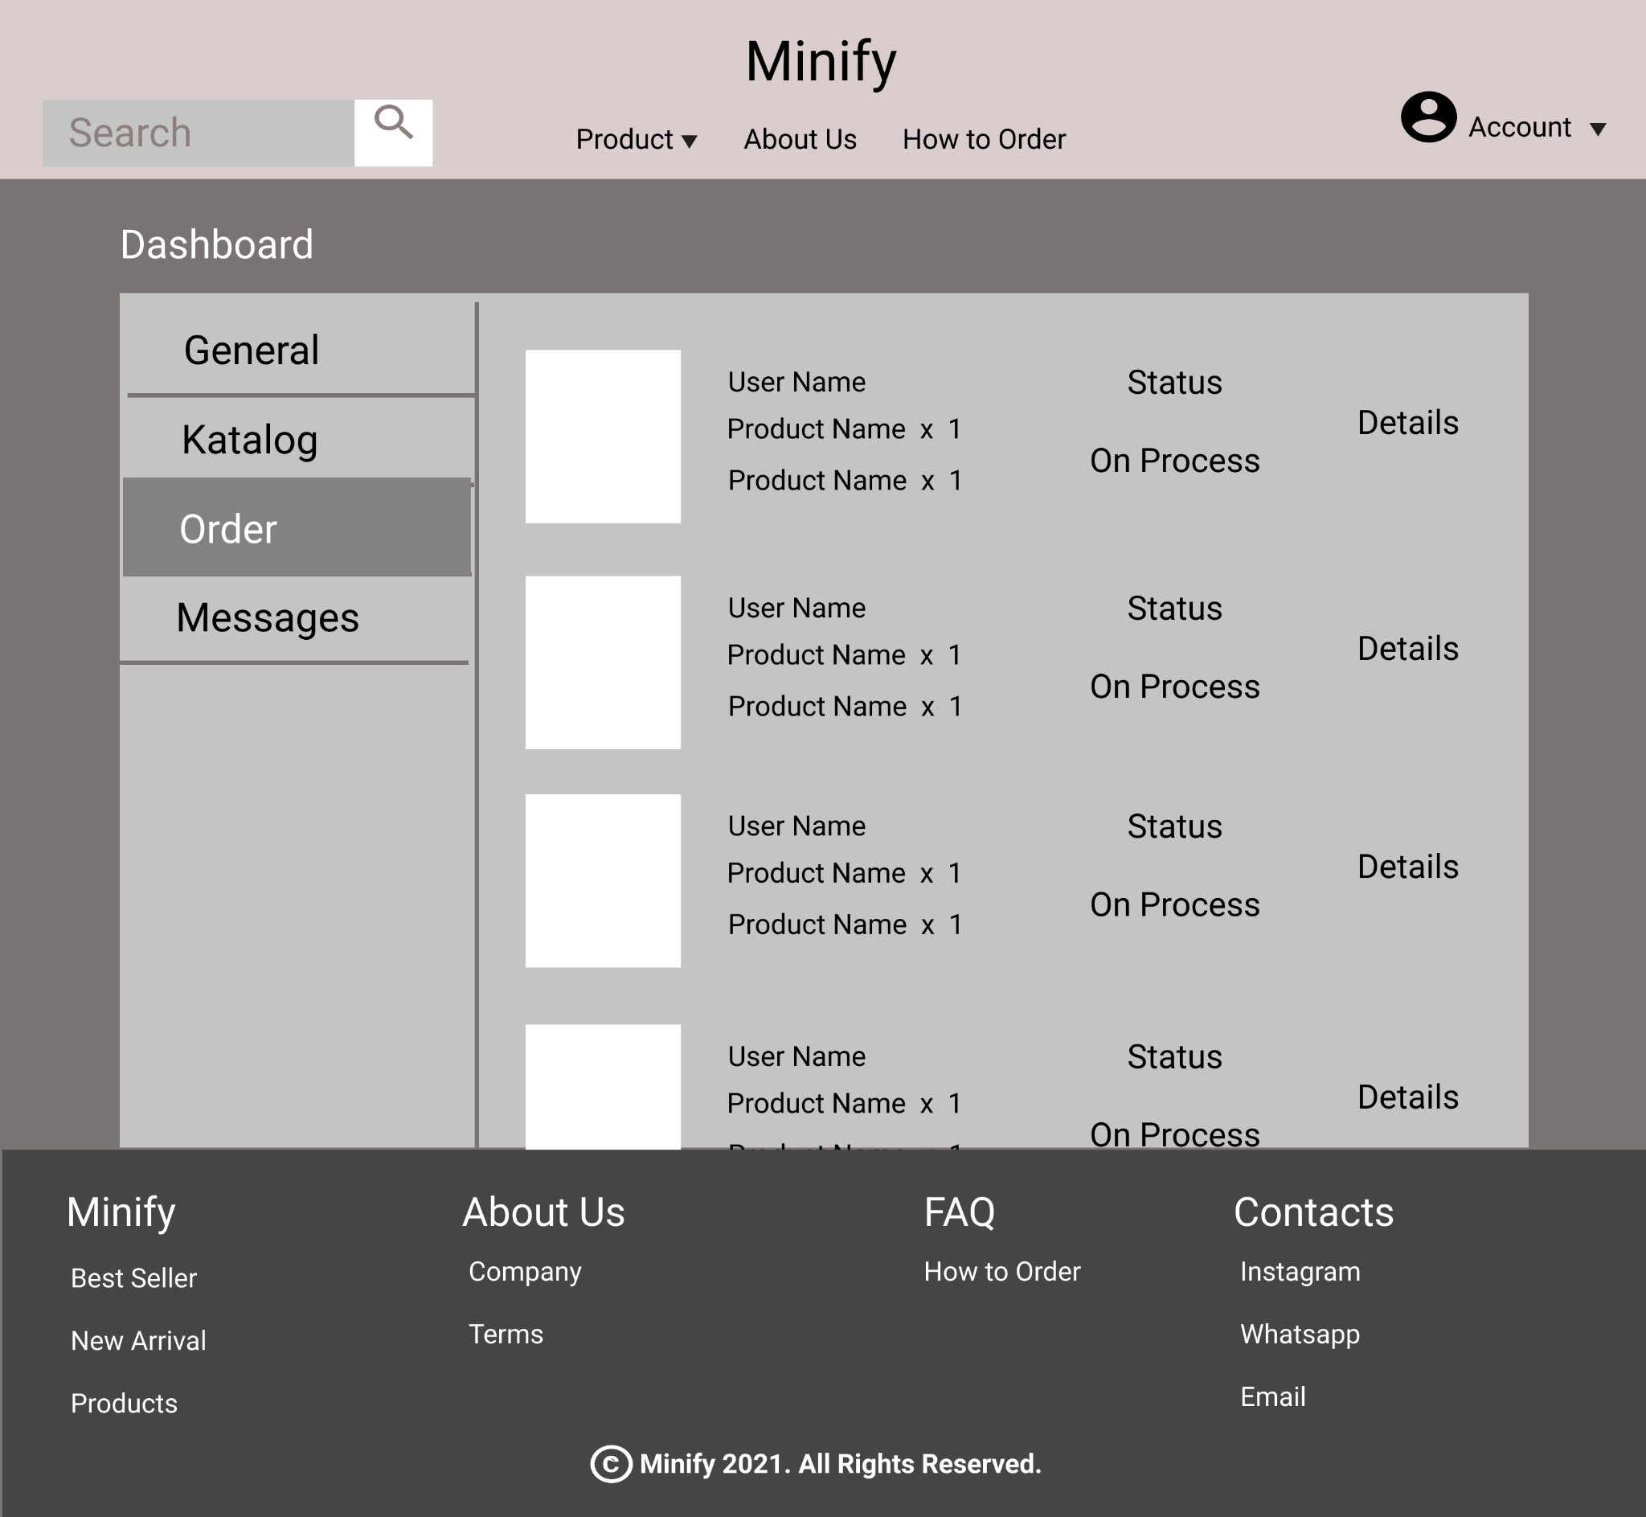

**25.3.1 Mock Up Order**

##### 25.3.B. Tampilan

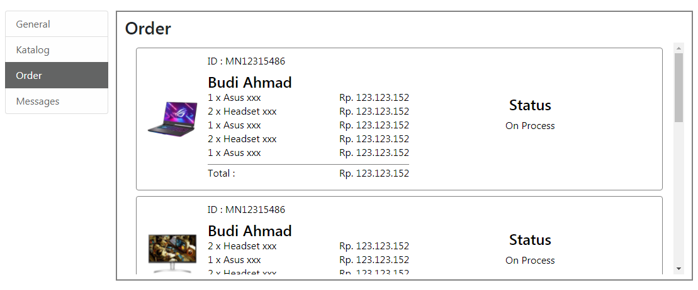

**25.3.2 Tampilan Order**

##### 25.3.C. Flowchart

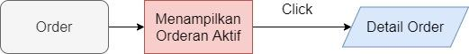

**25.3.3 Flowchart Order**

##### 25.3.D. Fitur

Menampilkan order-order yang aktif. Tampilan dari order-order tersebut terdiri dari :

* ID Orderan
* Username pembeli
* Foto dari produk pertama yang dibeli
* Ringkasan jumlah barang, nama produk, dan harga total
* Status orderan.

Jika orderan di klik maka pengguna akan diarahkan ke halaman detail order.

#### 25.4. Messages

##### 25.4.A. Mock Up

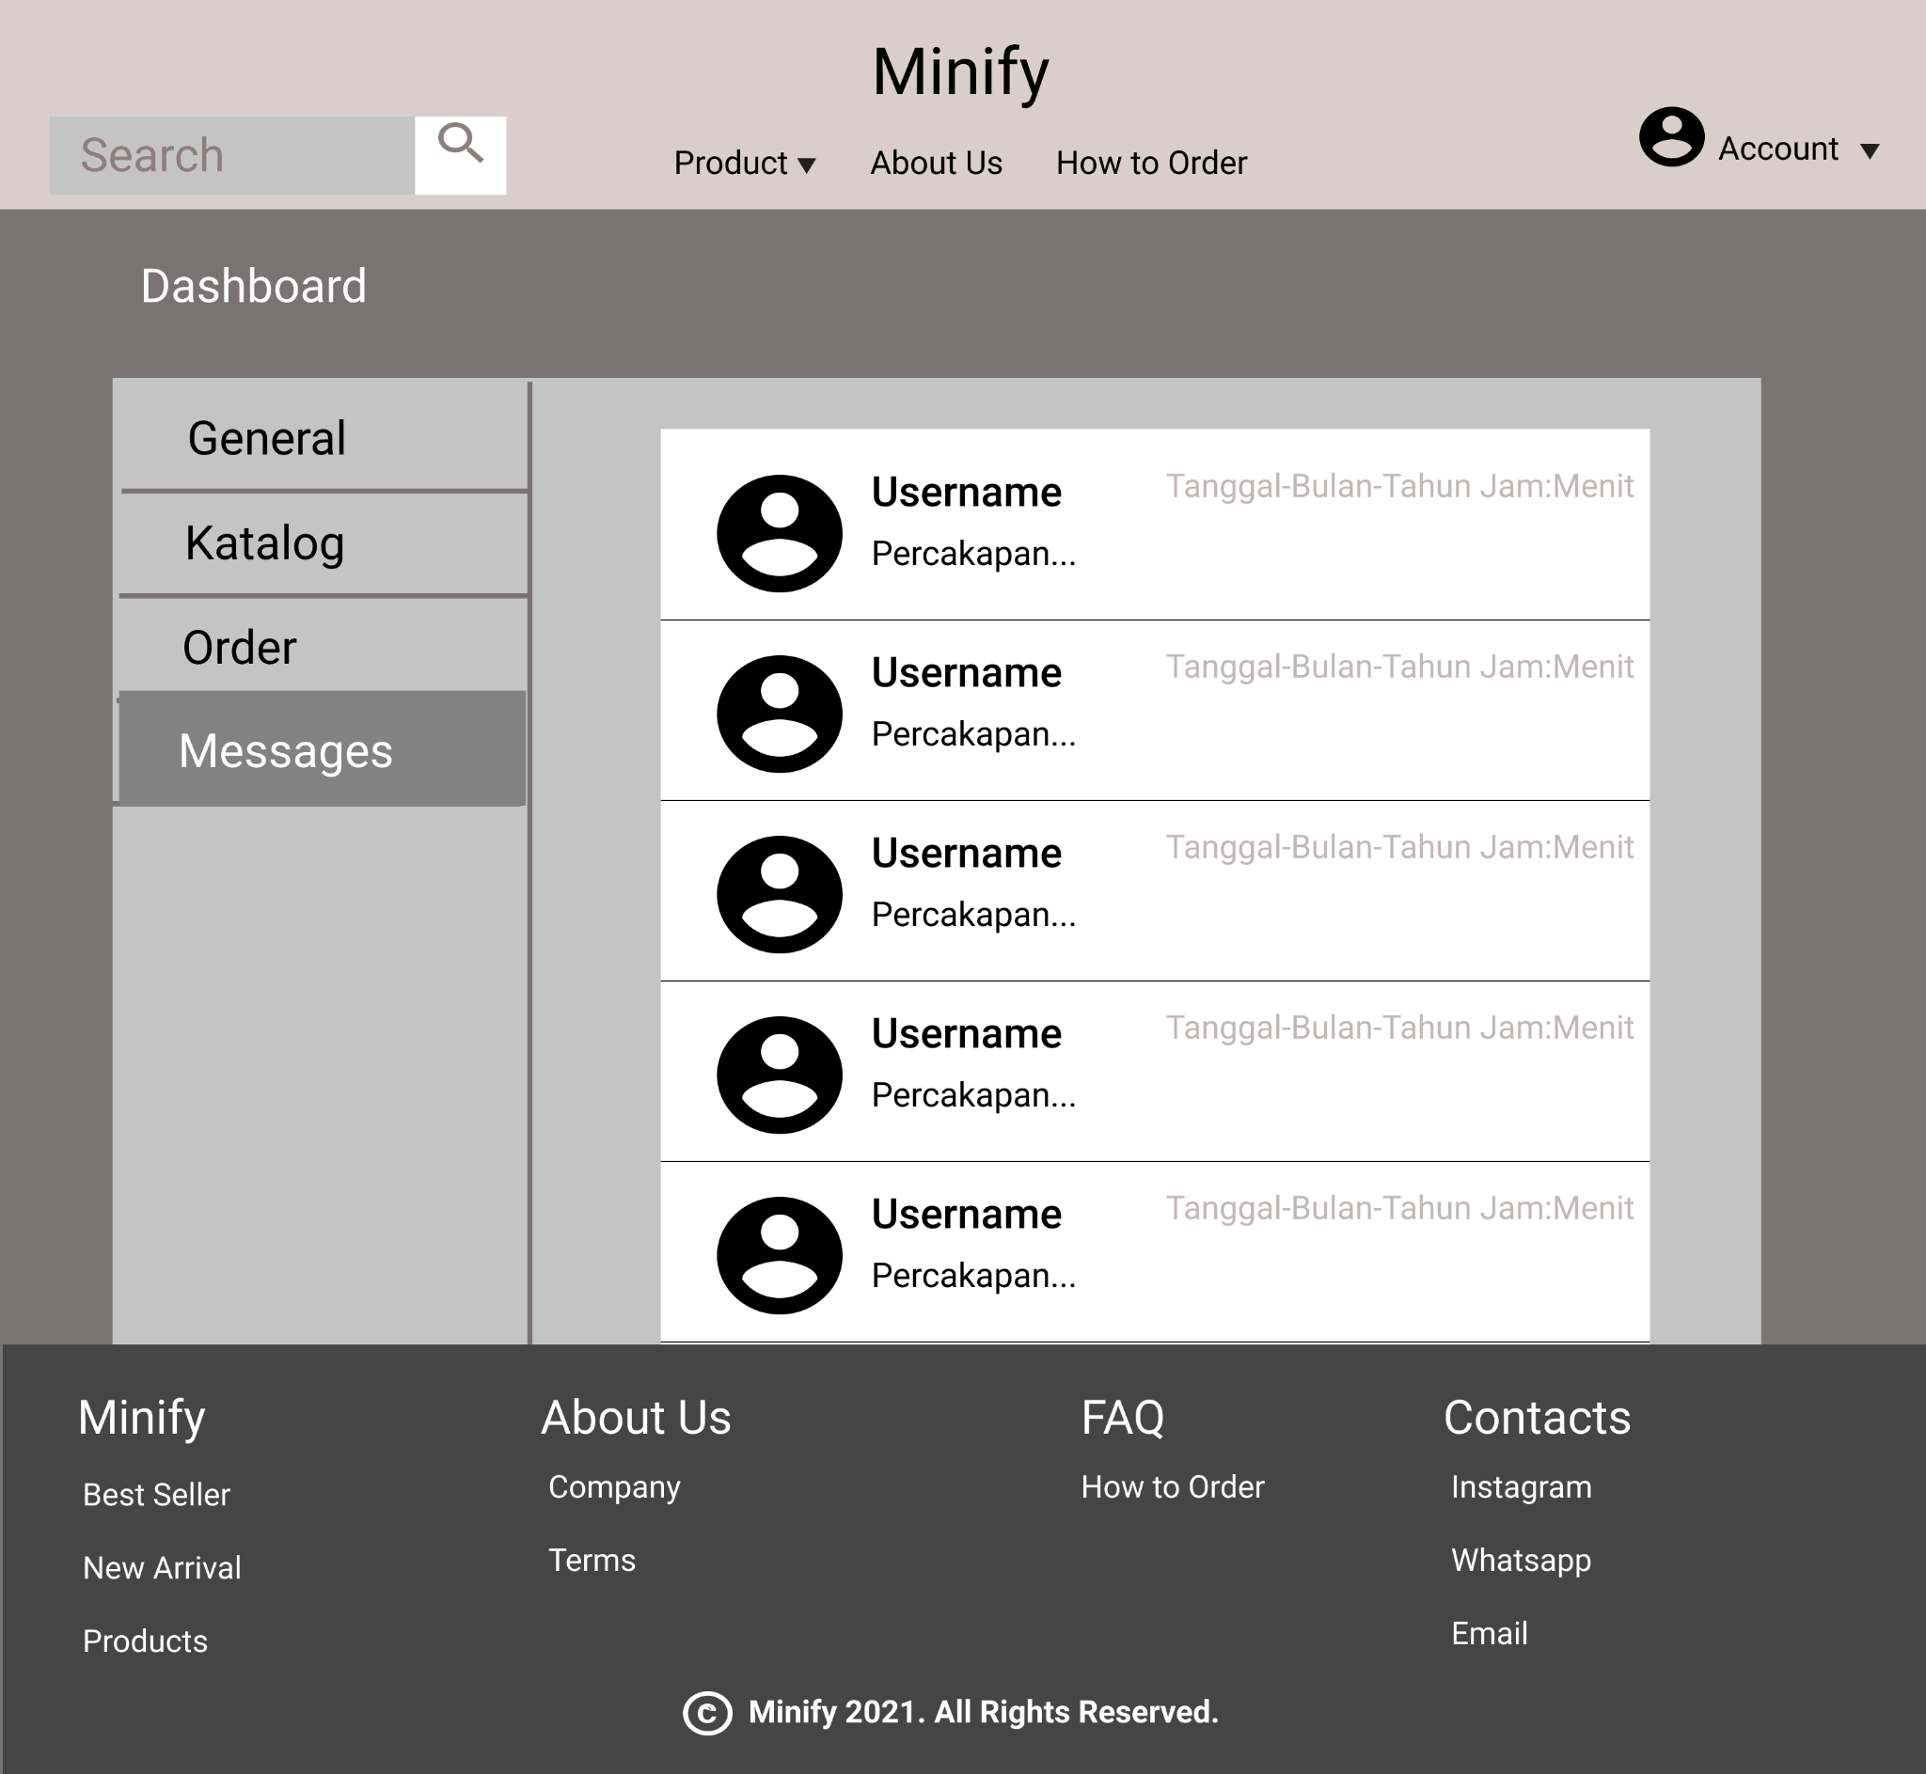

**25.4.1 Mock Up Messages**

##### 25.4.B. Tampilan

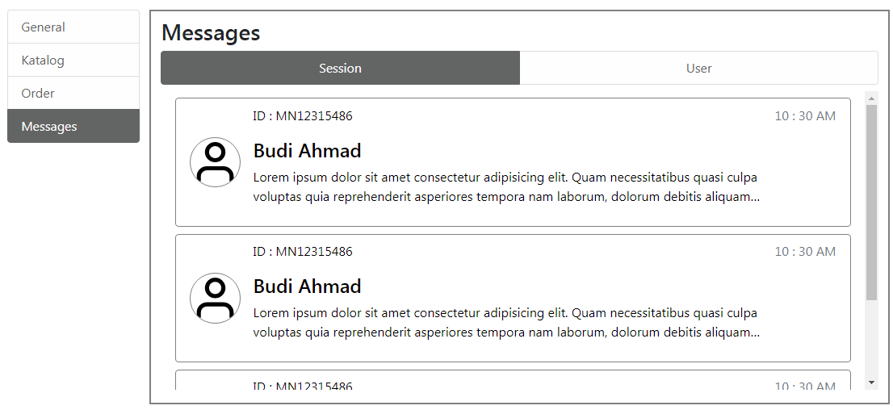

**25.4.2. Tampilan Messages Session**

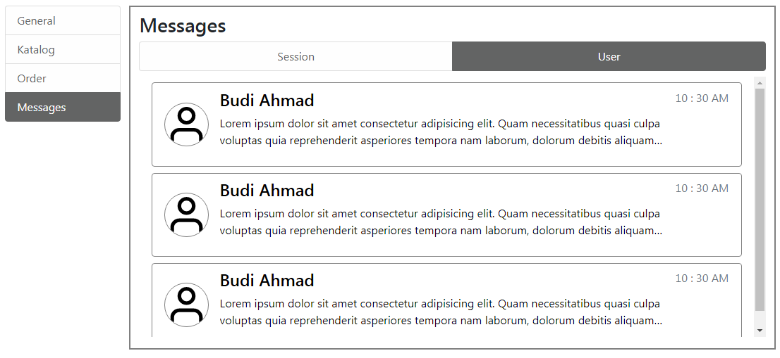

**25.4.3. Tampilan Messages User**

##### 25.4.C. Flowchart

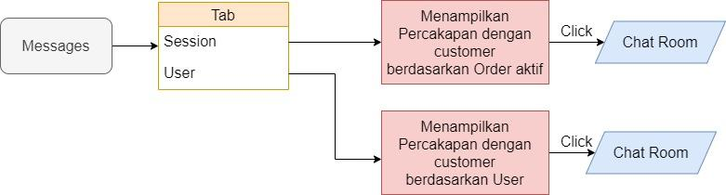

**25.4.4.. Flowchart Messages**

##### 25.4.D. Fitur

Pada bagian atas terdapat tab navigasi untuk menampilkan percakapan berdasarkan sesi order atau berdasarkan user. Percakapan yang ditampilkan dari :

* foto profil,
* username,
* cuplikan pesan terakhir sepanjang 2 baris,
* waktu pesan diterima/dikirim,
* ID order (khusus tampilan percakapan berdasarkan sesi order).

Jika percakapan di klik maka pengguna akan diarahkan ke halaman chat room.

### Add Products

#### 26.A. Tampilan

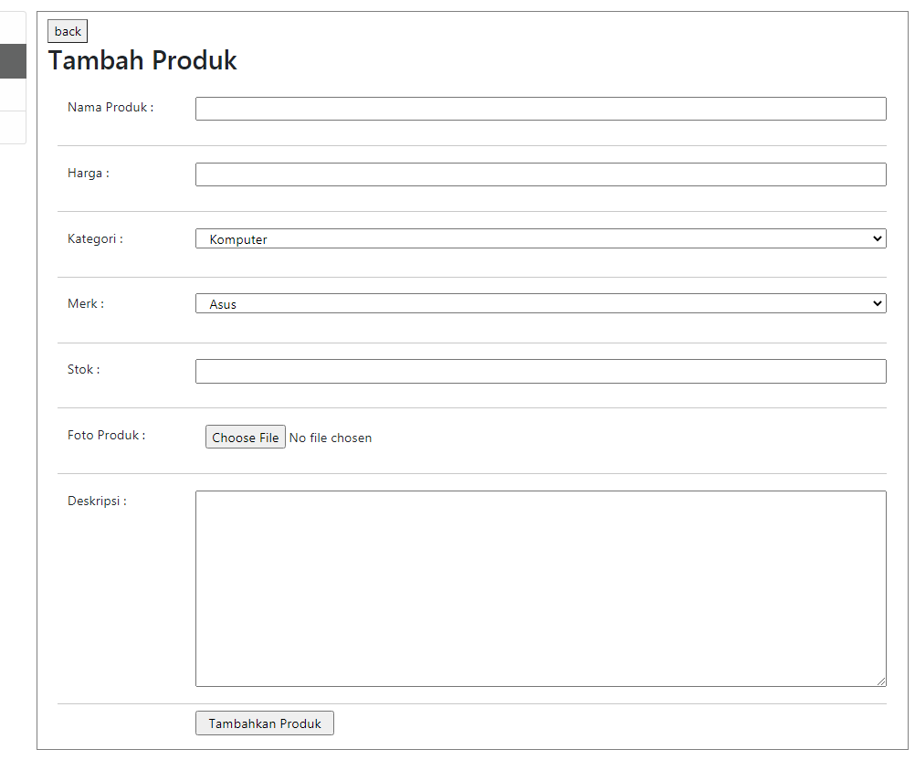

**Gambar 26.1. Tampilan Add Products**

#### 26.B. Flowchart



**Gambar 26.2. Flowchart Add Products**

#### 26.C. Fitur

Digunakan untuk menambah produk ke dalam database. Data yang diperlukan untuk menambah produk adalah :

* Nama,
* Harga,
* Kategori,
* Merk,
* Stok,
* Foto Produk,
* Deskripsi.

Jika sudah selesai mengisi data maka pengguna dapat menekan tombol “Tambahkan produk”, kemudian akan muncul pertanyaan verifikasi untuk menambahkan produk, jika pengguna memilih ya maka produk akan ditambahkan dan pengguna diarahkan kembali ke halaman katalog, jika pengguna memilih tidak maka pengguna akan kembali ke halaman tambah produk. Di bagian paling atas terdapat tombol back yang digunakan untuk kembali ke halaman katalog.

### Add Category/Brand

#### 27.A. Tampilan

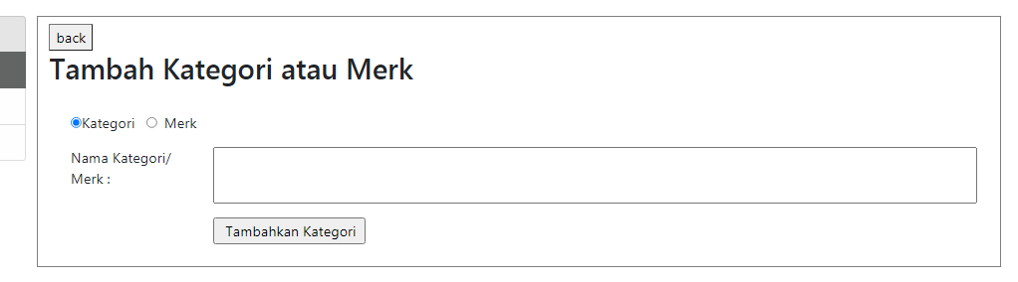

**Gambar 27.1. Tampilan Add Category/Brand**

#### 27.B. Flowchart



**Gambar 27.1. Flowchart Add Category/Brand**

#### 27.C. Fitur

Digunakan untuk menambah kategori produk atau merek ke dalam database. Di bawah judul terdapat radio button untuk memilih ingin menambahkan produk atau merek. Kemudian dibawahnya terdapat kolom untuk mengisikan nama kategori atau merek yang ingin ditambahkan.

Jika sudah selesai mengisi data maka pengguna dapat menekan tombol “Tambahkan kategori”, kemudian akan muncul pertanyaan verifikasi untuk menambahkan kategori/merek, jika pengguna memilih ya maka kategori/merek akan ditambahkan dan pengguna diarahkan kembali ke halaman katalog, jika pengguna memilih tidak maka pengguna akan kembali ke halaman tambah kategori/merek. Di bagian paling atas terdapat tombol back yang digunakan untuk kembali ke halaman katalog.

### Edit Product

#### 28.A. Tampilan

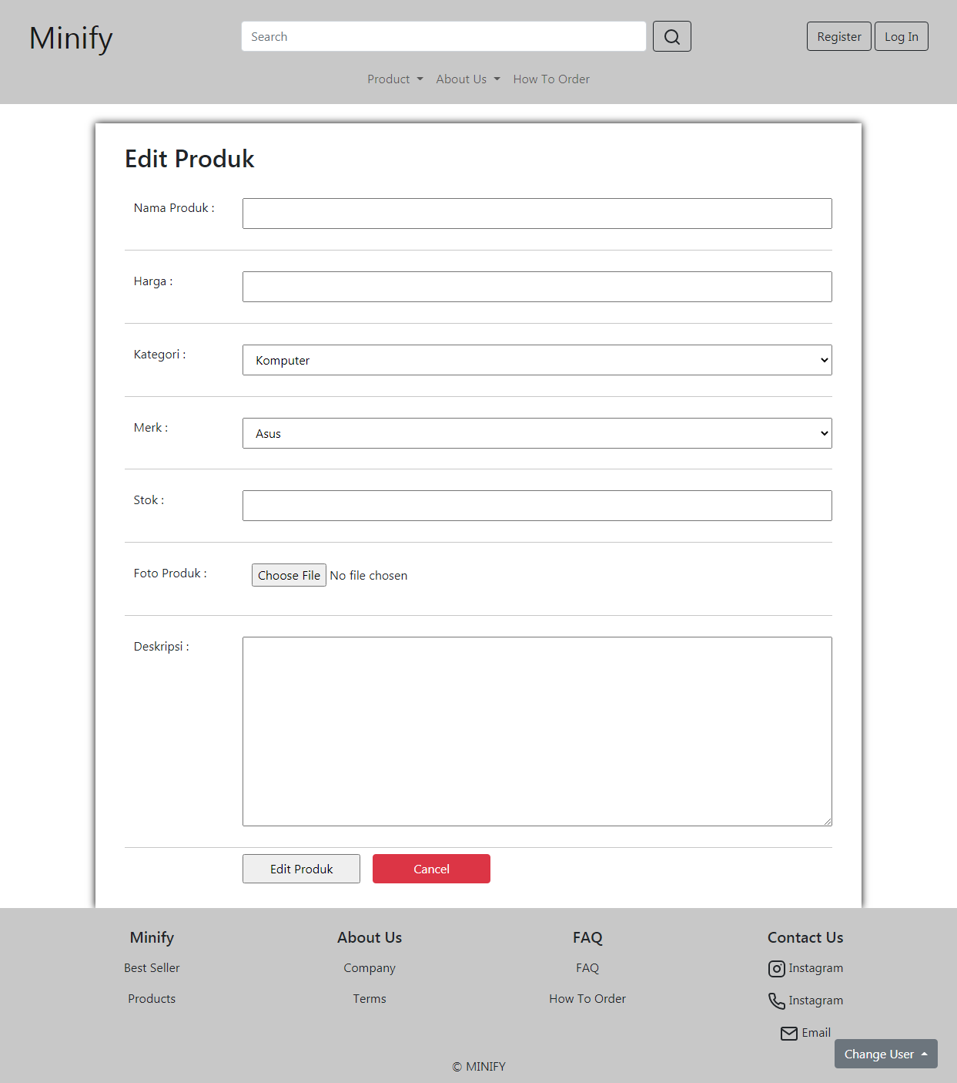

**Gambar 28.1. Tampilan Edit Product**

#### 28.B. Flowchart



**Gambar 28.2. Flowchart Edit Product**

#### 28.C. Fitur

Halaman ini diakses dengan cara mengklik produk yang ditampilkan pada katalog. Halaman ini digunakan untuk mengubah data produk yang sudah ada. Data yang dapat diubah adalah :

* Nama,
* Harga,
* Kategori,
* Merk,
* Stok,
* Foto Produk,
* Deskripsi.

Jika sudah selesai mengubah data maka pengguna dapat menekan tombol “Edit produk”, kemudian akan muncul pertanyaan verifikasi untuk mengedit produk, jika pengguna memilih ya maka produk akan diubah dan pengguna diarahkan kembali ke halaman katalog, jika pengguna memilih tidak maka pengguna akan kembali ke halaman edit produk. Di samping tombol “Edit produk” terdapat tombol “Cancel” yang digunakan untuk kembali ke halaman katalog.

#### 28.D. Source Code

##### Html

**<section>**

**<div id="editProduct">**

**<h2>Edit Produk</h2>**

**<form action="" class="container" onsubmit="return false">**

**<div class="row">**

**<p class="col-lg-2">Nama Produk :</p>**

**<input class="col" type="text" name="namaProduk" />**

**</div>**

**<div class="row">**

**<p class="col-lg-2">Harga :</p>**

**<input class="col" type="number" name="hargaProduk" />**

**</div>**

**<div class="row">**

**<p class="col-lg-2">Kategori :</p>**

**<select class="col" name="kategoriProduk" id="">**

**<option value="Komputer">Komputer</option>**

**<option value="Laptop">Laptop</option>**

**<option value="Aksesoris">Aksesoris</option>**

**<option value="LainLain">Lain-lain</option>**

**</select>**

**</div>**

**<div class="row">**

**<p class="col-lg-2">Merk :</p>**

**<select class="col" name="kategoriProduk" id="">**

**<option value="Asus">Asus</option>**

**<option value="Acer">Acer</option>**

**<option value="Lenovo">Lenovo</option>**

**<option value="Msi">Msi</option>**

**<option value="Dell">Dell</option>**

**<option value="Hp">Hp</option>**

**</select>**

**</div>**

**<div class="row">**

**<p class="col-lg-2">Stok :</p>**

**<input class="col" type="number" name="StokProduk" />**

**</div>**

**<div class="row">**

**<p class="col-lg-2">Foto Produk :</p>**

**<input class="col" type="file" name="fotoProduk" />**

**</div>**

**<div class="row">**

**<p class="col-lg-2">Deskripsi :</p>**

**<textarea**

**class="col"**

**name="deskripsiProduk"**

**id=""**

**cols="50"**

**rows="10"**

**style="vertical-align: text-top"**

**></textarea>**

**</div>**

**<section class="row my-2">**

**<p class="col-lg-2"></p>**

**<input**

**id="edit-product-submit"**

**class="col-lg-2"**

**type="submit"**

**value="Edit Produk"**

**/>**

**<button**

**type="button"**

**onclick="history.back();"**

**class="col-lg-2 my-2 my-lg-0 mx-lg-3 btn btn-danger"**

**>**

**Cancel**

**</button>**

**</section>**

**</form>**

**</div>**

**</section>**

##### CSS

**<style>**

**#editProduct {**

**width: 80%;**

**margin: 2% auto 0;**

**padding: 2% 3%;**

**box-shadow: 0 0 10px black;**

**}**

**#editProduct div {**

**padding: 3% 0;**

**border-bottom: 1px solid rgb(200, 200, 200);**

**}**

**</style>**

##### Javascript

**<script>**

**$("#edit-product-submit").click(function () {**

**if (confirm("Simpan perubahan?")) {**

**window.location.href = "Dashboard.html";**

**}**

**});**

**</script>**

### Source Code Dashboard, Add Product, dan Add Category/Brand

##### Html

**<section style="height: fit-content; margin: 3%">**

**<div class="row">**

**<!-- tab list kiri -->**

**<div class="col-2 d-none d-lg-block">**

**<div**

**class="list-group"**

**id="list-tab"**

**role="tablist"**

**style="height: 100%; background-color: white"**

**>**

**<a**

**class="**

**list-group-item list-group-item-action**

**active**

**list-group-item-light**

**"**

**id="list-general-list"**

**data-bs-toggle="list"**

**href="#list-general"**

**role="tab"**

**aria-controls="list-home"**

**>General</a**

**>**

**<a**

**class="**

**list-group-item list-group-item-action list-group-item-light**

**"**

**id="list-catalog-list"**

**data-bs-toggle="list"**

**href="#list-catalog"**

**role="tab"**

**aria-controls="list-profile"**

**>Katalog</a**

**>**

**<a**

**class="**

**list-group-item list-group-item-action list-group-item-light**

**"**

**id="list-order-list"**

**data-bs-toggle="list"**

**href="#list-order"**

**role="tab"**

**aria-controls="list-order"**

**>Order</a**

**>**

**<a**

**class="**

**list-group-item list-group-item-action list-group-item-light**

**"**

**id="list-messages-list"**

**data-bs-toggle="list"**

**href="#list-messages"**

**role="tab"**

**aria-controls="list-messages"**

**>Messages</a**

**>**

**</div>**

**</div>**

**<!-- tab list atas responsive -->**

**<nav class="d-block d-lg-none mb-2">**

**<div class="nav nav-tabs" id="nav-tab" role="tablist">**

**<button**

**class="nav-link active text-dark"**

**data-bs-toggle="tab"**

**data-bs-target="#list-general"**

**type="button"**

**role="tab"**

**aria-selected="true"**

**>**

**General**

**</button>**

**<button**

**class="nav-link text-dark"**

**data-bs-toggle="tab"**

**data-bs-target="#list-catalog"**

**type="button"**

**role="tab"**

**aria-selected="false"**

**>**

**Katalog**

**</button>**

**<button**

**class="nav-link text-dark"**

**data-bs-toggle="tab"**

**data-bs-target="#list-order"**

**type="button"**

**role="tab"**

**aria-selected="false"**

**>**

**Order**

**</button>**

**<button**

**class="nav-link text-dark"**

**data-bs-toggle="tab"**

**data-bs-target="#list-messages"**

**type="button"**

**role="tab"**

**aria-selected="false"**

**>**

**Messages**

**</button>**

**</div>**

**</nav>**

**<!-- content kanan -->**

**<div class="col py-2" id="NavContent">**

**<div class="tab-content" id="nav-tabContent">**

**<!-- general -->**

**<div**

**class="tab-pane fade show active"**

**id="list-general"**

**role="tabpanel"**

**aria-labelledby="list-general-list"**

**>**

**<h3>General</h3>**

**<div class="row" style="text-align: center">**

**<div class="gen-block col">**

**<h4>Rp.xxx.xxx.xxx,xx</h4>**

**<h6>Total Penjualan / Bulan</h6>**

**</div>**

**<div class="gen-block col">**

**<h4>2478</h4>**

**<h6>Total Kunjungan Web / Bulan</h6>**

**</div>**

**<div id="chart">**

**<form action="" style="float: right">**

**<span>Time : </span>**

**<select name="start" id="">**

**<option value="Jan">Jan</option>**

**<option value="Feb">Feb</option>**

**<option value="Mar">Mar</option>**

**<option value="Apr">Apr</option>**

**<option value="May">May</option>**

**<option value="Jun">Jun</option>**

**<option value="Jul">Jul</option>**

**<option value="Aug">Aug</option>**

**<option value="Sep">Sep</option>**

**<option value="Oct">Oct</option>**

**<option value="Nov">Nov</option>**

**<option value="Dec">Dec</option>**

**</select>**

**<span>&nbsp; to &nbsp;</span>**

**<select name="start" id="">**

**<option value="Jan">Jan</option>**

**<option value="Feb">Feb</option>**

**<option value="Mar">Mar</option>**

**<option value="Apr">Apr</option>**

**<option value="May">May</option>**

**<option value="Jun">Jun</option>**

**<option value="Jul">Jul</option>**

**<option value="Aug">Aug</option>**

**<option value="Sep">Sep</option>**

**<option value="Oct">Oct</option>**

**<option value="Nov">Nov</option>**

**<option value="Dec">Dec</option>**

**</select>**

**<br class="d-lg-none" />**

**<span class="d-none d-lg-inline">&nbsp;|&nbsp;</span>**

**<span> Category : </span>**

**<select name="start" id="">**

**<option value="Penjualan">Penjualan</option>**

**<option value="KunjunganWeb">Kunjungan Web</option>**

**</select>**

**</form>**

**<table**

**class="**

**charts-css**

**line**

**show-data-axes**

**show-10-secondary-axes**

**show-heading**

**show-labels**

**"**

**id="my-chart"**

**>**

**<tbody>**

**<tr>**

**<td style="--start: 0; --size: 0.2">**

**<span class="data"> Rp.2000K </span>**

**</td>**

**<td style="--start: 0; --size: 0.5">**

**<span class="data"> 500 </span>**

**</td>**

**<th scope="row">Jan</th>**

**</tr>**

**<tr>**

**<td style="--start: 0.2; --size: 0.35">**

**<span class="data"> Rp.3500K </span>**

**</td>**

**<td style="--start: 0.5; --size: 0.6">**

**<span class="data"> 600 </span>**

**</td>**

**<th scope="row">Feb</th>**

**</tr>**

**<tr>**

**<td style="--start: 0.35; --size: 0.3">**

**<span class="data"> Rp.3000K </span>**

**</td>**

**<td style="--start: 0.6; --size: 0.55">**

**<span class="data"> 550 </span>**

**</td>**

**<th scope="row">Mar</th>**

**</tr>**

**<tr>**

**<td style="--start: 0.3; --size: 0.5">**

**<span class="data"> Rp.5000K </span>**

**</td>**

**<td style="--start: 0.55; --size: 0.6">**

**<span class="data"> 600 </span>**

**</td>**

**<th scope="row">Apr</th>**

**</tr>**

**<tr>**

**<td style="--start: 0.5; --size: 0.5">**

**<span class="data"> Rp.5000K </span>**

**</td>**

**<td style="--start: 0.6; --size: 0.7">**

**<span class="data"> 700 </span>**

**</td>**

**<th scope="row">May</th>**

**</tr>**

**<tr>**

**<td style="--start: 0.5; --size: 0.45">**

**<span class="data"> Rp.4500K </span>**

**</td>**

**<td style="--start: 0.7; --size: 0.8">**

**<span class="data"> 800 </span>**

**</td>**

**<th scope="row">Jun</th>**

**</tr>**

**<tr>**

**<td style="--start: 0.45; --size: 0.55">**

**<span class="data"> Rp.5500K </span>**

**</td>**

**<td style="--start: 0.8; --size: 0.75">**

**<span class="data"> 750 </span>**

**</td>**

**<th scope="row">Jul</th>**

**</tr>**

**</tbody>**

**</table>**

**</div>**

**</div>**

**</div>**

**<!-- Catalog -->**

**<div**

**class="tab-pane fade"**

**id="list-catalog"**

**role="tabpanel"**

**aria-labelledby="list-catalog-list"**

**>**

**<h3>Katalog</h3>**

**<div style="border-bottom: 2px solid gray; padding-bottom: 2%">**

**<div**

**class="nav nav-tabs"**

**id="nav-add-productncategory"**

**role="tablist"**

**>**

**<button**

**data-bs-toggle="tab"**

**data-bs-target="#list-add-product"**

**>**

**Add Product**

**</button>**

**<div style="width: 2%"></div>**

**<button**

**data-bs-toggle="tab"**

**data-bs-target="#list-add-category"**

**>**

**Add Category/Brand**

**</button>**

**<button**

**id="backToCatalog"**

**data-bs-toggle="tab"**

**data-bs-target="#list-catalog"**

**style="display: none"**

**></button>**

**</div>**

**</div>**

**<br />**

**<div class="row">**

**<div class="col-5 col-lg-2">**

**<h5>Filter</h5>**

**<div>**

**<button type="submit">Terapkan</button>**

**<ul style="list-style: none">**

**<li>**

**<input type="checkbox" name="filter" value="" /> Stok**

**Kosong**

**</li>**

**<li>**

**<input type="checkbox" name="filter" value="" />**

**Komputer**

**</li>**

**<li>**

**<input type="checkbox" name="filter" value="" /> Laptop**

**</li>**

**<li>**

**<input type="checkbox" name="filter" value="" />**

**Aksesoris**

**</li>**

**<li>**

**<input type="checkbox" name="filter" value="" />**

**Lain-lain**

**</li>**

**<li><b> Merk</b></li>**

**<li>**

**<input type="checkbox" name="filter" value="" /> Asus**

**</li>**

**<li>**

**<input type="checkbox" name="filter" value="" /> Acer**

**</li>**

**<li>**

**<input type="checkbox" name="filter" value="" /> Lenovo**

**</li>**

**<li>**

**<input type="checkbox" name="filter" value="" /> Msi**

**</li>**

**<li>**

**<input type="checkbox" name="filter" value="" /> Dell**

**</li>**

**<li>**

**<input type="checkbox" name="filter" value="" /> Hp**

**</li>**

**</ul>**

**</div>**

**</div>**

**<div class="col mx-2">**

**<div**

**class="row row-cols-1 row-cols-lg-3 col-rows-lg-1 g-3"**

**style="**

**max-height: 370px;**

**overflow: auto;**

**border-left: 2px solid gray;**

**"**

**>**

**<!-- items -->**

**<div class="col">**

**<a href="editProduct.html" class="card">**

**<div style="margin: 0 auto; height: 50%">**

**<img**

**class="card-img-top"**

**src="image/Asus.jpg"**

**alt="..."**

**/>**

**</div>**

**<div class="card-body">**

**<h4 class="card-title">ASUS XXX</h4>**

**<h5 class="card-text">Rp. xxx.000</h5>**

**<p>**

**<i**

**data-feather="star"**

**style="vertical-align: bottom"**

**></i>**

**5.0 | Stok : 10**

**</p>**

**</div>**

**</a>**

**</div>**

**<div class="col">**

**<a href="editProduct.html" class="card">**

**<div style="margin: 0 auto; height: 50%">**

**<img**

**class="card-img-top"**

**src="image/Asus.jpg"**

**alt="..."**

**/>**

**</div>**

**<div class="card-body">**

**<h4 class="card-title">ASUS XXX</h4>**

**<h5 class="card-text">Rp. xxx.000</h5>**

**<p>**

**<i**

**data-feather="star"**

**style="vertical-align: bottom"**

**></i>**

**5.0 | Stok : 10**

**</p>**

**</div>**

**</a>**

**</div>**

**<div class="col">**

**<a href="editProduct.html" class="card">**

**<div style="margin: 0 auto; height: 50%">**

**<img**

**class="card-img-top"**

**src="image/Asus.jpg"**

**alt="..."**

**/>**

**</div>**

**<div class="card-body">**

**<h4 class="card-title">ASUS XXX</h4>**

**<h5 class="card-text">Rp. xxx.000</h5>**

**<p>**

**<i**

**data-feather="star"**

**style="vertical-align: bottom"**

**></i>**

**5.0 | Stok : 10**

**</p>**

**</div>**

**</a>**

**</div>**

**<div class="col">**

**<a href="editProduct.html" class="card">**

**<div style="margin: 0 auto; height: 50%">**

**<img**

**class="card-img-top"**

**src="image/Asus.jpg"**

**alt="..."**

**/>**

**</div>**

**<div class="card-body">**

**<h4 class="card-title">ASUS XXX</h4>**

**<h5 class="card-text">Rp. xxx.000</h5>**

**<p>**

**<i**

**data-feather="star"**

**style="vertical-align: bottom"**

**></i>**

**5.0 | Stok : 10**

**</p>**

**</div>**

**</a>**

**</div>**

**<div class="col">**

**<a href="editProduct.html" class="card">**

**<div style="margin: 0 auto; height: 50%">**

**<img**

**class="card-img-top"**

**src="image/Asus.jpg"**

**alt="..."**

**/>**

**</div>**

**<div class="card-body">**

**<h4 class="card-title">ASUS XXX</h4>**

**<h5 class="card-text">Rp. xxx.000</h5>**

**<p>**

**<i**

**data-feather="star"**

**style="vertical-align: bottom"**

**></i>**

**5.0 | Stok : 10**

**</p>**

**</div>**

**</a>**

**</div>**

**</div>**

**</div>**

**</div>**

**</div>**

**<!-- Add Product -->**

**<div**

**class="tab-pane fade"**

**id="list-add-product"**

**role="tabpanel"**

**aria-labelledby="list-addProduct-list"**

**>**

**<button class="addBackBtn">back</button>**

**<h2>Tambah Produk</h2>**

**<form action="" class="container" onsubmit="return false">**

**<div class="row">**

**<p class="col-lg-2">Nama Produk :</p>**

**<input class="col" type="text" name="namaProduk" />**

**</div>**

**<div class="row">**

**<p class="col-lg-2">Harga :</p>**

**<input class="col" type="number" name="hargaProduk" />**

**</div>**

**<div class="row">**

**<p class="col-lg-2">Kategori :</p>**

**<select class="col" name="kategoriProduk" id="">**

**<option value="Komputer">Komputer</option>**

**<option value="Laptop">Laptop</option>**

**<option value="Aksesoris">Aksesoris</option>**

**<option value="LainLain">Lain-lain</option>**

**</select>**

**</div>**

**<div class="row">**

**<p class="col-lg-2">Merk :</p>**

**<select class="col" name="kategoriProduk" id="">**

**<option value="Asus">Asus</option>**

**<option value="Acer">Acer</option>**

**<option value="Lenovo">Lenovo</option>**

**<option value="Msi">Msi</option>**

**<option value="Dell">Dell</option>**

**<option value="Hp">Hp</option>**

**</select>**

**</div>**

**<div class="row">**

**<p class="col-lg-2">Stok :</p>**

**<input class="col" type="number" name="StokProduk" />**

**</div>**

**<div class="row">**

**<p class="col-lg-2">Foto Produk :</p>**

**<input class="col" type="file" name="fotoProduk" />**

**</div>**

**<div class="row">**

**<p class="col-lg-2">Deskripsi :</p>**

**<textarea**

**class="col"**

**name="deskripsiProduk"**

**id=""**

**cols="50"**

**rows="10"**

**style="vertical-align: text-top"**

**></textarea>**

**</div>**

**<section class="row my-2">**

**<p class="col-lg-2"></p>**

**<input**

**id="add-product-submit"**

**class="col-lg-2"**

**type="submit"**

**value="Tambahkan Produk"**

**/>**

**</section>**

**</form>**

**</div>**

**<!-- Add Category -->**

**<div**

**class="tab-pane fade"**

**id="list-add-category"**

**role="tabpanel"**

**aria-labelledby="list-addCategory-list"**

**>**

**<button class="addBackBtn">back</button>**

**<h2>Tambah Kategori atau Merk</h2>**

**<br />**

**<form action="" class="container" onsubmit="return false">**

**<p>**

**<input**

**type="radio"**

**name="addCategory"**

**value="kategori"**

**checked="checked"**

**/>Kategori**

**<input**

**type="radio"**

**name="addCategory"**

**value="merk"**

**class="mx-2"**

**/>Merk**

**</p>**

**<div class="row">**

**<p class="col-lg-2">Nama Kategori/ Merk :</p>**

**<input class="col" type="text" name="namaKategori" />**

**</div>**

**<div class="row">**

**<div class="col-lg-2"></div>**

**<input**

**id="add-category-submit"**

**class="col-lg-2 my-3"**

**type="submit"**

**value="Tambahkan Kategori"**

**/>**

**</div>**

**</form>**

**</div>**

**<!-- ORDER -->**

**<div**

**class="tab-pane fade"**

**id="list-order"**

**role="tabpanel"**

**aria-labelledby="list-order-list"**

**>**

**<h3>Order</h3>**

**<div**

**class="card-group-order"**

**style="max-height: 370px; overflow: auto"**

**>**

**<!-- orederan dummy -->**

**<a href="productDetails.html" class="card">**

**<img src="image/Asus.jpg" class="card-img-left" alt="..." />**

**<div class="card-desc">**

**<p>ID : MN12315486</p>**

**<h4>Budi Ahmad</h4>**

**<p>1 x Asus xxx <span>Rp. 123.123.152</span></p>**

**<p>2 x Headset xxx<span>Rp. 123.123.152</span></p>**

**<p>1 x Asus xxx<span>Rp. 123.123.152</span></p>**

**<p>2 x Headset xxx<span>Rp. 123.123.152</span></p>**

**<p>1 x Asus xxx<span>Rp. 123.123.152</span></p>**

**<p class="total">Total :<span>Rp. 123.123.152</span></p>**

**</div>**

**<div class="card-status text-center w-25 mx-auto">**

**<h4>Status</h4>**

**<p>On Process</p>**

**</div>**

**</a>**

**<a href="productDetails.html" class="card">**

**<img**

**src="image/monitor.jpg"**

**class="card-img-left"**

**alt="..."**

**/>**

**<div class="card-desc">**

**<p>ID : MN12315486</p>**

**<h4>Budi Ahmad</h4>**

**<p>2 x Headset xxx<span>Rp. 123.123.152</span></p>**

**<p>1 x Asus xxx<span>Rp. 123.123.152</span></p>**

**<p>2 x Headset xxx<span>Rp. 123.123.152</span></p>**

**<p class="total">Total :<span>Rp. 123.123.152</span></p>**

**</div>**

**<div class="card-status text-center w-25 mx-auto">**

**<h4>Status</h4>**

**<p>On Process</p>**

**</div>**

**</a>**

**<a href="productDetails.html" class="card">**

**<img**

**src="image/headset.jpg"**

**class="card-img-left"**

**alt="..."**

**/>**

**<div class="card-desc">**

**<p>ID : MN12315499</p>**

**<h4>Budi Ahmad</h4>**

**<p>1 x Asus xxx<span>Rp. 123.123.152</span></p>**

**<p>2 x Headset xxx<span>Rp. 123.123.152</span></p>**

**<p>1 x Asus xxx<span>Rp. 123.123.152</span></p>**

**<p>2 x Headset xxx<span>Rp. 123.123.152</span></p>**

**<p>1 x Asus xxx<span>Rp. 123.123.152</span></p>**

**<p>2 x Headset xxx<span>Rp. 123.123.152</span></p>**

**<p class="total">Total :<span>Rp. 123.123.152</span></p>**

**</div>**

**<div class="card-status text-center w-25 mx-auto">**

**<h4>Status</h4>**

**<p>Menunggu Pembayaran</p>**

**</div>**

**</a>**

**<a href="productDetails.html" class="card">**

**<img src="image/Asus.jpg" class="card-img-left" alt="..." />**

**<div class="card-desc">**

**<p>ID : MN12315856</p>**

**<h4>Carl Max</h4>**

**<p>1 x Buku Tutorial CSS<span>Rp. 123.123.152</span></p>**

**<p>2 x Mic xxx<span>Rp. 123.123.152</span></p>**

**<p class="total">Total :<span>Rp. 123.123.152</span></p>**

**</div>**

**<div class="card-status text-center w-25 mx-auto">**

**<h4>Status</h4>**

**<p>Sedang Dikirim</p>**

**</div>**

**</a>**

**<a href="productDetails.html" class="card">**

**<img**

**src="image/keyboard.jpg"**

**class="card-img-left"**

**alt="..."**

**/>**

**<div class="card-desc">**

**<p>ID : MN12311286</p>**

**<h4>Budi Ahmad</h4>**

**<p>1 x Asus xxx<span>Rp. 123.123.152</span></p>**

**<p>2 x Headset xxx<span>Rp. 123.123.152</span></p>**

**<p>1 x Asus xxx<span>Rp. 123.123.152</span></p>**

**<p>2 x Headset xxx<span>Rp. 123.123.152</span></p>**

**<p>1 x Asus xxx<span>Rp. 123.123.152</span></p>**

**<p>2 x Headset xxx<span>Rp. 123.123.152</span></p>**

**<p class="total">Total :<span>Rp. 123.123.152</span></p>**

**</div>**

**<div class="card-status text-center w-25 mx-auto">**

**<h4>Status</h4>**

**<p>On Process</p>**

**</div>**

**</a>**

**</div>**

**</div>**

**<!-- messages -->**

**<div**

**class="tab-pane fade"**

**id="list-messages"**

**role="tabpanel"**

**aria-labelledby="list-messages-list"**

**>**

**<h3>Messages</h3>**

**<div style="text-align: center">**

**<div**

**class="list-group list-group-horizontal"**

**id="list-tab-messages"**

**role="tablist"**

**>**

**<a**

**class="**

**list-group-item**

**list-group-item-light**

**list-group-item-action**

**active**

**"**

**id="tab-chat-session"**

**data-bs-toggle="list"**

**href="#list-chat-session"**

**role="tab"**

**aria-controls="list-chat-session"**

**>**

**Session**

**</a>**

**<a**

**class="**

**list-group-item**

**list-group-item-light**

**list-group-item-action**

**"**

**id="tab-chat-user"**

**data-bs-toggle="list"**

**href="#list-chat-user"**

**role="tab"**

**aria-controls="list-chat-user"**

**>**

**User**

**</a>**

**</div>**

**</div>**

**<!-- chat dummy -->**

**<div class="col py-2" id="chatContent">**

**<div class="tab-content" id="nav-tabContent-chat">**

**<div**

**class="tab-pane fade show active"**

**id="list-chat-session"**

**role="tabpanel"**

**aria-labelledby="list-chatSession-list"**

**>**

**<div**

**class="card-group-messages"**

**style="max-height: 370px; overflow: auto"**

**>**

**<a href="chatRoom.html" class="card">**

**<img**

**src="image/user.svg"**

**class="card-avatar"**

**alt="..."**

**/>**

**<div class="card-desc">**

**<p>ID : MN12315486</p>**

**<h4>Budi Ahmad</h4>**

**<p>**

**Lorem ipsum dolor sit amet consectetur adipisicing**

**elit. Quam necessitatibus quasi culpa voluptas quia**

**reprehenderit asperiores tempora nam laborum,**

**dolorum debitis aliquam dolore nisi doloremque nobis**

**corrupti itaque amet molestiae!**

**</p>**

**</div>**

**<div**

**class="**

**card-time**

**text-end**

**w-25**

**mx-auto**

**mb-auto**

**text-secondary**

**"**

**>**

**<p>10 : 30 AM</p>**

**</div>**

**</a>**

**<a href="chatRoom.html" class="card">**

**<img**

**src="image/user.svg"**

**class="card-avatar"**

**alt="..."**

**/>**

**<div class="card-desc">**

**<p>ID : MN12315486</p>**

**<h4>Budi Ahmad</h4>**

**<p>**

**Lorem ipsum dolor sit amet consectetur adipisicing**

**elit. Quam necessitatibus quasi culpa voluptas quia**

**reprehenderit asperiores tempora nam laborum,**

**dolorum debitis aliquam dolore nisi doloremque nobis**

**corrupti itaque amet molestiae!**

**</p>**

**</div>**

**<div**

**class="**

**card-time**

**text-end**

**w-25**

**mx-auto**

**mb-auto**

**text-secondary**

**"**

**>**

**<p>10 : 30 AM</p>**

**</div>**

**</a>**

**<a href="chatRoom.html" class="card">**

**<img**

**src="image/user.svg"**

**class="card-avatar"**

**alt="..."**

**/>**

**<div class="card-desc">**

**<p>ID : MN12315486</p>**

**<h4>Budi Ahmad</h4>**

**<p>**

**Lorem ipsum dolor sit amet consectetur adipisicing**

**elit. Quam necessitatibus quasi culpa voluptas quia**

**reprehenderit asperiores tempora nam laborum,**

**dolorum debitis aliquam dolore nisi doloremque nobis**

**corrupti itaque amet molestiae!**

**</p>**

**</div>**

**<div**

**class="**

**card-time**

**text-end**

**w-25**

**mx-auto**

**mb-auto**

**text-secondary**

**"**

**>**

**<p>10 : 30 AM</p>**

**</div>**

**</a>**

**</div>**

**</div>**

**<div**

**class="tab-pane fade"**

**id="list-chat-user"**

**role="tabpanel"**

**aria-labelledby="list-chatUser-list"**

**>**

**<div**

**class="card-group-messages"**

**style="max-height: 370px; overflow: auto"**

**>**

**<a href="chatRoom.html" class="card">**

**<img**

**src="image/user.svg"**

**class="card-avatar"**

**alt="..."**

**/>**

**<div class="card-desc">**

**<h4>Budi Ahmad</h4>**

**<p>**

**Lorem ipsum dolor sit amet consectetur adipisicing**

**elit. Quam necessitatibus quasi culpa voluptas quia**

**reprehenderit asperiores tempora nam laborum,**

**dolorum debitis aliquam dolore nisi doloremque nobis**

**corrupti itaque amet molestiae!**

**</p>**

**</div>**

**<div**

**class="**

**card-time**

**text-end**

**w-25**

**mx-auto**

**mb-auto**

**text-secondary**

**"**

**>**

**<p>10 : 30 AM</p>**

**</div>**

**</a>**

**<a href="chatRoom.html" class="card">**

**<img**

**src="image/user.svg"**

**class="card-avatar"**

**alt="..."**

**/>**

**<div class="card-desc">**

**<h4>Budi Ahmad</h4>**

**<p>**

**Lorem ipsum dolor sit amet consectetur adipisicing**

**elit. Quam necessitatibus quasi culpa voluptas quia**

**reprehenderit asperiores tempora nam laborum,**

**dolorum debitis aliquam dolore nisi doloremque nobis**

**corrupti itaque amet molestiae!**

**</p>**

**</div>**

**<div**

**class="**

**card-time**

**text-end**

**w-25**

**mx-auto**

**mb-auto**

**text-secondary**

**"**

**>**

**<p>10 : 30 AM</p>**

**</div>**

**</a>**

**<a href="chatRoom.html" class="card">**

**<img**

**src="image/user.svg"**

**class="card-avatar"**

**alt="..."**

**/>**

**<div class="card-desc">**

**<h4>Budi Ahmad</h4>**

**<p>**

**Lorem ipsum dolor sit amet consectetur adipisicing**

**elit. Quam necessitatibus quasi culpa voluptas quia**

**reprehenderit asperiores tempora nam laborum,**

**dolorum debitis aliquam dolore nisi doloremque nobis**

**corrupti itaque amet molestiae!**

**</p>**

**</div>**

**<div**

**class="**

**card-time**

**text-end**

**w-25**

**mx-auto**

**mb-auto**

**text-secondary**

**"**

**>**

**<p>10 : 30 AM</p>**

**</div>**

**</a>**

**</div>**

**</div>**

**</div>**

**</div>**

**</div>**

**</div>**

**</div>**

**</div>**

**</section>**

##### CSS

**<style>**

**#list-general .gen-block {**

**padding: 5% 0;**

**margin: 2%;**

**background-color: rgb(200, 200, 200);**

**}**

**#NavContent {**

**margin-right: 2%;**

**border: 2px solid gray;**

**}**

**/* KATALOG */**

**#list-catalog .card {**

**/* position: inherit; */**

**overflow: hidden;**

**margin: 0 2%;**

**text-decoration: none;**

**color: black;**

**display: flex;**

**height: 275px;**

**align-items: stretch;**

**border: 1px solid gray;**

**}**

**#list-catalog .card-img-top {**

**height: 100%;**

**padding: 10%;**

**}**

**#list-catalog .card-body {**

**border-top: 1px solid gray;**

**background-color: rgb(200, 200, 200);**

**}**

**#list-catalog .card:hover .card-body {**

**color: white;**

**background-color: rgb(150, 150, 150);**

**transition: 0.2s;**

**}**

**/* ORDER */**

**#list-order .card {**

**margin: 1% 2%;**

**border: 1px solid gray;**

**padding: 1% 2%;**

**text-decoration: none;**

**color: black;**

**height: fit-content;**

**align-items: center;**

**flex-direction: row;**

**}**

**#list-order .card-desc {**

**margin-left: 2%;**

**width: 40%;**

**line-height: 40%;**

**margin-top: 1%;**

**}**

**#list-order .card-desc span {**

**float: right;**

**}**

**#list-order .card-desc .total {**

**border-top: 1px solid gray;**

**padding-top: 3%;**

**}**

**#list-order .card-img-left {**

**width: 10%;**

**}**

**#list-order .card:hover {**

**background-color: rgb(230, 230, 230);**

**transition: 0.2s;**

**}**

**/* MESSAGES */**

**#list-messages .card {**

**margin: 1% 2%;**

**border: 1px solid gray;**

**padding: 1% 2%;**

**text-decoration: none;**

**color: black;**

**height: fit-content;**

**align-items: center;**

**flex-direction: row;**

**}**

**#list-messages .card-avatar {**

**width: 20%;**

**margin-right: 2%;**

**border-radius: 100%;**

**border: 1px solid gray;**

**}**

**#list-messages .card-desc {**

**flex-grow: initial;**

**}**

**#list-messages .card-desc p {**

**display: -webkit-box;**

**-webkit-line-clamp: 2;**

**-webkit-box-orient: vertical;**

**overflow: hidden;**

**text-overflow: ellipsis;**

**}**

**#list-messages .card:hover {**

**background-color: rgb(230, 230, 230);**

**transition: 0.2s;**

**}**

**#chart {**

**border: 1px solid black;**

**margin: 0 auto;**

**width: 96%;**

**border-radius: 10px;**

**padding: 2% 10%;**

**height: 400px;**

**}**

**#chart tbody {**

**margin: 2% 0;**

**}**

**#list-add-product div {**

**align-items: flex-start;**

**padding: 2% 0;**

**border-bottom: 1px solid rgb(200, 200, 200);**

**}**

**/* media query */**

**@media screen and (max-width: 770px) {**

**#chart {**

**padding: 2% 6%;**

**}**

**#chart tbody {**

**height: 320px;**

**font-size: 12px;**

**}**

**#list-order .card-desc {**

**font-size: 13px;**

**width: 60%;**

**}**

**#list-order .card-status {**

**font-size: 13px;**

**}**

**#list-order .card-status h4 {**

**font-size: 18px;**

**}**

**.card-group-messages {**

**font-size: smaller;**

**}**

**#list-messages .card-desc {**

**width: 100%;**

**}**

**}**

**</style>**

##### Javascript

**<script>**

**$("#add-product-submit").click(function () {**

**if (confirm("Tambahkan produk?")) {**

**$("#backToCatalog").trigger("click");**

**}**

**});**

**$("#add-category-submit").click(function () {**

**if (confirm("Tambahkan kategori/Merk?")) {**

**$("#backToCatalog").trigger("click");**

**}**

**});**

**$(".addBackBtn").click(function () {**

**$("#backToCatalog").trigger("click");**

**});**

**</script>**